Fig. S5
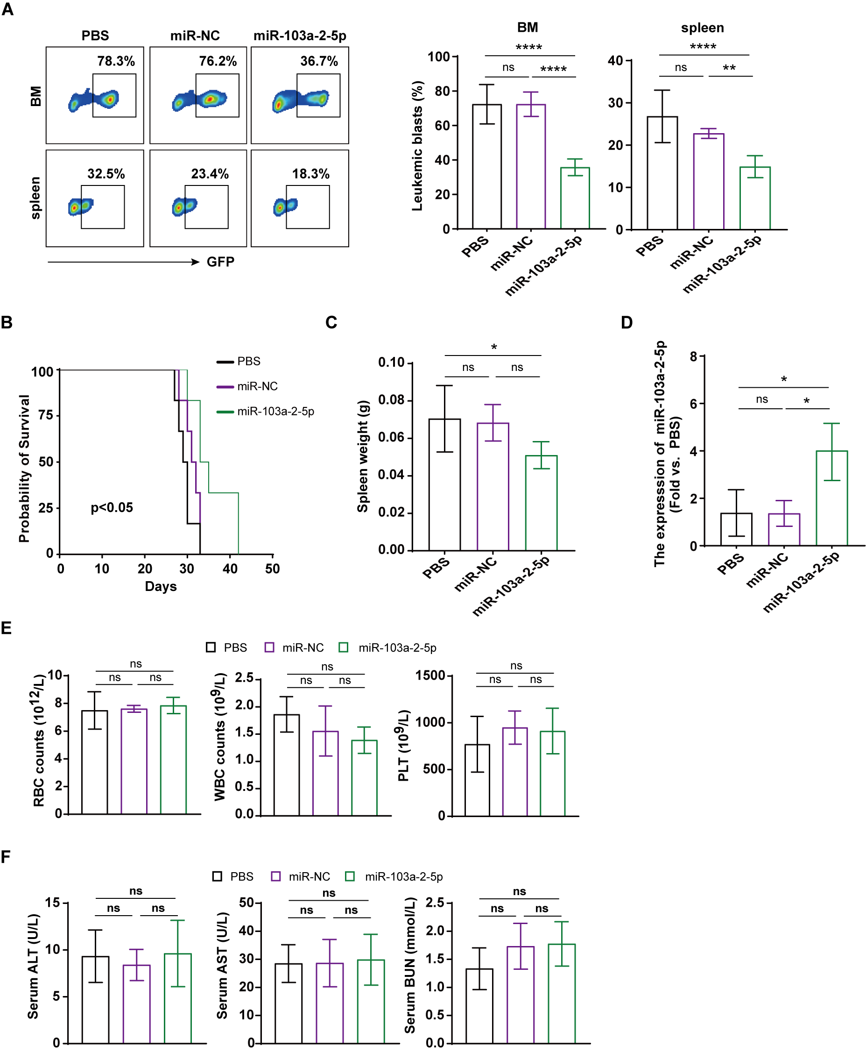
Figure S5 The influence of miR-103a-2-5p in the AML tail vein mouse model.
(A) Flow cytometry analysis for detecting GFP-tagged THP-1 cells in the spleens and bone marrows of AML mice. (B) Animal survival curve. (C) The weight of spleens. (D) qRT-PCR for detecting the level of miR-103a-2-5p in mouse peripheral blood. (E) Routine blood test of mice after the treatment. (F) Changes in biochemical indicators of liver and kidney function in mice after the treatment. n=6; mean ± SD; * P < 0.05, **P < 0.01, *** P < 0.001, ns: no significance, vs. control miRNA (miR-NC) or PBS.

