Fig. S2
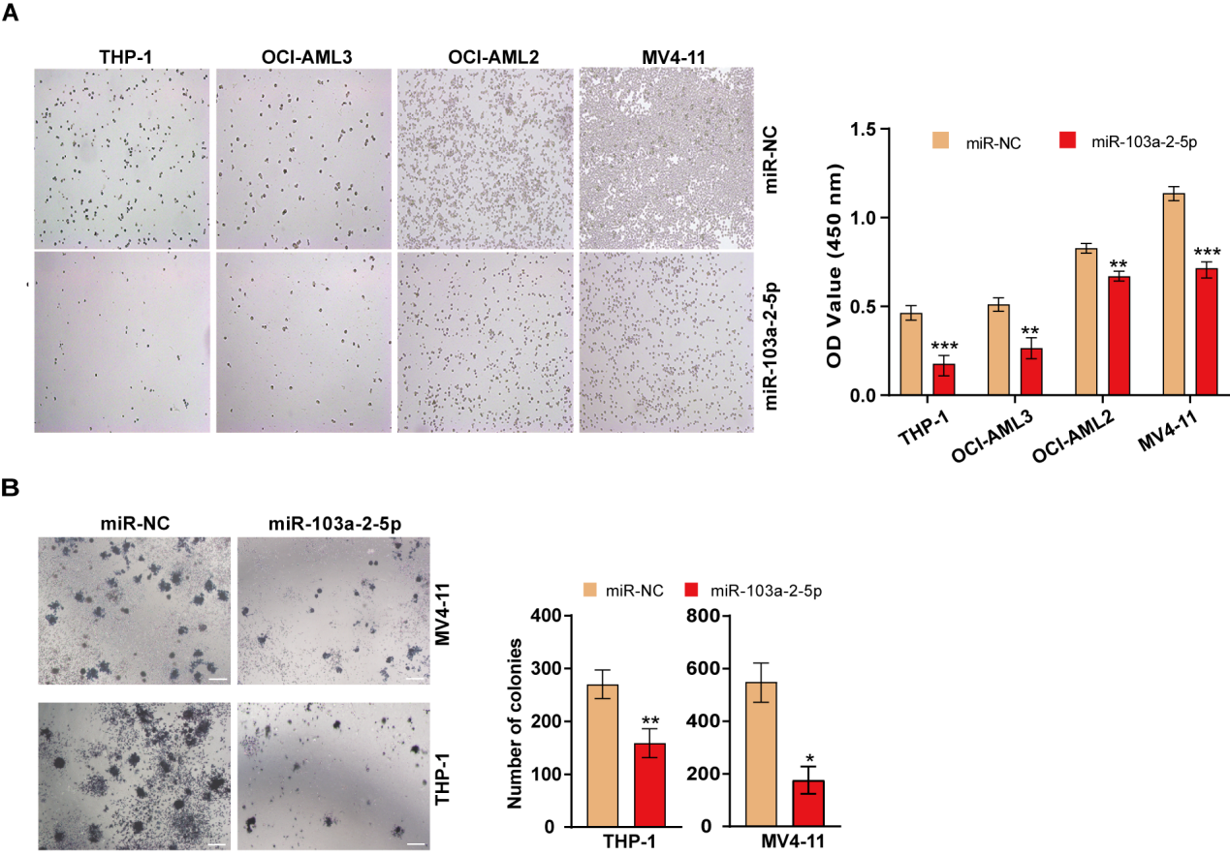

Figure S2. The inhibitory effect of miR-103a-2-5p on the migration and colony formation of AML cells.
(A) Transwell migration assays of THP-1, OCI-AML3, OCI-AML2, and MV4-11 cells transfected with miR-103a-2-5p or miR-NC. (B) Colony formation of THP-1 and MV4-11 cells transfecting with miR-103a-2-5p or miR-NC, cultured for 14 days. Statistical significance was determined as * P < 0.05, ** P < 0.01, *** P < 0.001 vs. control miRNA (miR-NC). Cell experiments were performed three times independently.

