Fig. S3
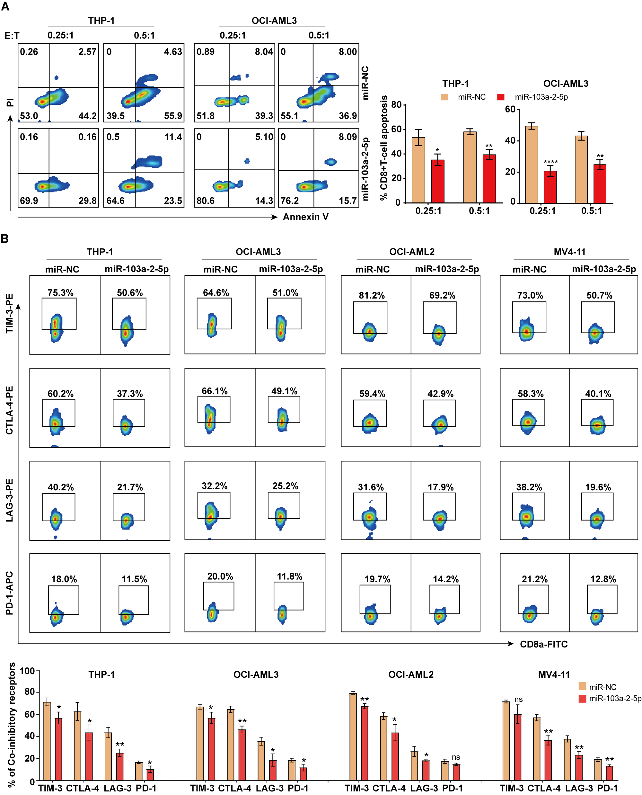

Figure S3 MiR-103a-2-5p enhances CD8+ T cells survival and reduces inhibitory receptor generation. Tumor cells and PBMCs were co-cultured in the U-bottom 96-well plate for 72 h, and (A) CD8+ T cell apoptosis was detected by flow cytometry. (B) The expression of immune checkpoints on T cells was detected by flow cytometry. All results are presented as the mean ± SD, * P < 0.05, **P < 0.01, *** P < 0.001 vs. control miRNA (miR-NC). Cell experiments were performed three times independently.

