Fig. S4
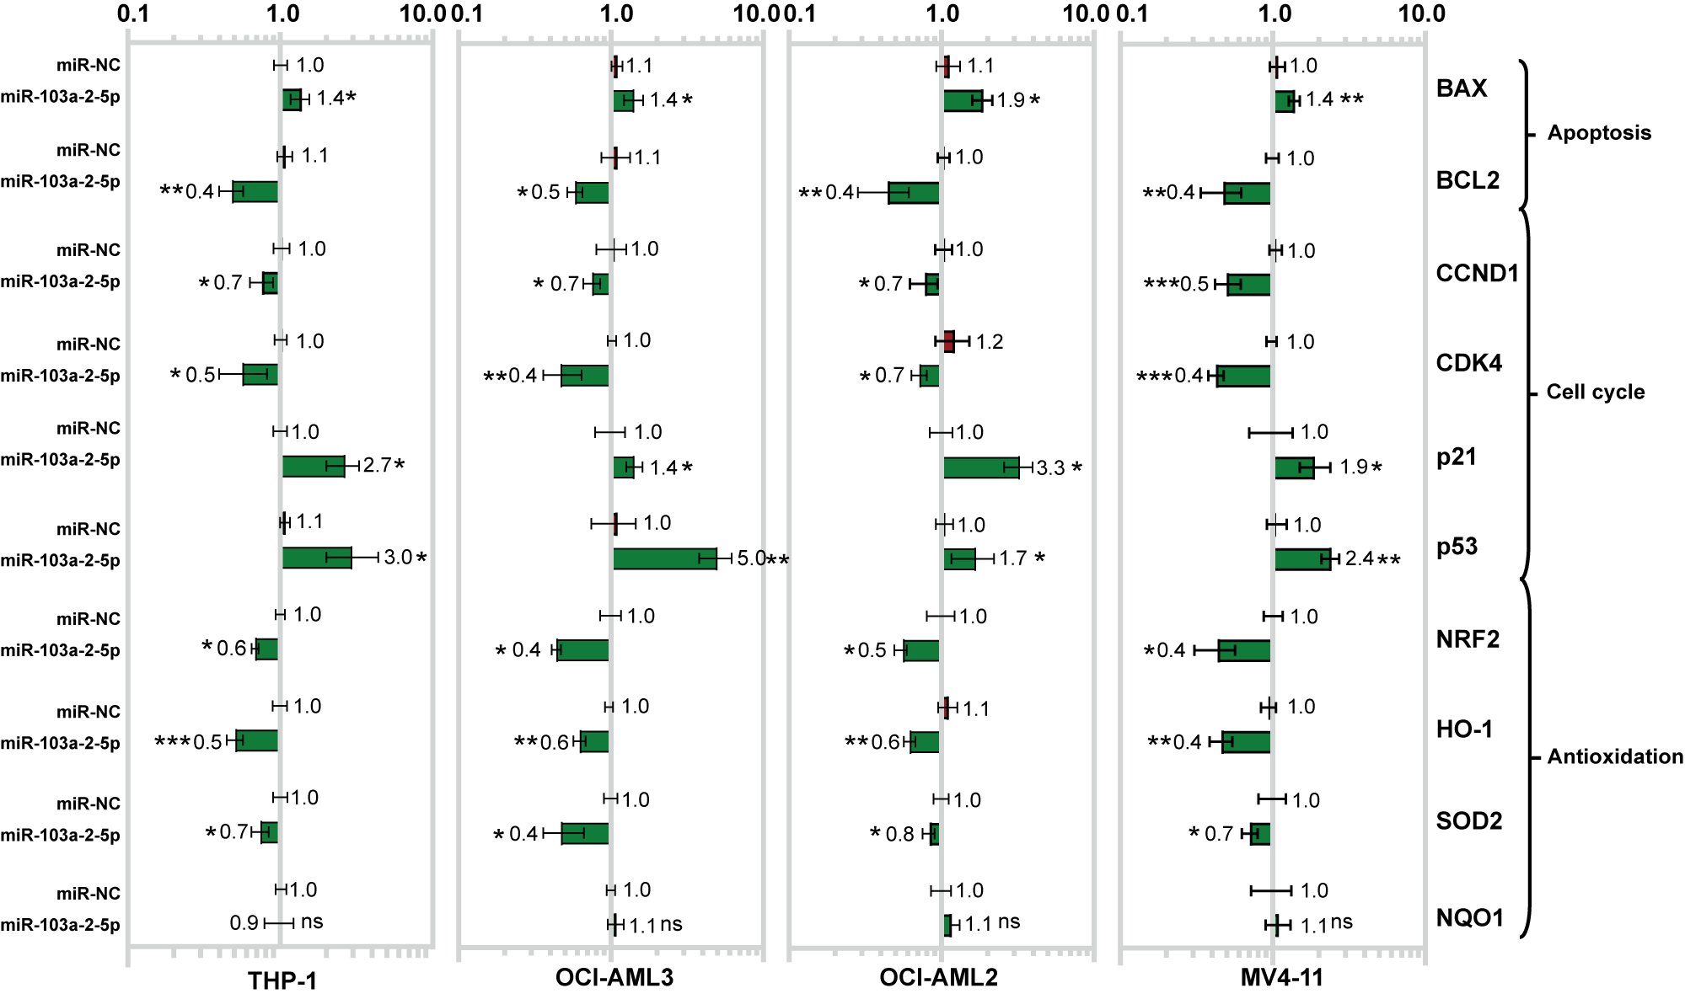

Figure S4. The mRNA expression of genes related to cell apoptosis, cell cycle, and antioxidation.
The mRNA expression of genes was detected by qRT-PCR after AML cells transfected with miR-103a-2-5p or miR-NC. All results are presented as the mean ± SD, * P < 0.05, **P < 0.01, *** P < 0.001 vs. control miRNA (miR-NC). Cell experiments were performed three times independently.

