Supplementary Materials for

IL-33 regulates adipogenesis via Wnt/β-catenin/PPAR-γ signaling pathway in preadipocytes

Danning Xu¹, Siqi Zhuang¹, Hongzhi Chen², Mengjie Jiang¹ , Ping Jiang¹, Qian Wang¹, Xuemei Wang¹, Ruohong Chen¹, Haoneng Tang^{1*}, Lingli Tang^{1*}
¹Department of Laboratory Medicine, The Second Xiangya Hospital, Central South University, Changsha, Hunan, China
²National Clinical Research Center for Metabolic Disease, Key Laboratory of Diabetes Immunology, Ministry of Education, Metabolic Syndrome Research Center, and Department of Metabolism & Endocrinology, The Second Xiangya Hospital, Central South University, Changsha, Hunan, China

*Tang Haoneng and Tang Lingli contributed equally to this study
Corresponding authors:
Haoneng Tang. E-mail: 505462@csu.edu.cn.
Lingli Tang. E-mail: linglitang@csu.edu.cn.

This PDF file includes:
Table S1
Fig. S1

Table S1. List of primers used for real-time quantitative PCR(qRT-PCR).
Name | Forward(5’-3’) | Reverse(5’-3’)
actin | AGCCATGTACGTAGCCATCC | CTCTCAGCTGTGGTGGTGAA
IL-33 | GCTGCGTCTGTTGACACATT | CACCTGGTCTTGCTCTTGGT
PPARγ | ATGTCTCACAATGCCATCAGG | TCTGGGTTCAGCTGGTCGAT
C/EBPα | CAAGAACAGCAACGAGTACCG | GTCACTGGTCAACTCCAGCAC
FABP4 | AAGGTGAAGAGCATCATAACCCT | TCACGCCTTTCATAACACATTCC
LPL  Adipoq  CD36 | TGGCGTAGCAGGAAGTCTGA  GCCTGGAGAAGCCGCTTATGTG  ATGGGCTGTGATCGGAACTG | TGCCTCCATTGGGATAAATGTC  TGCCAGTGCTGCCGTCATAATG  GTCTTCCCAATAAGCATGTCTCC

Supplementary Figure. S1
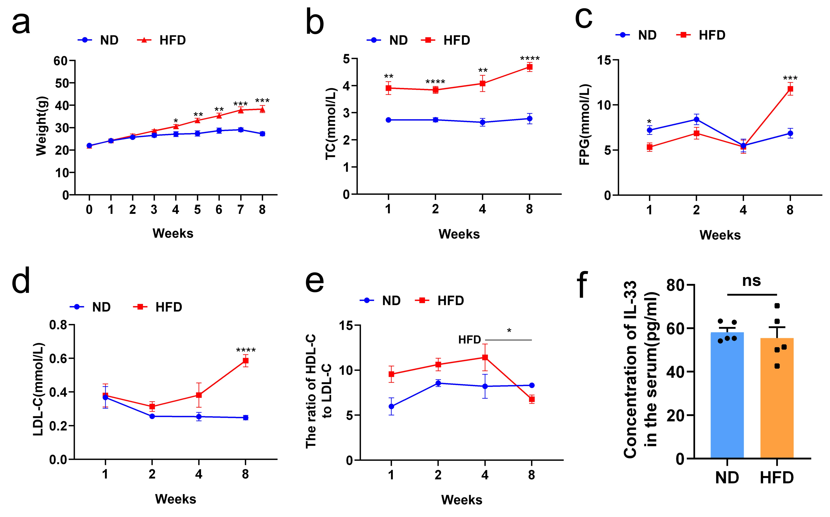
Fig.S1. The model of obese mice fed high fat diet was established successfully and serum IL-33 levels were measured in eight-week-old mice. Mice were fed with HFD or ND for 8 weeks. (a-e)the level of weights(a), TC (b), FPG(c), LDL-C(d) and HDL-C/LDL-C(e) of mice. (f) Serum IL-33 levels were detected by ELISA at 8 weeks. Data are represented as means ± SEM. n = 5 per group. *P< 0.05, **P < 0.01, ***P < 0.001 and ****P < 0.0001 versus the ND group. HFD, high-fat diet; ND, normal chow diet.

