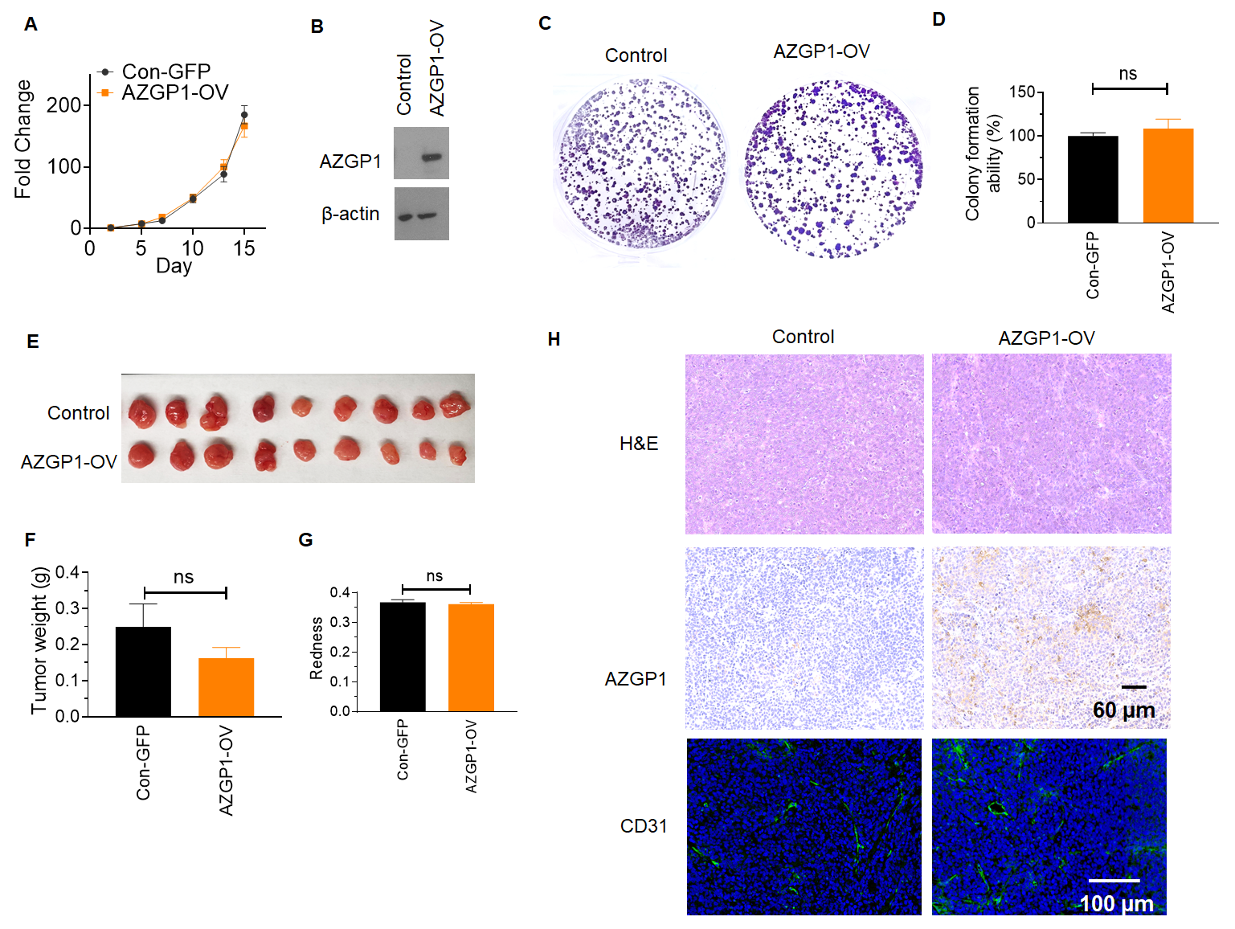
Figure S1. (A) Overexpression of AZGP1 in AZGP1-OV 22Rv1 cells did not affect cell proliferation. (B) Western blot confirming increased AZGP1 protein expression in 22Rv1 AZGP1-OV cells. (C) Overexpressing of AZGP1 does not affect colony formation in 22Rv1 cells. (D) Quantification of colony formation in control and AZGP1-OV 22Rv1. (E) Rpresentative images of 22Rv1 vector control and 22Rv1 AZGP1-OV tumor xenografts. (F) Tumor weight of 22Rv1 vector control and 22Rv1 AZGP1-OV. (G) Representative images showing similar tumor morphology by H & E, validation of AZGP1 overexpression, and CD31 staining microvessels in 22Rv1-AZGP1-OV tumors and control tumors.
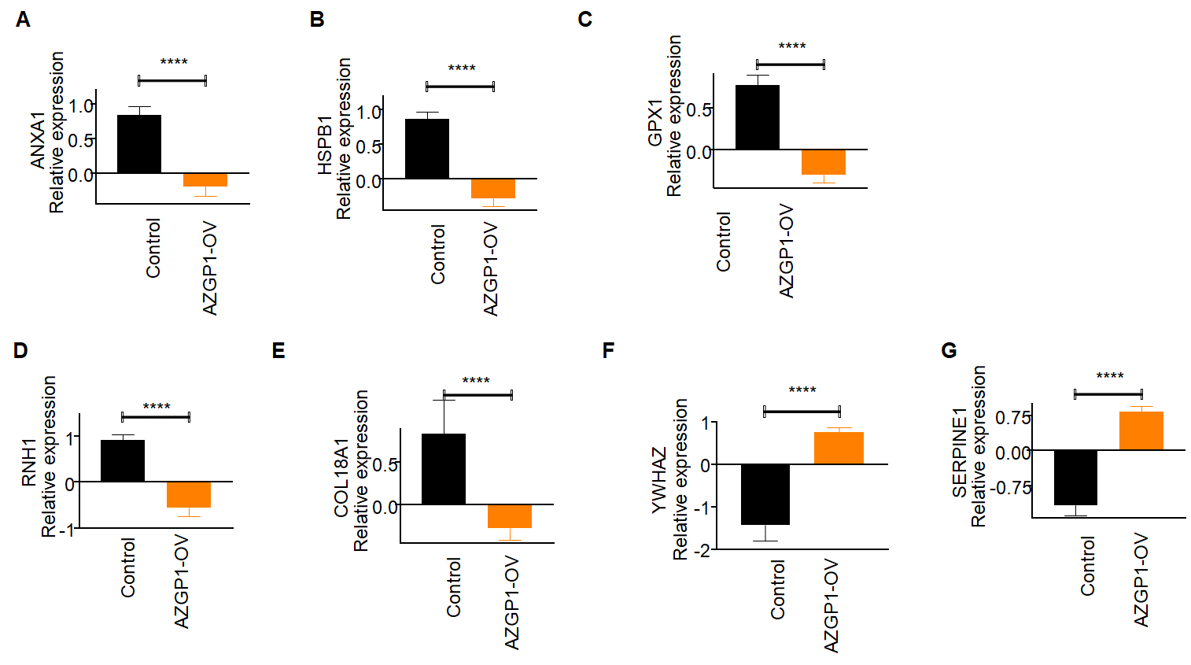
Figure S2. Relative expression levels of (A) ANXA1, (B) HSPB1, (C) GPX1, (D) RNH1, (E) COL18A1, (F) YWHAZ, (G) SERPINE1 in PC3 control and AZGP1-OV tumors, determined by mass spectrometry.

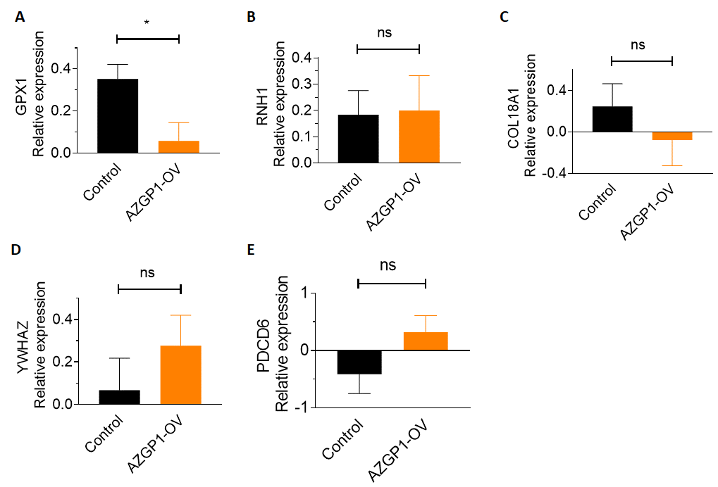
Figure S3. Relative expression levels of (A) GPX1, (B) RNH1, (C) COL18A1, (D) YWHAZ, (E) PDCD6 in DU145 control and AZGP1-OV tumors, determined by mass spectrometry.

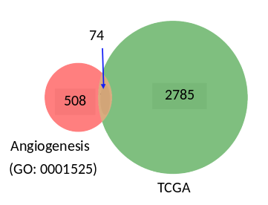
Figure S4 Genes correlated with AZGP1 expression levels in TCGA-PRAD overlapped with 74 genes in the GO term angiogenesis pathway.

Table 1 A list of genes exhibiting upregulation and downregulation in AZGP1-OV PC3 tumors in contrast to vector control PC3 tumors
Gene Name | log2 (fc) | -log(p)
SERPINE1 | 2.003062 | 6.067896
YWHAZ | 2.180557 | 4.413624
EPHA2 | 1.497037 | 4.319662
PDCD6 | 1.519989 | 4.245097
GTF2I | 1.112674 | 3.65412
PKM | 1.54521 | 3.540235
HK2 | 1.340204 | 3.489449
PXN | 0.9847 | 3.406086
PGK1 | 1.048806 | 3.379259
CTNNB1 | 2.073469 | 3.304442
PNPLA6 | 0.942191 | 3.058408
ROCK2 | 1.660978 | 2.996045
HMGB1 | 1.667595 | 2.879129
ANXA2 | 0.96719 | 2.8454
PARVA | 1.207348 | 2.719219
CLIC4 | 1.66429 | 2.523227
CDC42 | 1.9547 | 2.473512
MYH9 | 0.663242 | 2.229714
MAPK14 | 1.09679 | 2.214652
RHOA | 1.024672 | 2.034992
STAT1 | 0.426674 | 1.895267
ACTG1 | 4.528359 | 1.678165
FN1 | 0.82456 | 1.653815
EPN1 | 1.16068 | 1.649192
PLCG1 | 0.901481 | 1.619949
FLNA | 0.612487 | 1.532775
NRP1 | 0.789286 | 1.494189
RNF213 | 1.560479 | 1.455726
TJP1 | 0.459119 | 1.428735
MMP9 | -7.1448 | 10.49804
GPX1 | -1.06614 | 5.711038
HSPB1 | -1.13777 | 5.669291
COL18A1 | -1.11887 | 5.308254
RNH1 | -1.48418 | 5.130718
CALD1 | -1.98011 | 4.40121
ANXA1 | -1.03436 | 4.367334
ANPEP | -1.38031 | 4.095995
ANXA3 | -0.8228 | 3.756164
PLAU | -2.02011 | 3.697024
ERAP1 | -1.76457 | 3.536119
COL4A1 | -1.29719 | 3.122154
LOXL2 | -2.50268 | 2.953424
THBS1 | -1.03145 | 2.911205
IL18 | -2.93753 | 2.890796
TNFAIP2 | -2.83203 | 2.877164
NAXE | -1.05232 | 2.828925
PRCP | -1.83404 | 2.379302
LGALS3 | -0.71302 | 2.275703
DCN | -2.53527 | 2.259456
MYDGF | -0.73867 | 2.187877
CIB1 | -1.25718 | 1.974782
EGLN1 | -1.50547 | 1.966979
COL4A2 | -0.95185 | 1.906903
STAT3 | -1.15305 | 1.606961

