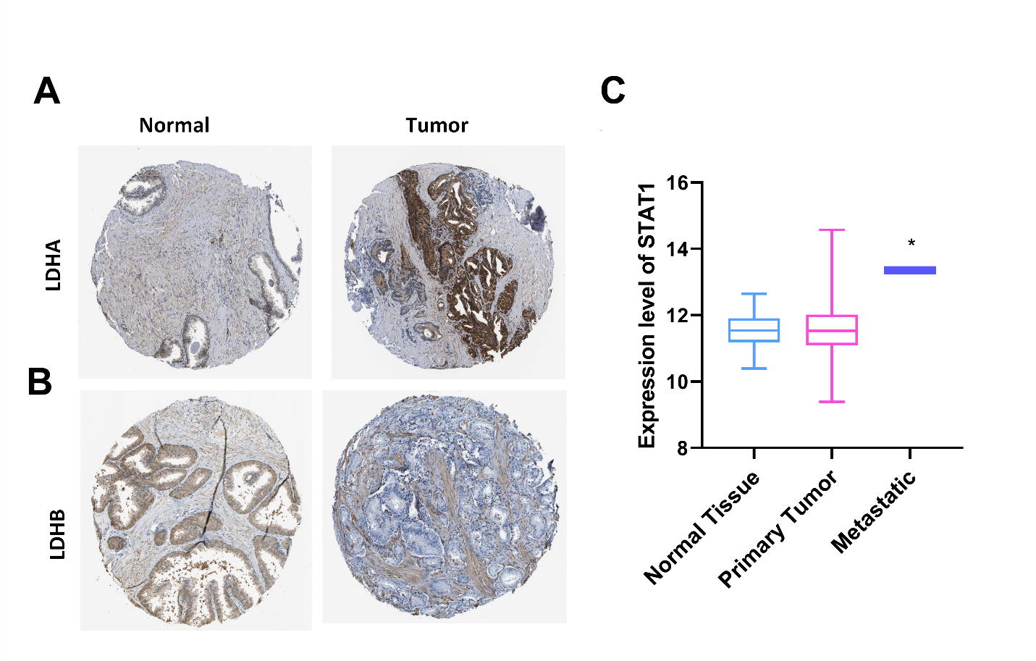
Supplementary figure S1. Expression of LDHA, LDHB proteins, and STAT1 mRNA in PCa. THE HUMAN PROTEIN ATLAS (HPA) database (https://www.proteinatlas.org/) was used to explore the protein expression of (A) LDHA and (B) LDHB in prostate adenocarcinoma samples and normal samples via immunohistochemistry. (C) The expression of STAT1 in normal tissue, primary PCa samples, and metastatic PCa samples was explored using the TCGA data downloaded from the UCSC Xena database. *p<0.05.

