Supplementary Material
Table S1. Primer used in the qRT-PCR assays
Gene | Primer sequences
iNOS | F: 5’-CAGAAGTGCAAAGTCTCAGACAT-3’  R: 5’-CAGGAGCGTTAGTGACAGCAG-3’
CD86 | F: 5’-CTGCTCATCATTGTATGTCAC-3’  R: 5’-ACTGCCTTCACTCTGCATTTG-3’
Arg | F: 5’-ACAAGACAGGGCTCCTTTCAG-3’  R: 5’-TGAGTTCCGAAGCAAGCCAA-3’
TNFα | F: 5’-CTGAACTTCGGGGTGATCGG-3’  R: 5’-GGCTTGTCACTCGAATTTTGAGA-3’
IL1α | F: 5’-CGAAGACTACAGTTCTGCCATT-3’  R: 5’-GACGTTTCAGAGGTTCTCAGAG-3’
IL1β | F: 5’-TGGAGAGTGTGGATCCCAAG-3’  R: 5’-GGTGCTGATGTACCAGTTGG-3’
TNFαip8l1 | F: 5’-GTTTGTGGACAATACCAGCAGT-3’  R: 5’-GTTCTTCACTACCCTCTGTGC-3’
IL6 | F: 5’-ATAGTCCTTCCTACCCCAATTTCC-3’  R: 5’-GATGAATTGGATGGTCTTGGTCC-3’
TGFβ1 | F: 5’-CAGTACAGCAAGGTCCTTGC-3’  R: 5’-ACGTAGTAGACGATGGGCAG-3’
IL1RN | F: 5’-GCTCATTGCTGGGTACTTACAA-3’  R: 5’-CCAGACTTGGCACAAGACAGG-3’
MMP9 | F: 5’-TTCGACTTGAAGTCTCAGAAGGTG-3’  R: 5’-TTCGACTTGAAGTCTCAGAAGGTG-3’
OCN | F: 5’-CTGACAAAGCCTTCATGTCCAA-3’  R: 5’-GCGCCGGAGTCTGTTCACTA-3’
GADPH | F: 5’-TCAGCAATGCCTCCTGCAC-3’  R: 5’-TCTGGGTGGCAGTGATGGC-3’

Figure S1. EDS results indicated that the major chemical elements in PHA and FPHA are similar.
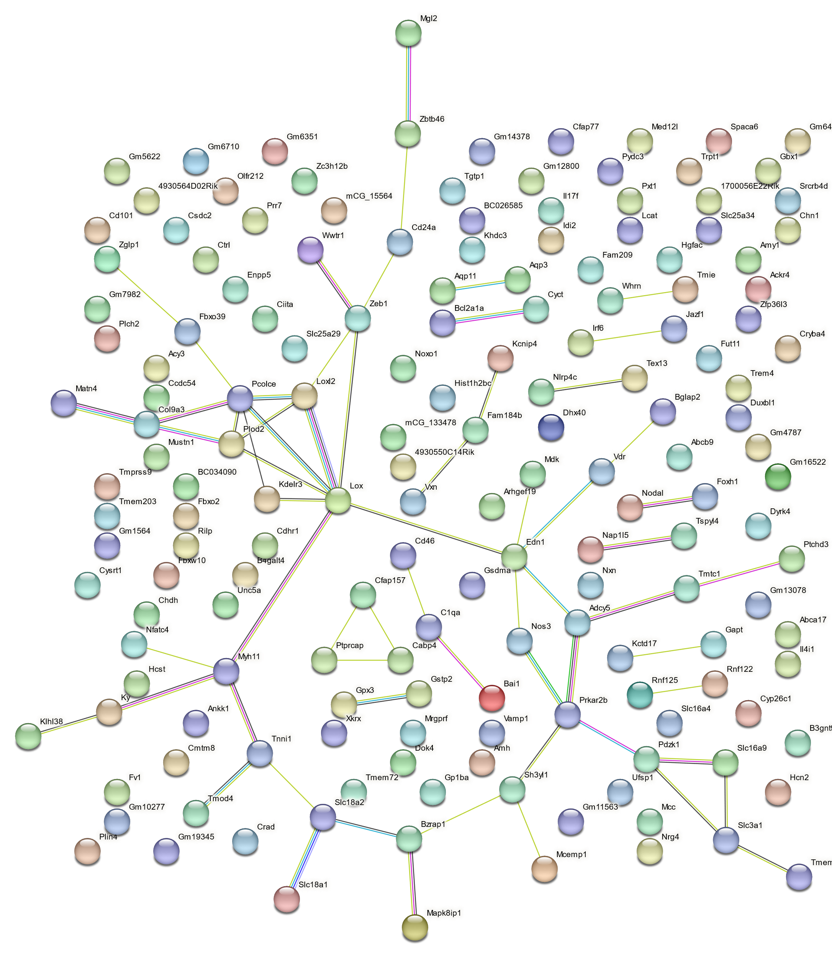

Figure S2. STRING results revealed the protein-protein interaction network.

