Additional file 1
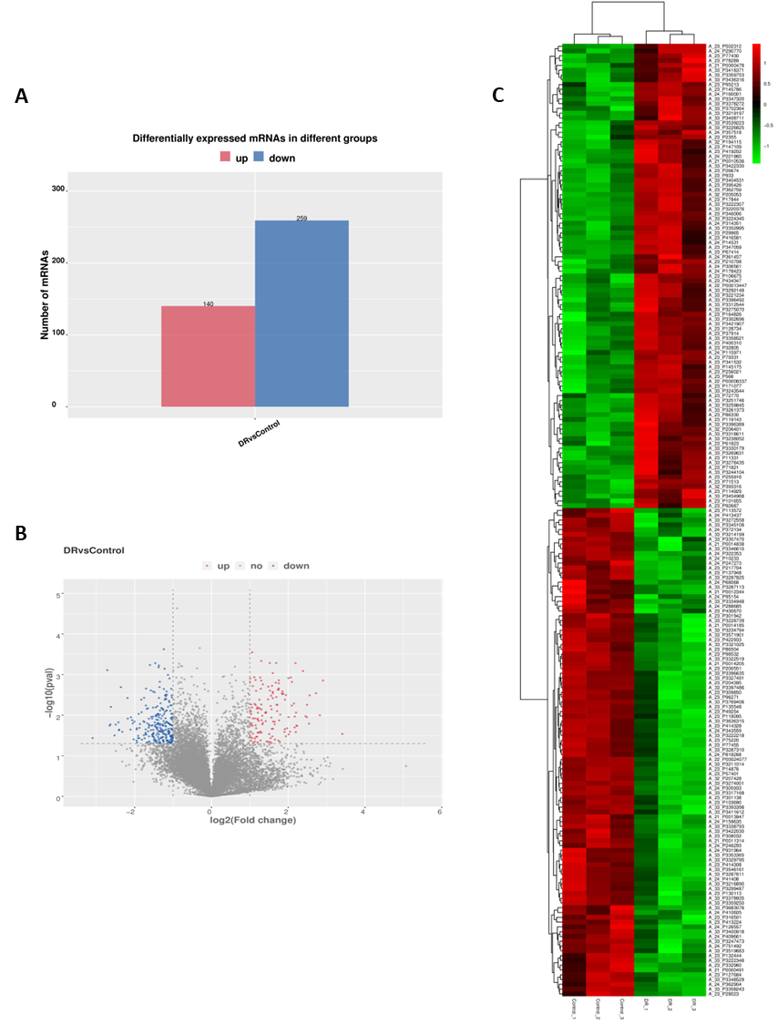
Fig. S1: NSUN2 is highly expressed in Microarray analysis.
(A) Column chart demonstrates the number of differentially expressed up- and down-regulated mRNAs. (B) Heatmaps demonstrates differentially expressed mRNAs between control group and DR group. (C) Volcano plot demonstrates differentially expressed mRNAs between control group and DR group.
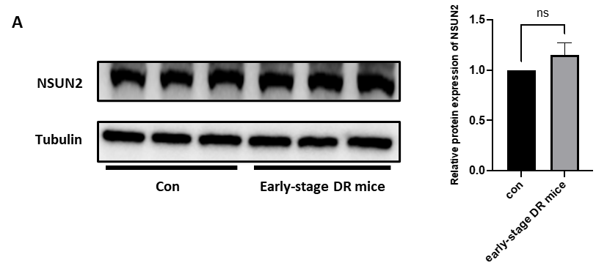
Fig. S2: NSUN2 is not differentially expressed in early DR.
(A) NSUN2 protein expression in control mice versus early DR mice.

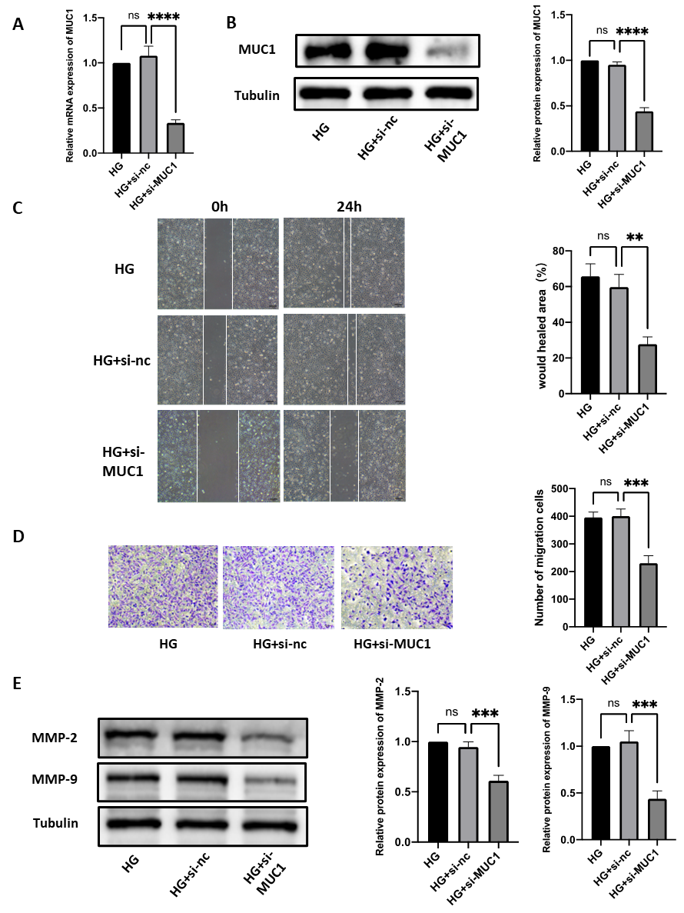
Fig. S3: Effect of MUC1 on cell migration.
(A) qRT-PCR was used to evaluate the transfection efficiency of MUC1. (B) Western blot analysis of the transfection efficiency of MUC1. (C) Wound healing assay was performed to detect changes in cell migration ability after si-MUC1 treatment. (D) Transwell assays were used to measure the alteration in cell migration ability after si-MUC1 transfection. (E) Western blot analysis of the changes in the MMP-2 and MMP-9 protein levels after si-MUC1 treatment.

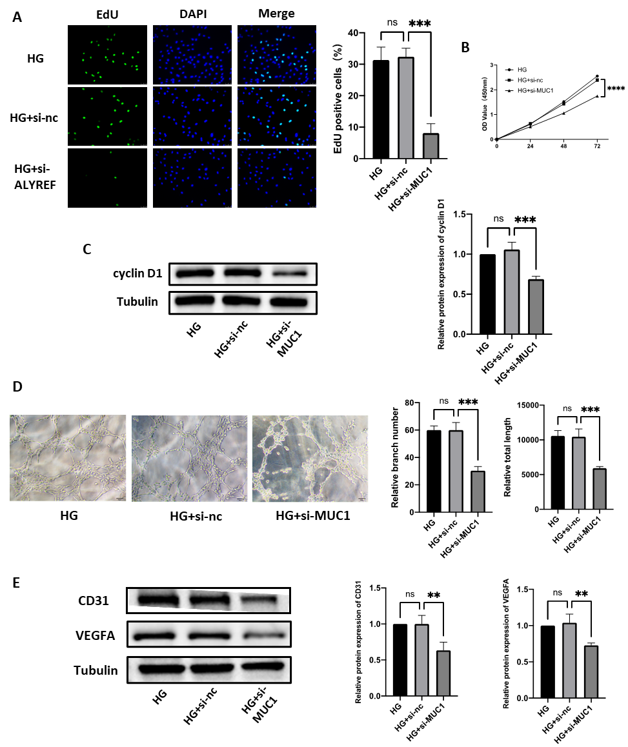
Fig. S4: Effect of MUC1 on cell proliferation and angiogenesis.
(A) An EdU assay was performed to detect the effect of si-MUC1 on cell proliferation. (B) A CCK-8 assay was performed to detect the effect of si-MUC1 on cell proliferation. (C) Western blot analysis of the changes in cyclin D1 protein levels after si- MUC1 transfection. (D) Effect of HG and si-MUC1 on the tube formation ability of HRMECs was examined by tube formation assay. (E) Western blot was used to measure the changes in CD31 and VEGFA protein levels after si-MUC1.

Table S1: The sequences of siRNAs
siRNA | Sequence (5′-3′)
siNSUN2  siALYREF  siMUC1 | GCAGUGUCCCAUCGUCUUATT GGAAACTGCTGGTGTCCAATC  CGGGATACCTACCATCCTA

Table S2: Primer sequences for qRT-PCR
Gene | Primer sequences
NSUN2  （human）  NSUN2  （Mouse） | Forward: CAAGCTGTTCGAGCACTACTAC  Reverse: CTCCCTGAGAGCGTCCATGA  Forward: GGGAAAGCTGTCATCTGCTG  Reverse: CAGAGGCTTGGGTTTCCCTA
ALYREF | Forward: GCAGGCCAAAACAACTTCCC  Reverse: AGTTCCTGAATATCGGCGTCT
MUC1（human）  MUC1（Mouse）  Tubulin（human）  Tubulin  （Mouse） | Forward: CCTGCCTGAATCTGTTCTGC  Reverse: TGTAAGCACTGTGAGGAGCA  Forward: CGTCAGGCTCAGCTATCATTC  Reverse: GGGTATTGACTTGGCACTGAA  Forward: CAGCTCATCACAGGCAAGGA  Reverse: TGCTCTTACCAGCTTGCGAA  Forward:CAGCTCATCACAGGCAAGGA  Reverse:TGCTCTTACCAGCTTGCGAA

Table S3: Primary antibodies for Western blot assay
Antibody name | Dilutions | Vendor name | Cat No.
NSUN2 | 1:10000 | Proteintech | 20854-1-AP
ALYREF | 1:1000 | Abcam | ab202894
YBX1 | 1:1000 | Abcam | ab76149
MMP2 | 1:1000 | Proteintech | 10373-2-AP
MMP9 | 1:1000 | Proteintech | 10374-2-AP
CD31 | 1:10000 | Proteintech | 11265-1-AP
VEGFA | 1:1000 | Abcam | ab214424
Cyclin D1 | 1:1000 | CST | 67116-1-Ig
MUC1 | 1:1000 | Abcam | ab45167
Tubulin | 1:5000 | Proteintech | 66240-1-Ig

Table S4: The screened potential target genes of NSUN2/RNA m5C
Gene sets | Gene numbers | Gene symbols
RNA m⁵C modified transcripts in Hela cells | 77 | GALM, WDR44, ACAA2, ROCK2, ECE1, PRDX5, FECH, LSP1, RIN2, PRDX6,DNAJC24, MTCH1, CAPNS1, QSOX1, HSPA9, TALDO1,TBL3, TMEM109, LMO7, GSTZ1, IST1, TPM2, HNRNPA1, EPHX1, SETD7, NOL9, RCN2, ETFB, CISD1, TPM1, MAPK3, FLNB, AUH, RABIF, GCLC, TKT, ECI1, NAV2, ADPRHL2,PEBP1, CBX8, SND1,TMEM33,ARHGAP27, MIEN1, EFHD2, TPT1, RPS28, LUZP1, CTSC, RPS9, POLDIP2, LTIH4, SHMT2, UBAC1, CCDC51, CPOX, UHRF1, RYR1, CNN3, GPX1, PDLIM7, NOLC1, DUT, MGAT2, SSR3, UTP6, COPG1, HINT1, MIF, DDX21, FOCAD, MUC1, RRM2, IMP4, DDX18, TPM4
Upregulated proteins | 39 | RYR1, LSP1,TPM4, NOLC1,TPM1,MUC1,SHMT2, TPM2, TBL3, CTSC, DDX21, RRM2, MGAT2, LTIH4, EFHD2, RPS28,IMP4, HSPA9, ECE1, DDX18, FLNB, DUT, TMEM33, LUZP1, RPS9, SSR3, PDLIM7, NOL9, TPT1, CPOX, SND1, QSOX1, HNRNPA1, COPG1, CNN3, POLDIP2, UTP6, UHRF1, CCDC51

