Fig. S1 The differential expression analysis of eRNA in melanoma. A Volcano plot of differentially expressed enhancers between tumor and normal. The red dots in the plot represent upregulated enhancers, the blue dots represent downregulated enhancers in tumor (fold change > 1.5, Padj < 0.05). Data were collected from TCGA. B-D Volcano plot of differentially expressed enhancers between high-metastasis and low-metastasis. The red dots in the plot represent upregulated enhancers, while the blue dots represent downregulated enhancers in metastasis (fold change > 1.5, Padj < 0.05). Data were collected from GSE153592 (B), GSE200217 (C), and GSE35704 (D). E The Venn diagram presents the results of the above three datasets (B-D).

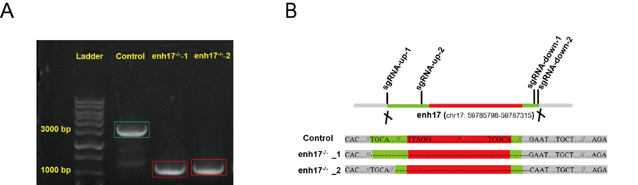
Fig. S2 enh17 was successfully knocked out. A The agarose gel electrophoresis shows the size of the PCR products. B The Sanger sequencing results confirm the genomic region of enh17 was deleted as expected.

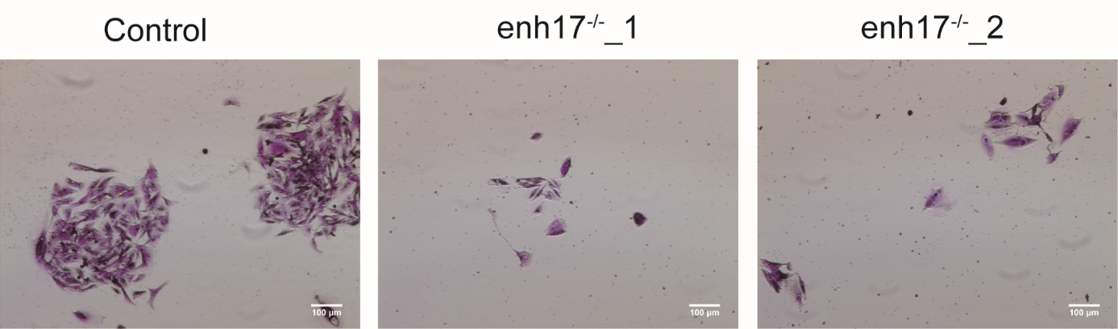
Fig. S3 enh17 knockout inhibits the clonogenic ability of A375 cells.
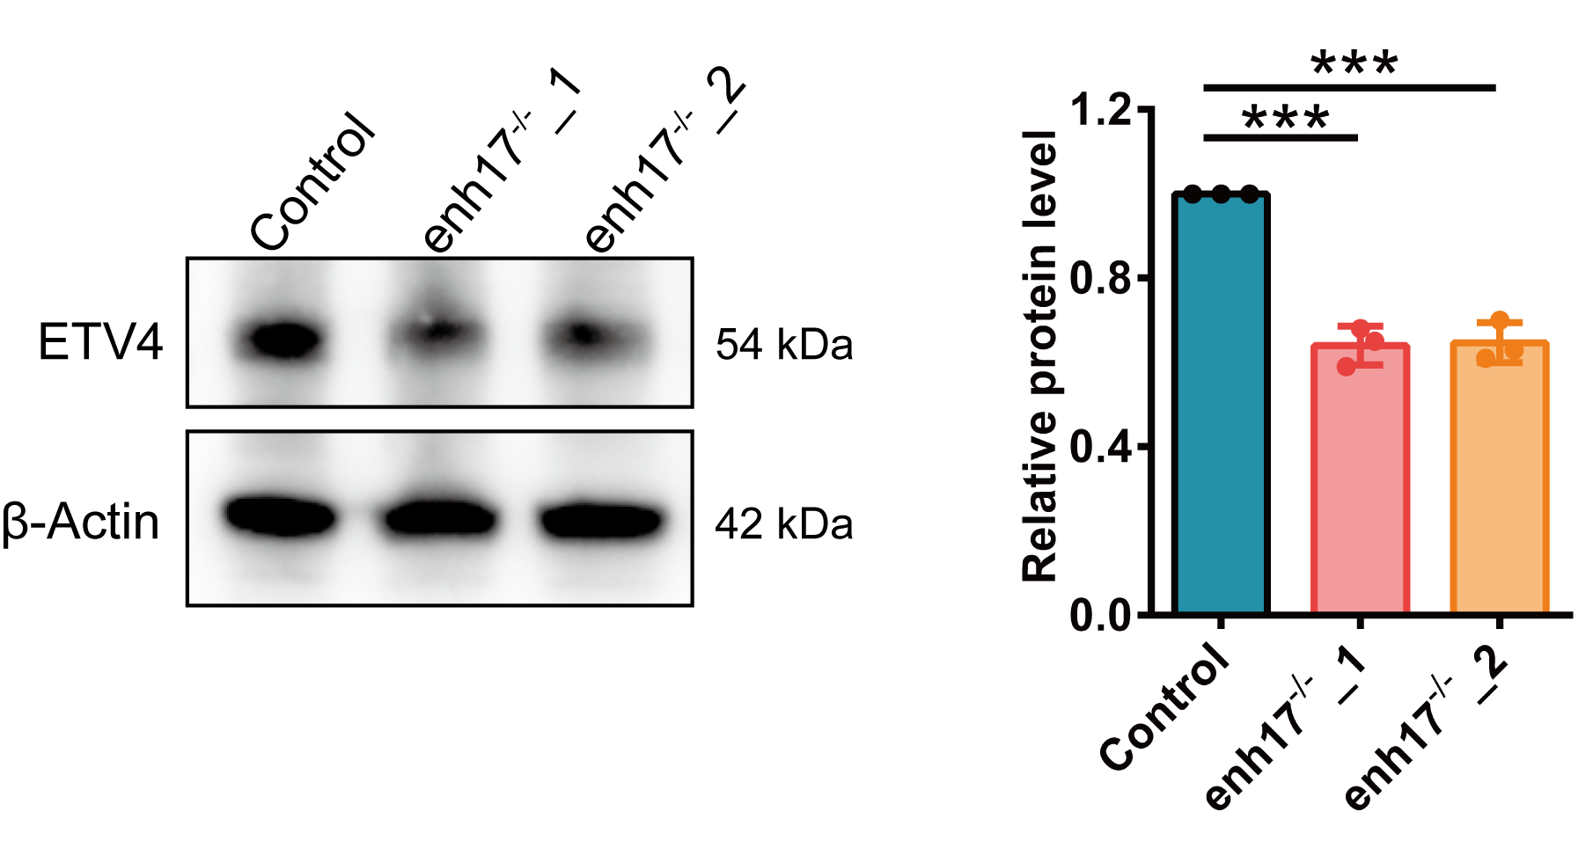
Fig. S4 ETV4 protein level is significantly decreased in enh17 knockout cell lines. Representative result (left) and relative protein level (right) are shown. The data are presented as mean ± SD (n = 3). P values are calculated using non-paired Student’s t test. ***P < 0.001.

Fig. S5 The expression of ETV4 is significantly increased in the metastatic tissue. A The expression level of ETV4 in metastatic and primary SKCM tissues from TCGA data. B The expression level of ETV4 in malignant cells from metastatic and primary tissues of SKCM patients. scRNA-seq data were collected from GSE72056 and GSE115978.

