B
A

Figure S1 A) miR-223 basal levels in LSCC (FaDu, HEp-2 and HNO-210) and normal (HaCaT) cell lines. B) miR-223 expression levels in HNO-210 cells transduced with either miR-223 Mimic or Inhibitor, analysed in comparison with the corresponding Nc. The p-value was calculated by t-test * p < 0.05, *** p < 0.001

Figure S2 Ectopic miR-223 Mimic and miR-223 Inhibitor affect HNO-210 cell growth. Cell growth of HNO-210 cells, transfected with either miR-223 Mimic and miR-223 Inhibitor was evaluated by MTT Assay at 24, 48 and 72h in comparison with the corresponding Nc. The p-value was calculated by t-test * p < 0.05, ** p < 0.005.
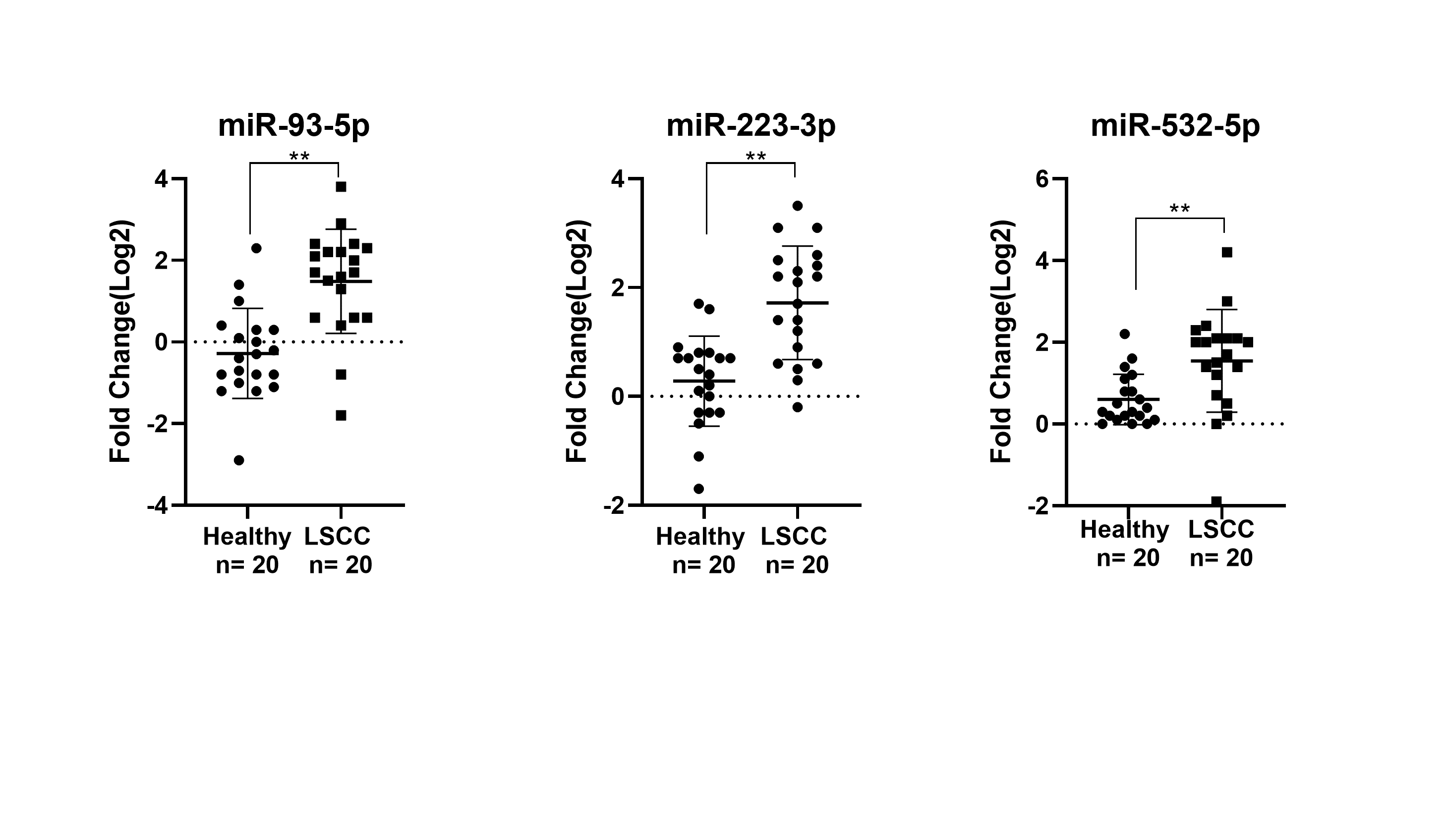
Figure S3 Serum miR-93, miR-223, and miR-532 expression levels in 20 LSCC patients. The expression levels of serum miR-93, miR-223, and miR-532 in LSCC patients (n = 20) compared with healthy donors (n = 20), validated by qRT-PCR. Exogenous cel-miR-39 was used as normalizer. The p-value was calculated by t-test **p <0.001.

