Supporting Information for:
Accumulated β-catenin is associated with Atrial Fibrosis and Atrial Fibrillation
Ying Bai; Rui Li; Jun Feng Hao; Lian-Wan Chen; Si-Tong Liu; Xi-Lin Zhang; Gregory Y. H. Lip; Jin-Kui Yang; Yi-Xi Zou; Hao Wang

Table S1. AF duration time
AF number | Gender | Age | AF type | AF Duration(years)
1 | Female | 80 | Paroxysmal AF | 0.5
2 | Female | 62 | Persistent AF | 10
3 | Female | 66 | Persistent AF | 0.4
4 | Female | 74 | Persistent AF | 0.5
5 | Male | 77 | Persistent AF | 1
6 | Male | 63 | Paroxysmal AF | 0.04
7 | Male | 60 | Paroxysmal AF | 10
8 | Female | 67 | Paroxysmal AF | 0.25
9 | Male | 55 | Paroxysmal AF | 7
10 | Male | 58 | Persistent AF | 0.5
11 | Male | 50 | Persistent AF | 0.5
12 | Male | 41 | Paroxysmal AF | 4
13 | Female | 45 | Paroxysmal AF | 1
14 | Female | 63 | Persistent AF | 0.08
15 | Male | 58 | Persistent AF | 3
16 | Female | 63 | Paroxysmal AF | 4
17 | Male | 79 | Persistent AF | 0.5
18 | Female | 55 | Persistent AF | 4
19 | Female | 52 | Persistent AF | 2
20 | Male | 28 | Paroxysmal AF | 0.04
21 | Female | 59 | Paroxysmal AF | 3
22 | Male | 64 | Persistent AF | 1
23 | Male | 68 | Persistent AF | 0.04
24 | Male | 61 | Persistent AF | 10
25 | Female | 59 | Persistent AF | 0.25
26 | Male | 51 | Persistent AF | 8
27 | Male | 72 | Persistent AF | 1
28 | Female | 67 | Persistent AF | 30
29 | Male | 34 | Paroxysmal AF | 2
30 | Female | 54 | Persistent AF | 0.2
31 | Male | 59 | Persistent AF | 0.08
32 | Female | 62 | Persistent AF | 0.08
AF, Atrial fibrillation.

Table S2. Full name of the Abbreviations used in the manuscript
Abbreviation | Full name
AF | atrial fibrillation
SR | sinus rhythm
Cx | connexin
GSK-3β | glycogen synthase kinase 3β
APC | adenomatous polyposis coli
hRAA | human right atrial appendage
ECG | electrocardiogram
ND | normal diet
HFD | high fat diet
PYP | pyrvinium pamoate
EDTA | ethylenediaminetetraacetic acid
HE | hematoxylin and eosin
PBS | phosphate-buffered saline
EGTA | ethylene glycol-bis(β-aminoethyl ether)-N,N,N′,N′-tetraacetic acid
RIPA | radioimmunoprecipitation assay
PMSF | phenylmethylsulfonyl fluoride
SDS-PAGE | sodium dodecyl-sulfate polyacrylamide gel electrophoresis
PVDF | polyvinylidene fluoride
ECL | enhanced chemiluminescence
GAPDH | glyceraldehyde-3-phosphate dehydrogenase
BSA | bovine serum albumin
SE | standard error
IQR | interquartile range
HCM | hypertrophic cardiomyopathy
LEF1 | lymphoid enhancer factor 1
DAPI | 4′,6-diamidino-2-phenylindole
PBS | phosphate buffered saline
TBST | Tris Buffered Saline with Tween
PB | phosphate buffer
DMEM | Dulbecco's Modified Eagle's Medium
HBSS | Hank's Balanced Salt Solution

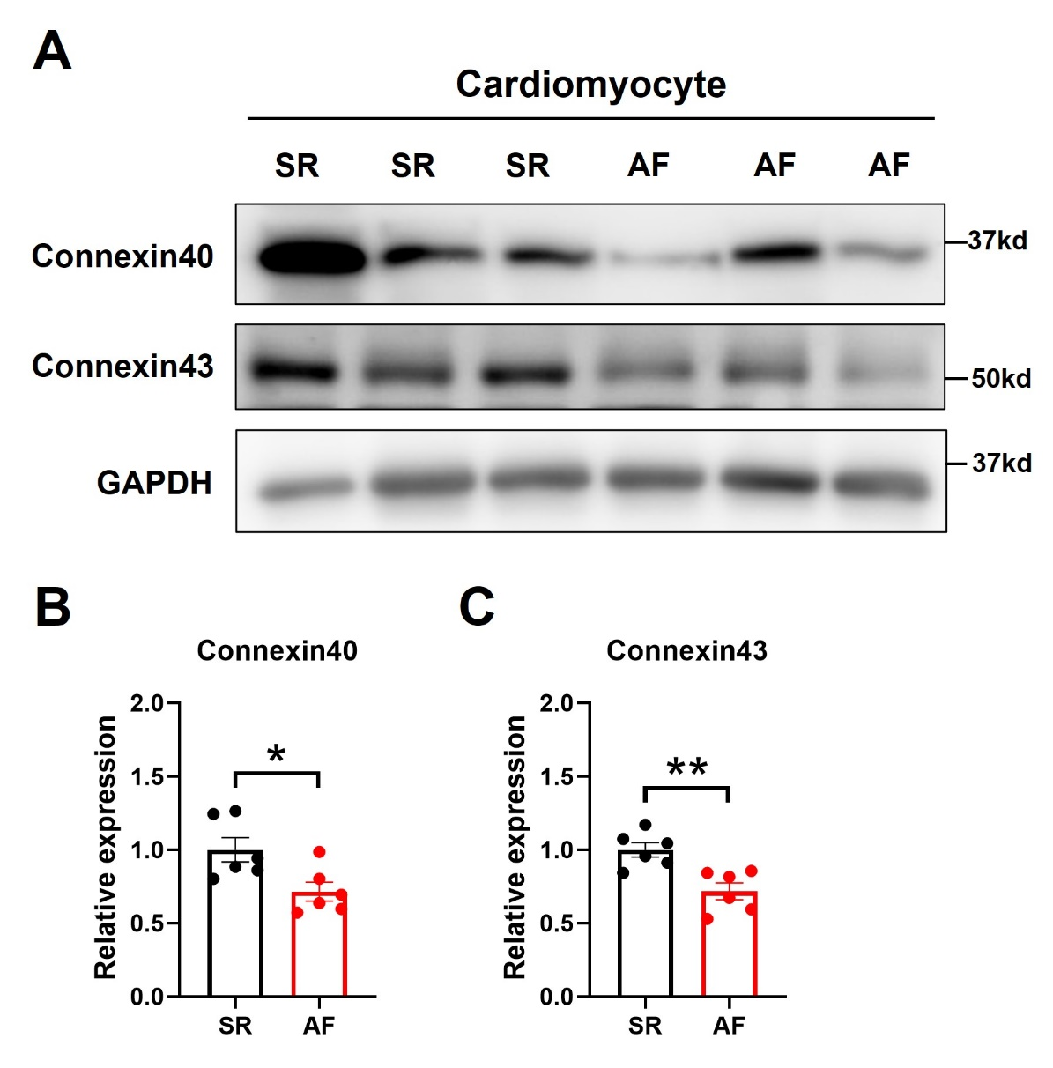
Figure S1. Expression of Connexin40 and Connexin43 in human cardiomyocytes.
(A) Western Blot analysis of Connexin40 and Connexin43 in cardiomyocytes from hRAA. (B, C) Protein expression levels of Connexin40 (B) and Connexin43 (C) from western blot analysis were quantified by immunosignal intensity analysis (n = 6 for each group). RAA, right atrial appendage. The statistical significance of differences between means was assessed by Student t test. *p＜0.05, **p＜0.01.

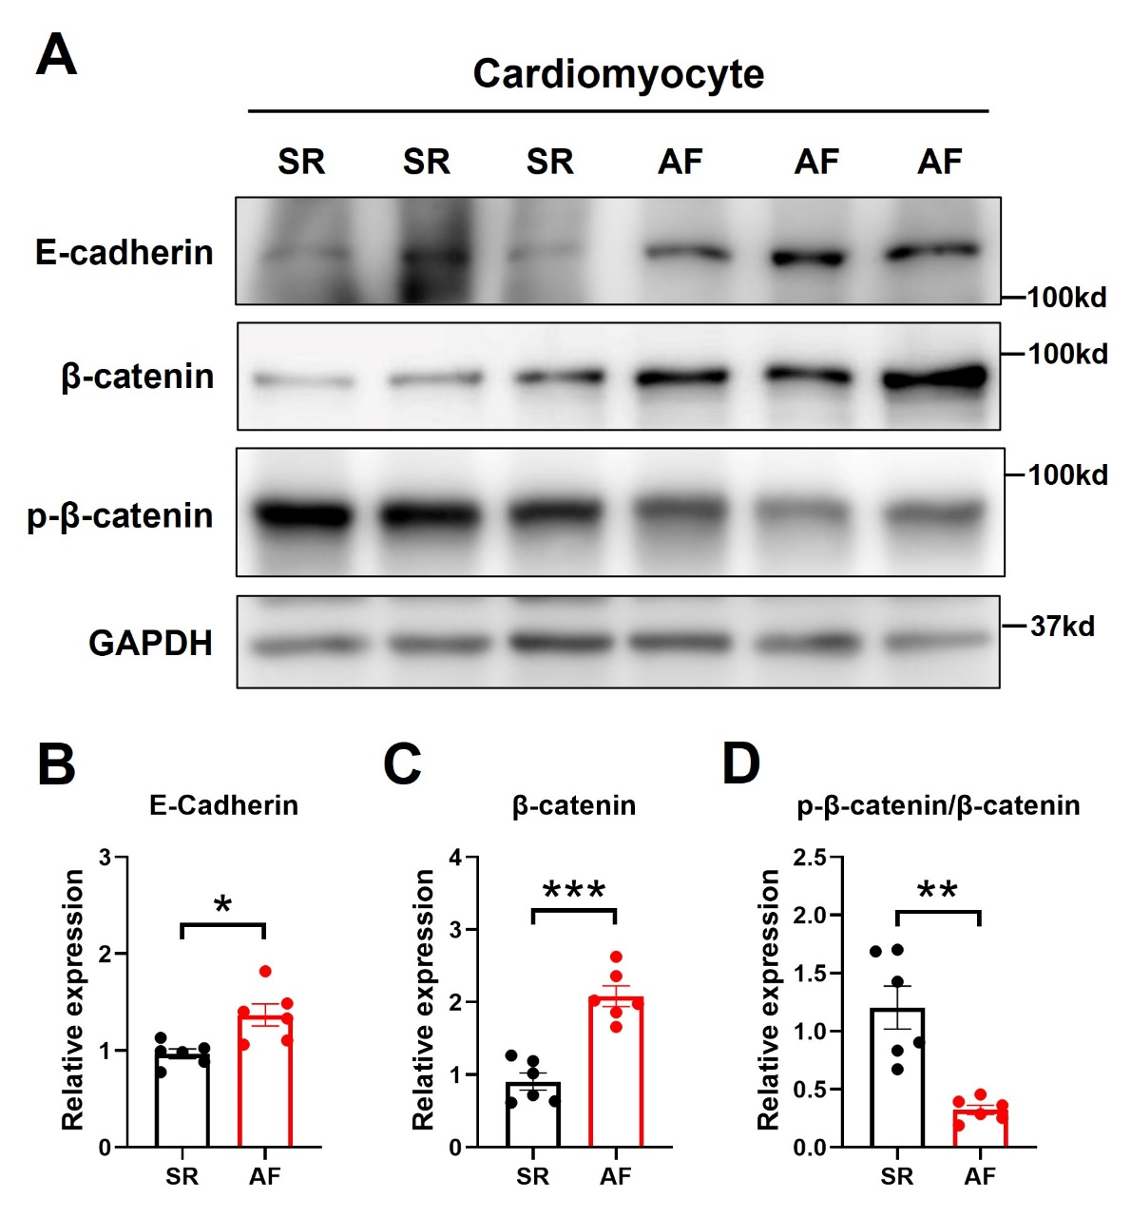
Figure S2. Expression of β-catenin and E-cadherin in human cardiomyocytes.
(A) Western Blot analysis of β-catenin, phospho-β-catenin and E-cadherin in cardiomyocytes from hRAA. (B-C) Protein expression levels of E-cadherin (B), β-catenin (C) and ratio of phosphor-β-catenin and β-catenin from western blot analysis were quantified by immunosignal intensity analysis (n = 6 for each group). RAA, right atrial appendage. The statistical significance of differences between means was assessed by Student t test. *p＜0.05, **p＜0.01, ***p＜0.001.

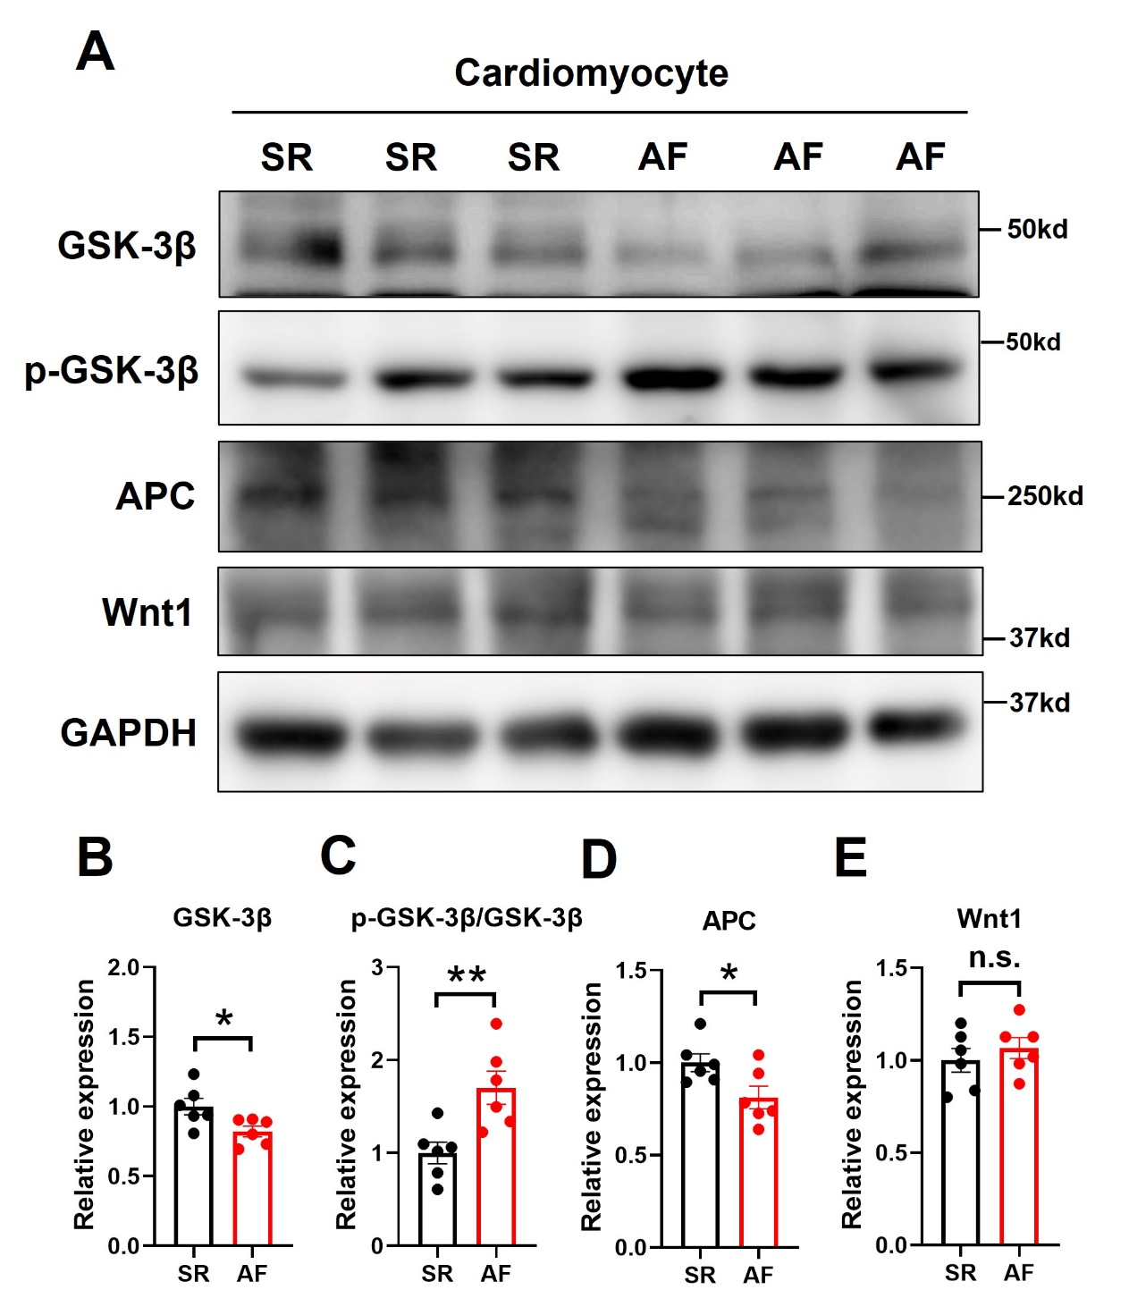
Figure S3. Expression of GSK-3β in human cardiomyocytes.
(A) Western Blot analysis of GSK-3β, phospho-GSK-3β, Wnt1 and APC in cardiomyocytes from hRAA. (B) Protein expression level of GSK-3β, ratio of phospho-GSK-3β and GSK-3β, Wnt1 and APC from western blot analysis was quantified by immunosignal intensity analysis (n = 6 for each group). RAA, right atrial appendage. The statistical significance of differences between means was assessed by Student t test. *p＜0.05, **p＜0.01, n.s. means not significant.
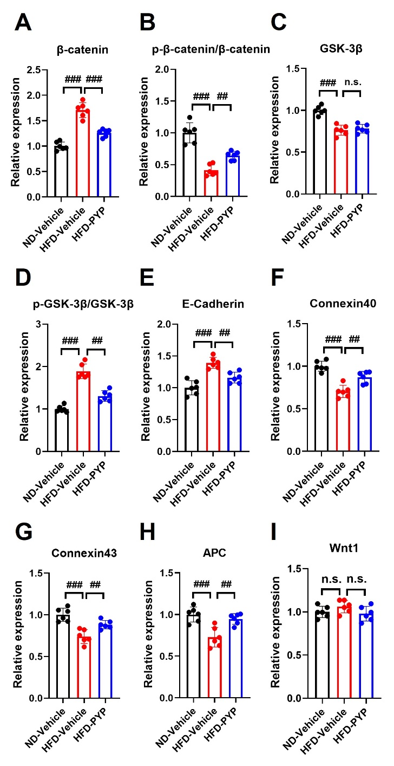
Figure S4. Relative change of the band intensity for corresponding proteins in Figure 6H.
(A-I) Protein expression levels from western blot analysis correspond to Fig.6H were quantified by immunosignal intensity analysis (n = 6 for each group). The statistical significance of differences between means was assessed by one-way ANOVA. ##p＜0.01, ###p＜0.001, n.s. means not significant.

