Supplementary Figure 1.
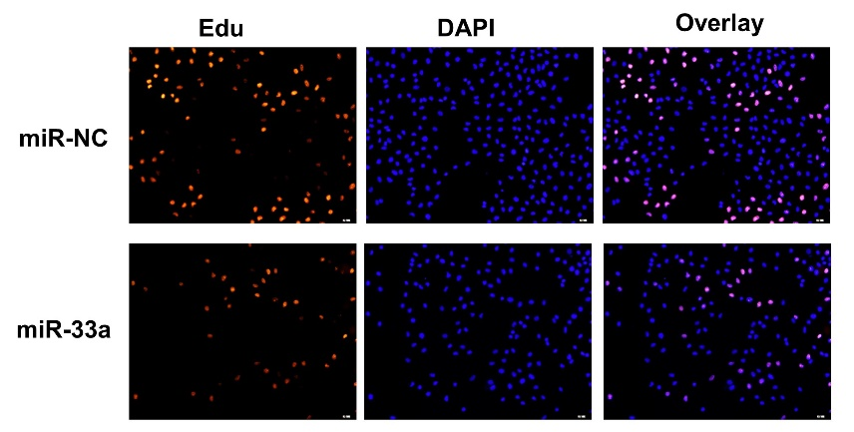
Supplementary Figure 1. The proliferation rates were determined by EdU staining. The left, Edu (red); the middle, DAPI (blue); the right, overlay (EdU and DAPI merged).

Supplementary Figure 2.

Supplementary Figure 2. (A) Caspase 3, cleaved Caspase 3, and Bax were upregulated in miR-33a-overexpressed cells with gefitinib treatment, whereas levels of Bcl2 were downregulated in miR-33a-overexpressed cells with gefitinib treatment. (B) Overexpression of miR-33a significantly enhanced the sensitivity of PC9/G cells to erlotinib treatment. (C) The protein expression levels of HDAC1 were markedly increased in lung adenocarcinoma according to the CPTAC database. (D, E) A positive correlation was found between HDAC1 and FOXK1 gene expression levels in TCGA-LUAD (C) and TCGA-LUSC (D) Cohorts. *, **, and *** indicate significant differences at P < 0.05, P < 0.01, and P < 0.001, respectively.

Supplementary Figure 3.

Supplementary Figure 3. (A) Effects of HDAC1 knockdown (KD) on the efficacy of gefitinib in inhibiting tumors were imaged in a xenograft nude mice at Day 22. The tumor weights (B) were analyzed on Day 22, and tumor volumes (C) were recorded at the indicated days . * and ** indicate results were significantly different at P < 0.05 and P < 0.01, respectively.

Supplementary Figure 4.

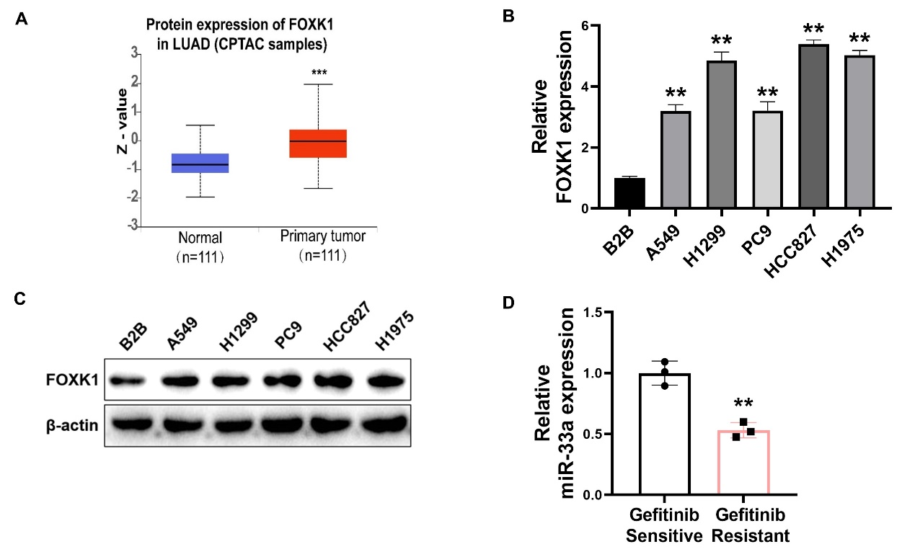
Supplementary Figure 4. (A) The protein expression levels of FOXK1 were increased in lung adenocarcinoma tissues analyzed using the CPTAC database. (B, C) FOXK1 levels were increased in lung cancer cells (A549, H1299, PC9, HCC827, and H1975) compared to the control cells. (D) MiR-33a levels were decreased in the gefitinib resistant NSCLC samples compared to gefitinib sensitive samples. ** indicates significant differences at P < 0.01.

Supplementary Table 1. The clinical trials utilizing epigenetic modulators in NSCLC
(as of May 23, 2024)
Class | Target | Drug | Trial design | Study Status | NCT number
DNMTs | DNMT1 | FdCyd | Phase II | Completed | NCT00978250
KMTs | EZH2 | Tazemetostat | Phase Ib/II | Not yet recruiting | NCT05467748
KMTs | EZH2 | XNW5004 | Phase Ib/II | Recruiting | NCT06022757
KDMs | LSD1 | CC-90011 | Phase II | Completed | NCT04350463
HATs | CBP | CCS1477 | Phase I/IIa | Recruiting | NCT03568656
HDACs | HDAC | Vorinostat | Phase I | Completed | NCT00821951
HDACs | HDAC | vorinostat | Phase I | Completed | NCT01059552
HDACs | HDAC | vorinostat | Phase Ib/II | Completed | NCT02437136
HDACs | HDAC | vorinostat | Phase I | Terminated | NCT00424775
HDACs | HDAC | vorinostat | Phase II | Terminated | NCT00702572
HDACs | HDAC | vorinostat | Phase I | Completed | NCT00423449
HDACs | HDAC | vorinostat | Phase I/II | Terminated | NCT00503971
HDACs | HDAC | Vorinostat | Phase II/III | Terminated | NCT00473889
HDACs | HDAC | Vorinostat | Phase I | Completed | NCT00667082
HDACs | HDAC | vorinostat | Phase I | Completed | NCT00106626
HDACs | HDAC | vorinostat | Phase I | Completed | NCT00635791
HDACs | HDAC | vorinostat | Phase II | Completed | NCT00138203
HDACs | HDAC | vorinostat | Phase II | Completed | NCT00798720
HDACs | HDAC | vorinostat | Phase II | Terminated | NCT00126451
HDACs | HDAC | vorinostat | NA | Completed | NCT00735826
HDACs | HDAC | vorinostat | Phase I | Completed | NCT00731952
HDACs | HDAC | vorinostat | Phase I/II | Terminated | NCT00662311
HDACs | HDAC | vorinostat | Phase II | Completed | NCT00481078
HDACs | HDAC | Vorinostat | Phase I/II | Terminated | NCT01413750
HDACs | HDAC | vorinostat | Phase I | Terminated | NCT00565227
HDACs | HDAC | vorinostat | Phase I | Completed | NCT00045006
HDACs | HDAC | vorinostat | Phase I | Terminated | NCT01249443
HDACs | HDAC | vorinostat | Phase I | Completed | NCT00020579
HDACs | HDAC | vorinostat | Phase I/II | Terminated | NCT00251589
HDACs | HDAC | vorinostat | Phase I | Completed | NCT00946673
HDACs | HDAC | Panobinostat | Phase I | Completed | NCT00738751
HDACs | HDAC | Panobinostat | Phase I | Completed | NCT01005797
HDACs | HDAC | Panobinostat | Phase I | Completed | NCT01336842
HDACs | HDAC | Panobinostat | Phase I | Completed | NCT01336842
HDACs | HDAC | Panobinostat | Phase I | Completed | NCT00535951
HDACs | HDAC | Panobinostat | Phase I | Terminated | NCT00907179
HDACs | HDAC | Entinostat | Phase II | Completed | NCT00602030
HDACs | HDAC | Entinostat | Phase II | Completed | NCT01928576
HDACs | HDAC | Entinostat | Phase II | Terminated | NCT01207726
HDACs | HDAC | Entinostat | Phase I | Completed | NCT01594398
HDACs | HDAC | Entinostat | Phase I | Terminated | NCT01886573
HDACs | HDAC | Entinostat | Phase II | Terminated | NCT00750698
HDACs | HDAC | Entinostat | Phase I/II | Completed | NCT00387465
HDACs | HDAC | Entinostat | Phase II | Terminated | NCT01935947
HDACs | HDAC | Mocetinostat | Phase I/II | Terminated | NCT02805660
HDACs | HDAC | Mocetinostat | Phase I | Terminated | NCT00511576
HDACs | HDAC | Mocetinostat | Phase II | Terminated | NCT02954991
HDACs | HDAC | Belinostat | Phase I/II | Completed | NCT01310244
HDACs | HDAC | Belinostat | Phase Ib/II | Terminated | NCT01090830
HDACs | HDAC | Belinostat | Phase I/II | Terminated | NCT01188707
HDACs | HDAC | Pivanex | Phase II | Completed | NCT00073385
HDACs | HDAC | Quisinostat | Phase I | Completed | NCT02728492
HDACs | HDAC | FR901228 | Phase II | Completed | NCT00020202
HDACs | HDAC | tacedinaline | phase III | Completed | NCT00005093
HDACs | HDAC | Depsipeptide | Phase I | Terminated | NCT00094978
HDACs | HDAC | Depsipeptide | Phase I | Completed | NCT00037817
HDACs | HDAC | Abexinostat | Phase I | Completed | NCT03590054
HDACs | HDAC | Romidepsin | Phase I | Completed | NCT01302808
HDACs | HDAC | CUDC-101 | Phase I | Completed | NCT01171924
Histone readers | BRD | INCB054329 | Phase I/II | Terminated | NCT02431260
Histone readers | BRD | Birabresib | Phase I | Completed | NCT02259114
DNMTs, DNA methyltransferases; KMTs, Histone lysine methyltransferases; KDMs, Histone lysine demethylases; HATs, Histone acetyltransferases; HDACs, Histone deacetylases; NA, Not Applicable;

