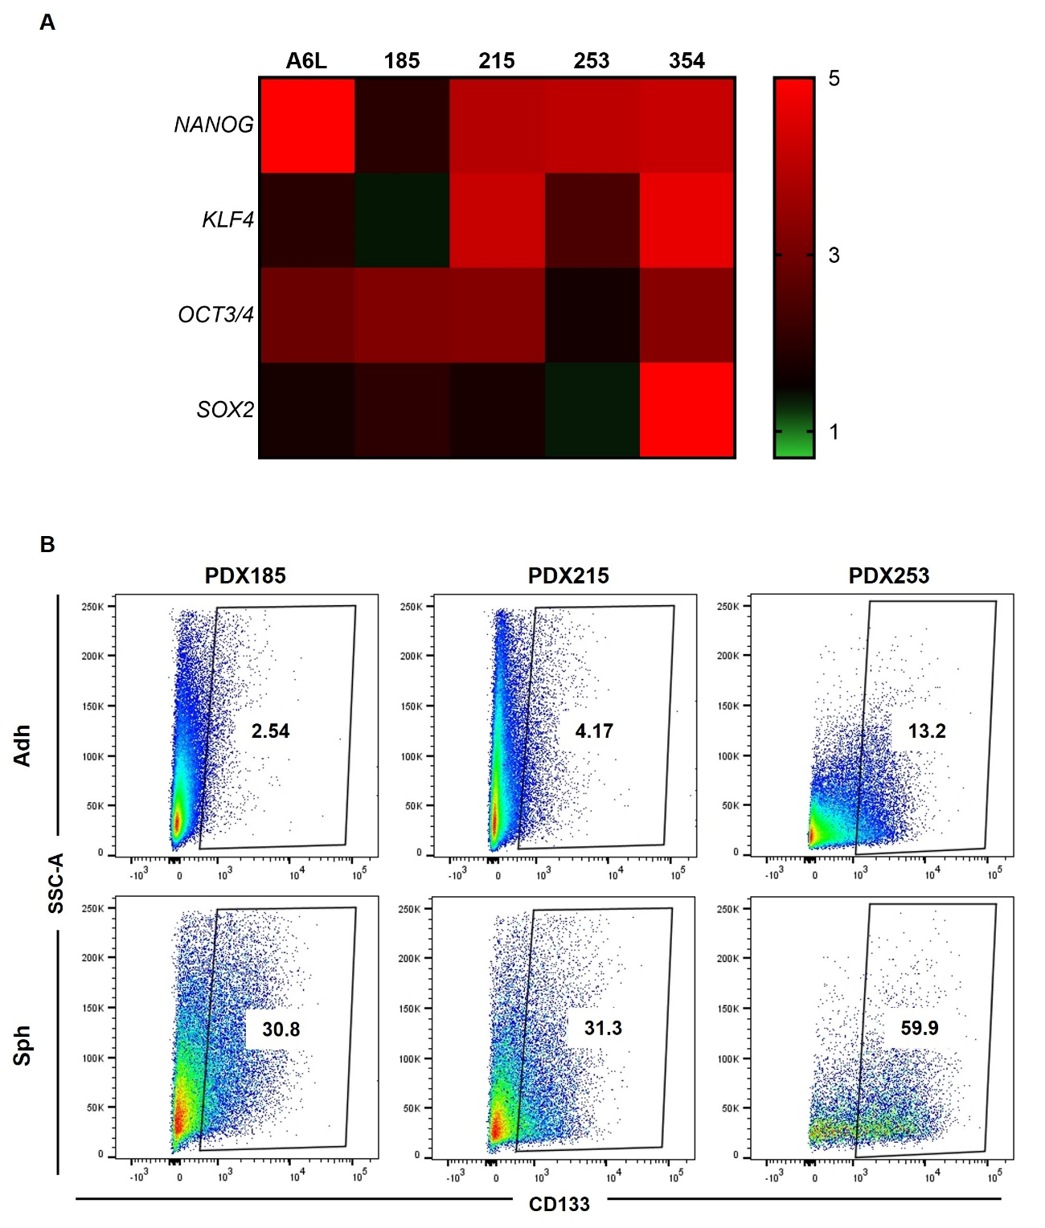
Figure S1, related to Figure 1. Spheres are enriched in CSC markers. A) Heatmap of CSC genes overexpressed in PaCSC-enriched cultures (spheres) from five PDAC PDXs (A6L, 185, 215, 253, 354), evaluated by RTqPCR. B) Representative flow cytometry plots of CD133 expression of the indicated PDXs grown in adherent conditions (Adh) or as spheres (Sph).
Figure S2, related to Figure 5. FAO inhibition impairs CSC functionality. Cells were treated for 48h with Etomoxir (200 μM), Mildronate (100 µM), Perhexiline (1 μM) and Ranolazine (100 μM). A) LD540 staining of ungated cells, parallel to the data shown in Figure 5A. B) Annexin V staining of ungated cells parallel to data shown in Figure 5C. Left panels: mean value of each cell type. Right panels: pooled data. The data are presented as mean ± SEM of at least three independent experiments.
Figure S3, related to Figure 7. Lipid modulators enhance the response to Gemcitabine in vitro. A) Annexin V and double positive staining of CD133⁺ cells after 48 h of treatment with PA, OA, LNA, Gemcitabine or Gemcitabine plus FAs. Left panel: mean value of each cell separately. Right panels: pooled data. B) Annexin V levels relative to the phase contrast quantified by fluorescence after 5 days of inhibitor administration in 185 PDX. Gemcitabine was administered 48 h before the administration of the inhibitors. The data are presented as mean ± SEM of at least three independent experiments. * p<0.05.

