Supplementary materials

MRI image acquisition
Breast MRI acquisition involved Optima MR360 (GE Healthcare) and 1.5-T Philips Achieva (Philips) at Center I. Center II used a 3.0-T Architect (GE Healthcare), whereas Centers III used a 1.5-T Signa voyager (GE Healthcare) and Centers IV used 1.5-T Avanto (Siemens) and a 3.0-T Verio (Siemens). A 16-channel dedicated breast coil was utilized in all cases. The breast enhanced MRI (DCE-MRI) protocol comprised one plain scan followed by five or six enhanced axial image acquisitions. Gd-DTPA was administered intravenously at the elbow at a dose of 0.1 mmol/kg, followed by a 15 mL saline flush at a flow rate of 2.0 mL/s.
The DCE-MRI images from TCIA were performed using the 1.5T MRI scanner (Avanto, Siemens Medical Solutions, Erlangen, Germany; Optima MR360; GE Healthcare, America). The DCE-MRI images from DUKE were performed using the 1.5T or 3.0T MRI scanner (Avanto; TrioTim; Skyra; Siemens Medical Solutions, Erlangen, Germany) and 1.5T or 3.0T MRI scanner (Optima MR450w, Signa HDx, Signa HDxt, and Signa Excite, GE Healthcare, America). The DCE-MRI protocol comprised one plain scan followed by four enhanced axial image acquisitions. Next, Gd-DTPA was injected into the patients at a rate of 2mL/s and a dose of 0.2mL/kg body weight using an MRI compatible power injector.

Table S1. MRI scanning parameters
Hospital | Scanner | Sequence | TR/TE (msec) | Acquisition  Matrix | Slice Thickness  (mm) | Slice Gap  (mm) | Flip Angle
Centre I | GE 3.0T  (Optima MR360) | T1+C | 5.09/2.35 | 256/244 | 1.2 | 0.6 | 10
Centre I | Philips 1.5T (Achieva) | T1+C | 5.03/2.22 | 320/320 | 1 | 0.5 | 15
Centre II | GE 3.0T (Architec) | T1+C | 4.3/2.1 | 320/320 | 1 | 0.5 | 12
Centre III | GE 1.5T  (Signa voyager) | T1+C | 7.0/2.0 | 320/320 | 0.7 | 0.5 | 15
Centre IV | Siemens 1.5T (Avanto) | T1+C | 4.43/1.5 | 340/340 | 1.2 | 0 | 10
Centre IV | Siemens 3.0T (Verio) | DCE-MRI | 4.51/1.61 | 340/340 | 1 | 0 | 10
TCIA | Siemens (Avanto) | T1+C | 1.11-1.38/3.87-4.54 | (384-448)/(269-336) | 0.9-2 | NA | 10
TCIA | GE  (Optima MR360) | T1+C | 2.31-4.2/4.82-7.77 | 256-360/192-350 | 2-3.2 | NA | 10
DUKE | GE 1.5  (Optima MR450w, Signa HDx, Signa HDxt) | T1+C | 5.38/2.51 | 360/360 | 1.1-2 | NA | 10
DUKE | GE 3.0  (Signa HDx, Signa HDxt, Signa Excite) | T1+C | 7.395/2.704 | 340/384 | 1.1-2.2 | NA | 10, 12
DUKE | Siemens 1.5T (Avanto) | T1+C | 4.68/1.54 | 320/448 | 1.04-2 | NA | 10, 12
DUKE | Siemens 3.0T (Trio Tim, Skyra) | T1+C | 4.09/1.6 | 448/448 | 1.1-2.5 | NA | 7-10
TR = repetition time; TE = echo time; T2WI = T2 weighted imaging; T1+C, contrast-enhanced T1-weighted imaging.

Table S2. Clinical characteristics analysis for predicting ALN burden by univariate and multivariate logistic regression analysis
Characteristics |  | OR (univariable) | OR (multivariable) | OR (final)
Age | Mean ± SD | 0.98 (0.97-0.99, p<.001) | 0.99 (0.97-1.02, p=.629)
Menopausal Status | Postmenopausal
 | Premenopausal | 1.58 (1.21-2.08, p=.001) | 1.82 (1.08-3.06, p=.024) | 2.00 (1.45-2.76, p<.001)
Histological grade | Grade 1 (low)
 | Grade 2 (intermediate) | 1.02 (0.58-1.80, p=.932)
 | Grade 3 (high) | 1.28 (0.72-2.29, p=.404)
Histological type | Ductal
 | Lobular | 1.76 (0.76-4.07, p=.186)
 | Other | 0.83 (0.42-1.66, p=.607)
MRI ALN status | Mass
 | No-mass | 6.93 (5.07-9.49, p<.001) | 3.47 (2.44-4.94, p<.001) | 3.49 (2.46-4.96, p<.001)
MRI ALN burden | Negative
 | Positive | 58.27 (18.36-184.94, p<.001) | 22.65 (6.90-74.34, p<.001) | 22.42 (6.84-73.45, p<.001)
Ki67 | ＜14
 | ≥14 | 1.38 (1.00-1.90, p=.049) | 0.91 (0.64-1.31, p=.615)
ER | Negative
 | Positive | 0.93 (0.65-1.34, p=.695)
PR | Negative
 | Positive | 0.93 (0.65-1.34, p=.695)
HER2 | Negative
 | Positive | 1.39 (0.99-1.95, p=.056)
 | Uncertainty | 1.21 (0.57-2.54, p=.622)
Molecular subtype | Luminal
 | HER2-positive | 1.36 (0.81-2.29, p=.247)
 | Triple-negative | 0.75 (0.44-1.28, p=.290)
Clinical T stage | T1
 | T2 | 3.17 (2.33-4.32, p<.001) | 1.91 (1.36-2.69, p<.001) | 1.89 (1.35-2.65, p<.001)
ALN, axillary lymph node burden; ER, estrogen receptor; PR, progesterone receptor; OR, Odds Ratio.

Table S3. Radiomics features and weights screened by elastic-logistic
Features | Coefficient | OR
original_shape_Sphericity | -0.1566 | 0.855042
wavelet.LHL_glcm_MCC | -0.14072 | 0.868735
wavelet.HLL_glcm_MCC | -0.0847 | 0.918786
wavelet.HHL_glcm_MCC | -0.06616 | 0.935977
wavelet.LHH_glcm_Correlation | -0.05672 | 0.944856
wavelet.HHL_gldm_SmallDependenceLowGrayLevelEmphasis | -0.05203 | 0.949302
wavelet.LLH_firstorder_Median | 0.00236 | 1.002363
wavelet.LHH_glcm_Idn | 0.019214 | 1.0194
wavelet.LLH_glcm_Idn | 0.09107 | 1.095346
OR, Odds Ratio.

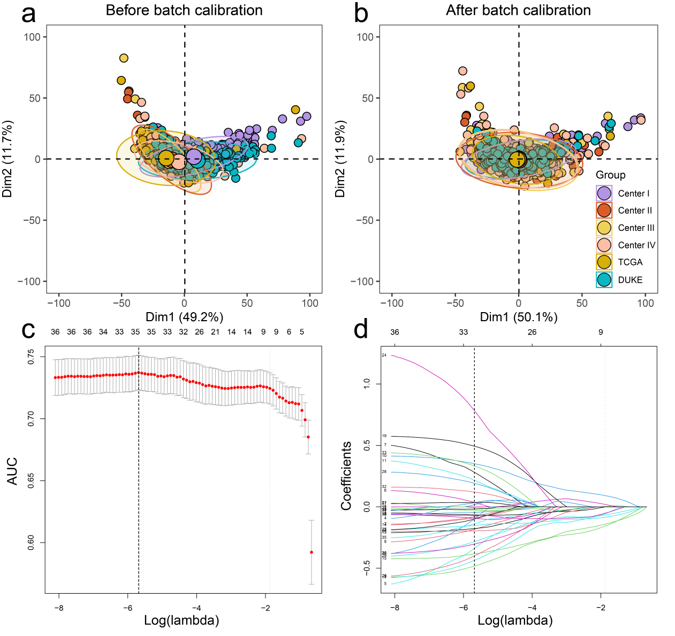
Figure S1: Radiomics feature selection. (a) principal component analysis scatter plot before batch adjustment, with each color indicating a different data source. (b) Principal component analysis scatter plot after batch adjustment, showing improved data integration. The X and Y axes present the two principal component dimensions. GD, JX, HN and SZ represent Center I to Center IV respectively. (c-d) Cross-validation curve for the lasso model, with the optimal lambda highlighted. Elastic-logistic coefficient path diagram of radiomic features. The x-axis represents the value of the regularization parameter, and the y-axis represents the absolute value or scaled value of the characteristic coefficient.
Figure S2: GSEA analysis in low-score group and high-score group. Each panel represents an enrichment plot for a specific biological process, with the ranking metric on the x-axis and the running enrichment score on the y-axis, indicating overrepresentation of gene sets at the top or bottom of the ranked list of genes. The main enriched KEGG pathways like epidermal cell differentiation(a), keratinocyte differentiation(b), epidermis development(c), cell chemotaxis(d), positive regulation of chemotaxis(e), and cell-substrate adhesion(f).

