Additional file 1: Table S1
Correlations of baseline abdominal obesity indices with incident CVD among postmenopausal women after adjusted using Model 1, 2 and 3
Indices | HR(95%CI)
Indices | Model 1 | Model 2 | Model 3
WC
Per Unit increase | 1.027(1.008,1.046)** | 1.029(1.009,1.048)** | 1.021(1.000,1.041)*
Per SD increase | 1.281(1.077,1.525)** | 1.304(1.093,1.557)** | 1.211(1.003,1.461)*
Quartiles
Q1 | 1.00 | 1.00 | 1.00
Q2 | 1.195(0.673,2.119） | 1.240(0.697,2.205) | 1.070(0.595,1.925)
Q3 | 1.635(0.953,2.805) | 1.615(0.937,2.782) | 1.352(0.773,2.364)
Q4 | 1.998(1.189,3.358)** | 2.120(1.258,3.573)** | 1.676(0.975,2.880)
WHR
Per Unit increase | 2.004(0.084,47.880) | 2.737(0.119,62.768) | 0.967(0.031,29.736)
Per SD increase | 1.038(0.875,1.233) | 1.056(0.891,1.251) | 0.998(0.829,1.201)
Quartiles
Q1 | 1.00 | 1.00 | 1.00
Q2 | 0.679(0.388,1.186) | 0.745(0.425,1.308) | 0.675(0.381,1.194)
Q3 | 1.058(0.643,1.742) | 1.118(0.678,1.846) | 0.990(0.594,1.651)
Q4 | 1.219(0.754,1.971) | 1.283(0.789,2.084) | 1.178(0.716,1.937)
LAP
Per Unit increase | 1.002(0.999,1.005) | 1.003(1.000,1.005) | 1.002(0.999,1.005)
Per SD increase | 1.112(0.971,1.274) | 1.135(0.990,1.301) | 1.098(0.948,1.271)
Quartiles
Q1 | 1.00 | 1.00 | 1.00
Q2 | 0.861(0.486,1.528) | 0.890(0.500,1.587) | 0.807(0.450,1.447)
Q3 | 1.169(0.685,1.997) | 1.175(0.686,2.014) | 1.059(0.607,1.848)
Q4 | 1.798(1.100,2.938)* | 1.875(1.144,3.073)* | 1.753(1.016,3.023)*
VAI
Per Unit increase | 1.068(1.032,1.106)*** | 1.053(1.013,1.094)** | 1.052(1.010,1.095)*
Per SD increase | 1.188(1.085,1.299)*** | 1.142(1.033,1.264)** | 1.141(1.027,1.268)*
Quartiles
Q1 | 1.00 | 1.00 | 1.00
Q2 | 0.892(0.526,1.515) | 0.911(0.535,1.552) | 0.762(0.445,1.306)
Q3 | 0.883(0.520,1.499) | 0.944(0.554,1.608) | 0.826(0.4811,1.419)
Q4 | 1.375(0.852,2.220) | 1.403(0.868,2.268) | 1.315(0.785,2.202)
CVAI
Per Unit increase | 1.013(1.007,1.019)*** | 1.013(1.007,1.020)*** | 1.011(1.004,1.018)**
Per SD increase | 1.483(1.231,1.785)*** | 1.508(1.251,1.819)*** | 1.408(1.148,1.727)**
Quartiles
Q1 | 1.00 | 1.00 | 1.00
Q2 | 0.846(0.457,1.564) | 0.823(0.444,1.527) | 0.663(0.353,1.244)
Q3 | 1.133(0.637,2.017) | 1.144(0.641,2.041) | 0.883(0.485,1.607)
Q4 | 2.382(1.414,4.011)** | 2.449(1.449,4.140)*** | 1.897(1.081,3.329)*
*p < 0.05
**p < 0.01
***p < 0.001
Model 1: adjusted by age; Model 2: adjusted by age, education, smoking, drinking and physical activity; Model 3: adjusted by age, education, number of children, smoking, drinking, physical activity, TC, LDL-C, utilization of antihypertensive drugs, antidiabetic drugs and antilipemic drugs, energy intake percentage of fat and carbohydrates, and diagnosed with DM and hypertension at baseline
CVD cardiovascular disease, HR hazard ratio, CI confidence interval, WC waist circumference, SD standard deviation, WHR waist-hip ratio, LAP lipid accumulation product, VAI visceral adiposity index, CVAI Chinese visceral adiposity index

Additional file 1: Table S2
The predictive performance of abdominal obesity indices for incident CHD and stroke among postmenopausal women
CHD
Indices | C-statistic(95%CI) | P-value | P for comparison
CVAI | 0.632(0.567,0.698) | <0.001 | Ref.
LAP | 0.592(0.527,0.657) | 0.004 | 0.034
WC | 0.596(0.533,0.659) | 0.003 | 0.073
VAI | 0.554(0.486,0.622) | 0.096 | 0.005
WHR | 0.554(0.487,0.621) | 0.097 | 0.005
Stroke
Indices | C-statistic(95%CI) | P-value | P for comparison
CVAI | 0.613(0.527,0.700) | 0.011 | Ref.
LAP | 0.537(0.460,0.614) | 0.405 | 0.001
WC | 0.543(0.455,0.630) | 0.333 | 0.023
VAI | 0.512(0.427,0.596) | 0.793 | 0.025
WHR | 0.517(0.426,0.608) | 0.703 | 0.106
p values in bold are＜0.05
CHD coronary heart disease, CI confidence interval, CVAI Chinese visceral adiposity index, Ref. Reference, LAP lipid accumulation product, WC waist circumference, VAI visceral adiposity index, WHR waist-hip ratio

Additional file 1: Table S3
Correlations of baseline CVAI with incident CHD and stroke among postmenopausal women
CVAI | Event/Total | Model 1 |  | Model 2 |  | Model 3 |  | Model4
CVAI | Event/Total | HR(95%CI) | P-value | HR(95%CI) | P-value | HR(95%CI) | P-value | HR(95%CI) | P-value
CHD
Per Unit increase | 85/1252 | 1.014(1.007,1.022) | <0.001 | 1.015(1.008,1.023) | <0.001 | 1.013(1.004,1.021) | 0.002 | 1.012(1.004,1.021) | 0.002
Per SD increase | 85/1252 | 1.557(1.248,1.942) | <0.001 | 1.594(1.271,1.998) | <0.001 | 1.468(1.147,1.878) | 0.002 | 1.466(1.146,1.877) | 0.002
Quartiles
Q1 | 16/313 | 1.00 |  | 1.00 |  | 1.00 |  | 1.00
Q2 | 13/313 | 0.805(0.387,1.675) | 0.561 | 0.766(0.366,1.601) | 0.478 | 0.652(0.308,1.381) | 0.264 | 0.654(0.309,1.386) | 0.268
Q3 | 16/313 | 0.990(0.490,2.000) | 0.978 | 0.986(0.486,1.998) | 0.968 | 0.799(0.385,1.659) | 0.548 | 0.795(0.383,1.650) | 0.538
Q4 | 40/313 | 2.551(1.385,4.701) | 0.003 | 2.611(1.405,4.851) | 0.002 | 2.003(1.026,3.911) | 0.042 | 1.985(1.018,3.872) | 0.044
P for trend |  | <0.001 |  | <0.001 |  | 0.002 |  | 0.002
Stroke
Per Unit increase | 44/1252 | 1.010(1.000,1.021) | 0.044 | 1.011(1.001,1.021) | 0.037 | 1.010(0.999,1.022) | 0.063 | 1.011(1.000,1.022) | 0.055
Per SD increase | 44/252 | 1.374(1.008,1.871) | 0.044 | 1.389(1.020,1.890) | 0.037 | 1.377(0.983,1.929) | 0.063 | 1.390(0.993,1.947) | 0.055
Quartiles
Q1 | 6/313 | 1.00 |  | 1.00 |  | 1.00 |  | 1.00
Q2 | 10/313 | 1.611(0.585, 4.440) | 0.356 | 1.554(0.561,4.303) | 0.396 | 1.198(0.424,3.389) | 0.733 | 1.245(0.440,3.524) | 0.680
Q3 | 11/313 | 1.691(0.617,4.633) | 0.307 | 1.694(0.616,4.657) | 0.307 | 1.367(0.488,3.830) | 0.522 | 1.390(0.496,3.892) | 0.531
Q4 | 17/313 | 2.581(0.981,6.793) | 0.055 | 2.636(1.004,6.922) | 0.049 | 2.331(0.854,6.363) | 0.099 | 2.451(0.894,6.717) | 0.081
P for trend |  | 0.259 |  | 0.224 |  | 0.268 |  | 0.234
p values in bold are < 0.05
Model 1: adjusted by age; Model 2: adjusted by age, education, smoking, drinking and physical activity; Model 3: adjusted by age, education, smoking, drinking, physical activity, TC, LDL-C, utilization of antihypertensive drugs, antidiabetic drugs and antilipemic drugs, energy intake percentage of fat and carbohydrates, and diagnosed with DM and hypertension at baseline; Model 4: adjusted by variables in Model 3 plus age at menopause
CVAI Chinese visceral adiposity index, CHD coronary heart disease, HR hazard ratio, CI confidence interval, SD standard deviation

Figure S1. Kaplan-Meier curves of CHD and stroke by CVAI quartiles
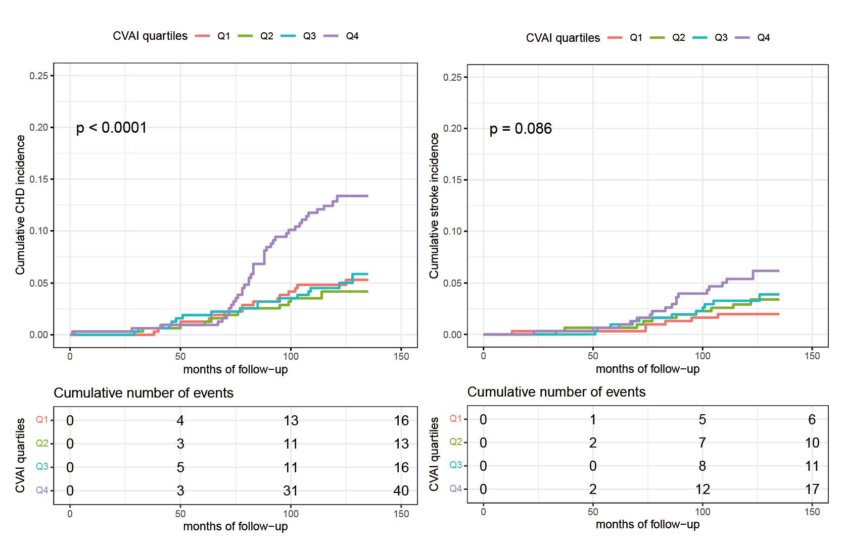
The cumulative incidence of CHD and stroke during follow-up grouped by CVAI quartiles was described using Kaplan-Meier curves, with p value calculated using the log-rank test. CHD coronary heart disease, CVAI Chinese visceral adiposity index

