Example of VLEKT diet therapy with meal replacement
(New Penta Srl, Cuneo, Italy)
Based on the Ketogenic nutritional therapy (KeNuT) protocol of the Italian Society of Endocrinology (SIE)

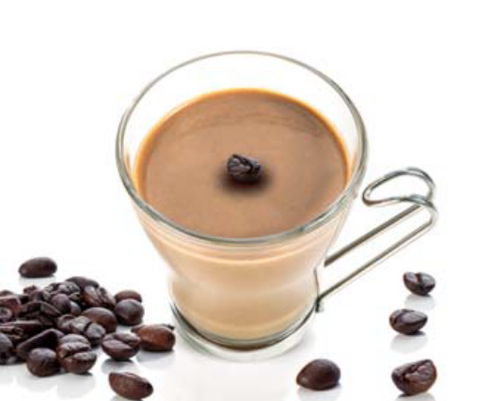
Breakfast (meal replacement, cappuccino drink)*
AVERAGE NUTRITIONAL ANALYSIS
Kcal/KJ | 91 / 386
Fat (g) | 0,5
of which saturated fatty acids (g) | 0,4
Carbohydrates (g) | 2,7
of which sugars (g) | 1,7
Fiber (g) | 1,7
Protein (g) | 18
Salt (g) | 0,33

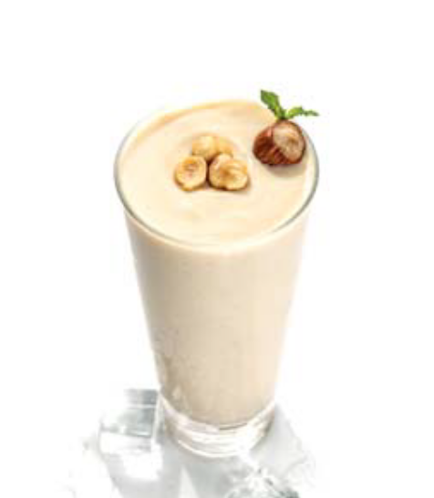
Mid-morning snack (meal replacement, milkshake-flavored drinks)*
AVERAGE NUTRITIONAL ANALYSIS
Kcal/KJ | 88 / 371
Fat (g) | 0,7
of which saturated fatty acids (g) | 0,2
Carbohydrates (g) | 1,4
of which sugars (g) | 1,1
Fiber (g) | 2,5
Protein (g) | 18
Salt (g) | 0,32

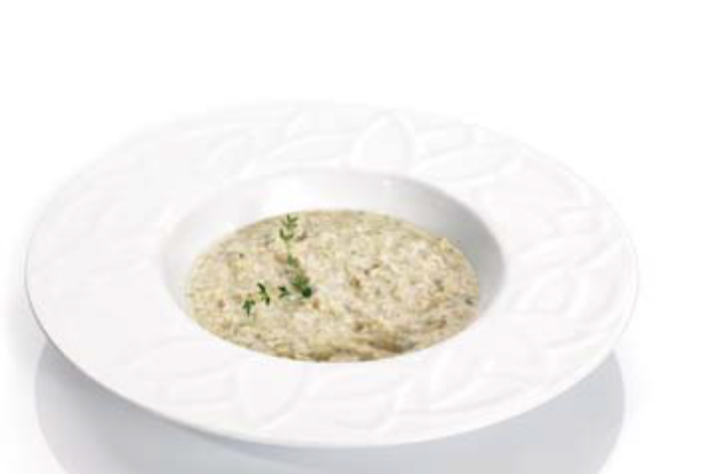
Lunch, meal replacement (protein pasta)*
AVERAGE NUTRITIONAL ANALYSIS
Kcal/KJ | 143 / 605
Fat (g) | 1,3
of which saturated fatty acids (g) | 0,9
Carbohydrates (g) | 1,6
of which sugars (g) | 1,2
Fiber (g) | 3,2
Protein (g) | 15
Salt (g) | 0,27


+ 200 g of low glycaemic index vegetables (e.g. courgettes)

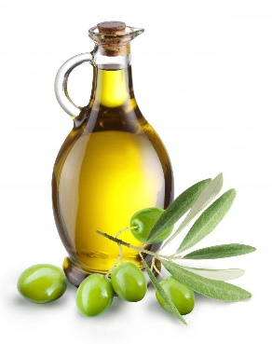

+ 15 g of extra virgin olive oil

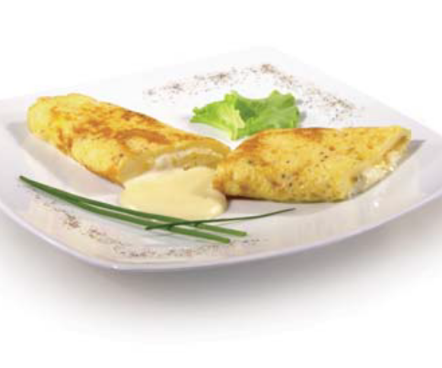
Dinner, meal replacement (type omelette)*
AVERAGE NUTRITIONAL ANALYSIS
Kcal/KJ | 113 / 476
Fat (g) | 2,6
of which saturated fatty acids (g) | 0,1
Carbohydrates (g) | 2,5
of which sugars (g) | 0,5
Fiber (g) | 0,5
Protein (g) | 20
Salt (g) | 1,4

+ 200 g of low glycaemic index vegetables (e.g. courgettes)

+ 15 g of extra virgin olive oil

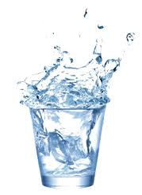
In addition:

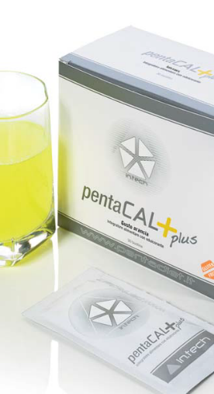
+ Drink at least 2.5 liters of water per day

+ Multi-vitamin and saline supplements to maintain physiological ac-id/base balance (PentaCal, New Penta, Srl., Cuneo, Italy) (B complex vitamins, C and E vitamins, minerals, including potassium, sodium, magnesium, calcium, and omega-3 fatty acids.

Calories and nutrients from meal replacements
Kcal/KJ | 435/1838
Fat (g) | 5,1
of which saturated fatty acids (g) | 1,6
Carbohydrates (g) | 8,2
of which sugars (g) | 4,5
Fiber (g) | 7,9
Protein (g) | 71
Salt (g) | 2,32

Calories and nutrients from EVOO and vegetables
 | EVOO  (30 g) | Vegetables (e.g. courgettes)  (200 g + 200 g)
Kcal/KJ | 269,7/1108,8 | 44/192
Fat (g) | 29,97 | 0,4
of which saturated fatty acids (g) | 0 | 0
Carbohydrates (g) | 0 | 5,6
of which sugars (g) | 0 | 0
Fiber (g) | 0 | 5,2
Protein (g) | 0 | 5,2
Salt (g) | 0 | 4

Average values of the VLEKT
Kcal/KJ | 748,7/3138,8
Protein (g) | 76,2
Carbohydrates (g) | 13,8
of which sugars (g) | 4,5
Fat (g) | 35,47
of which saturated fatty acids (g) | 1,6
Salt (g) | 6,32
Fiber (g) | 7,9

* https://pentadiet.it/prodotti

