Supplementary Material
Immunosuppressive and monoclonal antibody in adults with myasthenia gravis: A network meta‐analysis

Jian Gu^{1,*}, Yue Qiao¹, Rui Huang¹ , Shuyan Cong^{1, *}
¹Department of Neurology, Shengjing Hospital of China Medical University, Shenyang, Liaoning, China, 110000

* Correspondence: Shuyan Cong; Department of Neurology, Shengjing Hospital of China Medical University, Shenyang, Liaoning, China, 110000
Email: congshuyan@hotmail.com
Jian Gu; Department of Neurology, Shengjing Hospital of China Medical University, Shenyang, Liaoning, China, 110000
Email: jackgu0801@126.com

Table S1. Detailed search strategy in four databases.
Database | Search strategy
Pubmed | 1 myasthenia gravis[MeSH]  2 (((((((((((((Myasthenia Gravis, Ocular[Title/Abstract]) OR (Ocular Myasthenia Gravis[Title/Abstract])) OR (Myasthenia Gravis, Generalized[Title/Abstract])) OR (Generalized Myasthenia Gravis[Title/Abstract])) OR (Muscle-Specific Receptor Tyrosine Kinase Myasthenia Gravis[Title/Abstract])) OR (Muscle Specific Receptor Tyrosine Kinase Myasthenia Gravis[Title/Abstract])) OR (Muscle-Specific Tyrosine Kinase Antibody Positive Myasthenia Gravis[Title/Abstract])) OR (Muscle Specific Tyrosine Kinase Antibody Positive Myasthenia Gravis[Title/Abstract])) OR (MuSK MG[Title/Abstract])) OR (MuSK Myasthenia Gravis[Title/Abstract])) OR (Myasthenia Gravis, MuSK[Title/Abstract])) OR (Anti-MuSK Myasthenia Gravis[Title/Abstract])) OR (Anti MuSK Myasthenia Gravis[Title/Abstract])) OR (Myasthenia Gravis, Anti-MuSK[Title/Abstract])  3 #1 OR #2  4 Antibodies, Monoclonal[MeSH Terms]  5 ((Monoclonal Antibodies[Title/Abstract]) OR (Monoclonal Antibody[Title/Abstract])) OR (Antibody, Monoclonal[Title/Abstract])  6 #4 OR #5  7 Fc receptor, neonatal[MeSH Terms]  8 (((((((Fc receptors, neonatal[Title/Abstract]) OR (neonatal Fc receptors[Title/Abstract])) OR (receptor, Fc neonatal[Title/Abstract])) OR (FcRn neonatal transfer protein[Title/Abstract])) OR (neonatal Fc receptor[Title/Abstract])) OR (FCGRT protein, human[Title/Abstract])) OR (FcRn protein, human[Title/Abstract])) OR (Neonatal Fc receptor, human[Title/Abstract])  9 #7 OR #8  10 Complement Inactivating Agents[MeSH Terms]  11 (((((((((Agents, Complement Inactivating[Title/Abstract]) OR (Inactivating Agents, Complement[Title/Abstract])) OR (Complement Inhibitors[Title/Abstract])) OR (Inhibitors, Complement[Title/Abstract])) OR (Complement Inhibiting Agents[Title/Abstract])) OR (Agents, Complement Inhibiting[Title/Abstract])) OR (Inhibiting Agents, Complement[Title/Abstract])) OR (Complement Inhibitor[Title/Abstract])) OR (Inhibitor, Complement[Title/Abstract])) OR (Complement Cytolysis Inhibiting Agents[Title/Abstract])  12 #10 OR #11  13 Antigens, CD[MeSH Terms]  14 ((((((((((((CD Antigens[Title/Abstract]) OR (CD Antigen[Title/Abstract])) OR (Antigen, CD[Title/Abstract])) OR (Cluster of Differentiation Antigens[Title/Abstract])) OR (Cluster of Differentiation Marker[Title/Abstract])) OR (Differentiation Marker Cluster[Title/Abstract])) OR (Marker Cluster, Differentiation[Title/Abstract])) OR (Cluster of Differentiation Markers[Title/Abstract])) OR (Cluster of Differentiation Antigen[Title/Abstract])) OR (Antigen Cluster, Differentiation[Title/Abstract])) OR (Differentiation Antigen Cluster[Title/Abstract])) OR (Leukocyte Differentiation Antigens, Human[Title/Abstract])) OR (Differentiation Antigens, Leukocyte, Human[Title/Abstract])  15 #13 OR #14  16 Immunosuppressive Agents[MeSH Terms]  17 ((((Agents, Immunosuppressive[Title/Abstract]) OR (Immunosuppressants[Title/Abstract])) OR (Immunosuppressive Agent[Title/Abstract])) OR (Agent, Immunosuppressive[Title/Abstract])) OR (Immunosuppressant[Title/Abstract])  18 #16 OR #17  19 #6 OR #9 OR #12 OR #15 OR #18  20 ((((random[Title/Abstract]) OR (placebo[Title/Abstract])) OR (double-blind[Title/Abstract])) OR (randomized controlled trial[Title/Abstract])) OR (randomized[Title/Abstract])  21 #3 AND #19 AND #20
Embase | 1 'myasthenia gravis'/exp  2 'ocular myasthenia gravis':ab,ti OR 'myasthenia gravis, ocular':ab,ti OR 'myasthenia gravis, generalized':ab,ti OR 'generalized myasthenia gravis':ab,ti OR 'muscle-specific receptor tyrosine kinase myasthenia gravis':ab,ti  3 'muscle specific receptor tyrosine kinase myasthenia gravis':ab,ti OR 'muscle-specific tyrosine kinase antibody positive myasthenia gravis':ab,ti OR 'muscle specific tyrosine kinase antibody positive myasthenia gravis':ab,ti OR 'musk mg':ab,ti  4 'musk myasthenia gravis':ab,ti OR 'myasthenia gravis, musk':ab,ti OR 'anti-musk myasthenia gravis':ab,ti OR 'anti musk myasthenia gravis':ab,ti OR 'myasthenia gravis, anti-musk':ab,ti  5 #1 OR #2 OR #3 OR #4  6 'antibodies, monoclonal'/exp  7 'monoclonal antibody':ab,ti  8 #6 OR #7  9 'neonatal fc receptor'/exp  10 'receptor, fc neonatal':ab,ti OR 'fc receptor, neonatal':ab,ti  11 #9 OR #10  12 'complement inactivating agents'/exp  13 'complement inhibitor':ab,ti OR 'complement inhibitors':ab,ti OR 'complement inhibiting agents':ab,ti  14 #12 OR #13  15 'antigens, cd'/exp  16 'cd antigens':ab,ti OR 'antigen, cd':ab,ti OR 'cluster of differentiation antigens':ab,ti OR 'cluster of differentiation marker':ab,ti OR 'cluster of differentiation markers':ab,ti OR 'cluster of differentiation antigen':ab,ti OR 'differentiation antigen cluster':ab,ti OR 'leukocyte differentiation antigens, human':ab,ti  17 #15 OR #16  18 'immunosuppressive agents'/exp  19 'agents, immunosuppressive':ab,ti OR 'immunosuppressants':ab,ti OR 'immunosuppressive agent':ab,ti OR 'agent, immunosuppressive':ab,ti OR 'immunosuppressant':ab,ti  20 #18 OR #19  21 #8 OR #11 OR #14 OR #17 OR #20  22 #5 AND #21  23 'random':ab,ti OR 'control':ab,ti OR 'double-blind':ab,ti  24 #22 AND #23
Web of Science | 1 ((((((((((((((TS=(myasthenia gravis)) OR TS=(Myasthenia Gravis, Ocular)) OR TS=(Ocular Myasthenia Gravis)) OR TS=(Myasthenia Gravis, Generalized)) OR TS=(Generalized Myasthenia Gravis)) OR TS=(Muscle-Specific Receptor Tyrosine Kinase Myasthenia Gravis)) OR TS=(Muscle Specific Receptor Tyrosine Kinase Myasthenia Gravis)) OR TS=(Muscle-Specific Tyrosine Kinase Antibody Positive Myasthenia Gravis)) NOT TS=(Muscle Specific Tyrosine Kinase Antibody Positive Myasthenia Gravis)) OR TS=(MuSK MG)) OR TS=(MuSK Myasthenia Gravis)) OR TS=(Myasthenia Gravis, MuSK)) OR TS=(Anti-MuSK Myasthenia Gravis)) OR TS=(Anti MuSK Myasthenia Gravis)) OR TS=(Myasthenia Gravis, Anti-MuSK)  2 (((((((((((((((((((((((((((((((((((((((((TS=(Antibodies, Monoclonal)) OR TS=(Monoclonal Antibodies)) OR TS=(Monoclonal Antibody)) OR TS=(Antibody, Monoclonal)) OR TS=(Fc receptor, neonatal )) OR TS=(Fc receptors, neonatal)) OR TS=(neonatal Fc receptors)) OR TS=(receptor, Fc neonatal)) OR TS=(FcRn neonatal transfer protein)) OR TS=(neonatal Fc receptor)) OR TS=(Fcgrt protein, mouse)) OR TS=(FcRn protein, mouse)) OR TS=(FCGRT protein, human)) OR TS=(FcRn protein, human)) OR TS=(Neonatal Fc receptor, human)) OR TS=(Fc fragment of IgG, receptor, transporter, alpha protein, human)) OR TS=(Complement Inactivating Agents)) OR TS=(Agents, Complement Inactivating)) OR TS=(Inactivating Agents, Complement)) OR TS=(Complement Inhibitors)) OR TS=(Inhibitors, Complement)) OR TS=(Complement Inhibiting Agents)) OR TS=(Agents, Complement Inhibiting)) OR TS=(Inhibiting Agents, Complement)) OR TS=(Complement Inhibitor)) OR TS=(Inhibitor, Complement)) OR TS=(Complement Cytolysis Inhibiting Agents)) OR TS=(Antigens, CD)) OR TS=(CD Antigens)) OR TS=(CD Antigen)) OR TS=(Antigen, CD)) OR TS=(Cluster of Differentiation Antigens)) OR TS=(Cluster of Differentiation Marker)) OR TS=(Cluster of Differentiation Markers)) OR TS=(Antigen Cluster, Differentiation)) OR TS=(Leukocyte Differentiation Antigens, Human)) OR TS=(Immunosuppressive Agents)) OR TS=(Agents, Immunosuppressive)) OR TS=(Immunosuppressants)) OR TS=(Immunosuppressive Agent)) OR TS=(Agent, Immunosuppressive)) OR TS=(Immunosuppressant)  3 ((((TS=(random)) OR TS=(placebo)) OR TS=(double-blind)) OR TS=(randomized controlled trial)) OR TS=(randomized)  4 #1 AND #2 AND #3
Cochrane | #1 MeSH descriptor: [Myasthenia Gravis] explode all trees 338  #2 (Ocular Myasthenia Gravis):ti,ab,kw OR (Generalized Myasthenia Gravis):ti,ab,kw OR (MuSK Myasthenia Gravis):ti,ab,kw OR (Muscle-Specific Receptor Tyrosine Kinase Myasthenia Gravis):ti,ab,kw OR (Anti-MuSK Myasthenia Gravis):ti,ab,kw 390  #3 #1 OR #2 597  #4 MeSH descriptor: [Antibodies, Monoclonal] explode all trees 21571  #5 (Monoclonal Antibody):ti,ab,kw OR (Monoclonal Antibodies):ti,ab,kw OR (Antibody, Monoclonal):ti,ab,kw 22783  #6 #4 or #5 30948  #7 MeSH descriptor: [Receptors, Fc] explode all trees 289  #8 (Receptor, Fc Fc Receptors):ti,ab,kw OR (FcRn neonatal transfer protein):ti,ab,kw 225  #9 #7 or #8 427  #10 MeSH descriptor: [Complement Inactivating Agents] explode all trees 101  #11 (Complement Cytolysis Inhibiting Agents):ti,ab,kw OR (Complement Inhibiting Agents):ti,ab,kw OR (Complement Inhibitors):ti,ab,kw OR (Complement Inhibitor):ti,ab,kw 992  #12 #10 OR #11 1028  #13 MeSH descriptor: [Antigens, CD] explode all trees 1267  #14 (Antigen Cluster, Differentiation):ti,ab,kw OR (CD Antigen):ti,ab,kw OR (Cluster of Differentiation Antigens):ti,ab,kw OR (Cluster of Differentiation Antigen):ti,ab,kw OR (Cluster of Differentiation Markers):ti,ab,kw 537  #15 (Differentiation Antigen Cluster):ti,ab,kw OR (Cluster of Differentiation Marker):ti,ab,kw OR (Differentiation Marker Cluster):ti,ab,kw OR (Leukocyte Differentiation Antigens, Human):ti,ab,kw 138  #16 #13 OR #14 OR #15 1574  #17 MeSH descriptor: [Immunosuppressive Agents] explode all trees 6937  #18 (Agents, Immunosuppressive):ti,ab,kw OR (Immunosuppressants):ti,ab,kw OR (Immunosuppressive Agent):ti,ab,kw OR (Agent, Immunosuppressive):ti,ab,kw OR (Immunosuppressant):ti,ab,kw 9987  #19 #17 OR #18 10182  #20 #6 OR #9 OR #12 OR #16 OR #19 41952  #21 #3 AND #20 171

Table S2 League Table of MG-ADL
MG-ADL, MD (95%CI)
BAT
-1.69 (-3.49, 0.12) | BEL
-0.2 (-1.77, 1.37) | 1.49 (-0.66, 3.64) | ECU
-1.43 (-2.65, -0.2) | 0.26 (-1.66, 2.17) | -1.23 (-2.92, 0.47) | EFG
-0.72 (-2.81, 1.37) | 0.97 (-1.57, 3.51) | -0.52 (-2.91, 1.85) | 0.71 (-1.48, 2.88) | ISC
-1.32 (-2.48, -0.15) | 0.37 (-1.51, 2.25) | -1.12 (-2.78, 0.53) | 0.11 (-1.22, 1.44) | -0.6 (-2.73, 1.55) | MMF
-0.54 (-2.15, 1.07) | 1.15 (-1.03, 3.33) | -0.34 (-2.33, 1.65) | 0.89 (-0.84, 2.61) | 0.18 (-2.24, 2.6) | 0.77 (-0.91, 2.47) | MTX
-0.84 (-2.86, 1.18) | 0.85 (-1.65, 3.34) | -0.64 (-2.98, 1.69) | 0.59 (-1.53, 2.71) | -0.12 (-2.84, 2.58) | 0.48 (-1.61, 2.55) | -0.3 (-2.66, 2.06) | NIP
-2 (-2.74, -1.26) | -0.31 (-1.96, 1.33) | -1.8 (-3.18, -0.42) | -0.57 (-1.55, 0.41) | -1.28 (-3.22, 0.68) | -0.68 (-1.58, 0.22) | -1.46 (-2.89, -0.03) | -1.16 (-3.03, 0.72) | PLA
-0.3 (-1.57, 0.98) | 1.39 (-0.56, 3.34) | -0.1 (-1.83, 1.62) | 1.13 (-0.3, 2.55) | 0.42 (-1.79, 2.64) | 1.02 (-0.36, 2.39) | 0.24 (-1.52, 2.01) | 0.54 (-1.61, 2.69) | 1.7 (0.66, 2.74) | RAV
-1.05 (-2.52, 0.42) | 0.63 (-1.44, 2.72) | -0.86 (-2.73, 1.02) | 0.37 (-1.22, 1.97) | -0.33 (-2.64, 2) | 0.27 (-1.29, 1.82) | -0.51 (-2.42, 1.39) | -0.21 (-2.48, 2.05) | 0.95 (-0.31, 2.21) | -0.75 (-2.38, 0.88) | RIT
0.2 (-0.88, 1.28) | 1.89 (0.07, 3.7) | 0.4 (-1.19, 1.98) | 1.62 (0.37, 2.88) | 0.92 (-1.18, 3.03) | 1.52 (0.32, 2.71) | 0.74 (-0.89, 2.37) | 1.04 (-1, 3.08) | 2.2 (1.41, 2.98) | 0.5 (-0.81, 1.8) | 1.25 (-0.23, 2.73) | ROZ
-0.87 (-1.91, 0.16) | 0.82 (-0.98, 2.61) | -0.67 (-2.23, 0.89) | 0.56 (-0.66, 1.77) | -0.15 (-2.23, 1.94) | 0.45 (-0.71, 1.6) | -0.33 (-1.92, 1.27) | -0.03 (-2.04, 1.99) | 1.13 (0.41, 1.85) | -0.57 (-1.83, 0.69) | 0.19 (-1.27, 1.63) | -1.07 (-2.13, 0) | TAC
0.15 (-1.12, 1.41) | 1.83 (-0.11, 3.77) | 0.34 (-1.37, 2.06) | 1.57 (0.16, 2.98) | 0.86 (-1.34, 3.07) | 1.46 (0.1, 2.82) | 0.68 (-1.07, 2.44) | 0.98 (-1.15, 3.12) | 2.14 (1.12, 3.16) | 0.44 (-1.01, 1.89) | 1.2 (-0.43, 2.81) | -0.06 (-1.34, 1.24) | 1.01 (-0.24, 2.26) | ZIL

Table S3 League Table of QMG
QMG, MD (95%CI)
BAT
-3.45 (-6.79, -0.09) | BEL
-2.39 (-4.44, -0.34) | 1.05 (-2.46, 4.58) | ECU
-3.5 (-5.12, -1.88) | -0.06 (-3.36, 3.24) | -1.11 (-3.12, 0.88) | EFG
-4.13 (-6.66, -1.6) | -0.68 (-4.51, 3.14) | -1.74 (-4.51, 1.04) | -0.62 (-3.12, 1.86) | ISC
-4.34 (-6.11, -2.56) | -0.89 (-4.27, 2.48) | -1.95 (-4.06, 0.18) | -0.83 (-2.56, 0.88) | -0.21 (-2.8, 2.39) | MMF
-3.59 (-6.31, -0.86) | -0.14 (-4.1, 3.83) | -1.2 (-4.17, 1.78) | -0.08 (-2.76, 2.61) | 0.54 (-2.77, 3.88) | 0.75 (-2.02, 3.54) | MTX
-5.2 (-7.45, -2.96) | -1.76 (-5.41, 1.86) | -2.81 (-5.34, -0.29) | -1.7 (-3.91, 0.5) | -1.08 (-4.02, 1.86) | -0.87 (-3.18, 1.45) | -1.62 (-4.72, 1.48) | NIP
-5.29 (-6.48, -4.09) | -1.84 (-4.96, 1.26) | -2.9 (-4.57, -1.24) | -1.79 (-2.89, -0.69) | -1.16 (-3.4, 1.08) | -0.95 (-2.27, 0.36) | -1.71 (-4.16, 0.74) | -0.09 (-1.99, 1.82) | PLA
-3.29 (-5.02, -1.55) | 0.16 (-3.2, 3.51) | -0.9 (-2.98, 1.19) | 0.21 (-1.46, 1.89) | 0.84 (-1.75, 3.41) | 1.05 (-0.77, 2.87) | 0.3 (-2.46, 3.04) | 1.91 (-0.37, 4.2) | 2 (0.74, 3.26) | RAV
-3.51 (-5.8, -1.23) | -0.07 (-3.74, 3.59) | -1.13 (-3.68, 1.42) | -0.01 (-2.24, 2.22) | 0.61 (-2.33, 3.57) | 0.82 (-1.52, 3.14) | 0.07 (-3.05, 3.19) | 1.69 (-1.04, 4.42) | 1.78 (-0.17, 3.71) | -0.23 (-2.53, 2.09) | RIT
-2.3 (-3.81, -0.79) | 1.15 (-2.1, 4.38) | 0.09 (-1.81, 1.98) | 1.21 (-0.23, 2.64) | 1.83 (-0.6, 4.24) | 2.04 (0.44, 3.64) | 1.29 (-1.34, 3.9) | 2.91 (0.79, 5.03) | 2.99 (2.08, 3.91) | 0.99 (-0.56, 2.54) | 1.22 (-0.93, 3.36) | ROZ
-3.87 (-5.68, -2.04) | -0.42 (-3.83, 2.98) | -1.48 (-3.63, 0.69) | -0.36 (-2.1, 1.4) | 0.26 (-2.37, 2.88) | 0.48 (-1.42, 2.38) | -0.27 (-3.1, 2.52) | 1.34 (-1, 3.69) | 1.43 (0.07, 2.8) | -0.58 (-2.43, 1.28) | -0.35 (-2.73, 2.02) | -1.57 (-3.2, 0.08) | TAC
-2.47 (-4.23, -0.71) | 0.98 (-2.39, 4.34) | -0.08 (-2.18, 2.03) | 1.04 (-0.66, 2.73) | 1.66 (-0.92, 4.25) | 1.87 (0.02, 3.71) | 1.12 (-1.67, 3.89) | 2.73 (0.45, 5.04) | 2.82 (1.53, 4.11) | 0.82 (-0.98, 2.63) | 1.05 (-1.27, 3.37) | -0.17 (-1.75, 1.4) | 1.4 (-0.49, 3.28) | ZIL

Table S4 League Table of MGC
MGC, MD (95%CI)
BAT
-5.15 (-8.52, -1.78) | BEL
-1.82 (-5.06, 1.42) | 3.34 (-0.69, 7.33) | ECU
-4.35 (-6.91, -1.8) | 0.8 (-2.71, 4.27) | -2.54 (-5.9, 0.84) | EFG
-3.31 (-6.88, 0.3) | 1.84 (-2.42, 6.16) | -1.49 (-5.67, 2.72) | 1.05 (-2.64, 4.75) | ISC
-1.82 (-5.17, 1.51) | 3.33 (-0.76, 7.41) | 0 (-4, 3.97) | 2.53 (-0.94, 5.98) | 1.48 (-2.81, 5.76) | MTX
-5.11 (-6.8, -3.42) | 0.04 (-2.88, 2.93) | -3.3 (-6.07, -0.52) | -0.77 (-2.68, 1.15) | -1.81 (-4.99, 1.35) | -3.29 (-6.15, -0.41) | PLA
-3.43 (-7.09, 0.25) | 1.73 (-2.65, 6.08) | -1.6 (-5.88, 2.67) | 0.92 (-2.84, 4.71) | -0.13 (-4.67, 4.44) | -1.61 (-5.96, 2.74) | 1.69 (-1.56, 4.95) | RIT
-0.58 (-2.41, 1.25) | 4.58 (1.57, 7.55) | 1.24 (-1.63, 4.1) | 3.77 (1.72, 5.81) | 2.72 (-0.53, 5.98) | 1.24 (-1.71, 4.22) | 4.53 (3.81, 5.25) | 2.84 (-0.49, 6.18) | ROZ
-1.98 (-4.45, 0.5) | 3.17 (-0.27, 6.59) | -0.16 (-3.47, 3.17) | 2.37 (-0.28, 5) | 1.32 (-2.32, 4.98) | -0.16 (-3.55, 3.23) | 3.14 (1.32, 4.95) | 1.45 (-2.28, 5.17) | -1.4 (-3.35, 0.55) | ZIL

Table S5 League Table of MG-QoL 15r
MG-QoL 15r, MD (95%CI)
BAT
3.74 (-0.94, 8.42) | ECU
-1.21 (-3.41, 1) | -4.95 (-9.65, -0.21) | EFG
-0.49 (-7.36, 6.42) | -4.22 (-12.26, 3.81) | 0.71 (-6.16, 7.63) | ISC
-2.46 (-8.83, 3.9) | -6.21 (-13.83, 1.4) | -1.26 (-7.65, 5.13) | -1.97 (-11.1, 7.17) | MTX
-2.04 (-5.18, 1.08) | -5.79 (-10.99, -0.56) | -0.84 (-4.02, 2.33) | -1.56 (-8.82, 5.68) | 0.42 (-6.35, 7.19) | NIP
-3.35 (-4.86, -1.84) | -7.1 (-11.51, -2.66) | -2.15 (-3.75, -0.53) | -2.86 (-9.6, 3.82) | -0.88 (-7.08, 5.29) | -1.3 (-4.03, 1.43) | PLA
-1.66 (-4.13, 0.82) | -5.41 (-10.25, -0.57) | -0.45 (-2.98, 2.09) | -1.16 (-8.18, 5.81) | 0.81 (-5.7, 7.29) | 0.38 (-2.98, 3.76) | 1.69 (-0.26, 3.66) | RAV
-2.05 (-5.99, 1.9) | -5.8 (-11.53, -0.04) | -0.84 (-4.83, 3.14) | -1.55 (-9.2, 6.08) | 0.43 (-6.79, 7.59) | -0.01 (-4.56, 4.55) | 1.3 (-2.35, 4.95) | -0.39 (-4.52, 3.73) | RIT
-0.25 (-2.61, 2.08) | -4.01 (-8.78, 0.79) | 0.94 (-1.48, 3.36) | 0.23 (-6.76, 7.16) | 2.21 (-4.24, 8.64) | 1.79 (-1.48, 5.06) | 3.09 (1.29, 4.88) | 1.4 (-1.27, 4.06) | 1.79 (-2.27, 5.85) | ZIL

Table S6 League Table of AEs

AEs, MD 95%CI
BAT
3.41 (0.31, 48.71) | BEL
1.6 (0.29, 8.66) | 0.47 (0.05, 3.51) | EFG
2.76 (0.13, 123.84) | 0.81 (0.03, 41.03) | 1.71 (0.11, 63.05) | ISC
1.35 (0.24, 7.5) | 0.4 (0.04, 3.04) | 0.84 (0.28, 2.5) | 0.49 (0.01, 7.79) | MMF
1.05 (0.06, 16.87) | 0.31 (0.01, 6.02) | 0.66 (0.06, 7.56) | 0.37 (0.01, 12.86) | 0.78 (0.07, 9.02) | MTX
0.83 (0.1, 7.99) | 0.24 (0.02, 3) | 0.52 (0.1, 3.26) | 0.3 (0.01, 6.81) | 0.61 (0.12, 3.96) | 0.8 (0.05, 13.74) | NIP
1.06 (0.23, 4.84) | 0.31 (0.03, 2.02) | 0.67 (0.31, 1.38) | 0.39 (0.01, 5.43) | 0.79 (0.35, 1.72) | 1.01 (0.1, 10.39) | 1.29 (0.24, 5.46) | PLA
0.68 (0.11, 4.16) | 0.2 (0.02, 1.63) | 0.43 (0.12, 1.44) | 0.25 (0.01, 4.08) | 0.51 (0.14, 1.75) | 0.65 (0.05, 8.16) | 0.82 (0.12, 4.69) | 0.65 (0.24, 1.66) | RAV
0.69 (0.08, 5.78) | 0.2 (0.01, 2.2) | 0.43 (0.08, 2.25) | 0.25 (0.01, 5.28) | 0.51 (0.09, 2.73) | 0.66 (0.04, 10.35) | 0.83 (0.09, 6.66) | 0.66 (0.14, 2.84) | 1.01 (0.17, 5.98) | RIT
0.51 (0.1, 2.57) | 0.15 (0.02, 1.04) | 0.32 (0.13, 0.79) | 0.19 (0.01, 2.77) | 0.38 (0.15, 0.98) | 0.49 (0.05, 5.33) | 0.62 (0.11, 2.9) | 0.49 (0.28, 0.82) | 0.75 (0.25, 2.32) | 0.74 (0.16, 3.81) | ROZ
0.8 (0.14, 4.53) | 0.24 (0.02, 1.82) | 0.5 (0.16, 1.52) | 0.29 (0.01, 4.64) | 0.6 (0.19, 1.86) | 0.76 (0.06, 9.09) | 0.97 (0.15, 5.17) | 0.76 (0.33, 1.73) | 1.17 (0.33, 4.23) | 1.15 (0.21, 6.69) | 1.56 (0.58, 4.16) | TAC
0.66 (0.13, 3.4) | 0.2 (0.02, 1.39) | 0.41 (0.15, 1.09) | 0.24 (0.01, 3.64) | 0.49 (0.18, 1.33) | 0.63 (0.06, 6.96) | 0.8 (0.13, 3.85) | 0.62 (0.33, 1.16) | 0.97 (0.31, 3.13) | 0.95 (0.19, 5.05) | 1.29 (0.56, 2.93) | 0.83 (0.29, 2.35) | ZIL

Table S7 League Table of SAEs
SAEs, OR (95% CI)
BAT
2.32 (0.12, 101.63) | BEL
0.81 (0.09, 5.37) | 0.35 (0.01, 3.68) | ECU
0.63 (0.06, 5.5) | 0.27 (0.01, 3.52) | 0.78 (0.16, 4.06) | EFG
0.56 (0.03, 9.21) | 0.24 (0, 5.51) | 0.7 (0.08, 7.74) | 0.9 (0.08, 11.67) | ISC
0.23 (0.03, 1.41) | 0.1 (0, 0.98) | 0.28 (0.08, 0.92) | 0.36 (0.07, 1.58) | 0.4 (0.04, 3.42) | MMF
3.68 (0.13, 179.16) | 1.56 (0.02, 98.78) | 4.62 (0.28, 172.68) | 5.92 (0.29, 241.48) | 6.66 (0.2, 373.93) | 16.37 (1.03, 599.11) | NIP
0.34 (0.04, 1.75) | 0.15 (0, 1.23) | 0.42 (0.16, 1.01) | 0.53 (0.13, 1.88) | 0.59 (0.06, 4.33) | 1.46 (0.68, 3.22) | 0.09 (0, 1.29) | PLA
0.2 (0.02, 1.27) | 0.09 (0, 0.87) | 0.25 (0.07, 0.82) | 0.32 (0.07, 1.42) | 0.36 (0.03, 3.08) | 0.9 (0.3, 2.69) | 0.05 (0, 0.88) | 0.61 (0.28, 1.31) | RAV
0.44 (0.05, 2.92) | 0.19 (0.01, 1.99) | 0.55 (0.15, 1.95) | 0.7 (0.13, 3.36) | 0.78 (0.07, 7.11) | 1.94 (0.59, 6.5) | 0.12 (0, 1.98) | 1.32 (0.53, 3.31) | 2.16 (0.67, 7.2) | RIT
0.14 (0.01, 0.88) | 0.06 (0, 0.6) | 0.17 (0.05, 0.58) | 0.22 (0.04, 1) | 0.24 (0.02, 2.12) | 0.61 (0.19, 1.9) | 0.04 (0, 0.61) | 0.42 (0.17, 0.94) | 0.68 (0.21, 2.11) | 0.31 (0.09, 1.06) | ROZ
0.38 (0.04, 2.89) | 0.16 (0, 1.92) | 0.47 (0.11, 2.04) | 0.6 (0.1, 3.35) | 0.67 (0.06, 6.8) | 1.67 (0.42, 6.75) | 0.1 (0, 1.86) | 1.14 (0.36, 3.64) | 1.87 (0.48, 7.57) | 0.86 (0.2, 3.74) | 2.76 (0.67, 11.8) | TAC
0.38 (0.04, 2.34) | 0.16 (0, 1.6) | 0.47 (0.14, 1.5) | 0.6 (0.12, 2.62) | 0.66 (0.06, 5.63) | 1.65 (0.56, 4.95) | 0.1 (0, 1.61) | 1.13 (0.52, 2.44) | 1.84 (0.63, 5.57) | 0.85 (0.26, 2.8) | 2.72 (0.88, 8.7) | 0.99 (0.25, 3.95) | ZIL

Table S8 The results of consistency and inconsistency tests.

Outcome | Consistency Check |  |  |  |  |  |  |  | Inconsistency Check
Outcome | Fixed-effects models |  |  |  | Randomiz-effects models |  |  |  | Fixed-effects models |  |  |  | Randomiz-effects models
 | Dbar | pD | DIC | I² | Dbar | pD | DIC | I² | Dbar | pD | DIC | I² | Dbar | pD | DIC | I²
QMG | 53.77 | 36.98 | 90.75 | 13 | 45.96 | 42.08 | 88.03 | 0 | 53.7 | 37.1 | 90.82 | 13 | 53.79 | 37 | 90.79 | 13
MGC | 34.84 | 25.01 | 59.85 | 11 | 30.06 | 28.11 | 58.17 | 0 | 34.83 | 24.99 | 59.82 | 11 | 34.81 | 24.97 | 59.78 | 11
MG-ADL | 39.39 | 36.03 | 75.42 | 0 | 39.82 | 37.36 | 77.18 | 0 | 39.39 | 36.01 | 75.40 | 0 | 39.37 | 35.99 | 75.36 | 0
MG-QOL15r | 26.54 | 23.96 | 50.50 | 0 | 26.82 | 25.37 | 52.19 | 0 | 26.59 | 24.01 | 50.60 | 0 | 26.59 | 24.01 | 50.60 | 0
AEs | 41.13 | 33.35 | 74.48 | 0.3 | 41.03 | 35.14 | 76.17 | 0.08 | 41.10 | 33.32 | 74.42 | 0.2 | 40.88 | 34.96 | 75.84 | 0
SAEs | 41.93 | 31.15 | 73.07 | 2 | 38.71 | 34.02 | 72.73 | 0 | 42.01 | 31.23 | 73.24 | 2 | 38.74 | 34.07 | 72.81 | 0

DIC,deviance information criteria; AEs, adverse events; SAEs,severe adverse events;MG-ADL,Myasthenia Gravis Activities of Daily Living; QMG,Quantitative Myasthenia Gravis; MGC,Myasthenia Gravis Composite; MG-QoL 15r,15-item revised version of the Myasthenia Gravis Quality of Life.

Figure S1. Sensitivity analysis of MG-ADL

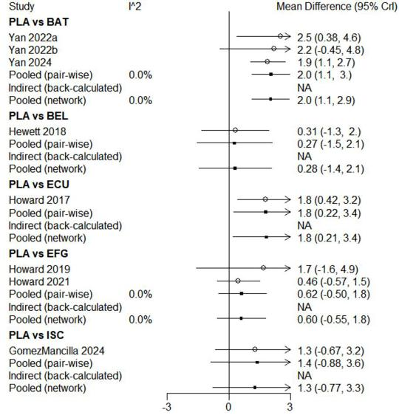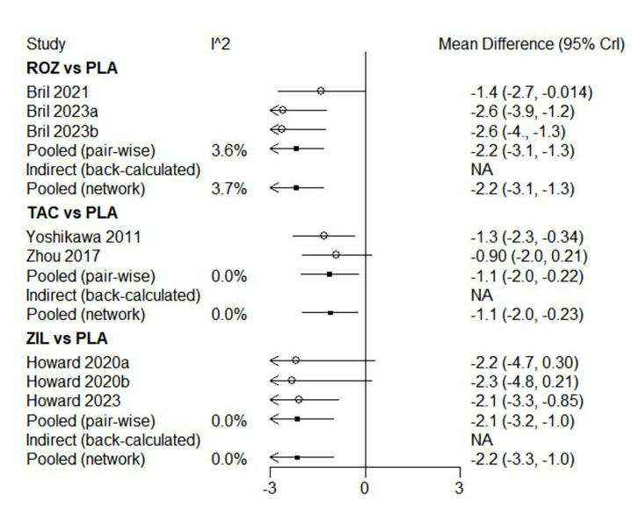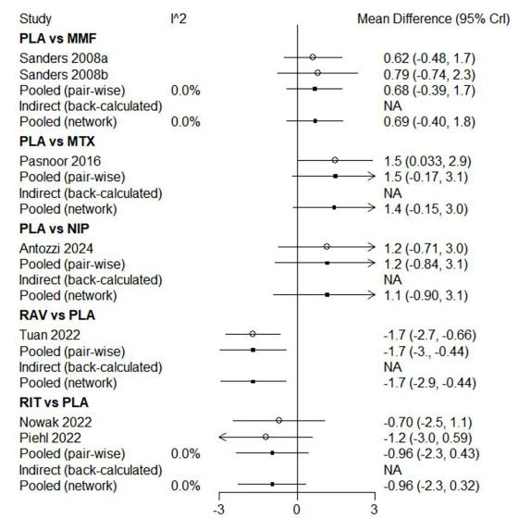
Figure S2. Sensitivity analysis of QMG

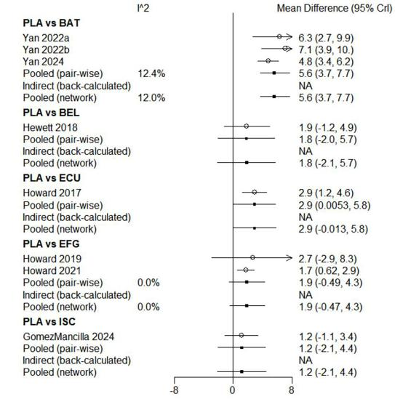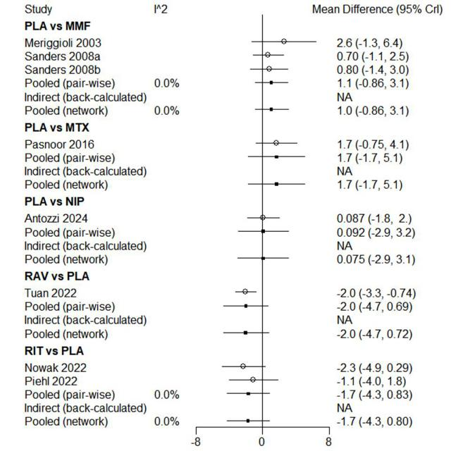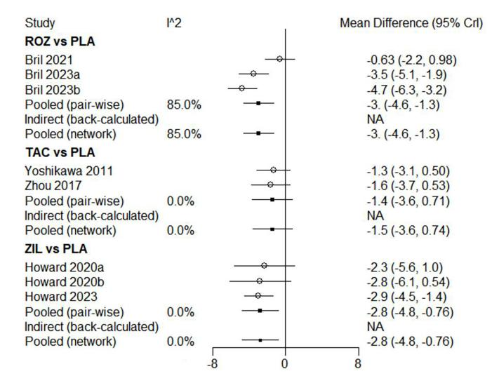
Figure S3. Sensitivity analysis of MGC
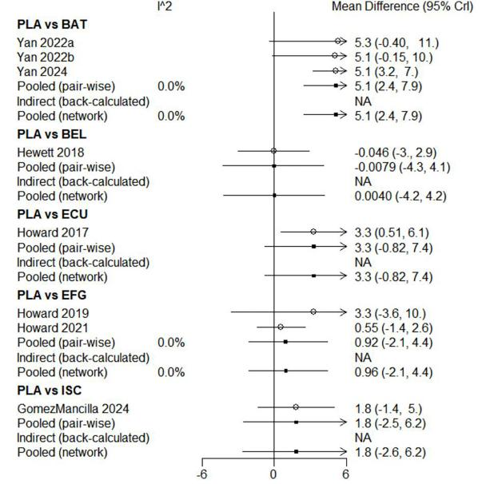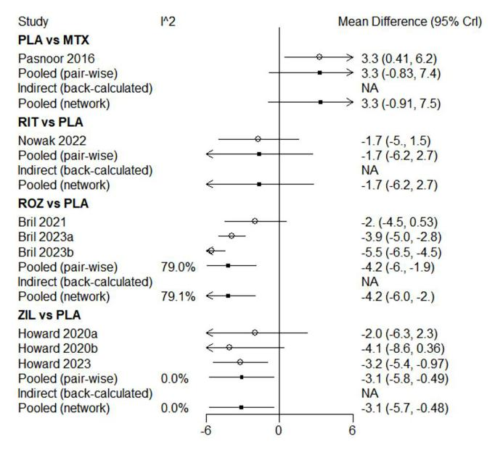

Figure S4. Sensitivity analysis of MG-QoL 15r

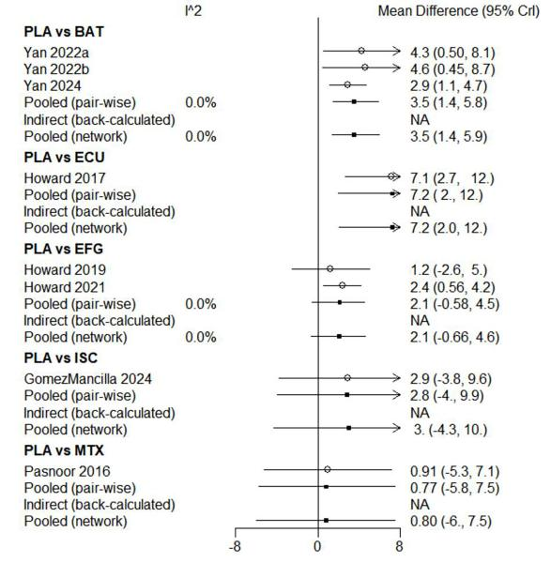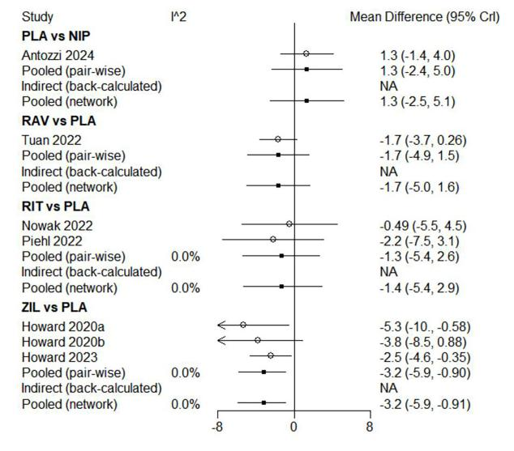
Figure S5. Sensitivity analysis of AEs
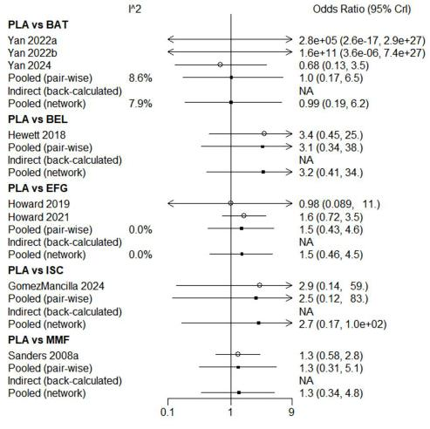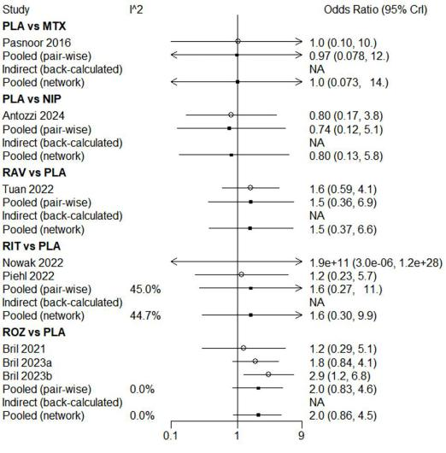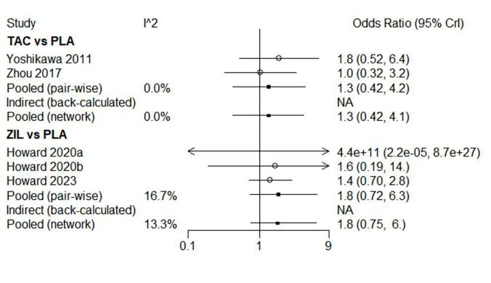

Figure S6. Sensitivity analysis of SAEs
