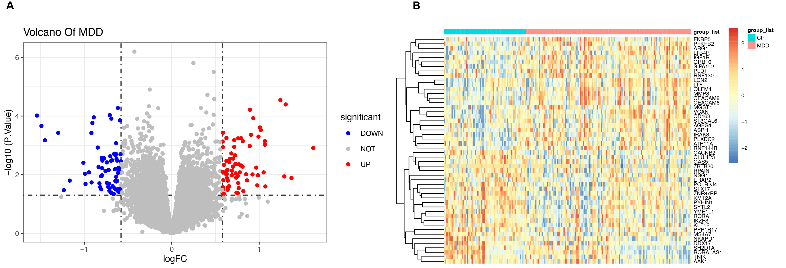

Supplementary Table 1 Comparison of basic demographic characteristics between male and female
Item | IBD（n=20） |  |  |  | IBD-MDD（n=20）
Item | Male（n=17） | Female（n=3） | Test | P | Male（n=5） | Female（n=15） | Test | P
Age (years. mean ± SD) | 27.00±14.02 | 30.00±12.00 | t=-0.300 | 0.768 | 38.40±15.79 | 45.25±20.06 | t=0.463 | 0.649
BMI | 21.96±5.83 | 17.00±1.22 | t=1.420 | 0.173 | 19.30±3.98 | 22.38±0.82 | t=-0.481 | 0.636
HAMD-17 total score | 2.00（1.00-2.50） | 1.00（1.00-2.00） | Z=-0.674 | 0.500 | 18.40±0.89 | 20.40±2.59 | Z=-1.455 | 0.146
HGB (g/L) | 135.60±22.53 | 130.00±18.68 | Z=-0.530 | 0.596 | 138.60±26.37 | 114.00±33.01 | t=1.868 | 0.078
ESR (mm/h) | 9.20±2.86 | 16.33±11.06 | t=0.210 | 0.836 | 12.00±10.77 | 27.50±13.53 | t=-2.051 | 0.057
CRP (mg/L) | 3.58±3.34 | 27.40±35.69 | t=-0.811 | 0.428 | 4.09±4.19 | 3.10±3.46 | t=-0.840 | 0.412
WBC (10^9/L) | 6.46±2.02 | 7.74±1.22 | t=-0.973 | 0.344 | 7.02±1.80 | 6.36±2.23 | t=1.960 | 0.066
NEUT (10^9/L) | 4.51±1.86 | 5.93±1.92 | t=-1.188 | 0.250 | 4.59±1.32 | 3.76±1.28 | t=2.092 | 0.051
EO (10^9/L) | 0.15±0.83 | 0.10±0.09 | t=1.019 | 0.322 | 0.18±0.12 | 0.13±0.08 | t=0.885 | 0.388
PLT (10^9/L) | 284.20±23.57 | 282.33±48.95 | t=0.747 | 0.465 | 292.20±19.25 | 392.25±198.28 | Z=-0.918 | 0.359
ALB (g/L) | 45.86±4.64 | 37.83±5.21 | t=2.358 | 0.030 | 43.38±3.80 | 43.38±5.22 | t=0.656 | 0.520
FCP (ug/g) | 353.68±422.51 | 896.1 | Z=-0.522 | 0.602 | 117.40±144.82 | 626.00±649.79 | t=-0.529 | 0.625
25-OH-VD, (nmol/L) | 17.61±6.01 | 16.46±6.07 | t=0.533 | 0.605 | 22.22±5.34 | 10.10±5.36 | t=2.424 | 0.030

