Supplementary data

The inclusion and exclusion criteria for patients are as follows:
(1) Inclusion Criteria:
1. Histologically confirmed diagnosis of osteosarcoma.
2. No prior systemic therapy received.
3. Tumor at the biopsy site is palpable or resectable.
4. At least one measurable lesion by CT scan within the past 21 days before entering the trial.
5. Age ≥ 16 to 65 years, male or female.
6. Life expectancy of at least 3 months.
7. ECOG performance status score of 0-2.
8. Hematological and biochemical parameters within the following ranges:
Required laboratory test values:
- Hemoglobin ≥ 9 g/dL (prior blood transfusions allowed)
- Absolute neutrophil count ≥ 1.0 × 10^9/L without growth factor support
- Platelet count > 80 × 10^9/L (prior blood transfusions allowed)
- Total bilirubin < 1.5 times the upper limit of normal for age (except for patients with Gilbert's syndrome)
- Serum alanine aminotransferase and/or aspartate aminotransferase < 2.5 × upper limit of normal
- Serum creatinine < 2.5 × upper limit of normal
- Glomerular filtration rate > 40 mL/min
(2) Exclusion Criteria:
1. Pregnant or lactating women.
2. Presence of biopsy contraindications.
3. Allergy to any component of ifosfamide or platinum-based agents.
4. Severe active cardiac disease, including: uncontrolled hypertension (systolic and diastolic blood pressure exceeding hypertensive crisis criteria), unstable angina pectoris, congestive heart failure, myocardial infarction within the past 6 months, or significant arrhythmias, with a history of pericarditis and myocarditis.
5. Currently taking high doses of non-steroidal anti-inflammatory drugs (NSAIDs) or corticosteroid therapy.
6. Any psychological, social, or medical condition, physical examination findings, or laboratory abnormalities, as judged by the investigator, that would make the patient a poor candidate for the trial or could interfere with protocol adherence or interpretation of trial results.
7. Any other active malignancy, except for adequately treated cervical carcinoma in situ by conization and non-melanoma skin lesions.
8. Known seropositive patients for hepatitis B, hepatitis C, or HIV.
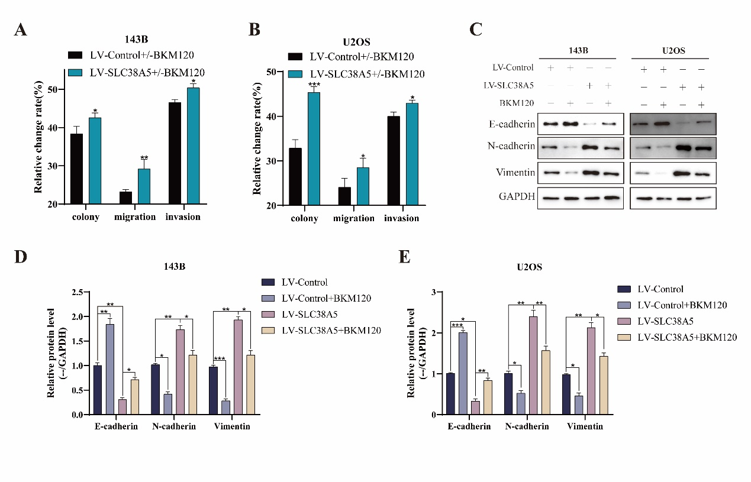
Supplementary Fig 1. PI3K inhibitor can counteract the effect of SLC38A5 in promoting osteosarcoma progression. (A-B) The relative change before and after the addition of BKM120 between the LV-Control and LV-SLC38A5 groups. (C-E) Western blot was used to evaluate E-cadherin, N-cadherin and Vimentin in the four groups.
* P <0.05, ** P <0.01, *** P <0.001.

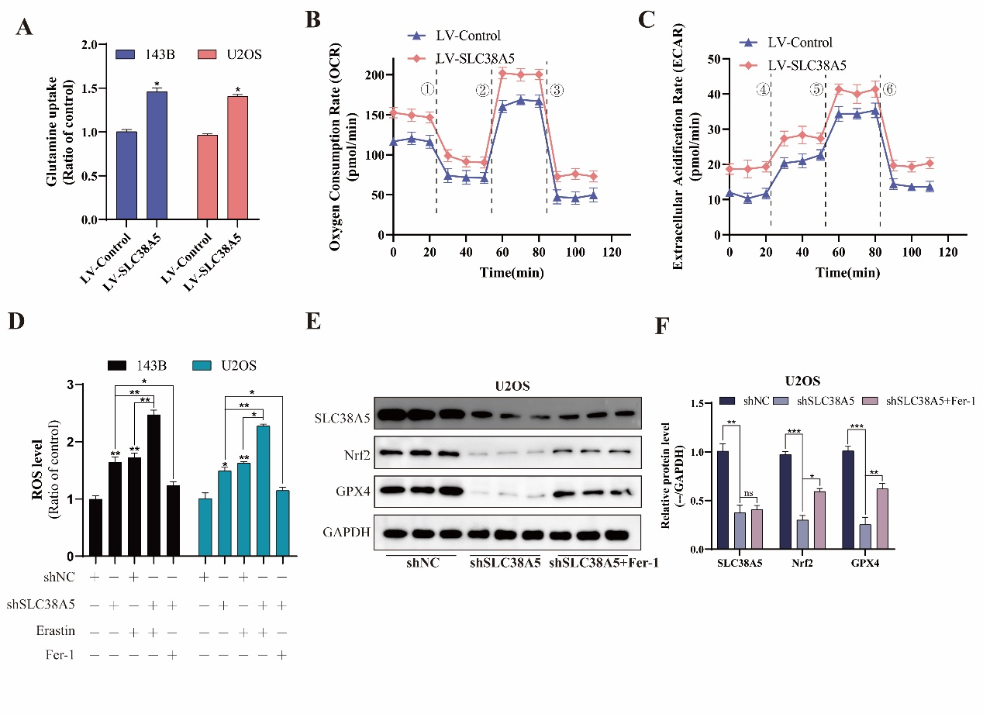
Supplementary Fig 2. SLC38A5 enhances glutamine uptake and inhibits ferroptosis in osteosarcoma cells. (A) Comparison of glutamine uptake of the LV-SLC38A5 and LV-Control groups cells. (B-C) The OCR and ECAR of 143B cells in the LV-SLC38A5 and LV-Control groups were measured and quantified, oligomycin, FCCP, Rotenone & Antimycin A, glucose, oligomycin, 2-DG. (D) The effect of SLC38A5 knockdown on the ROS level in osteosarcoma cells. (E-F) Western blot analysis of ferroptosis-related proteins including Nrf2 and GPX4.
* P <0.05, ** P <0.01, *** P <0.001.

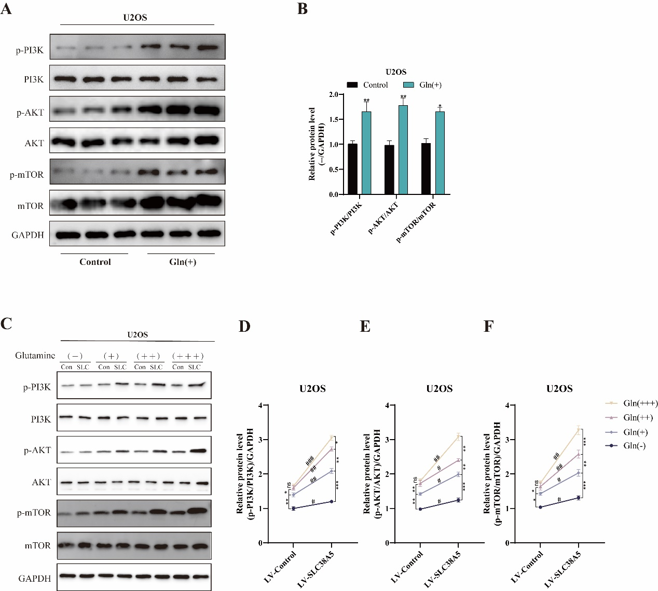

Supplementary Fig 3. SLC38A5 promotes the activation of the PI3K/AKT/mTOR signaling pathway through glutamine. (A-B) The U2OS cells were treated with glutamine (2 mM) and incubated for 48 hours, and then the key proteins of the PI3K/AKT/mTOR signaling pathway were detected by western blot. (C-F) (J-M) Under treatment with varying concentrations of glutamine, western blot was performed to detect the protein levels of p-PI3K, PI3K, p-AKT, AKT, p-mTOR, and mTOR in two groups of U2OS cells. Con: LV-Control group; SLC: LV-SLC38A5 group. The concentrations were as follows: Gln(-): 0 mM, Gln(+): 2 mM, Gln(++): 5 mM, and Gln(+++): 10 mM. Results from three independent experiments are summarized in a histogram format. Comparison between different concentrations: * P <0.05, ** P <0.01, *** P <0.001, ns, not significant. Comparison between different groups: # P <0.05, ## P <0.01, ### P <0.001, ns, not significant.

