Table 1 RNA oligonucleotides sequences.

 |  | Sequence (5 ′ -3 ′)
miR-4712-5p mimics | sense | UCCAGUACAGGUCUCUCAUUUC
miR-4712-5p mimics | antisense | AAUGAGAGACCUGUACUGGAUU
mimics control | sense | UUGUACUACACAAAAGUACUG
mimics control | antisense | UGAAAUCACUCUUACAGAGTT
miR-4712-5p inhibitor | sense | GAAAUGAGAGACCUGUACUGGA
Inhibitor control | sense | CAGUACUUUUGUGUAGUACAA

Table 2 Primer sequences for lncRNA

 | 方向 | 序 列 (5′-3′)
HSA_CIRCpedia_5280 | FORWARD | TACTGGACAGACTGGGGTGAG
HSA_CIRCpedia_5280 | REVERSE | ACGGTGGATGAAGCTGAGC
HSA_CIRCpedia_51817 | FORWARD | AGCAAAAGAAGTGCGAGCAG
HSA_CIRCpedia_51817 | REVERSE | GTGTCCTCTCTACCTCGTTGC
HSA_CIRCpedia_51816 | FORWARD | AGCAAAAGAAGTGCGAGCAG
HSA_CIRCpedia_51816 | REVERSE | GTGTCCTCTCTACCTCGTTGC
HSA_CIRCpedia_7403 | FORWARD | ACATGCCTTCAGCCAACAGA
HSA_CIRCpedia_7403 | REVERSE | TCAGAACCATCCAGAGCTGC
LRP5 | FORWARD | AGACGAGGCGGACTGTGAC
LRP5 | REVERSE | GAGGGCGGCTTGGTGATTTC
miR-4712-5P | FORWARD | GCGCAATGAGAGACCTGTACTGT
miR-770-5P | FORWARD | TCCAGTACCACGTGTCAGGG
miR-4640-5p | FORWARD | ATATATTGGGCCAGGGAGCAGCT
miR-4726-5p | FORWARD | CTTATAGGGCCAGAGGAGCCTG
miR-455-3p | FORWARD | CGGCAGTCCATGGGCATATACAC
miR-3190-3p | FORWARD | TGTGGAAGGTAGACGGCCAGA
miR-6511b-5p | FORWARD | GCTTTACTGCAGGCAGAAGTGG
GAPDH | FORWARD | UGACCUCAACUACAUGGUUTT
GAPDH | REVERSE | AACCAUGUAGUUGAGGUCATT
U6 | FORWARD | AGAGAAGATTAGCATGGCCCCTG
U6 | REVERSE | ATCCAGTGCAGGGTCCGAGG

Figure 1 Enrichment analysis of circRNA GO pathway

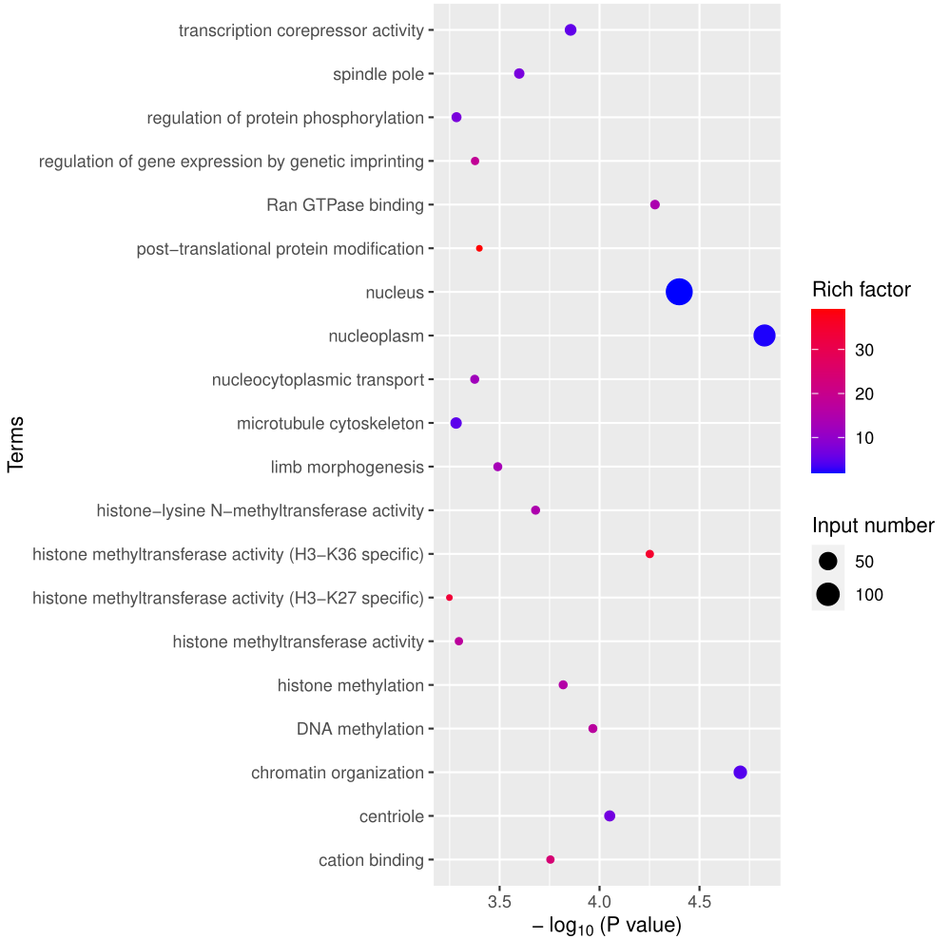

Figure 2 Analysis of circRNA GO channel classification.

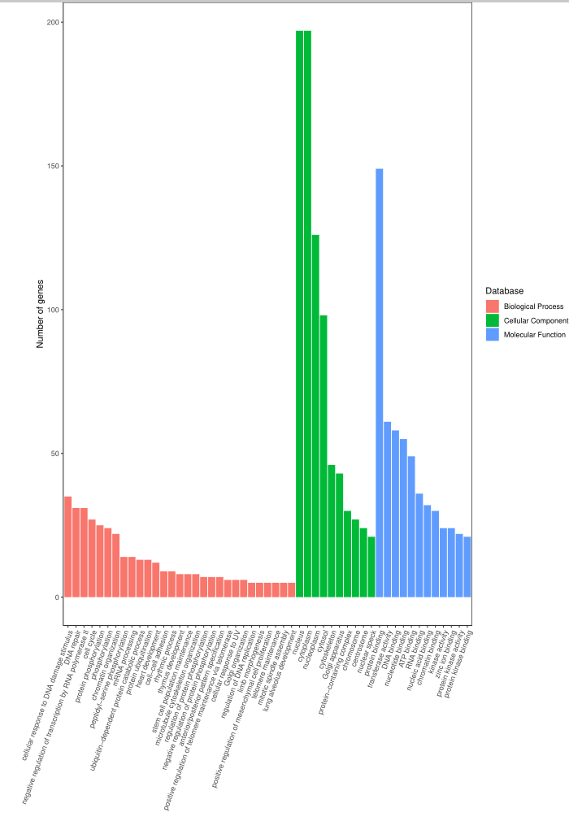

Table 3 circRNA-mRNA associated with autophagy
circRNA-mRNA | mRNA
HSA_CIRCpedia_5280 | LRP5
HSA_CIRCpedia_7403 | LRP6
HSA_CIRCpedia_51817 | RICTOR
HSA_CIRCpedia_51816 | RICTOR

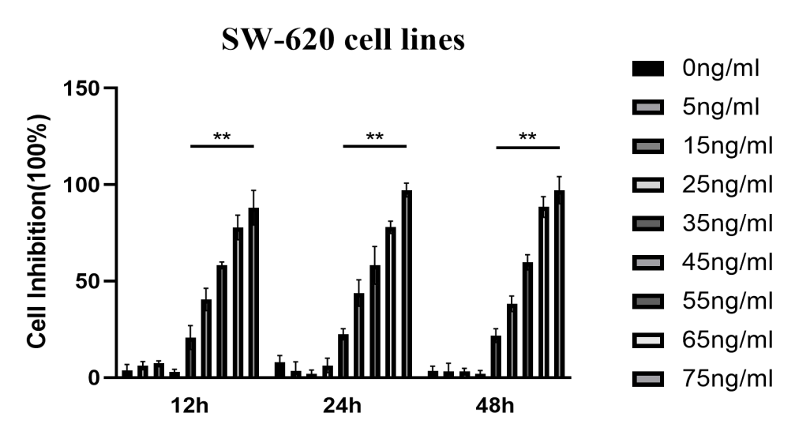

Figure S1.SW-620 was incubated with a specified dose of hBD-1 (0-75 ng/ml) for 12 h, 24 h, and 48 h, and the cytotoxicity was determined by CCK-8.vs 0 ng/ml. *p < 0.05, **p < 0.01.

Figure S2.RT-qPCR detected hBD-1 expreSion.vs NCM-460 . ****p < 0.0001.

A
B
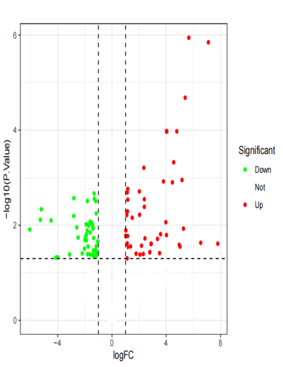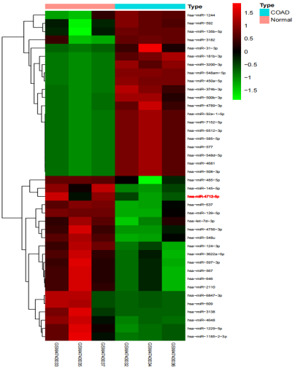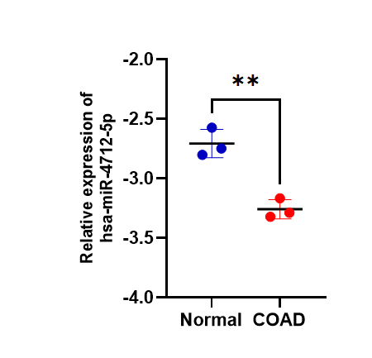
Figure S3. (A). The expreSion of mir-4712-5p in the clinical dataset for liver cancer patients .(B). The expreSion of mir-4712-5p in the clinical dataset for colon cancer patients . vs Liver-N,*p < 0.05. vs Normal, **p < 0.01.

Figure S4.RT-qPCR detected has-circpedia-5280 expreSion.vs Normal. ***p <0.001.

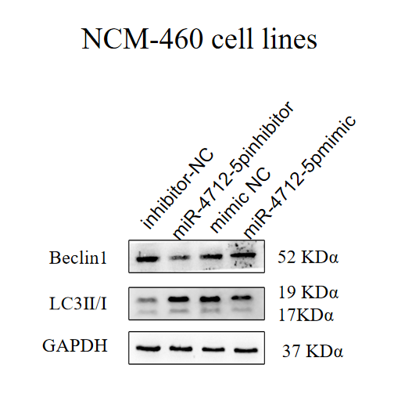
Figure S5.LC3II/I ratio, and Beclin-1 expreSion, the representative Western blotting bands, and the quantification of protein expreSion.vs inhibitor-NC . *p < 0.05.vs mimic-NC . #p < 0.05.

