Supplementary materials
Table S1 Primer sequences used for qPCR gene expression analysis
 | Forward | Reverse
β-actin | GATTACTGCTCTGGCTCCTAGC | GACTCATCGTACTCCTGCTTGC
IL-1α | ACGGCTGAGTTTCAGTGAGACC | CACTCTGGTAGGTGTAAGGTGC
IL-1β | TGGACCTTCCAGGATGAGGACA | GTTCATCTCGGAGCCTGTAGTG
IL-6 | TACCACTTCACAAGTCGGAGGC | CTGCAAGTGCATCATCGTTGTTC
TNF-α | GGTGCCTATGTCTCAGCCTCTT | CCATAGAACTGATGAGAGGGAG
IL-18 | GGAGACCTGGAATCAGACAA | CCACAGGCCAGTCCTCTTACTT
VEGF-b | CACATTGGCTGTGTTCTTCCAGG | ACTGGGCAACACCAAGTCCGAA
ANG-1 | GGCAAGCCATTCTCACAGGCAA | GAGCGAATGGAAGCCCTTACAG
iNOS | GCTCTACACCTCCAATGTGACC | CTGCCGAGATTTGAGCCTCATG
CD163 | GGCTAGACGAAGTCATCTGCAC | CTTCGTTGGTCAGCCTCAGAGA
CD206 | GTTCACCTGGAGTGATGGTTCTC | AGGACATGCCAGGGTCACCTTT
CD86 | ACGTATTGGAAGGAGATTACAGCT | TCTGTCAGCGTTACTATCCCGC

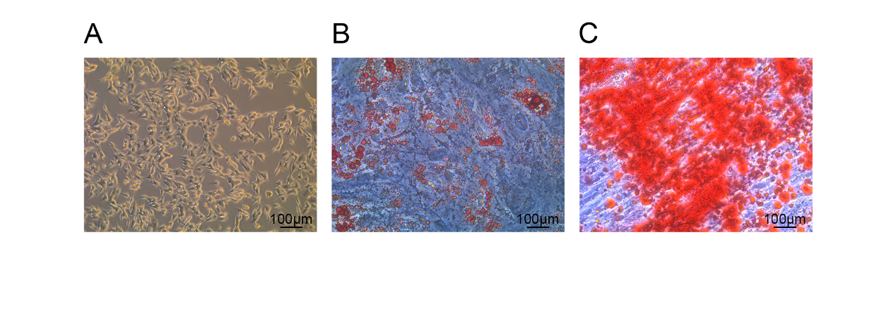
Fig. S1 Characterization of ADSC. (A) ADSC in primary were shuttle-shaped and swirled under light microscope (Scale bar: 100 μm); (B) ADSC induced to differentiate into adipocytes were stained with oil red O staining (Scale bar: 100 μm); (C) ADSC induced to differentiate into osteoblasts were stained with alizarin red staining (Scale bar: 100 μm);
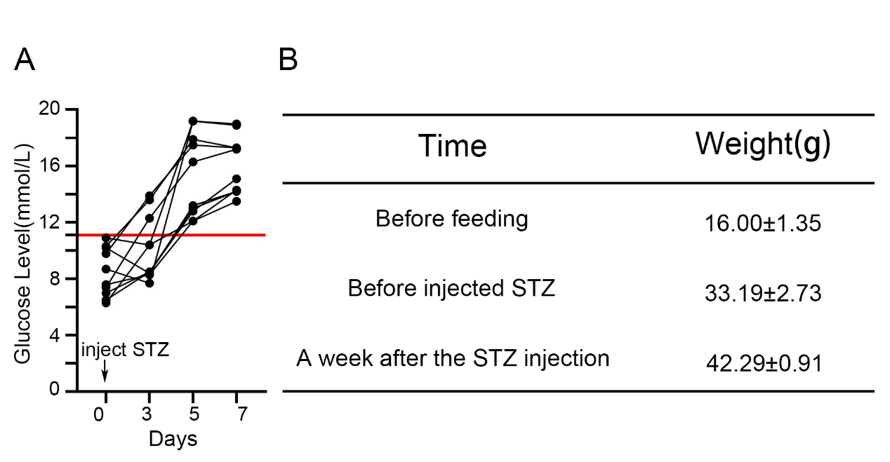
Fig. S2 Indicators for screening diabetic mice.
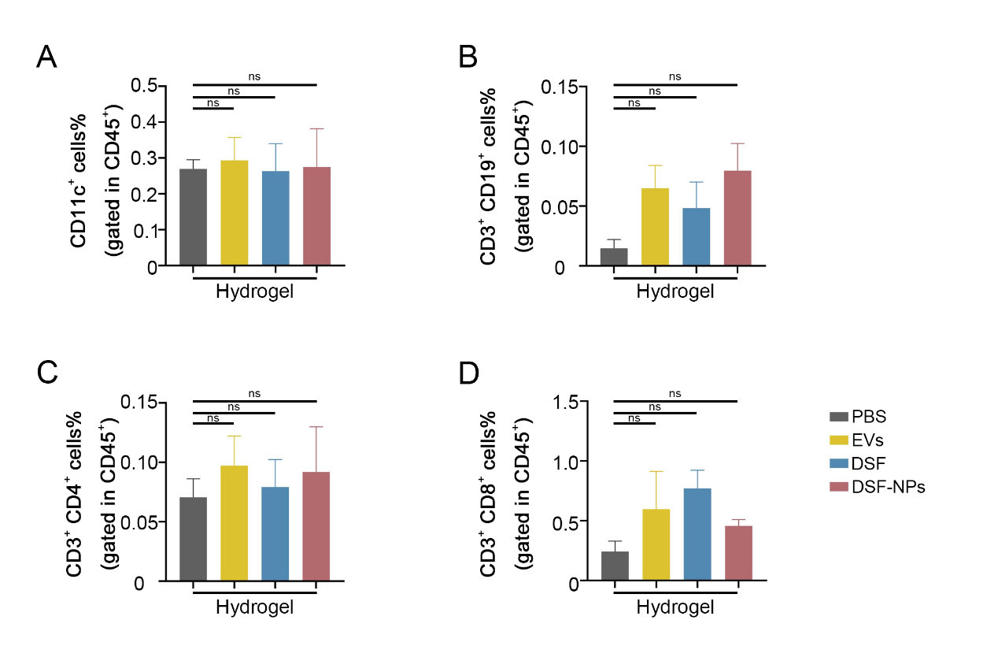
Fig. S3 Other immune cell infiltration in the wound. Representative flow cytometry plots and corresponding statistical plots showed the proportions of CD45⁺CD11c⁺ DC (A)、CD45⁺CD3⁺CD19⁺ B cell (B)、CD45⁺CD3⁺CD4⁺ T cell (C)、CD45⁺CD3⁺CD8⁺ T cell (D) in the wounds of diabetic mice different treatment at day 3. *p < 0.05, **p < 0.01, ***p < 0.001.
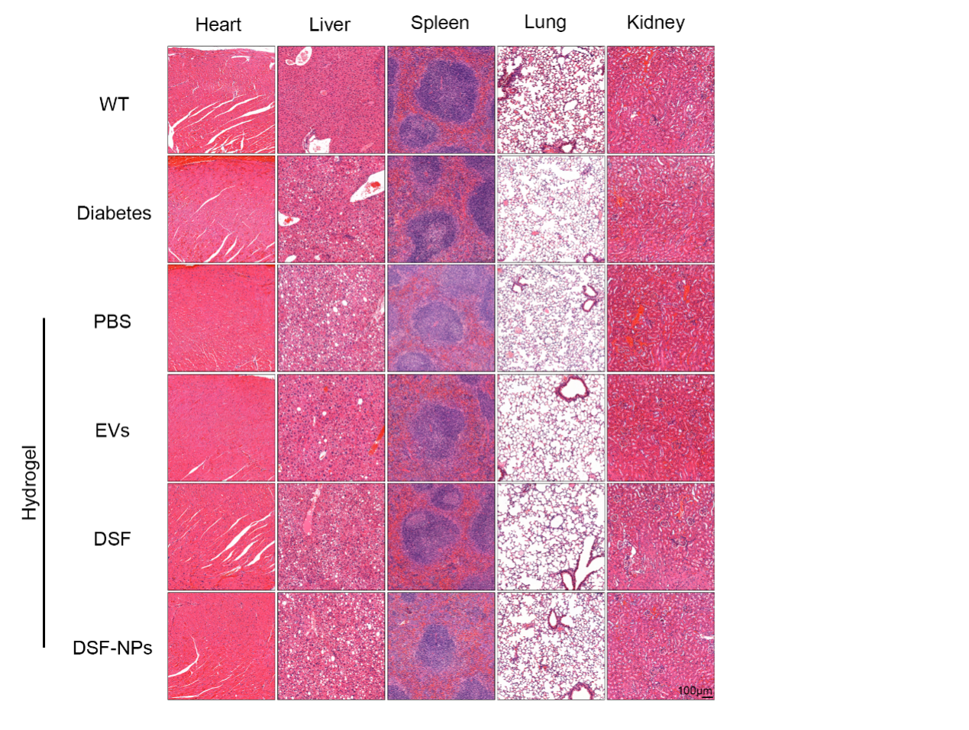
Fig. S4 Biosafety of DSF-NPs@SA. Representative HE staining images showing pathological changes of heart, liver, spleen, lung, kidney. (scale bar = 100 μm).

