Discovery of novel VEGFR2 inhibitors against Non-Small Cell Lung Cancer based on Fingerprint-enhanced Graph Attention Convolutional Network
Zixiao Wang^{a*#}, Lili Sun^{b#}, Yu Xu^{c}, Jing Huangª, Fang Yangª, Yu Changª
ª Department of Pharmacy, Honghui Hospital, Xi’ an Jiaotong University, Xi’ an 710054, China.
^{b} Department of Pharmacy, The First Affiliated Hospital of Xi’an Jiaotong University, Xi’an 710061, China.
^{c} State Key of Natural Medicines, Jiangsu Key Laboratory of Drug Discovery for Metabolic Diseases, Center of Drug Discovery, China Pharmaceutical University, Nanjing 210009, China.
# Zixiao Wang and Lili Sun have contributed equally to this work.
* Correspondence: Zixiao Wang, E-mail: zixiaowang1112@foxmail.com; Yu Chang, E-mail: changyu0552@163.com
Table S1. Performance evaluation of the models in the VEGFR2 (AUC%)
ID | Validation set |  |  |  |  |  | Test set
ID | GAT | GIN | ECC | Graph  SAGE | GAT  GCN | FnGAT  GCN | GAT | GIN | ECC | Graph  SAGE | GAT  GCN | FnGAT  GCN
01 | 93.00 | 94.01 | 91.29 | 95.41 | 96.25 | 98.02 | 93.91 | 93.40 | 90.37 | 95.03 | 96.99 | 97.61
02 | 93.81 | 94.39 | 91.34 | 94.94 | 97.10 | 97.98 | 92.24 | 93.90 | 90.28 | 94.20 | 95.74 | 96.73
03 | 93.11 | 94.60 | 91.09 | 95.76 | 96.67 | 97.65 | 94.62 | 95.12 | 90.29 | 96.00 | 97.37 | 97.31
04 | 93.77 | 95.54 | 92.12 | 96.19 | 96.88 | 97.37 | 95.70 | 96.83 | 92.05 | 96.78 | 97.57 | 97.97
05 | 95.02 | 97.10 | 92.61 | 95.98 | 97.43 | 98.03 | 93.93 | 95.88 | 91.91 | 95.09 | 96.29 | 97.73
06 | 94.35 | 95.91 | 91.15 | 96.50 | 96.36 | 98.49 | 95.63 | 95.76 | 92.90 | 95.97 | 96.82 | 98.18
07 | 94.92 | 95.23 | 91.62 | 95.55 | 96.92 | 98.12 | 94.52 | 95.78 | 92.10 | 95.93 | 97.32 | 98.44
08 | 94.16 | 96.09 | 92.00 | 96.29 | 97.19 | 98.66 | 94.70 | 97.05 | 92.81 | 96.41 | 97.62 | 98.47
09 | 93.27 | 96.10 | 91.35 | 96.52 | 97.48 | 98.34 | 93.59 | 94.93 | 91.29 | 95.80 | 95.96 | 97.33
10 | 93.03 | 96.04 | 92.27 | 96.43 | 97.36 | 98.31 | 92.92 | 95.30 | 90.90 | 96.08 | 96.76 | 97.94
Table S2. Performance evaluation of the models in the VEGFR2 (BA%)
ID | Validation set |  |  |  |  |  | Test set
ID | GAT | GIN | ECC | Graph  SAGE | GAT  GCN | FnGAT  GCN | GAT | GIN | ECC | Graph  SAGE | GAT  GCN | FnGAT  GCN
01 | 85.61 | 86.71 | 83.13 | 88.30 | 90.62 | 92.51 | 84.13 | 86.02 | 81.96 | 87.72 | 91.14 | 91.68
02 | 84.80 | 87.69 | 82.09 | 85.67 | 90.58 | 92.66 | 84.23 | 86.95 | 81.75 | 86.09 | 89.40 | 90.83
03 | 85.17 | 88.52 | 82.72 | 89.35 | 91.29 | 92.15 | 84.09 | 88.68 | 80.63 | 89.37 | 91.53 | 91.84
04 | 87.05 | 88.94 | 83.24 | 91.06 | 91.60 | 93.13 | 88.78 | 90.63 | 83.60 | 91.41 | 91.53 | 93.61
05 | 87.25 | 90.73 | 85.44 | 89.98 | 92.21 | 93.81 | 86.40 | 90.12 | 82.61 | 87.61 | 89.18 | 92.85
06 | 85.93 | 89.62 | 82.00 | 90.08 | 90.71 | 93.82 | 86.92 | 90.05 | 84.87 | 89.51 | 91.30 | 93.22
07 | 86.47 | 88.95 | 84.32 | 91.81 | 92.94 | 95.81 | 86.86 | 89.38 | 84.63 | 91.69 | 92.97 | 94.98
08 | 86.65 | 90.06 | 84.92 | 89.30 | 92.00 | 94.10 | 85.21 | 87.77 | 82.68 | 89.85 | 92.04 | 94.04
09 | 85.01 | 89.97 | 81.70 | 90.62 | 91.66 | 93.04 | 85.00 | 88.80 | 82.93 | 89.03 | 90.82 | 93.45
10 | 83.49 | 90.09 | 85.33 | 90.15 | 91.89 | 93.81 | 83.43 | 89.16 | 83.54 | 89.80 | 91.20 | 93.02
Table S3. Performance evaluation of the models in the VEGFR2 (F1%)
ID | Validation set |  |  |  |  |  | Test set
ID | GAT | GIN | ECC | Graph  SAGE | GAT  GCN | FnGAT  GCN | GAT | GIN | ECC | Graph  SAGE | GAT  GCN | FnGAT  GCN
01 | 89.06 | 89.52 | 86.81 | 90.92 | 92.62 | 94.15 | 87.53 | 88.52 | 85.62 | 90.04 | 92.49 | 92.88
02 | 88.10 | 90.36 | 86.23 | 89.00 | 92.23 | 93.83 | 88.24 | 90.31 | 86.19 | 89.73 | 91.63 | 92.36
03 | 88.32 | 90.10 | 86.36 | 90.91 | 92.11 | 93.37 | 87.78 | 90.51 | 84.90 | 91.09 | 92.14 | 93.15
04 | 89.49 | 90.59 | 86.66 | 92.31 | 92.43 | 94.20 | 90.74 | 91.92 | 86.72 | 92.72 | 92.40 | 94.54
05 | 89.78 | 92.45 | 88.36 | 91.48 | 93.41 | 94.49 | 89.51 | 92.02 | 86.88 | 89.72 | 91.18 | 93.83
06 | 90.10 | 92.11 | 86.32 | 92.41 | 92.75 | 95.23 | 90.48 | 92.52 | 87.86 | 91.77 | 93.10 | 94.51
07 | 90.00 | 91.36 | 87.74 | 91.81 | 92.94 | 95.81 | 89.85 | 91.56 | 87.40 | 91.69 | 92.97 | 94.98
08 | 89.31 | 91.81 | 87.84 | 90.04 | 93.01 | 94.64 | 89.17 | 90.91 | 87.14 | 91.08 | 93.56 | 94.97
09 | 87.56 | 91.35 | 85.35 | 91.79 | 92.58 | 93.93 | 88.10 | 90.57 | 86.65 | 90.54 | 92.19 | 94.47
10 | 88.03 | 92.18 | 88.50 | 92.16 | 93.51 | 94.82 | 87.49 | 91.15 | 86.35 | 91.60 | 92.74 | 94.22
Table S4. Performance evaluation of the models in the VEGFR2 (MCC%)
ID | Validation set |  |  |  |  |  | Test set
ID | GAT | GIN | ECC | Graph  SAGE | GAT  GCN | FnGAT  GCN | GAT | GIN | ECC | Graph  SAGE | GAT  GCN | FnGAT  GCN
01 | 73.14 | 74.56 | 67.65 | 77.97 | 82.24 | 85.98 | 70.36 | 73.14 | 65.71 | 76.72 | 82.77 | 83.73
02 | 72.01 | 77.61 | 67.22 | 74.24 | 82.16 | 85.95 | 71.19 | 76.52 | 65.89 | 75.02 | 79.99 | 82.04
03 | 73.21 | 77.73 | 68.33 | 79.53 | 82.66 | 85.16 | 71.47 | 78.31 | 64.14 | 79.67 | 82.89 | 84.48
04 | 75.17 | 78.21 | 68.01 | 82.31 | 82.99 | 86.60 | 78.14 | 81.30 | 68.14 | 83.03 | 82.77 | 87.33
05 | 76.03 | 82.51 | 72.54 | 80.43 | 84.91 | 87.61 | 74.84 | 81.19 | 68.00 | 75.85 | 79.22 | 85.80
06 | 75.24 | 80.61 | 65.70 | 81.38 | 82.33 | 88.44 | 76.45 | 81.72 | 70.49 | 80.01 | 83.33 | 86.86
07 | 74.75 | 78.63 | 69.47 | 80.06 | 82.82 | 89.74 | 75.20 | 79.64 | 69.78 | 80.44 | 83.36 | 88.06
08 | 75.60 | 81.53 | 72.03 | 78.48 | 84.44 | 88.25 | 73.77 | 78.22 | 68.47 | 79.61 | 84.86 | 88.32
09 | 71.90 | 80.83 | 66.43 | 81.89 | 83.73 | 86.70 | 72.33 | 78.51 | 68.69 | 78.60 | 82.32 | 87.55
10 | 70.72 | 81.41 | 72.24 | 81.38 | 84.67 | 87.92 | 69.99 | 79.35 | 67.96 | 80.48 | 83.19 | 86.67
Table S5. Performance evaluation of the models in the A549(AUC%)
ID | Validation set |  |  |  |  |  | Test set
ID | GAT | GIN | ECC | Graph  SAGE | GAT  GCN | FnGAT  GCN | GAT | GIN | ECC | Graph  SAGE | GAT  GCN | FnGAT  GCN
01 | 91.89 | 92.45 | 92.61 | 93.69 | 96.02 | 97.74 | 90.31 | 90.88 | 92.02 | 92.37 | 94.16 | 95.99
02 | 91.89 | 90.88 | 87.82 | 92.75 | 93.38 | 95.24 | 89.82 | 91.40 | 89.13 | 91.19 | 92.38 | 95.49
03 | 90.10 | 93.04 | 85.34 | 93.86 | 93.41 | 96.62 | 91.33 | 92.83 | 85.45 | 92.46 | 94.41 | 96.84
04 | 93.28 | 94.24 | 90.51 | 95.01 | 96.87 | 99.01 | 90.62 | 92.25 | 86.11 | 92.79 | 93.41 | 96.01
05 | 91.44 | 92.09 | 90.68 | 94.44 | 96.03 | 96.79 | 89.21 | 90.89 | 87.19 | 92.86 | 93.24 | 95.10
06 | 91.15 | 92.49 | 85.92 | 92.10 | 94.65 | 95.25 | 89.68 | 89.92 | 86.48 | 91.73 | 93.96 | 94.30
07 | 88.69 | 90.94 | 85.76 | 92.13 | 93.31 | 95.26 | 90.72 | 90.19 | 87.10 | 92.43 | 93.54 | 94.75
08 | 91.58 | 91.61 | 88.80 | 93.22 | 96.52 | 96.57 | 91.29 | 91.79 | 86.32 | 91.95 | 94.64 | 95.45
09 | 92.15 | 91.41 | 84.59 | 94.27 | 94.69 | 97.22 | 90.92 | 89.55 | 83.74 | 92.01 | 93.80 | 95.91
10 | 92.07 | 92.81 | 91.57 | 94.93 | 95.56 | 96.39 | 93.08 | 89.72 | 88.43 | 91.58 | 92.66 | 93.93
Table S6. Performance evaluation of the models in the A549(BA%)
ID | Validation set |  |  |  |  |  | Test set
ID | GAT | GIN | ECC | Graph  SAGE | GAT  GCN | FnGAT  GCN | GAT | GIN | ECC | Graph  SAGE | GAT  GCN | FnGAT  GCN
01 | 81.62 | 84.87 | 83.79 | 86.79 | 88.72 | 93.75 | 77.69 | 83.84 | 83.11 | 84.34 | 87.36 | 89.68
02 | 77.84 | 83.65 | 72.65 | 84.78 | 87.16 | 88.11 | 78.95 | 83.18 | 77.52 | 84.44 | 87.02 | 90.05
03 | 81.95 | 84.28 | 76.25 | 79.51 | 85.41 | 89.72 | 82.02 | 85.11 | 76.40 | 79.33 | 86.92 | 91.87
04 | 84.07 | 89.77 | 80.15 | 88.22 | 87.18 | 95.26 | 80.58 | 83.68 | 76.47 | 85.53 | 83.24 | 90.65
05 | 78.79 | 85.00 | 80.32 | 86.20 | 89.94 | 91.48 | 77.23 | 82.83 | 76.31 | 84.31 | 89.05 | 89.58
06 | 79.14 | 81.57 | 71.69 | 84.02 | 86.17 | 89.14 | 78.84 | 84.83 | 71.69 | 83.07 | 86.20 | 88.46
07 | 76.79 | 86.03 | 76.92 | 86.21 | 87.48 | 91.03 | 79.03 | 83.70 | 74.53 | 84.67 | 86.53 | 90.89
08 | 81.09 | 85.10 | 78.26 | 87.11 | 87.13 | 90.85 | 80.88 | 84.27 | 78.29 | 85.83 | 86.22 | 90.06
09 | 76.55 | 85.27 | 70.30 | 84.46 | 86.84 | 91.96 | 78.68 | 82.59 | 72.54 | 83.96 | 86.40 | 88.80
10 | 80.31 | 83.40 | 80.84 | 87.69 | 87.22 | 88.77 | 81.80 | 82.24 | 81.07 | 84.82 | 84.83 | 86.52
Table S7. Performance evaluation of the models in the A549(F1%)
ID | Validation set |  |  |  |  |  | Test set
ID | GAT | GIN | ECC | Graph  SAGE | GAT  GCN | FnGAT  GCN | GAT | GIN | ECC | Graph  SAGE | GAT  GCN | FnGAT  GCN
01 | 75.93 | 78.17 | 78.03 | 80.86 | 84.59 | 91.01 | 70.16 | 77.09 | 76.66 | 77.09 | 83.00 | 85.88
02 | 69.23 | 74.43 | 60.91 | 77.18 | 78.86 | 83.16 | 72.67 | 76.79 | 69.93 | 78.31 | 81.08 | 87.28
03 | 75.86 | 78.55 | 65.78 | 72.99 | 80.26 | 85.99 | 74.40 | 78.67 | 65.10 | 71.22 | 81.19 | 85.29
04 | 76.61 | 83.60 | 69.23 | 79.75 | 82.07 | 92.21 | 73.13 | 77.44 | 65.71 | 77.60 | 78.06 | 87.24
05 | 72.13 | 80.85 | 72.94 | 82.01 | 85.87 | 88.70 | 68.38 | 76.29 | 65.12 | 77.38 | 83.54 | 84.89
06 | 70.54 | 72.66 | 58.58 | 75.43 | 79.72 | 83.62 | 72.08 | 80.73 | 58.58 | 76.97 | 82.01 | 84.03
07 | 67.81 | 77.87 | 67.32 | 76.72 | 81.93 | 85.63 | 70.73 | 73.79 | 61.19 | 73.08 | 79.29 | 84.54
08 | 73.26 | 77.18 | 68.36 | 79.61 | 83.21 | 84.97 | 72.41 | 75.88 | 68.53 | 76.60 | 81.25 | 84.35
09 | 68.48 | 76.88 | 57.03 | 78.41 | 79.75 | 88.33 | 72.22 | 74.18 | 61.48 | 77.74 | 80.69 | 84.55
10 | 73.29 | 77.48 | 73.43 | 82.12 | 84.21 | 85.04 | 75.18 | 75.54 | 73.31 | 77.23 | 79.86 | 80.27
Table S8. Performance evaluation of the models in the A549(MCC%)
ID | Validation set |  |  |  |  |  | Test set
ID | GAT | GIN | ECC | Graph  SAGE | GAT  GCN | FnGAT  GCN | GAT | GIN | ECC | Graph  SAGE | GAT  GCN | FnGAT  GCN
01 | 68.92 | 69.19 | 70.09 | 73.00 | 78.64 | 87.36 | 68.92 | 69.19 | 70.09 | 73.00 | 78.64 | 87.36
02 | 62.88 | 66.27 | 54.79 | 70.21 | 72.01 | 78.27 | 67.33 | 68.16 | 62.80 | 69.96 | 73.34 | 82.76
03 | 69.78 | 72.25 | 55.60 | 67.89 | 74.44 | 81.51 | 67.02 | 72.19 | 54.56 | 64.11 | 75.37 | 80.39
04 | 69.61 | 78.33 | 59.27 | 73.12 | 76.94 | 89.73 | 64.55 | 69.82 | 52.84 | 68.78 | 71.97 | 82.70
05 | 65.89 | 75.04 | 63.43 | 75.90 | 80.28 | 84.41 | 61.36 | 69.75 | 54.45 | 70.33 | 78.10 | 80.02
06 | 63.96 | 65.13 | 51.29 | 68.21 | 74.02 | 78.86 | 65.41 | 75.05 | 51.29 | 68.75 | 75.90 | 77.84
07 | 59.63 | 69.51 | 57.58 | 67.89 | 75.56 | 80.32 | 64.97 | 66.10 | 50.98 | 64.96 | 73.44 | 80.02
08 | 66.48 | 70.20 | 60.06 | 73.23 | 79.14 | 80.26 | 64.52 | 68.09 | 59.77 | 68.73 | 76.10 | 79.26
09 | 64.10 | 68.79 | 50.77 | 71.99 | 72.80 | 84.46 | 67.36 | 63.91 | 53.92 | 69.87 | 73.46 | 78.90
10 | 65.02 | 69.85 | 64.22 | 75.12 | 79.66 | 79.72 | 69.25 | 69.36 | 66.25 | 70.11 | 74.92 | 74.24

Drug repurposing is a strategy aimed at identifying alternative applications for approved or investigational drugs beyond their originally intended medical indications. This method can enhance drug discovery efficiency and reduce drug development risks [1]. In this study, we employed the FnGATGCN model for cross-screening and identified 390 potential molecules with VEGFR2 inhibitory activity from the A549 cell activity dataset. Subsequently, using the k-means algorithm, these molecules were clustered into 10 groups, with the cluster represented by CHEMBL3318073 containing the highest number of active molecules (size =76). Similarly, within the VEGFR2 activity dataset, we discovered 508 potential molecules with anti-A549 proliferation activity. Clustering results revealed that the cluster represented by CHEMBL204427 contained the highest number of active molecules (size =108). It's worth mentioning that compound CHEMBL4517008 has been reported to possess anti-A549 cell proliferation activity, with an IC₅₀ of 240 nM [2]. Due to its testing conditions not meeting our inclusion criteria, it was not included in the previous training set. The specific information is shown in Table 5, this further demonstrates the reliability of our model. The central molecules of these three clusters adhere to Lipinski's Rule of Five. More detailed clustering results can be found in Supplementary Tables S9 and S10.
Table S9. The potential VEGFR2 inhibitors from A549 cell growth inhibitors
Cluster | Size | Centered ID | Centered Structure | Predicted Probability  VEGFR2 | IC₅₀(nM)  A549 | RO5
1 | 64 | CHEMBL2419657 |  | 0.9398 | 160 | 3
2 | 28 | CHEMBL4280004 |  | 0.9798 | 210 | 0
3 | 19 | CHEMBL4879161 |  | 0.5836 | 15.8 | 2
4 | 62 | CHEMBL2435965 |  | 0.9669 | 990 | 4
5 | 16 | CHEMBL3612310 |  | 0.6536 | 450 | 2
6 | 76 | CHEMBL3318073 |  | 0.6849 | 0.51 | 0
7 | 18 | CHEMBL3339345 |  | 0.9964 | 280 | 3
8 | 66 | CHEMBL3290916 |  | 0.8998 | 150 | 3
9 | 41 | CHEMBL4081754 |  | 0.9221 | 90 | 3
10 | 26 | CHEMBL4078189 |  | 0.9674 | 420 | 0
Table S10. The potential A549 cell growth inhibitors from VEGFR2 inhibitors

Cluster | Size | Centered ID | Centered Structure | Predicted Probability  A549 | IC50(nM)  VEGFR2 | RO5
1 | 99 | CHEMBL362634 |  | 0.7433 | 0.5 | 0
2 | 108 | CHEMBL204427 |  | 0.7388 | 42 | 0
3 | 19 | CHEMBL380905 |  | 0.9426 | 24 | 0
4 | 102 | CHEMBL47166 |  | 0.7891 | 135 | 0
5 | 78 | CHEMBL4517008 |  | 0.7488 | 650 | 0
6 | 19 | CHEMBL3986984 |  | 0.8931 | 3 | 3
7 | 52 | CHEMBL2031893 |  | 0.9365 | 8 | 1
8 | 10 | CHEMBL5186340 |  | 0.5742 | 757 | 2
9 | 21 | CHEMBL3690473 |  | 0.8009 | 313 | 0
10 | 58 | CHEMBL3287597 |  | 0.7779 | 196.2 | 4

Table S11. The SMILES of Z1-Z11 and Sorafenib
Compounds | ZINC ID | SMILES
Sorafenib | —— | CNC(=O)c1cc(Oc2ccc(NC(=O)Nc3ccc(Cl)c(C(F)(F)F)c3)cc2)ccn1
Z1 | ZINC33068301 | O=C(Nc1ccc(OCc2cc(=O)n3cc(Cl)ccc3n2)cc1)Nc1ccc(F)cc1F
Z2 | ZINC33067816 | Cc1ccc(NC(=O)Nc2ccc(F)cc2F)cc1OCc1cc(=O)n2ccccc2n1
Z3 | ZINC8598095 | O=C(Nc1cccc(OCc2cc(=O)n3ccccc3n2)c1)Nc1cccc(C(F)(F)F)c1
Z4 | ZINC33067799 | Cc1ccc(NC(=O)c2ccccc2F)cc1OCc1cc(=O)n2ccccc2n1
Z5 | ZINC41089729 | Cc1cc2nc(CSc3ccc(NC(=O)Nc4ccc(F)cc4F)cc3)cc(=O)n2o1
Z6 | ZINC85393782 | CNC(=O)c1cc(C(=O)c2ccc3[nH]c(Nc4ccc(Cl)cc4)nc3c2)ccn1
Z7 | ZINC65460318 | Cc1cccc(C(=O)Nc2cc(NC(=O)c3cccc4nccnc34)ccc2C)c1
Z8 | ZINC33326674 | Cc1nc(Nc2ccc(NC(=O)Nc3ccc(C)c(F)c3)cc2)cc(N(C)C)n1
Z9 | ZINC23353178 | Cc1ccc(C(=O)Nc2cnc3ccccc3c2)cc1NC(=O)c1ccco1
Z10 | ZINC170642714 | Cc1ccc(C(=O)Nc2cnc3ccccc3c2)cc1S(=O)(=O)Nc1ccc(F)cc1
Z11 | ZINC64801237 | CCNc1nc(C)cc(Nc2ccc(NC(=O)Nc3ccccc3F)cc2)n1

Figure S1. The chemical space of compounds. (A) Z1-Z11 and active compounds from VEGFR2 datasets. (B) Z1-Z11 and active compounds from A549 datasets.
Figure S2. The structural analysis spectra of Z1-Z6 provided by the supplier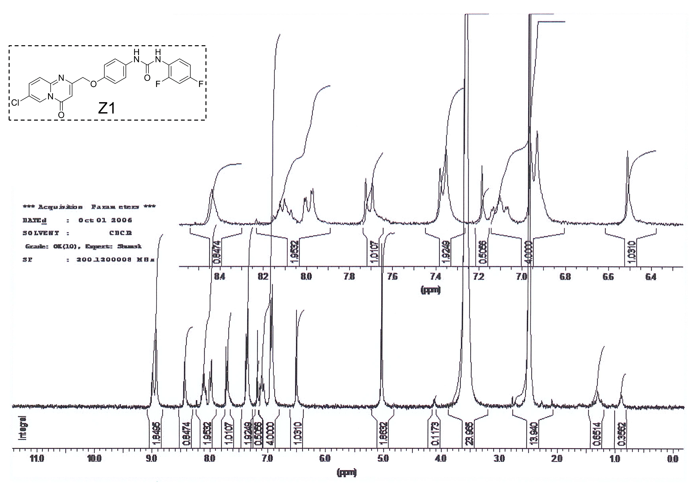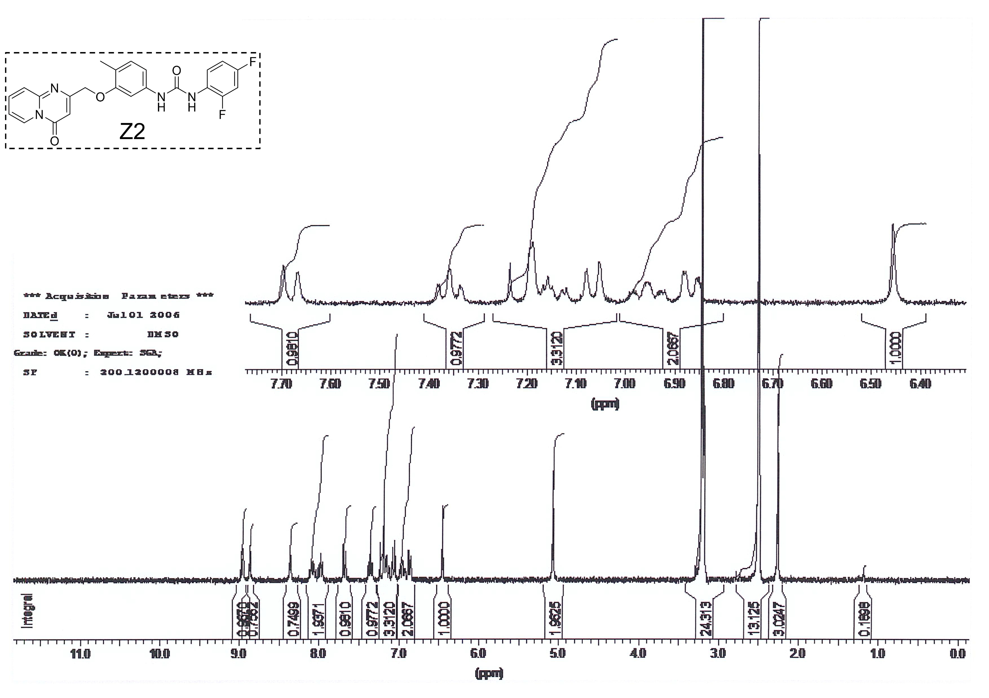
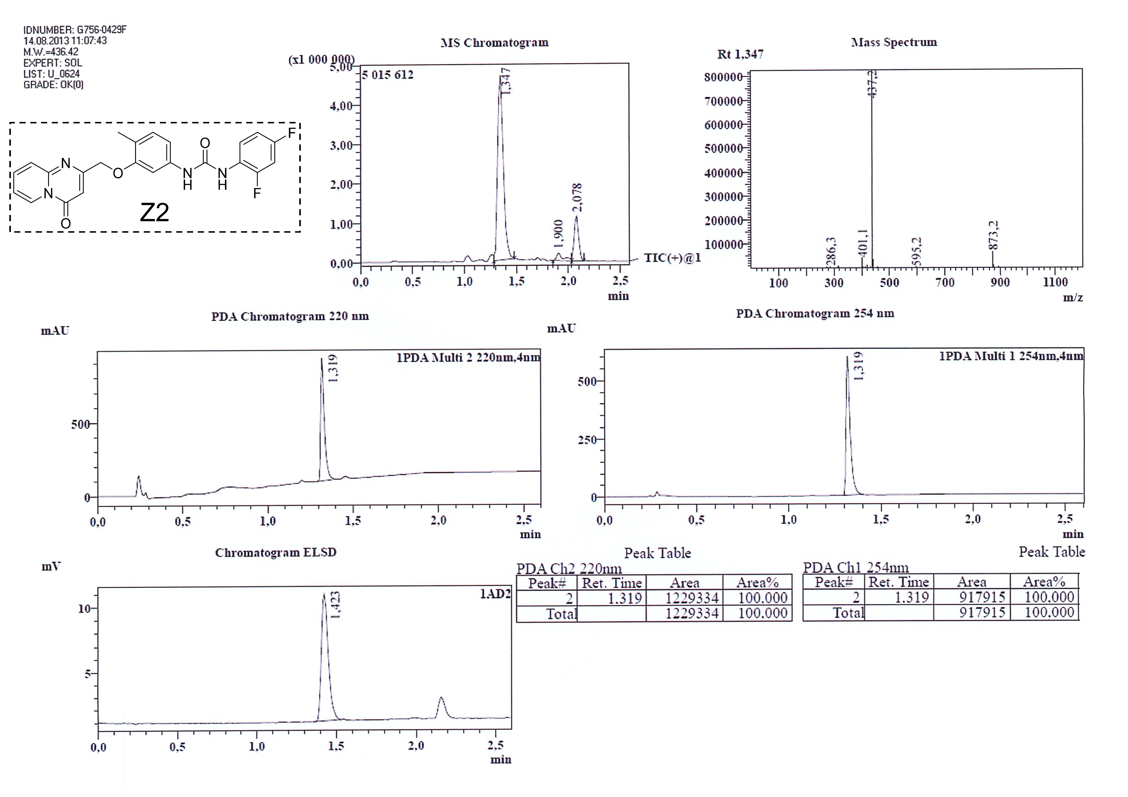
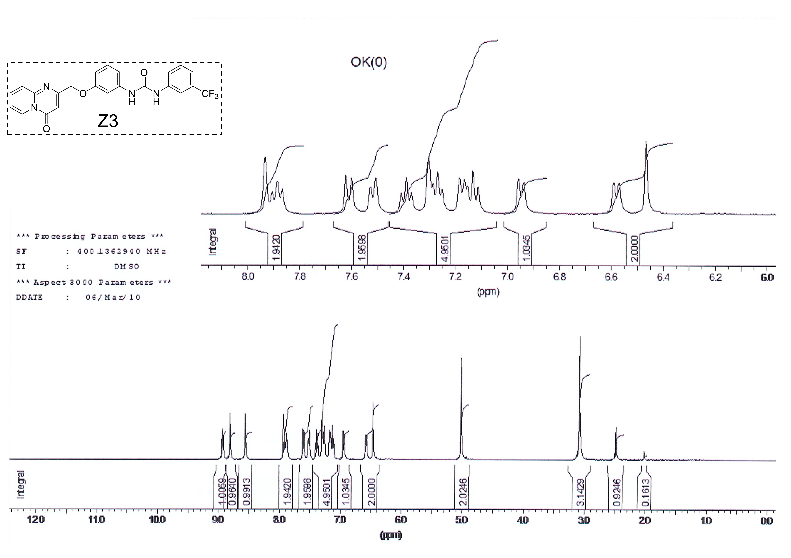

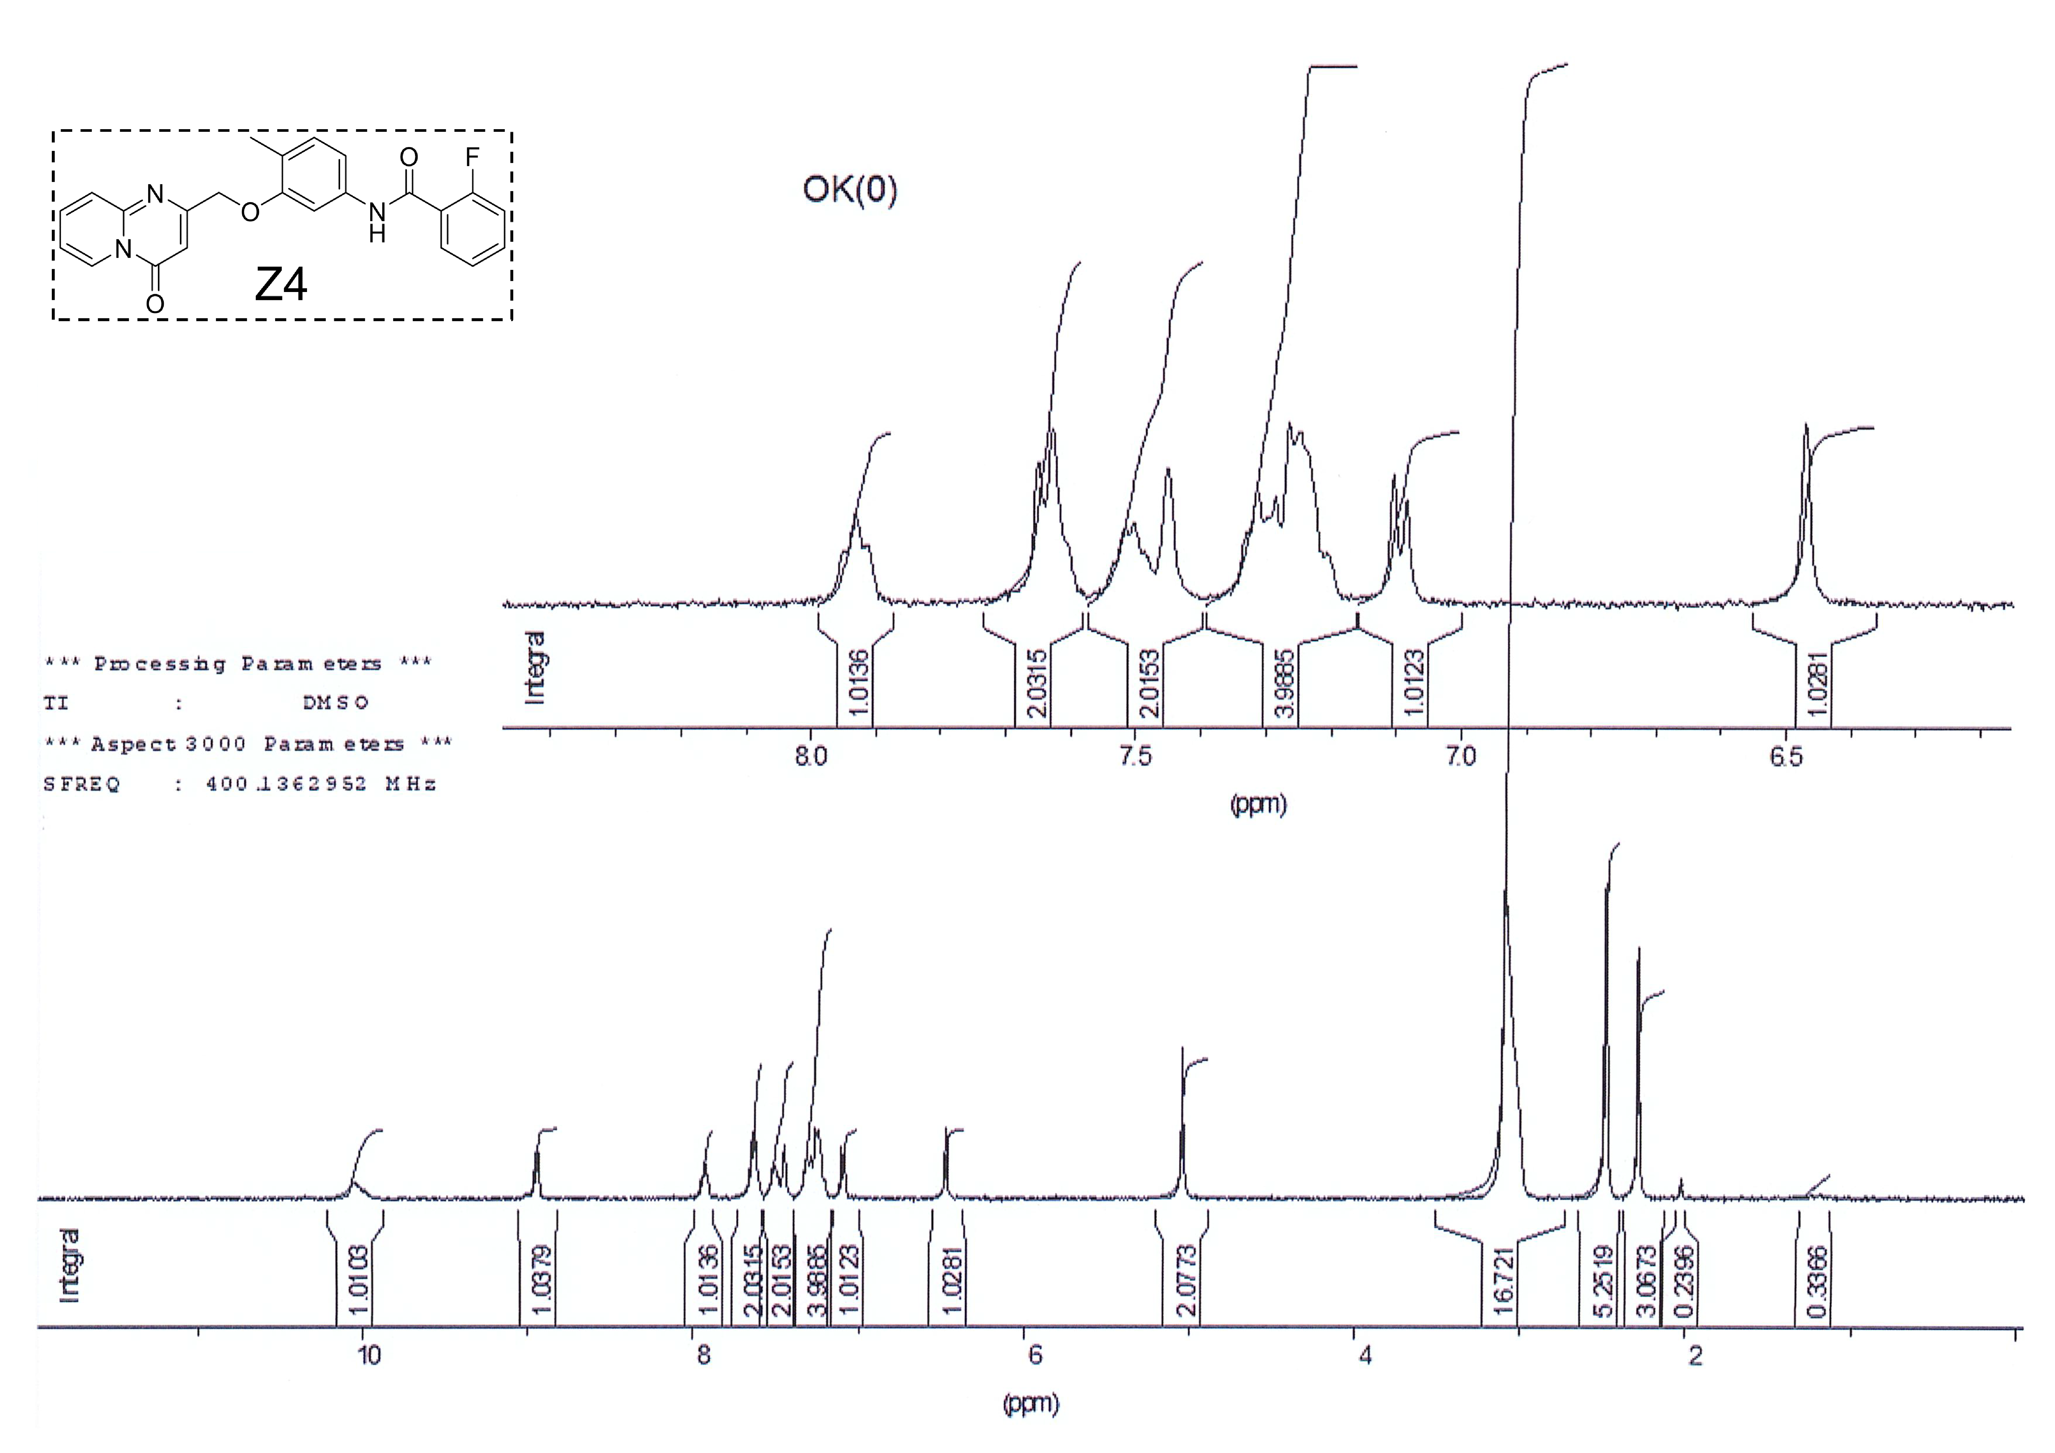
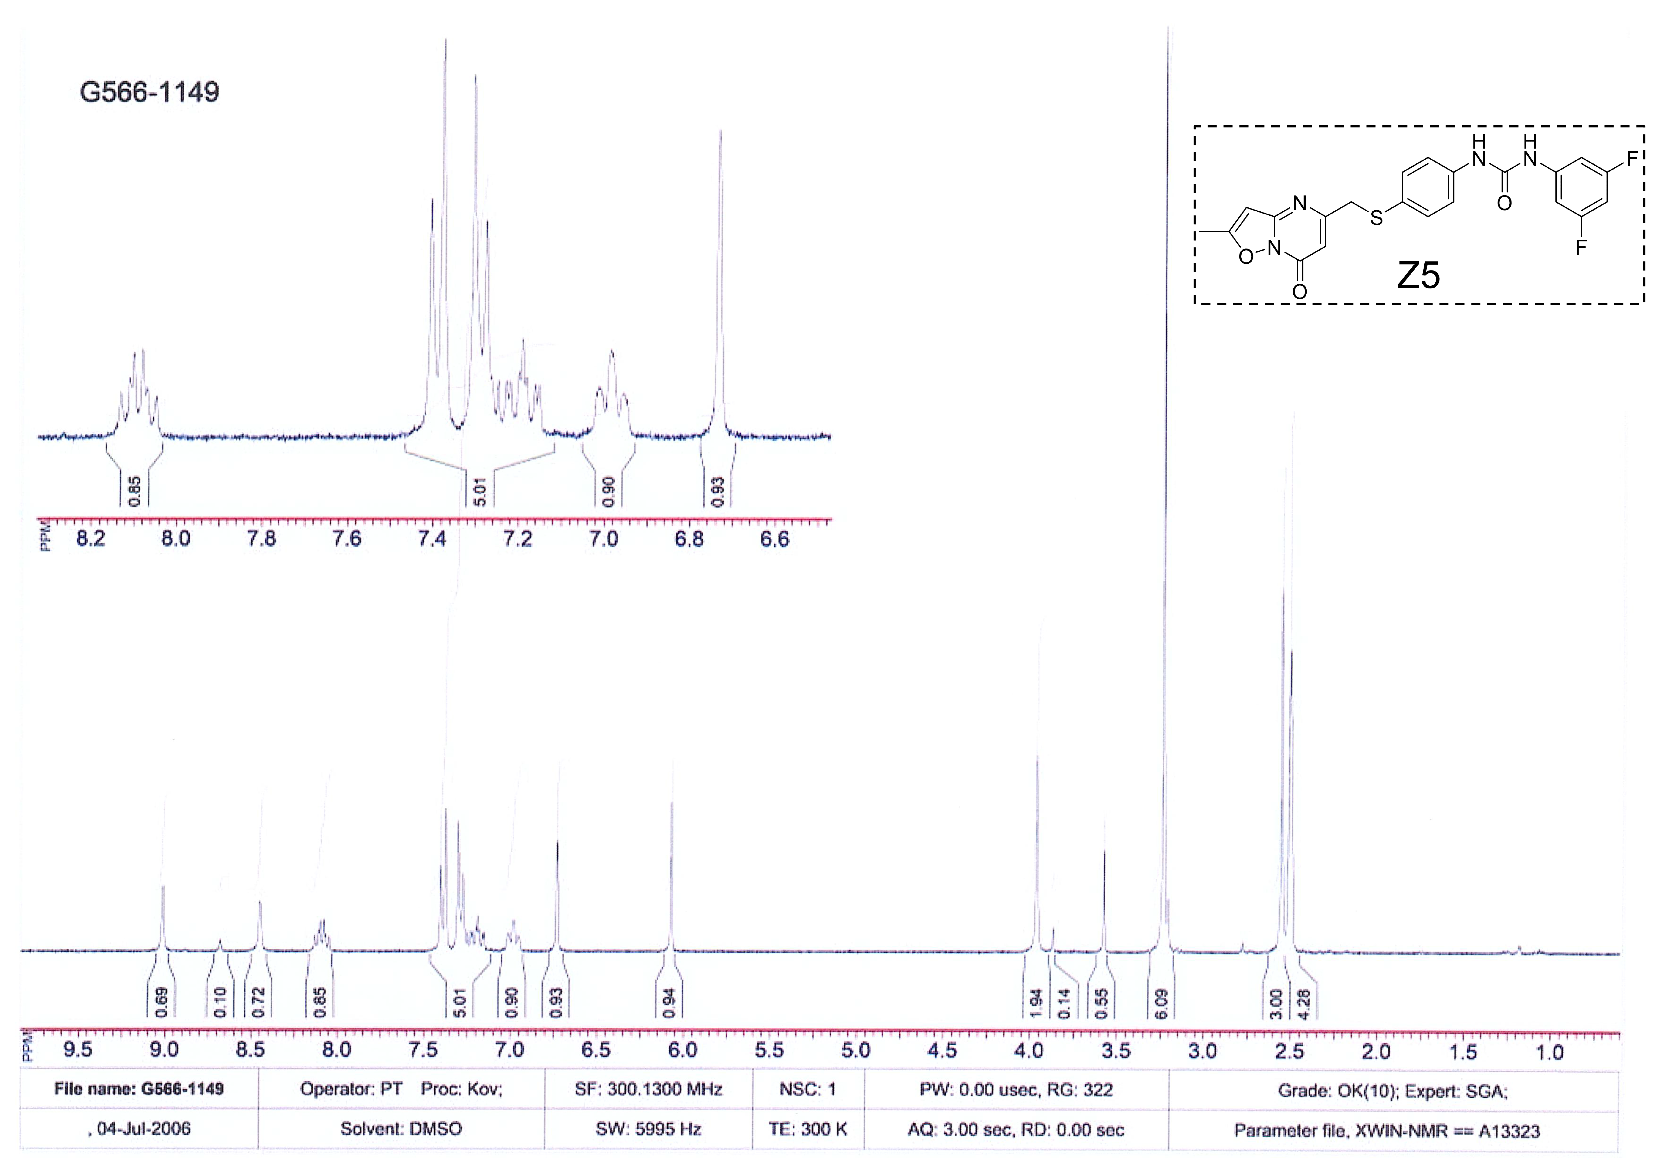

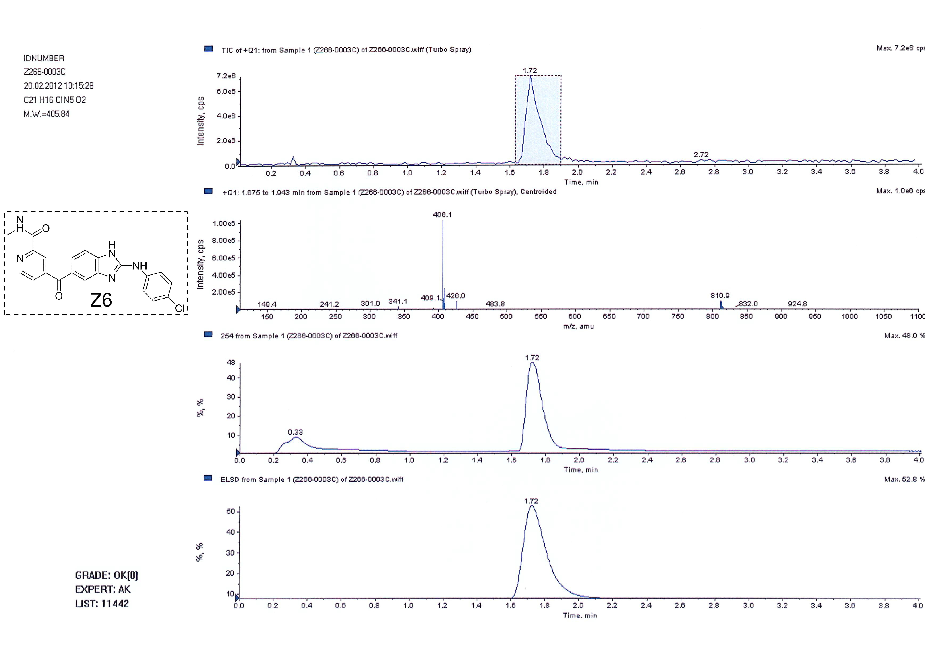
References
[1] Pushpakom S, Iorio F, Eyers PA, Escott KJ, Hopper S, Wells A, et al. Drug repurposing: progress, challenges and recommendations. Nat Rev Drug Discov. 2019;18(1):41-58.
[2] Zeidan MA, Mostafa AS, Gomaa RM, Abou-Zeid LA, El-Mesery M, El-Sayed MA, et al. Design, synthesis and docking study of novel picolinamide derivatives as anticancer agents and VEGFR-2 inhibitors. Eur J Med Chem. 2019;168:315-29.

