Additional file 1
Supplementary Figures
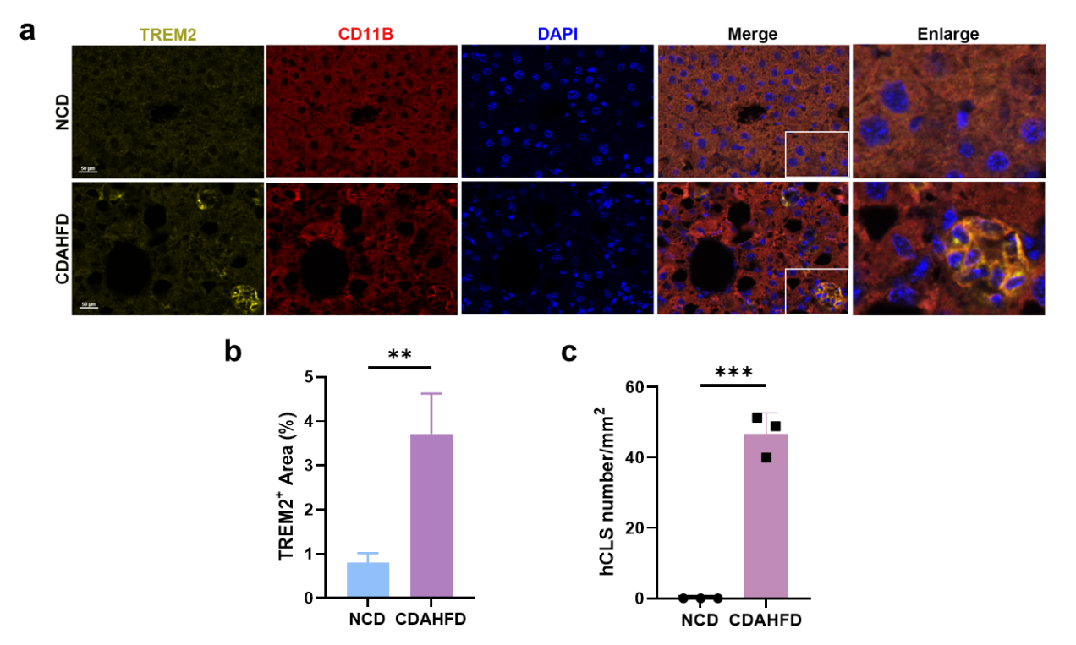
Figure S1. The proportion of TREM2 positive macrophages is associated with MASH severity. (a) Representative immunofluorescence images of TREM2 and CD11B in liver of CDAHFD-fed mice compared to NCD-fed mice (200× magnification). (b) Quantification of the relative TREM2⁺ area. (c) Quantification of hCLS numbers in MASH mice compared to control. Data are presented as mean ± SD. *P < 0.05, **P < 0.01, and ***P < 0.001 between groups.

Figure S2. Excess cholesterol accumulation is associated with M1-polarization in human THP-1 macrophages. (a-b) THP-1 cells were stimulated with 10 ng/ml PMA for 24 h, followed by PMA removal for 72 h to generate M0 macrophages. Cells were then treated with 20, 50, or 100 ug/mL ox-LDL for 24 h, and the relative mRNA levels of Cd86, Tnfa and Il1b were measured (n = 4). (c) Schematic of THP-1 cells differentiation. After generating the M0 state, which were then exposed to a combination of 10 ng/mL LPS and 20 ng/ml IFN-γ for 24h to induce M1 polarization. (d) Relative mRNA levels of Cd80, Cd86, Ccl2, Ccr7, Il1b, Il6 and Tnfa in cells (n = 4). (e) Inflammatory cytokine secretion of IL-1β, IL-6 and TNF-α (n = 4). (f) Representative immunofluorescence images of CD86 in THP-1 macrophages (magnification, 200×). (g) intracellular TC in THP-1 macrophages (n = 6). (h) THP-1 cells were treated with simvastatin (2.5 or 5 μM) in M1-polarized macrophages for 24 h, and the relative mRNA levels of Cd80, Cd86, Ccl2, Ccr7, Tnf-α and Il-6 were measured (n = 4). All data are presented as the mean ± SD. *P < 0.05, **P < 0.01, ***P < 0.001, and ****P < 0.0001 between groups.

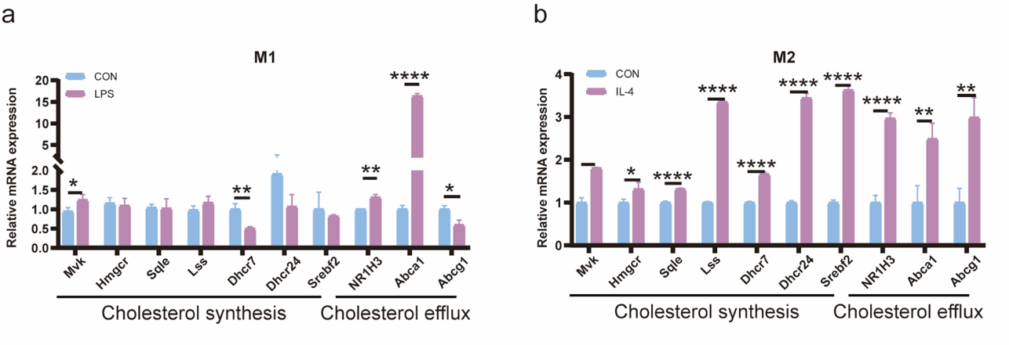
Figure S3. DHCR7 is strongly correlated with macrophage polarization in RAW264.7 cells. RAW264.7 macrophages were treated with LPS (100 ng/mL) or IL-4 (20 ng/mL) for 24 h. (a-b) Relative mRNA levels of Mvk, Hmgcr, Sqle, Lss, Dhcr7, Dhcr24, Srebf2, Insig1, Insig2, NRIH3, Abca1 and Abcg1 in LPS or IL-4 treated RAW264.7 (n = 4). All data are presented as the mean ± SD. *P < 0.05, **P < 0.01, ***P < 0.001, and ****P < 0.0001 between groups.

Figure S4. DHCR7 is strongly correlated with macrophage polarization in THP-1 macrophages.
THP-1 macrophages were treated with a combination of LPS (10 ng/mL) and IFN-γ (20 ng/ml), or IL-4 (20 ng/mL) for 24 h. (a-b) Relative mRNA levels of Mvk, Hmgcr, Sqle, Lss, Dhcr7, Dhcr24, Srebf2, Insig1, Insig2, NRIH3, Abca1 and Abcg1 in LPS+ IFN-γ or IL-4 treated THP-1 macrophages (n = 4). (c-d) Relative protein levels of DHCR7 in M1-polarized THP-1 (n = 3). (e) Representative images of immunofluorescence staining of DHCR7 in M1-polarized THP-1 (magnification, 200×). All data are presented as the mean ± SD. *P < 0.05, **P < 0.01, ***P < 0.001, and ****P < 0.0001 between groups.
Figure S5. DHCR7 inhibitor regulates the polarization of THP-1 macrophages. THP-1 macrophages were treated with 2.5, 5 or 10 μM AY9944 for 24 h. (a-b) Relative protein levels of DHCR7 (n = 2) and (c) the relative mRNA levels of Cd86, Cd80, Ccl2, Ccr7, Tnfα and Il1b in THP-1 macrophages (n = 4). (d) Representative images of immunofluorescence staining of CD86 in THP-1 macrophages (magnification, 200×). (e-h) Relative protein levels of CD86, CD206 and ARG-1 in THP-1 macrophages (n = 2). All data are presented as the mean ± SD. *P < 0.05, **P < 0.01, ***P < 0.001, and ****P < 0.0001 between groups.

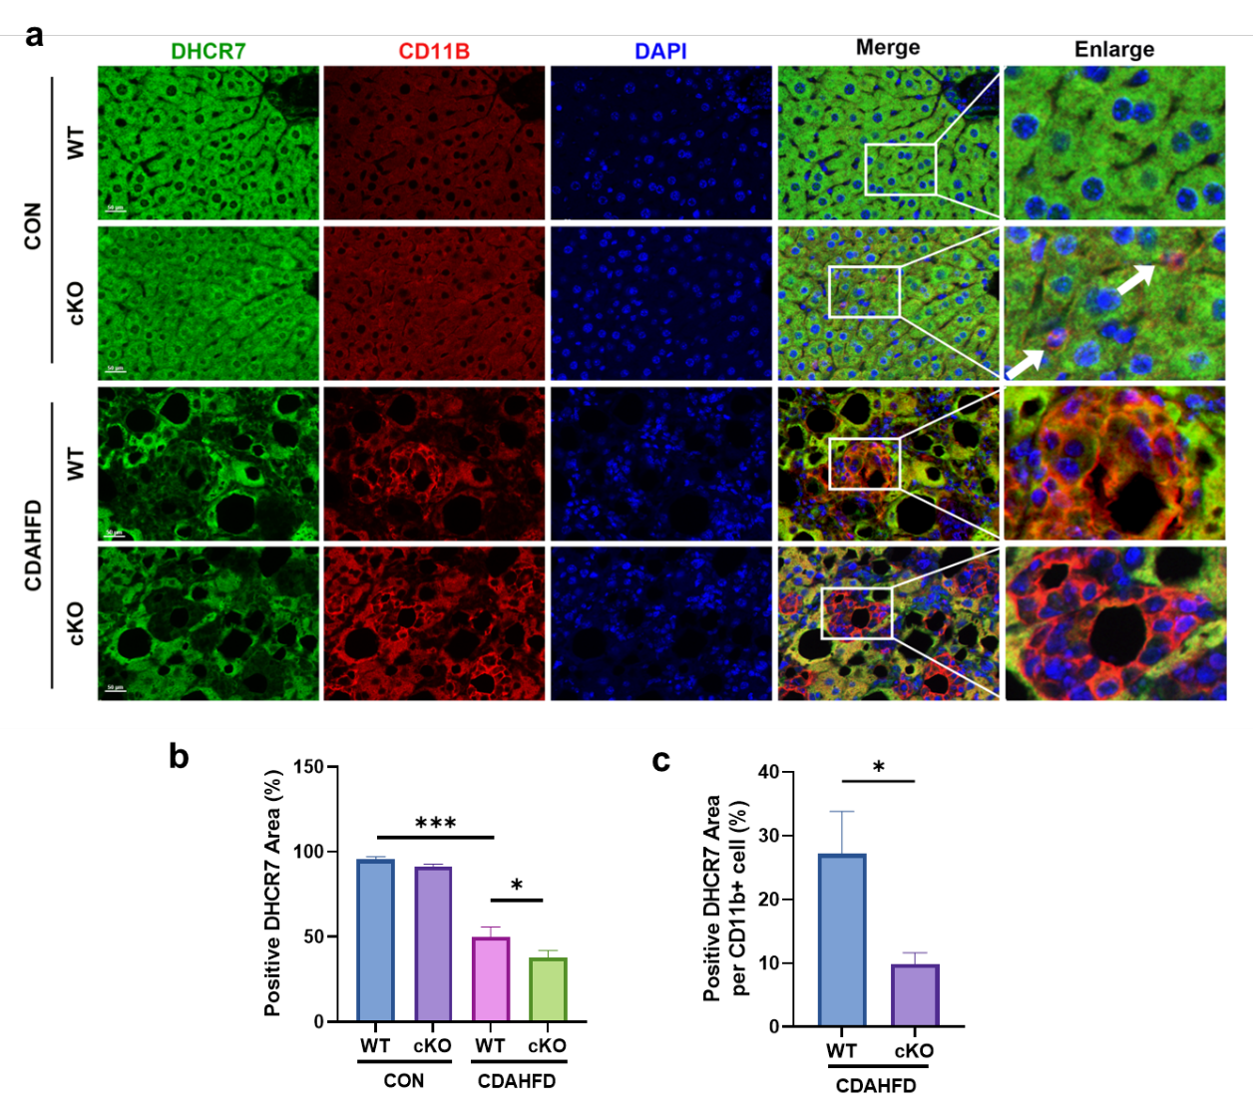
Figure S6. Validation of myeloid-specific DHCR7 knockout efficiency. (a) Multiplex immunofluorescences of liver sections from NCD- and CDAHFD-fed WT and DHCR7 cKO mice stained for DHCR7 (green) and macrophage marker CD11B (red) at 400× magnification. (b) Quantification of the DHCR7-positive area. (c) Proportion of DHCR7⁺ cells among total CD11B⁺ cells. All data are presented as the mean ± SD. *P < 0.05, and ***P < 0.001 between groups.

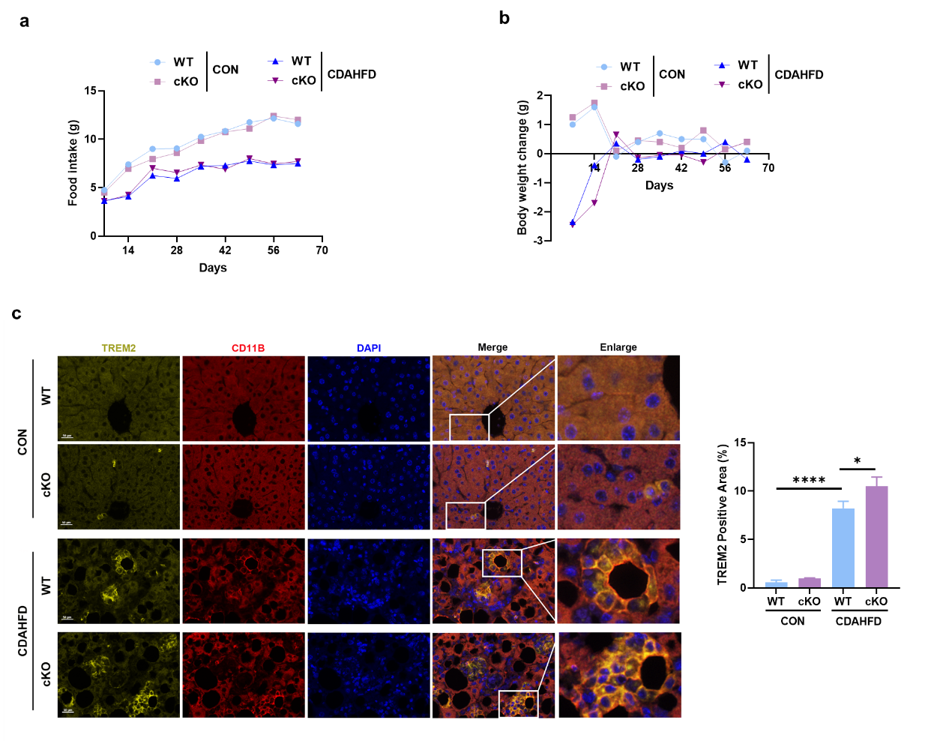
Figure S7. Analysis of food intake, body weight, and TREM2-positive macrophage expression in DHCR7 cKO and WT mice. (a) Weekly Food intake. (b) Body weight changes. (c) Representative immunofluorescence images for TREM2 (green) and CD11B (red) at 400× magnification. Quantification of the relative TREM2⁺ area is shown in the bar graph on the right. All data are presented as the mean ± SD. *P < 0.05, and ****P < 0.0001 between groups.

Supplementary Tables
Table S1. Primers used for RT-qPCR
Gene | Forward primer (5’-3’) | Reverse primer (5’-3’)
Mouse
Hmgcr | TTGGGTCTGGACGAAGATGTG | GCTAAACTCAGGGTAATCACTTGC
Mvk | CTGAAGTCAATCAACAAGTGGG | CTCTTCAAGGAAGACATCGTCC
Sqle | GCTATGGCAGAGCCCAATG | GAGTCCATCCGCAACAACG
Lss | TATTTCACGGACTTACCAAAAGC | GACCTGGCAAGAGGAAGAGC
Dhcr7 | CCAAGAAGGTGCCATTACTCC | GGTAAGCGTTCACAAACCAGAG
Dhcr24 | CATCCCTTTCGGCAACAAC | GGTATGCAGGGCCTGTGAC
NR1H3 | CCAAAATGCTGGGGAACG | GCGTGCTCCCTTGATGACA
Abcg1 | GAACTGCCCTACCTACCACAAC | AAACGGGTTCACATCGGTG
Srebf2 | AGTCTGGTGGACAGTGATGTGG | CGGCTCAGAGTCAATGGAATAG
Msr1 | GCAGTTAAATTCCTTGATTTCGTC | TCCTCCTGTTGCTTTGCTGTAG
GAPDH | TGTTCCTACCCCCAATGTGTC | TGAAGTCGCAGGAGACAACC
Tnfa | CCCTCCAGAAAAGACACCATG | CACCCCGAAGTTCAGTAGACAG
Il1b | GCTTCAGGCAGGCAGTATCA | TGCAGTTGTCTAATGGGAACG
Il6 | AAATGATGGATGCTACCAAACTG | CTCTGGCTTTGTCTTTCTTGTTATC
Cd32 | TGCAAAGGAAGTCTAGGAAGGAC | GGATAATAACAATGGCTGCGAC
Cd16 | CAACCCTGGGAACTCTTCTACTC | CATTTGACACCGATATTCTCCAC
Inos | AGACCTCAACAGAGCCCTCA | GCAGCCTCTTGTCTTTGACC
Mrc1 | AACAAAGGGACGTTTCGGTG | AGTCACTCCTTCTGCCCAATG
Human
Hmgcr | TTCTTGCCAACTACTTCGTGTT | GCTGCCAAATTGGACGACC
Mvk | TGGACCTCAGCTTACCCAACA | GACTGAAGCCTGGCCACATC
Sqle | GATGATGCAGCTATTTTCGAGGC | CCTGAGCAAGGATATTCACGACA
Lss | ATATGCGCTCCTCAACCTGT | GATGCTGATGCTCTTGGTGA
Dhcr7 | CGCAGGACTTTAGCCGGT | TGTCATTGGTGACGCCATCT
Dhcr24 | TGAAGACAAACCGAGAGGGC | CAGCCAAAGAGGTAGCGGAA
NR1H3 | TGTTCCCACGGATGCTAATG | CCTTCTCAGTCTGTTCCACTTC
Abcg1 | CATTGGCCTGCTGTACTT | CGAAGAAAGACTCCCATCTC
Abca1 | CTGCAATCTCGGCACTTT | GTCCAGCTTCTCTACCTAGTAA
Srebf2 | CAGCAGCCTTTGATATACCAGAATG | AGGATGTCACCAGGCTTTGGAC
Insig1 | CCTTTGGTGGACATTTGATCGT | GCGTAGCTAGAAAAGCTATGGTGAT
Insig2 | TAATGCGGTGTGTAGCAGTCT | GTCCAATGGATAGTGCAGCCA
Tnfa | CACGCTCTTCTGCCTGCTG | GGCTTGTCACTCGGGGTTC
Il1b | AAATGATGGCTTATTACAGTGGC | CTTGCTGTAGTGGTGGTCGG
Il6 | AAAGCAGCAAAGAGGCACTG | TACCTCAAACTCCAAAAGACCAG
Ccr7 | CGATACCTACCTGCTCAACCTG | TGCAAAAGTGGACACCGAAG
Ccl2 | CCTTCTGTGCCTGCTGCTC | GCTTCTTTGGGACACTTGCTG
Inos | GGGACCCGCACCACTACA | AGATTCTGCCGAGATTTGAGC
Cd80 | CAGCAAACTGGATTTCAATATGAC | TATCAGGAAAATGCTCTTGCTTG
Cd86 | ATTCGGACAGTTGGACCCTG | GGTTGACTGAAGTTAGCAAGCAC
GAPDH | ATCCCATCACCATCTTCCAGG | GATGACCCTTTTGGCTCCC

Table S2. Serum biological data of the NC and MASH groups
Group | N | ALT, U/L  mean ± SD | AST, U/L  mean ± SD | TBIL, μmol/L  mean ± SD | DBIL, μmol/L  mean ± SD
NC | 3 | 17.63 ± 2.99 | 11.47 ± 2.12 | 12.53 ± 1.70 | 3.3 ± 0.96
MASH | 3 | 75.87 ± 35.20 | 95.3 ± 50.07 | 13.12 ± 4.29 | 2.3 ± 0.66

