Table S1 RNA sequence used in this study
RNA | sequence（5’-3’）
Scramble | CUGCGUUACACGACUCUAGC
miR-210-3p KD | UCAGCCGCUGUCACACGCAC
mimic-NC | ACUACUGAGUGACAGUAGA
miR-210-3p mimic | AGCCGCUGUCACACGCACAGUU

Table S2 Primer sequences used in this study
gene | sequence（5’-3’）
miR-210-3p primer | AGCCCCTGCCCACCG
B4GALT5 forward primer | GATGAACTGTGATCTGCCGTGGTC
B4GALT5 reverse primer | GTGGGTTTGCCTCTGCTCTGAAG
DENND6A forward primer | CAATCTCGGCTGACTGCAACCTC
DENND6A reverse primer | CGTGGTGGCACATACCTGTAATCC
NFIX forward primer | CTGCCTGTGCTTGCTGGAGTC
NFIX reverse primer | TGGTGGTGGTGGTAGCGGATG

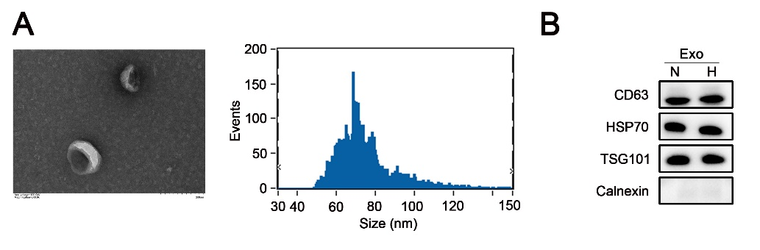
Figure S1 Identifying exosomes secreted from BMSCs. (A) Identification of exosomes derived from BMSCs cells by TEM and NTA analysis. (B) Levels of typical biomarkers for exosomes (CD63, CD81, HSP70 and calnexin) identified by western blot.

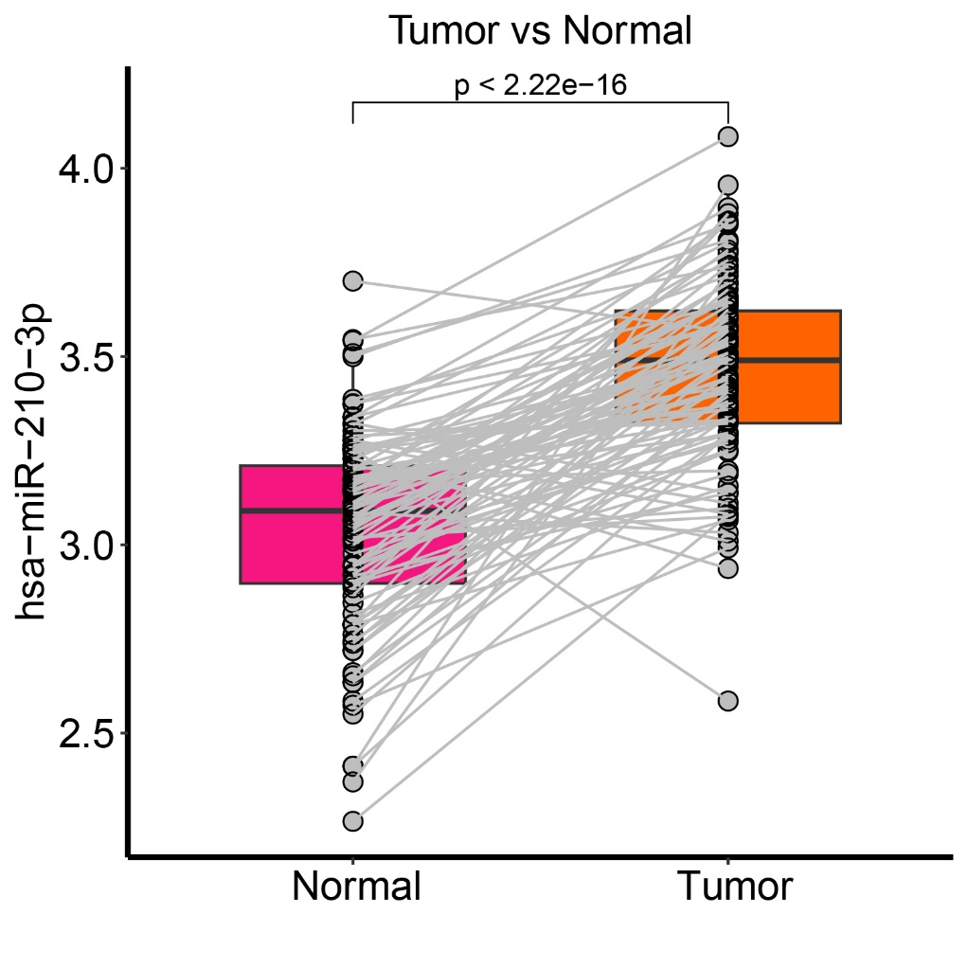
Figure S2 The expression of miR-210-3p in 102 paired samples of breast cancer.

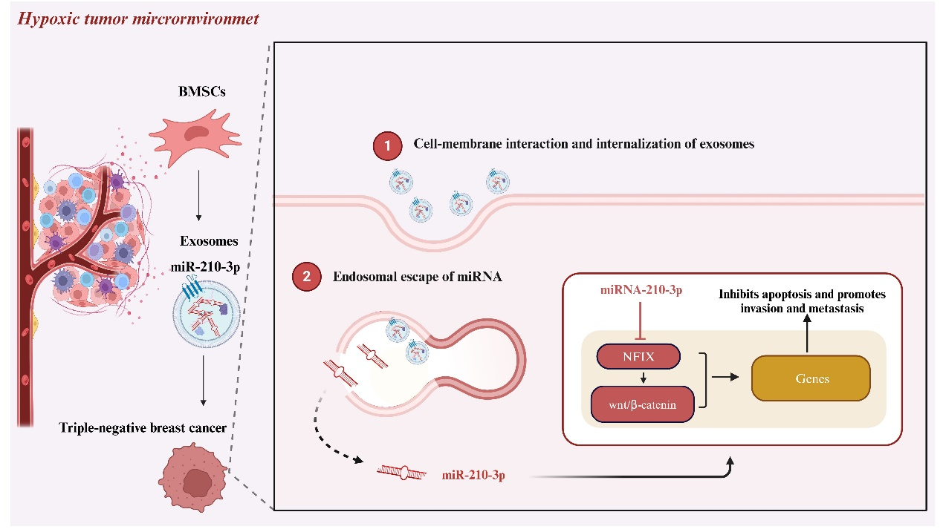
Figure S3 Hypoxic BMSC-derived exosomal miR-210-3p promotes progression of TNBC via NFIX-Wnt/β-catenin signaling axis

