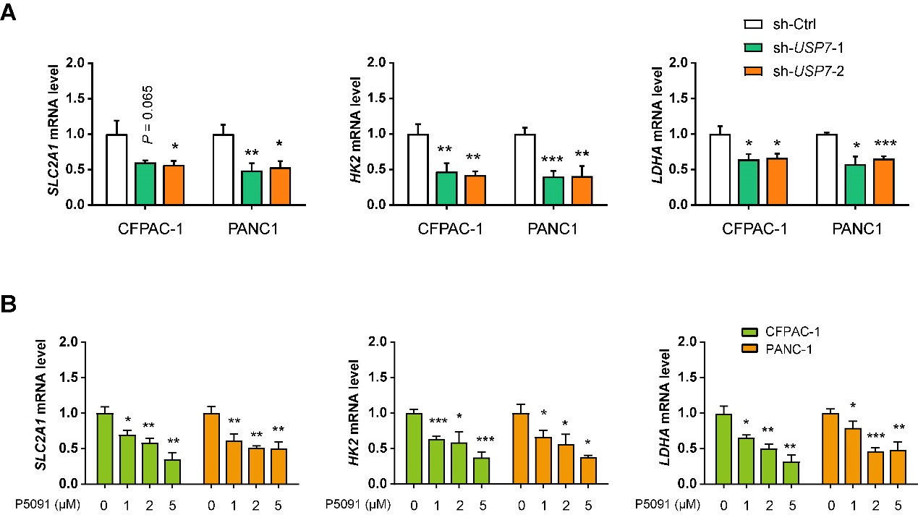
Fig. S1. USP7 knockdown or inhibition reduces the expression of glycolytic genes in PDAC cells.
(A) Real-time qPCR showed the expression of SLC2A1, HK2, and LDHA in sh-Ctrl and sh-USP7 CFPAC-1 and PANC1 cells (n = 3 per group).
(B) Real-time qPCR showed the expression of SLC2A1, HK2, and LDHA in PDAC cells following USP7 inhibition (n = 3 per group).
Values were compared by one-way ANOVA multiple comparisons with Tukey’s method among groups. *P < 0.05, **P < 0.01, ***P < 0.001.
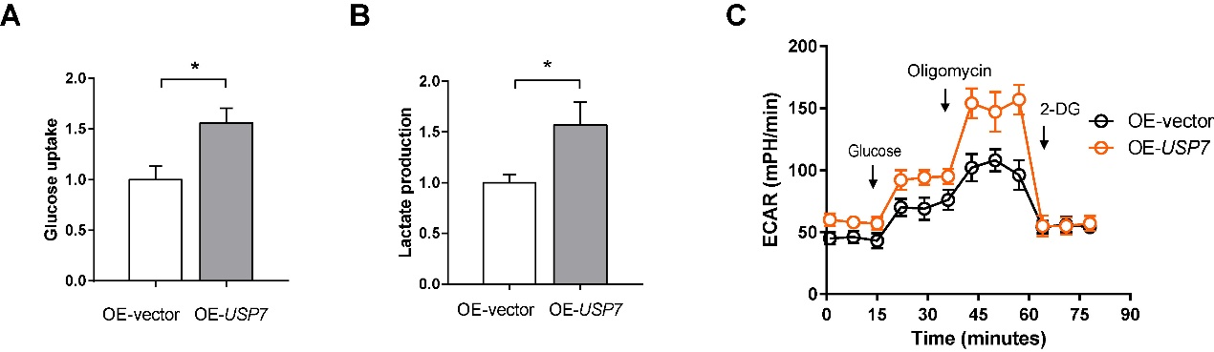
Fig. S2. USP7 overexpression promotes PDAC cell glycolysis.
(A-B) The effects of USP7 overexpression on the glucose uptake and lactate production in AsPC1 cells (n = 3 per group).
(C) Seahorse experiment showed the effect of USP7 overexpression on extracellular acidification rate (ECAR) of AsPC1 cells. ΔECAR represents the difference between the ECAR values induced by oligomycin and 2-DG (n = 3 per group).
Values were compared by the Student’s t test. *P < 0.05.

