Table 1S - Classification of Sports Activities by Category

Endurance Sports | Skill Sports | Strength Training | Team Sports
Acquagym | Boxing | Calisthenics | Acrobatic Dance
Cycling | Capoeira | Functional Bodybuilding | Basketball
Elliptical Bike | Golf | Home Work Out | Handball
Hydrobike | Gymnastics | Pilates | Hockey
Rowing | Horse Riding | Powerlifting | Rugby
Running | Martial arts | Pump | Soccer
Spinning | Padel | Weightlifting | Volleyball
Step | Ping Pong |  | Waterpolo
Total Body | Pole Dance
Treadmill | Skating
Trekking | Tai Qui
Walking | Tennis
 | Yoga
Table shows the classification of sports activities into groups: Endurance Sports, Skill Sports, Strength Training, and Team Sports.

Table 2S - Summary of the main characteristics of PCA groups
Key Questions | Balanced Eaters | Home-Cooked Focused | Routine Eaters | Restaurant Lovers | Varied Eaters
How many times do you eat per day? | Regularly 3-4 meals | 3 meals, one snack | 3 regular meals, limited snacks | 3 meals, sometimes 4 | Variable, 3-5 meals
Do you ever skip meals? | Rarely | Rarely | No | Sometimes, due to work | Frequently, but they make up with snacks
Do you eat quickly? | No, they eat slowly | No, they eat slowly | Sometimes, depending on the time | Yes, they often eat quickly | Variable, depending on the situation
Do you cook during the weekend? | Yes, they cook elaborate meals | Yes, they love to cook on weekends | Yes, but maintain a similar routine to the rest of the week | They prefer to eat out | Yes, but it varies depending on time
How often do you cook at home? | Frequently | Almost always | Regularly, especially breakfast and dinner | Rarely, they prefer to eat out | Variable, sometimes they cook, other times they don't
What do you do on weekends? | Cook and eat at home | Cook more elaborate dishes | Maintain my routine, with some variation | Eat out, mostly in restaurants | Variable, depending on plans
Do you eat alone or with company? | With company | With company | Often with company, but sometimes alone | Usually alone or with friends out | Variable, depending on mood
Do you follow a daily eating routine? | Yes, a well-defined routine | Yes, with home-cooked meals | Absolutely, with few changes | No, very flexible | No, varies often
How often do you snack? | Rarely, they prefer full meals | Occasionally | Limited, one per day | Frequently, especially between main meals | Very frequently, snacks between every meal
Are you hungry in the morning? | Yes, important breakfast | Yes, but light | Yes, regular | Sometimes skip breakfast | Variable, depending on the day
How often do you eat out? | Rarely, they prefer meals at home | Rarely | Sometimes, but maintain a routine | Very often, especially in restaurants | Variable, depending on the situation
Do you prefer to eat out or at home? | At home, preferably | At home, they love cooking | At home, but don't exclude dining out | Out, especially in restaurants | Variable, depending on the context
How often do you change your eating habits? | Little, stable routine | Little, follow a routine | Little, maintain the same routine | A lot, changes frequently | A lot, changes often
Do you eat at night? | No | No | No | Sometimes | Sometimes, but not regularly

Summary of key dietary behaviors for participants categorized into five distinct groups based on Principal Component Analysis (PCA): Balanced Eaters, Home-Cooked Focused, Routine Eaters, Restaurant Lovers, and Varied Eaters. The table highlights the typical responses of each group to various dietary behavior questions, illustrating differences in meal frequency, cooking habits, and eating routines.

Table 3S - Gender differences in dietary preferences across five Principal Component Analysis (PCA) groups.

Food Category | PCA 1 (M %) | PCA 1 (F %) | PCA 1 p-value | PCA 2 (M %) | PCA 2 (F %) | PCA 2 p-value | PCA 3 (M %) | PCA 3 (F %) | PCA 3 p-value | PCA 4 (M %) | PCA 4 (F %) | PCA 4 p-value | PCA 5 (M %) | PCA 5 (F %) | PCA 5 p-value
Low-fat white yogurt | 54.1 | 55.6 | 0.7233 | 60.8 | 55.5 | 0.3129 | 60.1 | 58.0 | 0.6505 | 57.1 | 54.6 | 0.5919 | 61.0 | 59.2 | 0.6397
Fresh cheeses | 86.4 | 84.6 | 0.5655 | 78.5 | 85.2 | 0.1041 | 86.0 | 81.3 | 0.1803 | 84.8 | 83.2 | 0.6371 | 84.2 | 87.5 | 0.2369
Meat | 89.1 | 84.0 | 0.0814 | 89.9 | 88.5 | 0.6784 | 91.7 | 84.0 | 0.0119 | 92.7 | 80.3 | <0.0001 | 90.0 | 80.6 | 0.0008
Red Meat | 93.2 | 85.8 | 0.0040 | 89.9 | 86.6 | 0.3328 | 94.8 | 87.2 | 0.0038 | 90.6 | 84.9 | 0.0540 | 92.3 | 86.2 | 0.0129
Processed Meat (es prosciutto) | 91.8 | 84.9 | 0.0105 | 89.9 | 83.3 | 0.0620 | 92.7 | 83.3 | 0.0016 | 91.6 | 84.2 | 0.0110 | 89.2 | 85.7 | 0.1848
Fish | 85.5 | 82.8 | 0.4063 | 84.8 | 85.6 | 0.8241 | 82.4 | 84.8 | 0.4918 | 86.4 | 82.6 | 0.2486 | 85.7 | 80.6 | 0.0892
Eggs | 87.3 | 84.9 | 0.4283 | 87.3 | 82.8 | 0.2214 | 89.6 | 86.8 | 0.3483 | 91.1 | 85.9 | 0.0690 | 89.6 | 85.1 | 0.0942
Legumes | 88.2 | 84.9 | 0.2642 | 88.6 | 87.6 | 0.7592 | 83.4 | 86.0 | 0.4564 | 89.0 | 88.2 | 0.7727 | 88.0 | 83.8 | 0.1294
Cooked vegetables | 85.5 | 94.4 | 0.0010 | 82.3 | 92.3 | 0.0051 | 87.6 | 93.8 | 0.0283 | 86.9 | 93.8 | 0.0157 | 86.1 | 94.7 | 0.0005
Raw vegetables | 67.7 | 69.8 | 0.6033 | 68.4 | 64.6 | 0.4504 | 56.5 | 66.9 | 0.0246 | 55.0 | 69.1 | 0.0018 | 64.1 | 71.6 | 0.0473
Fruits | 89.5 | 89.6 | 0.9701 | 89.9 | 87.6 | 0.4866 | 88.1 | 87.9 | 0.9627 | 87.4 | 90.1 | 0.3616 | 91.5 | 89.9 | 0.4963
Cereals (eg spelled. barley) | 81.4 | 87.9 | 0.0411 | 85.4 | 84.2 | 0.7448 | 79.3 | 84.0 | 0.1996 | 84.3 | 84.9 | 0.8637 | 78.8 | 84.1 | 0.0938
Whole grains food | 72.3 | 82.8 | 0.0041 | 81.0 | 81.8 | 0.8450 | 72.5 | 79.0 | 0.1170 | 69.1 | 82.2 | 0.0012 | 72.2 | 84.9 | 0.0002
Nuts | 87.3 | 86.7 | 0.8407 | 86.7 | 89.0 | 0.5106 | 82.9 | 87.2 | 0.2150 | 84.8 | 85.2 | 0.9084 | 87.3 | 87.8 | 0.8402
Tofu | 19.5 | 20.7 | 0.7374 | 20.9 | 22.0 | 0.7956 | 17.6 | 17.1 | 0.8911 | 19.4 | 20.7 | 0.7145 | 20.8 | 22.5 | 0.6097

The table presents the comparison of dietary preferences between male and female participants across five distinct PCA groups. For each food category, the percentage of “Yes” responses for both genders is reported, alongside the p-values indicating the significance of gender differences. Significant p-values (p < 0.05) are marked in bold to emphasize gender-specific patterns within each PCA group. This data provides insight into how dietary behaviors differ between genders in various eating habit clusters. P-values reflect the significance of gender differences within each PCA group, with significant differences (p < 0.05) highlighted in bold.

Figure 1S - Gender differences in food preference

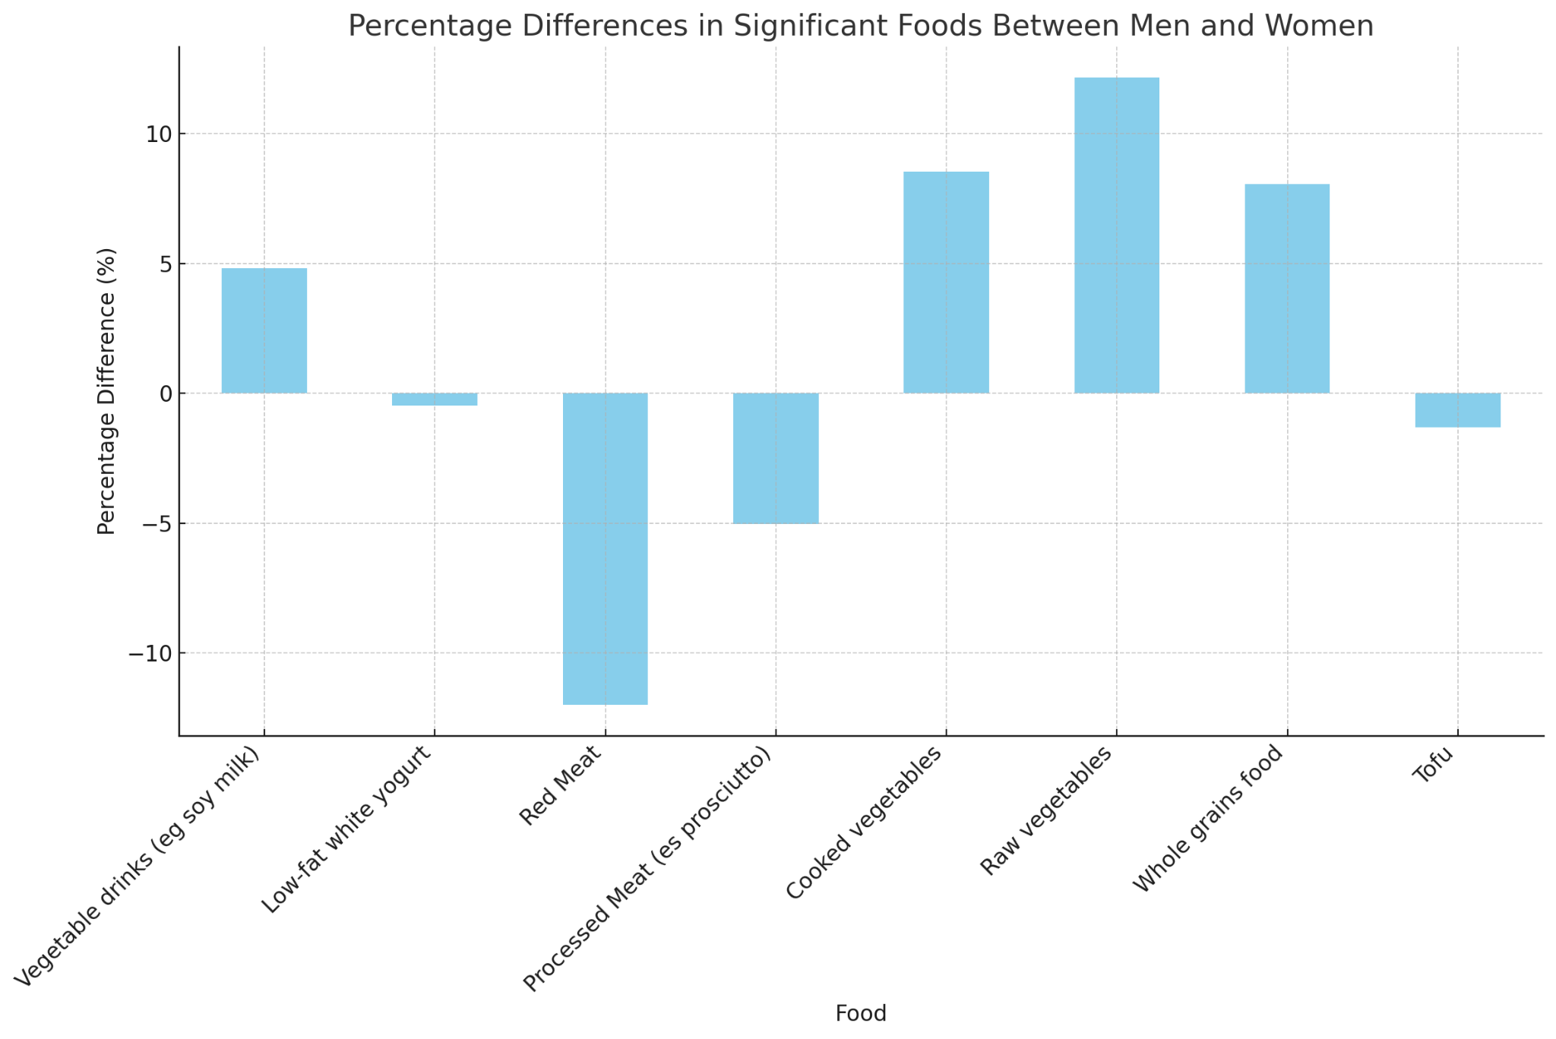

Significant percentage differences in food consumption between men and women. Foods included Vegetable drinks (eg soy milk), Low-fat white yoghurt, Red Meat, Processed Meat (eg ham), Cooked vegetables, Raw vegetables, Whole grains food, and Tofu. The differences were tested with the chi-square test for each food, with the following p-values: Vegetable drinks (eg soy milk) (p = 0.0429), Low-fat white yoghurt (p = 0. 0281), Red Meat (p = 0.00000117), Processed Meat (eg ham) (p = 0.0313), Cooked vegetables (p = 0.00000383), Raw vegetables (p = 0.00000000309), Whole grains food (p = 0.00116), Tofu (p = 0.00275).

Table 4S - Gender Differences in Nighttime Eating Behavior and Sleep Quality

Gender | F | % | M | %

Nighttime eating
Never | 1709 | 86.6 | 1063 | 80.5
Rarely (once a month) | 157 | 8 | 159 | 12
Often (>1/week) | 85 | 4.3 | 79 | 6
Everyday | 23 | 1.2 | 20 | 1.5
Sleep quality answers
Good | 929 | 47 | 692 | 52.4
I struggle to fall asleep | 229 | 11.6 | 175 | 13.2
I wake up several times during the night | 640 | 32.4 | 326 | 24.7
I wake up a lot sooner than I would like | 176 | 8.9 | 128 | 9.7

Percentages of reported nighttime eating behavior and sleep quality by gender. Nighttime eating responses include “Everyday,” “Never,” “Often (>1/week),” and “Rarely (once a month).” Sleep quality responses include “Good,” “I struggle to fall asleep,” “I wake up a lot sooner than I would like,” “I wake up several times during the night,” “I’m having a hard time falling asleep,” and “Well.”

Table 5S - Nighttime Eating Behavior and Sleep Quality by PCA Group

PCA | 1 | 2 | 3 | 4 | 5

Nighttime eating
Never | 78,67 | 80,65 | 81,11 | 82,83 | 82,70
Rarely (once a month) | 12,54 | 11,17 | 11,33 | 10,51 | 11,01
Often (>1/week) | 7,17 | 6,27 | 5,78 | 5,25 | 4,72
Everyday | 1,61 | 1,91 | 1,78 | 1,41 | 1,57
Sleep quality answers
Good | 50,00 | 52,04 | 52,44 | 49,70 | 46,23
I struggle to fall asleep | 11,83 | 15,26 | 10,00 | 12,12 | 11,79
I wake up several times during the night | 28,85 | 23,43 | 28,00 | 30,71 | 32,23
I wake up a lot sooner than I would like | 9,32 | 9,26 | 9,56 | 7,47 | 9,75

Percentages of nighttime eating behavior and reported sleep quality by PCA group. Nighttime eating responses include “Never,” “Rarely (once a month),” “Often (>1/week),” and “Everyday.” Sleep quality responses include “Good,” “I struggle to fall asleep,” “I wake up several times during the night,” and “I wake up a lot sooner than I would like.”

