CryoSCAPE: Scalable Immune Profiling Using Cryopreserved Whole Blood for Multi-omic Single Cell and Functional Assays

Alexander T. Heubeck*, Cole Phalen, Neel Kaul, Peter Wittig, Jessica Garber, Morgan Weiss, Palak Genge, Zach Thomson, Claire Gustafson, Julian Reading & Peter J. Skene*

Correspondence:
peter.skene@alleninstitute.org
alex.heubeck@alleninstitute.org

Supplementary Material
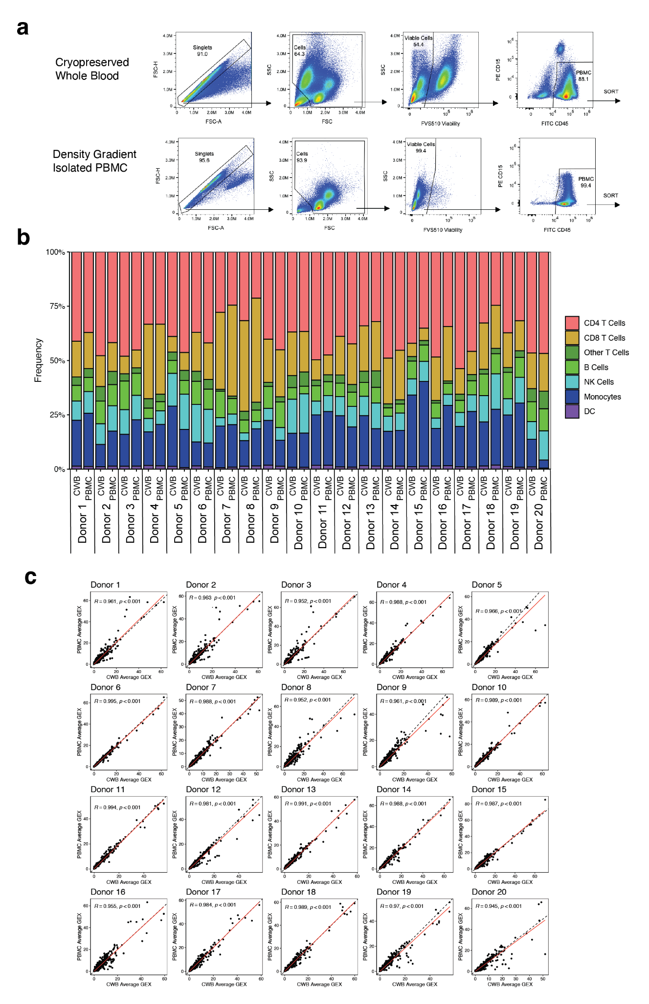
Supplement Figure 1: Comparison of Cell Recovery, Viability, Cell Type Frequencies, and Gene Expression Between Cryopreserved Whole Blood and Density Gradient Isolated PBMC Methods. a. Cell counts per mL of whole blood recovered in cryopreserved whole blood and density gradient isolated PBMC methods. Cells stained with acridine orange and propidium iodide (AOPI) and counted on Cellaca MX cell counter after thawing and processing. b. Viability of cells recovered in cryopreserved whole blood and density gradient isolated PBMC methods. c. Cell type frequencies for matched cryopreserved whole blood and density gradient isolated PBMC samples. d. Gene expression correlation plots matched cryopreserved whole blood and density gradient isolated PBMC samples.

Supplement Table 1: Differentially expressed genes between cryopreserved whole blood and density gradient isolated PBMCs
Upregulated Condition | Gene | Log2 Fold Change | P Value | P Value Adjusted
Upregulated in Cryopreserved Whole Blood | TTC30A | -2.37 | 1.56E-143 | 2.37E-139
Upregulated in Cryopreserved Whole Blood | TTC30B | -2.03 | 8.71E-74 | 4.40E-70
Upregulated in Cryopreserved Whole Blood | CCDC87 | -2.36 | 8.54E-30 | 1.18E-26
Upregulated in Cryopreserved Whole Blood | GPX6 | -3.23 | 7.32E-07 | 2.47E-05
Upregulated in Cryopreserved Whole Blood | APOBEC4 | -2.28 | 3.49E-05 | 5.63E-04
Upregulated in Cryopreserved Whole Blood | MORN5 | -2.42 | 1.84E-04 | 2.05E-03
Upregulated in Cryopreserved Whole Blood | CT55 | -2.05 | 3.45E-04 | 3.34E-03
Upregulated in Density Gradient Isolated PBMC | PRKCG | 3.20 | 2.16E-19 | 1.56E-16
Upregulated in Density Gradient Isolated PBMC | OLR1 | 3.88 | 5.29E-18 | 2.67E-15
Upregulated in Density Gradient Isolated PBMC | FAM71A | 2.65 | 3.50E-17 | 1.47E-14
Upregulated in Density Gradient Isolated PBMC | NR4A3 | 2.49 | 2.62E-14 | 6.96E-12
Upregulated in Density Gradient Isolated PBMC | LIF | 2.40 | 5.42E-14 | 1.42E-11
Upregulated in Density Gradient Isolated PBMC | HBB | 4.27 | 2.56E-12 | 4.84E-10
Upregulated in Density Gradient Isolated PBMC | SMIM41 | 2.12 | 4.78E-12 | 8.52E-10
Upregulated in Density Gradient Isolated PBMC | HDC | 2.08 | 7.10E-12 | 1.24E-09
Upregulated in Density Gradient Isolated PBMC | IL1A | 2.72 | 5.03E-11 | 7.47E-09
Upregulated in Density Gradient Isolated PBMC | STPG3 | 3.53 | 1.14E-10 | 1.49E-08
Upregulated in Density Gradient Isolated PBMC | SLC4A1 | 5.58 | 6.15E-10 | 6.54E-08
Upregulated in Density Gradient Isolated PBMC | ALAS2 | 5.55 | 6.28E-09 | 4.76E-07
Upregulated in Density Gradient Isolated PBMC | HBD | 3.68 | 8.10E-08 | 4.06E-06
Upregulated in Density Gradient Isolated PBMC | G0S2 | 2.28 | 1.76E-06 | 5.07E-05
Upregulated in Density Gradient Isolated PBMC | C6orf223 | 2.39 | 1.78E-06 | 5.08E-05
Upregulated in Density Gradient Isolated PBMC | HBA2 | 2.70 | 1.99E-06 | 5.57E-05
Upregulated in Density Gradient Isolated PBMC | LTF | 4.80 | 2.00E-06 | 5.58E-05
Upregulated in Density Gradient Isolated PBMC | CA1 | 4.24 | 1.95E-05 | 3.51E-04
Upregulated in Density Gradient Isolated PBMC | AHSP | 3.12 | 3.87E-05 | 6.11E-04
Upregulated in Density Gradient Isolated PBMC | HBM | 3.67 | 1.02E-04 | 1.29E-03
Upregulated in Density Gradient Isolated PBMC | PGLYRP1 | 3.06 | 1.69E-04 | 1.92E-03
Upregulated in Density Gradient Isolated PBMC | CXCL14 | 2.36 | 1.03E-03 | 7.86E-03
Upregulated in Density Gradient Isolated PBMC | DEFA3 | 3.37 | 1.10E-03 | 8.26E-03
Upregulated in Density Gradient Isolated PBMC | OLFM4 | 3.00 | 2.65E-03 | 1.63E-02
Upregulated in Density Gradient Isolated PBMC | CXCL6 | 2.09 | 2.80E-03 | 1.70E-02
Upregulated in Density Gradient Isolated PBMC | EPB42 | 2.78 | 3.49E-03 | 2.01E-02
Upregulated in Density Gradient Isolated PBMC | VGF | 2.16 | 3.89E-03 | 2.18E-02
Upregulated in Density Gradient Isolated PBMC | IFIT1B | 2.14 | 4.81E-03 | 2.56E-02
Upregulated in Density Gradient Isolated PBMC | CHST8 | 2.18 | 6.35E-03 | 3.17E-02
Upregulated in Density Gradient Isolated PBMC | GJB2 | 2.37 | 9.69E-03 | 4.35E-02

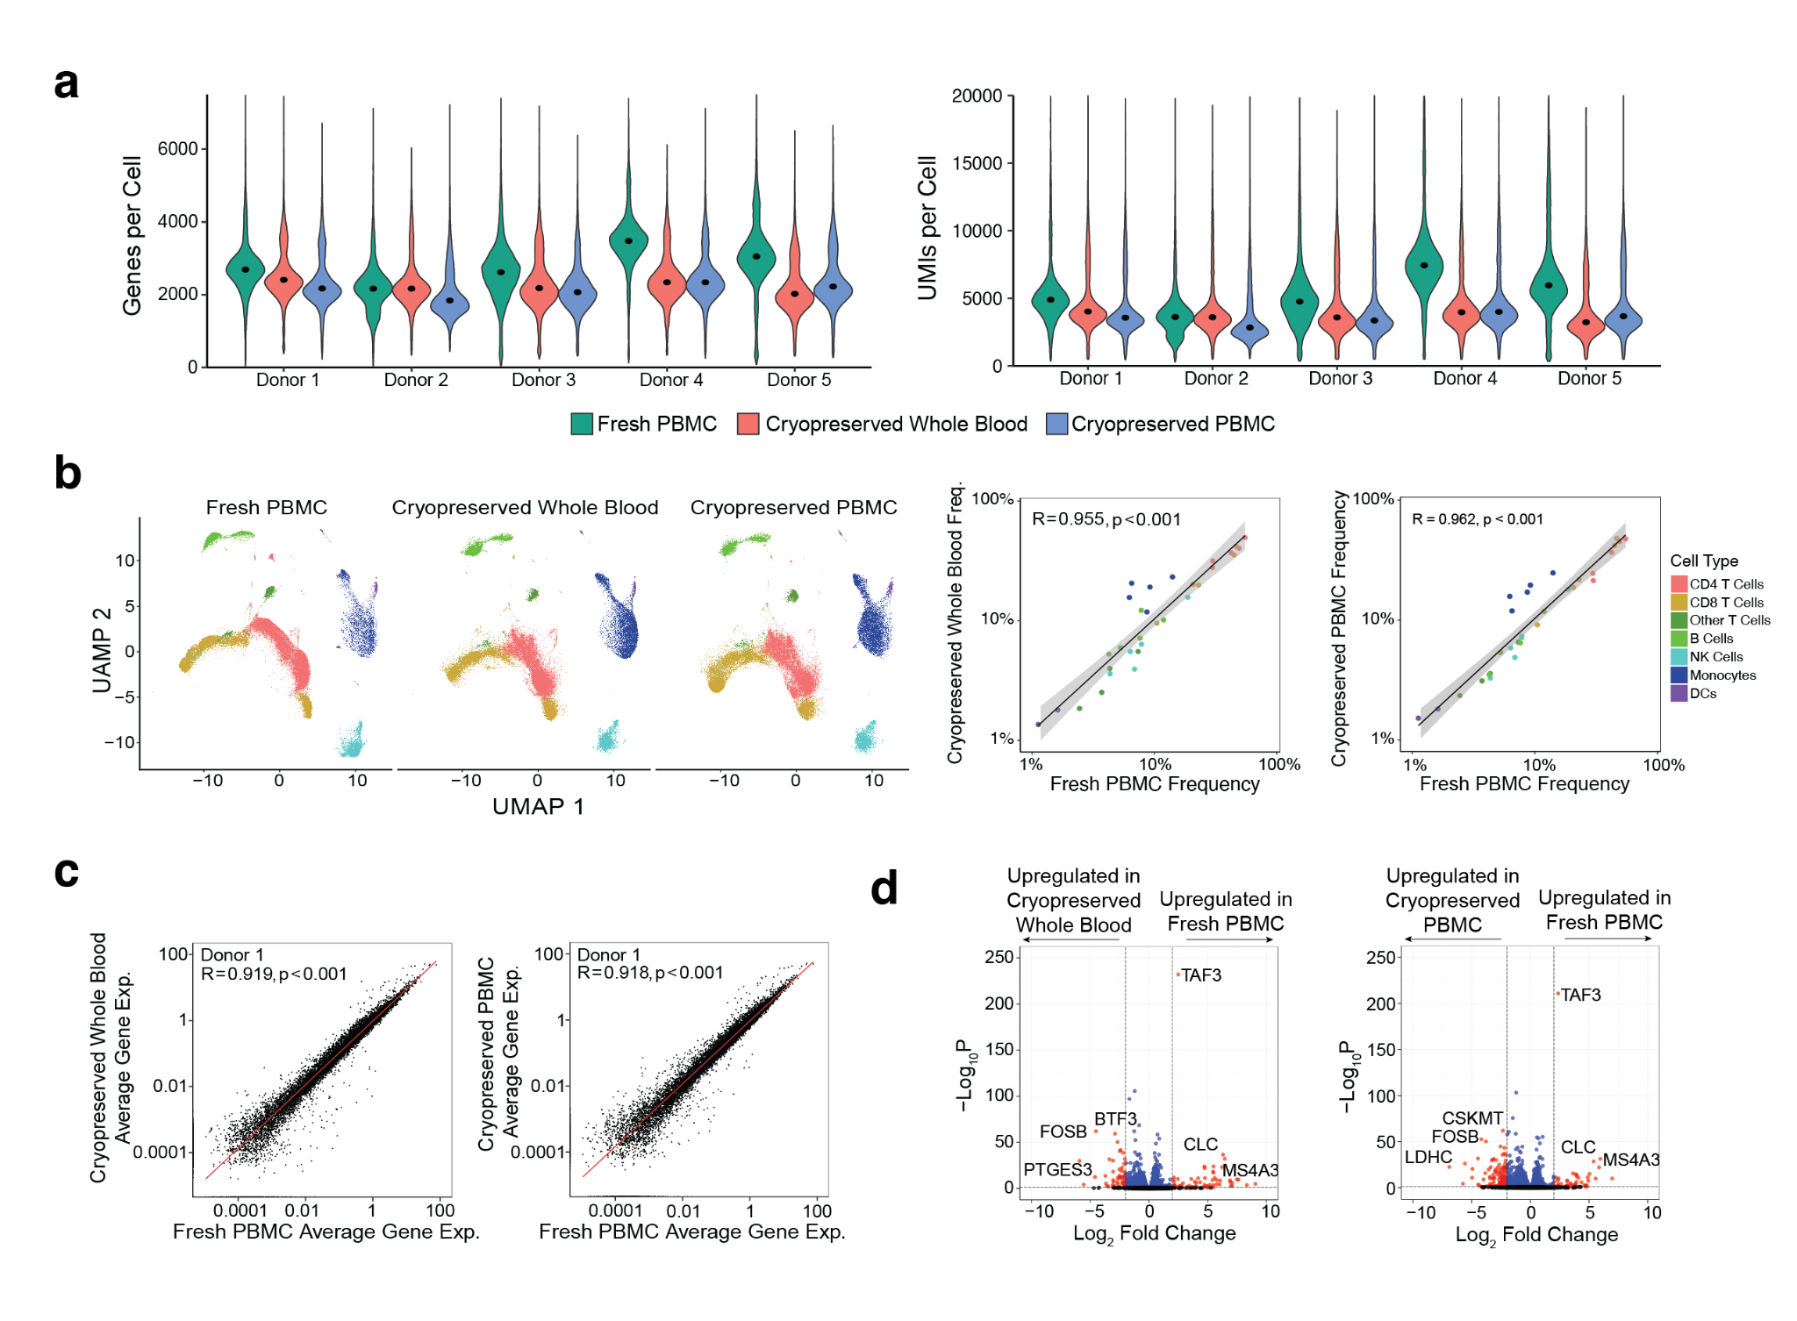
Supplement Figure 2: Comparison of scRNA-seq results between fresh isolated PBMCs, cryopreserved whole blood, and cryopreserved PBMCs. a. scRNA-seq quality metrics, including genes per cell and unique molecular identifiers (UMIs) per cell, for fresh PBMCs (green), cryopreserved whole blood (red) and cryopreserved PBMCs (blue) across 5 donors. B. (Left) UMAP visualization of gene expression data from fresh PBMCs, cryopreserved whole blood and cryopreserved PBMC samples, annotated with cell type labels. (Right) Correlation of cell type population frequencies between fresh PMBCs versus cryopreserved whole blood (left), and fresh PBMCS versus cryopreserved PBMCs (right). c. Gene expression correlation between fresh PMBCs versus cryopreserved whole blood (left), and fresh PBMCS versus cryopreserved PBMCs (right) for a representative donor (Donor 1). d. Differentially expressed genes, with genes upregulated in fresh PBMCs versus cryopreserved whole blood (left), and fresh PBMCS versus cryopreserved PBMCs (right). Genes with adjusted p values less than 0.05 are shown in blue, and genes with adjusted p values less than 0.05 and log fold change greater than 2 are shown in red.

Supplement Table 2: Bulk ATAC-Seq Summary Metrics Table
Donor ID | Condition | Read Count | % Reads in Peaks | % Reads in TSS | % Mitochondrial Reads
Donor 1 | PBMC | 18,546,680 | 19.00 | 8.00 | 1.22
Donor 1 | CWB | 19,933,577 | 20.00 | 8.00 | 1.20
Donor 2 | PBMC | 14,814,264 | 21.00 | 10.00 | 2.00
Donor 2 | CWB | 14,031,861 | 19.00 | 8.00 | 1.35
Donor 3 | PBMC | 19,258,569 | 21.00 | 10.00 | 1.59
Donor 3 | CWB | 17,798,421 | 19.00 | 8.00 | 1.12
Supplement Table 3: Differentially expressed genes between 6 month stored and 1 year stored cryopreserved whole blood samples.
Upregulated Condition | Gene | Log2 Fold Change | P Value | P Value Adjusted
Upregulated in 6 Month Stored Samples | BTF3 | -2.70 | 4.68E-127 | 6.15E-123
Upregulated in 6 Month Stored Samples | EIF2S2 | -2.24 | 3.07E-31 | 9.60E-29
Upregulated in 6 Month Stored Samples | IGHG1 | -2.62 | 3.95E-28 | 7.99E-26
Upregulated in 6 Month Stored Samples | TMEM265 | -2.11 | 2.95E-22 | 3.15E-20
Upregulated in 6 Month Stored Samples | SKA2 | -2.09 | 3.36E-22 | 3.56E-20
Upregulated in 6 Month Stored Samples | BRICD5 | -2.24 | 5.42E-21 | 5.24E-19
Upregulated in 6 Month Stored Samples | ZXDA | -2.16 | 8.63E-19 | 6.67E-17
Upregulated in 6 Month Stored Samples | PTGES3 | -3.44 | 1.06E-12 | 3.31E-11
Upregulated in 6 Month Stored Samples | SHISA8 | -2.12 | 3.91E-09 | 6.55E-08
Upregulated in 6 Month Stored Samples | LTB4R2 | -2.41 | 1.93E-08 | 2.78E-07
Upregulated in 6 Month Stored Samples | ZNF429 | -5.76 | 6.40E-07 | 6.80E-06
Upregulated in 6 Month Stored Samples | PPIAL4A | -2.14 | 1.25E-06 | 1.25E-05
Upregulated in 6 Month Stored Samples | LENEP | -2.33 | 4.23E-04 | 2.21E-03
Upregulated in 6 Month Stored Samples | GOLGA8R | -2.16 | 5.66E-04 | 2.84E-03
Upregulated in 6 Month Stored Samples | GPRC5D | -2.35 | 2.44E-03 | 9.90E-03
Upregulated in 6 Month Stored Samples | GP1BB | -3.35 | 9.71E-03 | 3.16E-02
Upregulated in 6 Month Stored Samples | GATA2 | -3.27 | 1.13E-02 | 3.58E-02
Upregulated in 6 Month Stored Samples | TUBB1 | -3.65 | 1.21E-02 | 3.79E-02
Upregulated in 6 Month Stored Samples | PF4 | -3.09 | 1.64E-02 | 4.88E-02
Upregulated in 1 Year Stored Samples | CXCL8 | 2.88 | 6.31E-09 | 1.02E-07
Upregulated in 1 Year Stored Samples | IL1B | 2.31 | 9.69E-09 | 1.51E-07
Upregulated in 1 Year Stored Samples | OLR1 | 2.41 | 9.81E-05 | 6.11E-04
Supplement Table 4: 10x Flex vs 10x 3’ v3.1 Cost Estimates for 64 Sample Batch Size
Batch Metrics | 10x Flex scRNA-seq | 10 3’ v3.1 scRNA-seq
Total Samples | 64 | 64
Total Cells Loaded per Well | 400,000 (1 well) | 11,651 (2 wells)
Estimated Singlets Captured per Well | 213,042 | 6,658
Estimated Singlets Captured per Sample | 13,315 | 13,315
Sequencing Reads per Cell | 10,000 | 20,000
Total Sequencing Reads | 9,696,969,697 | 17,044,480,000
10x Reagent Cost | $26,588 | $216,480
Sequencing Cost, NovaSeqX | $7,100 | $14,200
Total Cost | $33,688 | $230,680
Cost Per Sample | $526 | $3,604

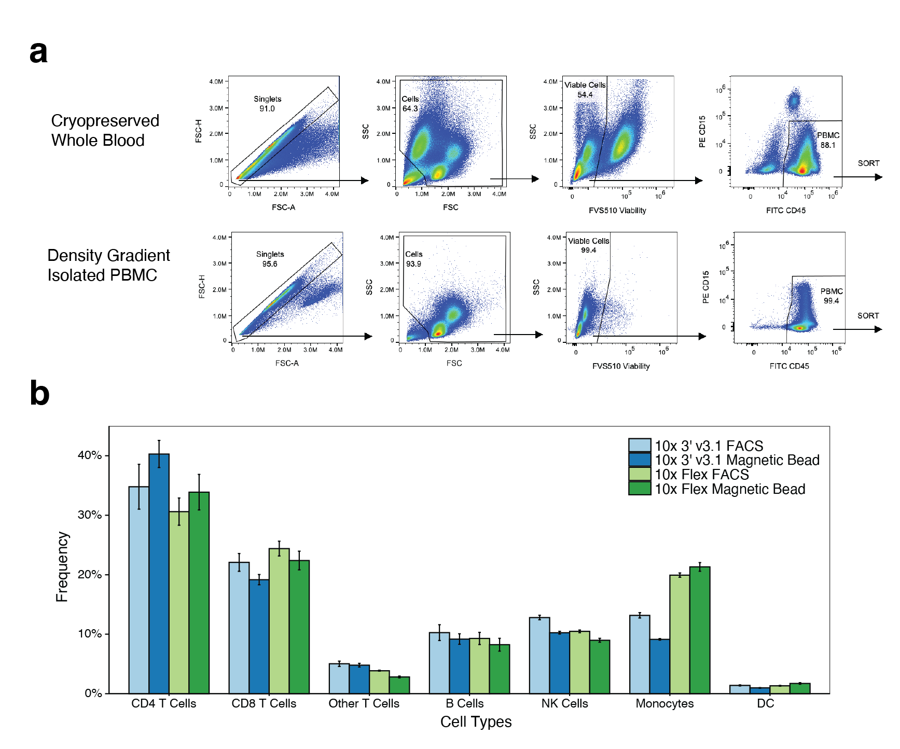
Supplement Figure 3: Development 10x Flex scRNA-seq methodology as a high throughput method for single cell transcriptome analysis of cryopreserved whole blood. a. FACS gating schemes for cryopreserved whole blood and density gradient isolated PBMC samples. b. Cell type frequencies for cryopreserved whole blood samples measured with the 10x 3’ v3.1 (blue) or the 10x Flex (green) scRNA-seq chemistries, and enriched with either FACS or magnetic bead based enrichment
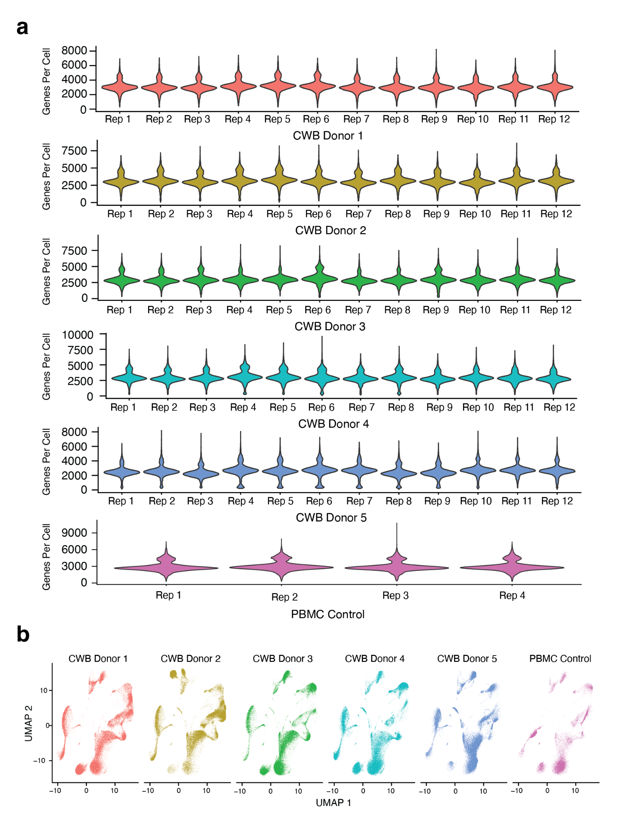
Supplement Figure 4: Verification of high throughput workflow with 60 cryopreserved whole blood samples through automated magnetic bead enrichment and scRNA-seq preparation. a. Genes per cell recovered using the 10x Flex chemistry with cryopreserved whole blood and density gradient isolated PBMC samples across all donors and replicates.
b. UMAP visualizations of single cell gene expression across each donor.
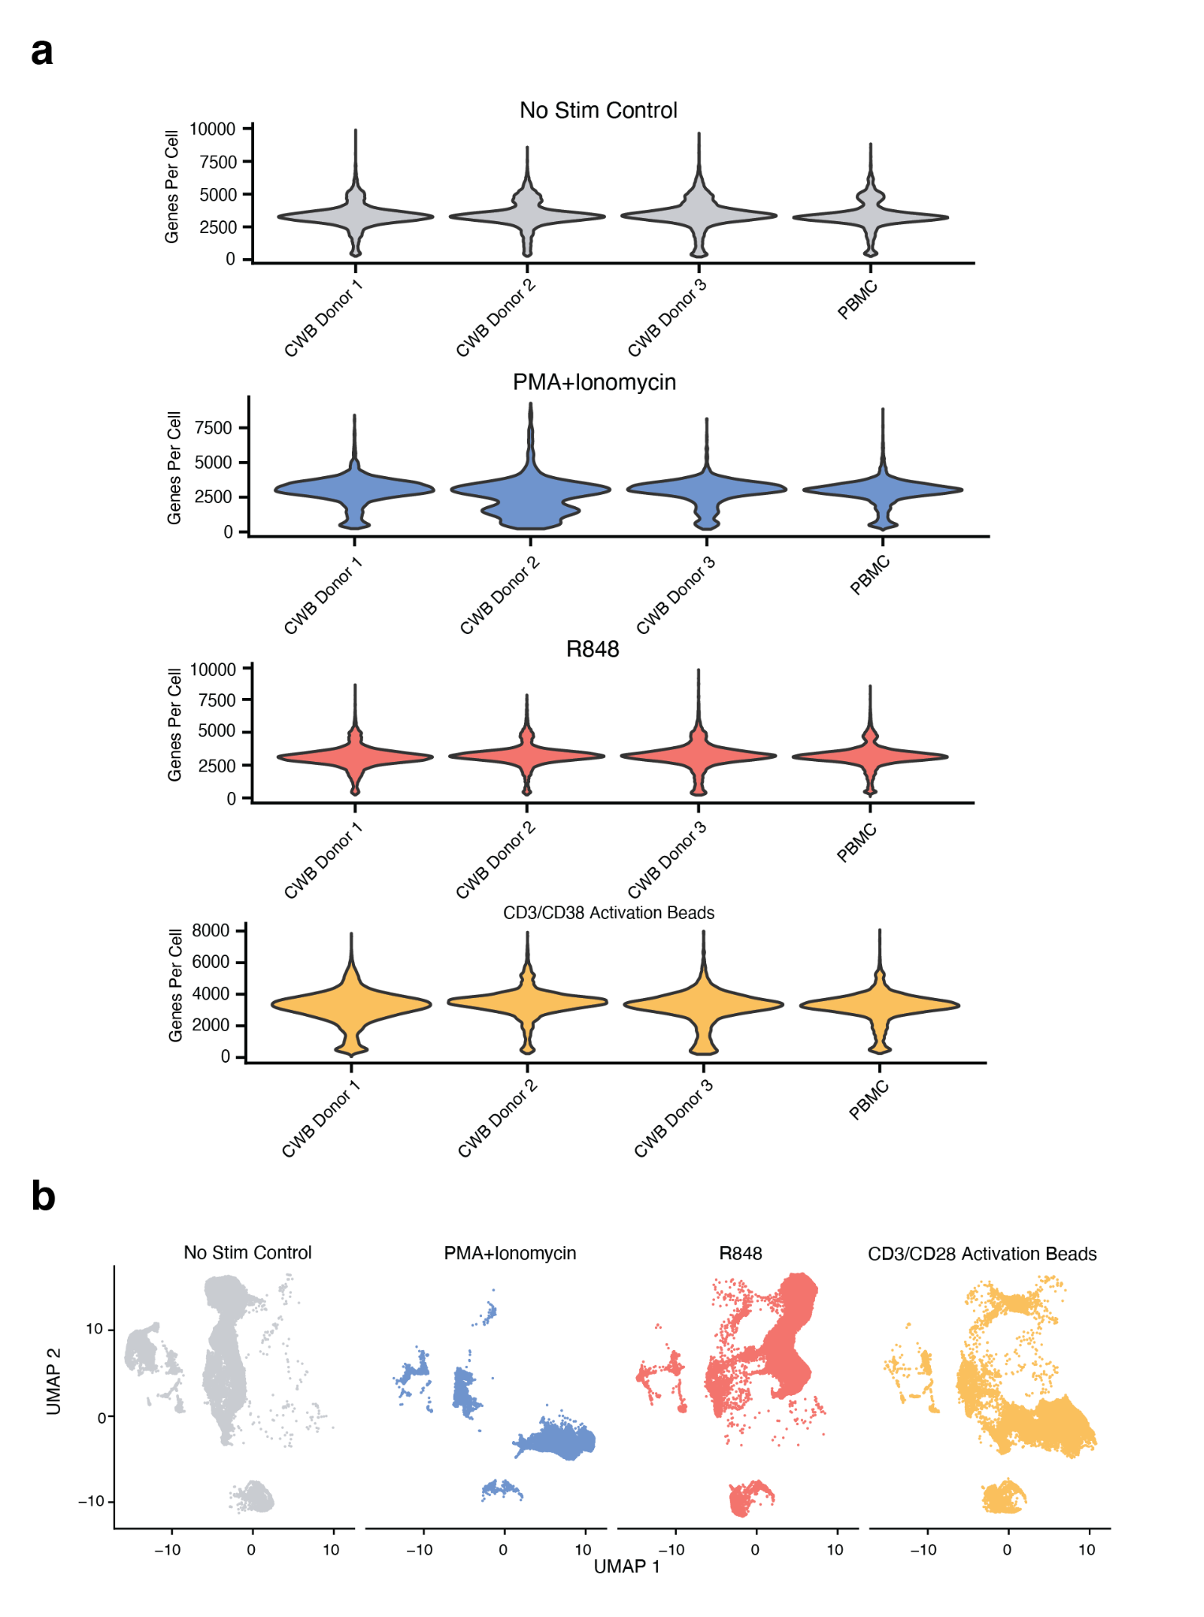
Supplement Figure 5: Functional assays using cryopreserved whole blood and multiplexed scRNA-seq. a. Genes per cell recovered using the 10x Flex chemistry with cryopreserved whole blood and density gradient isolated PBMC samples across all donors and stimulation conditions. b. UMAP visualizations of single cell gene expression across each stimulation condition.
Supplement Table 5: Sample Donor Key
Figure | Figure Donor ID | Sample Type | AIFI Donor ID | Sex | Age | Source
1 | Donor 1 | Matched CWB/PMBC | KT05111 | Male | 27 | Bloodworks NW
1 | Donor 2 | Matched CWB/PMBC | KT05113 | Male | 29 | Bloodworks NW
1 | Donor 3 | Matched CWB/PMBC | KT05401 | Female | 50 | Bloodworks NW
1 | Donor 4 | Matched CWB/PMBC | KT05402 | Female | 56 | Bloodworks NW
1 | Donor 5 | Matched CWB/PMBC | KT08951 | Female | 68 | Bloodworks NW
1 | Donor 6 | Matched CWB/PMBC | KT08952 | Male | 44 | Bloodworks NW
1 | Donor 7 | Matched CWB/PMBC | KT08954 | Female | 68 | Bloodworks NW
1 | Donor 8 | Matched CWB/PMBC | KT08955 | Female | 60 | Bloodworks NW
1 | Donor 9 | Matched CWB/PMBC | KT08956 | Male | 42 | Bloodworks NW
1 | Donor 10 | Matched CWB/PMBC | KT08957 | Female | 30 | Bloodworks NW
1 | Donor 11 | Matched CWB/PMBC | KT08958 | Female | 73 | Bloodworks NW
1 | Donor 12 | Matched CWB/PMBC | KT08961 | Male | 37 | Bloodworks NW
1 | Donor 13 | Matched CWB/PMBC | KT08962 | Male | 61 | Bloodworks NW
1 | Donor 14 | Matched CWB/PMBC | KT08964 | Male | 56 | Bloodworks NW
1 | Donor 15 | Matched CWB/PMBC | KT08969 | Male | 33 | Bloodworks NW
1 | Donor 16 | Matched CWB/PMBC | KT08972 | Male | 55 | Bloodworks NW
1 | Donor 17 | Matched CWB/PMBC | KT08973 | Female | 44 | Bloodworks NW
1 | Donor 18 | Matched CWB/PMBC | KT08974 | Male | 32 | Bloodworks NW
1 | Donor 19 | Matched CWB/PMBC | KT08975 | Female | 41 | Bloodworks NW
1 | Donor 20 | Matched CWB/PMBC | KT08976 | Female | 28 | Bloodworks NW
2 | Donor 1 | Matched CWB/PMBC | KT05111 | Male | 27 | Bloodworks NW
2 | Donor 2 | Matched CWB/PMBC | KT05113 | Male | 29 | Bloodworks NW
2 | Donor 3 | Matched CWB/PMBC | KT05402 | Female | 56 | Bloodworks NW
3A, 3B, 3C | Donor 1 | PBMC | KT00607 | Male | 32 | Benaroya Research
3A, 3B, 3C | Donor 2 | PBMC | KT00609 | Male | 31 | Benaroya Research
3A, 3B, 3C | Donor 3 | PBMC | KT00610 | Female | 36 | Benaroya Research
3D | CWB Donor 1 | CWB | KT05012 | Female | 40 | Bloodworks NW
3D | CWB Donor 2 | CWB | KT05044 | Female | 68 | Bloodworks NW
3D | CWB Donor 3 | CWB | KT05045 | Female | 63 | Bloodworks NW
3D | PBMC | PBMC | KT04745 | Female | 55 | Bloodworks NW
3E | CWB Donor 1 | CWB | KT05731 | Female | 40 | Bloodworks NW
3E | PBMC | PBMC | KT04745 | Female | 55 | Bloodworks NW
4 | CWB Donor 1 | CWB | KT05012 | Female | 40 | Bloodworks NW
4 | CWB Donor 2 | CWB | KT05013 | Male | 38 | Bloodworks NW
4 | CWB Donor 3 | CWB | KT05044 | Female | 68 | Bloodworks NW
4 | CWB Donor 4 | CWB | KT05045 | Female | 63 | Bloodworks NW
4 | CWB Donor 5 | CWB | KT05729 | Female | 72 | Bloodworks NW
4 | CWB Donor 6 | CWB | KT05730 | Female | 64 | Bloodworks NW
4 | CWB Donor 7 | CWB | KT05731 | Female | 40 | Bloodworks NW
4 | PBMC | PBMC | KT02183 | Male | 28 | Bloodworks NW
5 | CWB Donor 1 | CWB | KT05013 | Male | 38 | Bloodworks NW
5 | CWB Donor 2 | CWB | KT05045 | Female | 63 | Bloodworks NW
5 | CWB Donor 3 | CWB | KT05113 | Male | 29 | Bloodworks NW
5 | CWB Donor 4 | CWB | KT05759 | Male | 45 | Bloodworks NW
5 | CWB Donor 5 | CWB | KT05760 | Female | 65 | Bloodworks NW
5 | PBMC | PBMC | KT02183 | Male | 28 | Bloodworks NW
6 | CWB Donor 1 | CWB | KT05012 | Female | 40 | Bloodworks NW
6 | CWB Donor 2 | CWB | KT05111 | Male | 27 | Bloodworks NW
6 | CWB Donor 3 | CWB | KT05731 | Female | 40 | Bloodworks NW
6 | PBMC | PBMC | KT02183 | Male | 28 | Bloodworks NW

Technical Information Supplement Note

Flow Cytometry and FACS
Flow cytometry analysis was performed using a Cytek Aurora spectral flow cytometer. The analyzer was equipped with 5 lasers (ultra violet - 355 nm, violet - 405 nm, blue - 448 nm, yellow-green - 561 nm, red - 640 nm) and 64 fluorescent detectors. Instrument setup and performance tracking was performed daily using SpectroFlo QC beads (Cytek) using the Daily QC program. Experimental fluorescence gains were based on Cytek assay settings generated from Daily QC, while forward scatter (FSC-A) and side scatter (SSC-A) gains were optimized for healthy fixed PBMCs. The Aurora instrument was operated using Cytek SpectroFlo software version 2.2.0.4. All samples recorded on Medium flow rate (~30 uL/min) and event rate of ~5,000 events per second.

Fluorescent-activated cell sorting (FACS) was performed using a BD FACSAria Fusion cell sorter. The sorter was equipped with 4 lasers (violet - 405 nm, blue - 448 nm, yellow-green - 561 nm, red - 640 nm) and 14 fluorescent detectors. Instrument setup and performance tracking was performed daily using instrument specific Cytometer Setup and Tracking (CS&T) beads (BD) using the CS&T program. Experimental voltages were based on internal voltage optimization experiments with fixed healthy PBMCs. The FACSAria Fusion instrument was operated using BD FACSDiva software version 9.1. All samples sorted at a flow rate setting of 1 and event rate of ~5,000 events per second.

Cell Counting
Cell counting was performed using a Cellaca MX Cell Counter (Revvity) according to manufacturer specifications. Cells were stained 1:1 with Viastain Acridine Orange Propidium Iodine (AOPI) Staining Solution (Revvity) and 50uL plated into the counting wells of the 24 well counting plate (Revvity). The plate was loaded into the Cellaca MX and focus optimized per well. Live (AO) and dead cell (PI) populations were counted for viability and live cell calculations. Ratio of counted live cells to total counted cells was used to calculate viability.

For cell counts performed post-fixation, cells were stained with Viastain Propidium Iodine (PI) Staining solution (Revvity) 1:5 and 50uL plated into the counting wells of the 24 well counting plate (Revvity). The plate was loaded into the Cellaca MX and focus optimized per well. Total cell populations were counted to determine pooling normalization and GEM loading concentration.

Automated Liquid Handling
Automated liquid handling steps were completed using a Tecan Fluent 1080. The Tecan Fluent 1080 has a custom deck configuration including three CPAC 96 well plate heating/cooling units and 1 heating/cooling Thermoshake unit. A remote gripper arm (RGA) was used for labware transport, and flexible channel arm (FCA) or multiple channel arm (MCA) with extended volume adapter (EVA) attachment used for all liquid handling steps. Automated liquid handling scripts were developed and run using Tecan Fluent Control Build v2.7.19.54609. Deck layout and liquid handling scripts are available by request from the authors.

