Supplementary Fig. S1 The map of pGL3 plasmid containing ACE2 promoter.

Supplementary Fig. S2 Negative control for RNA decay experiment. The level of GAPDH mRNA in control, NEAT1 shRNA-infected (A), hnRNPA2B1siRNA-transfected (B), METTL3 siRNA-transfected (C), METTL14 siRNA-transfected (C), LIN28A siRNA-transfected (D), IGF2BP3 expression vector-transfected (E) AT-II cells at 0h, 1h, 2h, 3h, 4h, and 5h after actinomycin D treatment identified by qRT-PCR. NC, negative control; Vector, expression vector; OE, overexpression. N=3. Quantitative data were presented as mean±SD.

Supplementary Fig. S3 The level of methylated ACE2 mRNA. The level of methylated ACE2 mRNA in AT-II cells treated with or without METTL3 and METTL14 siRNAs under LPS condition detected by MeRIP. NC, negative control; siMETTL3, METTL3 siRNA; siMETTL14, METTL14 siRNA. N=3. Quantitative data were presented as mean±SD.

Supplementary Fig. S4 Positive control for RNA decay experiment. The level of MALAT1 in control and LIN28A siRNA-transfected AT-II cells at 0h, 1h, 2h, 3h, 4h, and 5h after actinomycin D treatment identified by qRT-PCR under LPS condition. NC, negative control. N=3. Quantitative data were presented as mean±SD. *P<0.05.
Supplementary Fig. S1
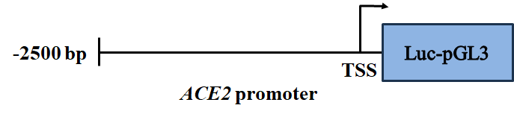

Supplementary Fig. S2
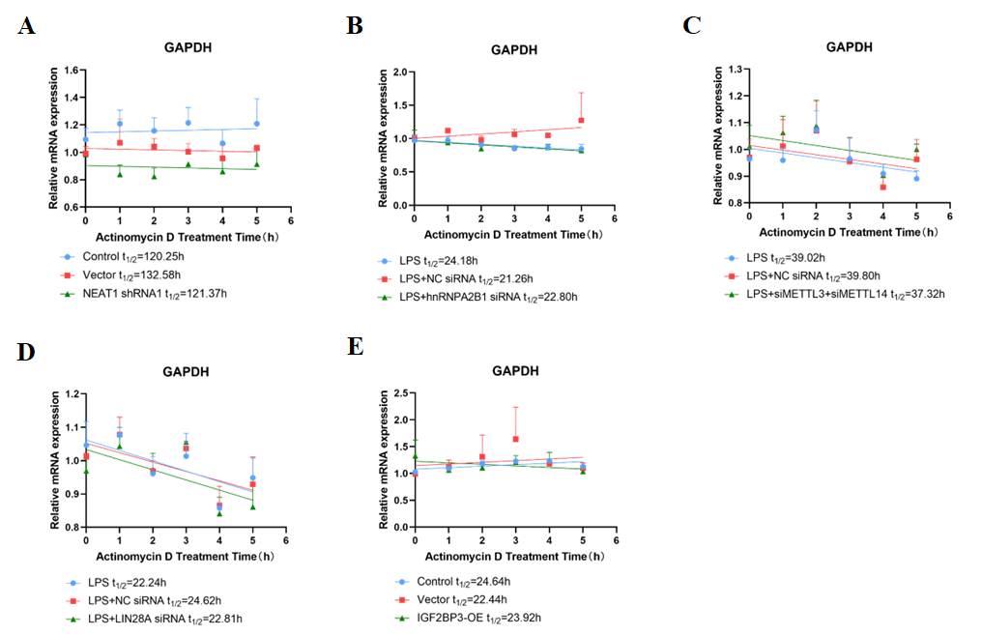

Supplementary Fig. S3

Supplementary Fig. S4

