Fig. S1 Quantitative analysis of mitochondria using TEM
A．The quantitative analysis bar chart of damaged mitochondria under TEM represented by Figure 3H.
B．The quantitative analysis bar chart of damaged mitochondria under TEM represented by Figure 4G.
Values are expressed as the mean ± SD from three independent experiments (n = 3). *p < 0.05, **p < 0.01, ***p < 0.001, ****p < 0.0001.

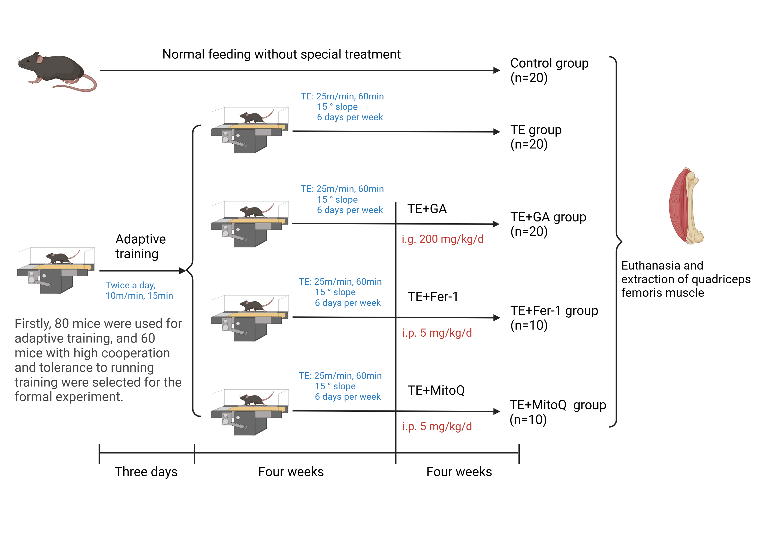
Fig. S2 Mice treatment protocol

Fig. S3 Identification of skeletal muscle cells
A. Observation of skeletal muscle cells under inverted microscope, where "_" represents 500 µm.
B. Immunofluorescence detection of MyoD and α-SMA expression in skeletal muscle cells, where "_" represents 100 µm.

Fig. S4 Images of mouse skeletal muscle stained with H&E and Sirius red

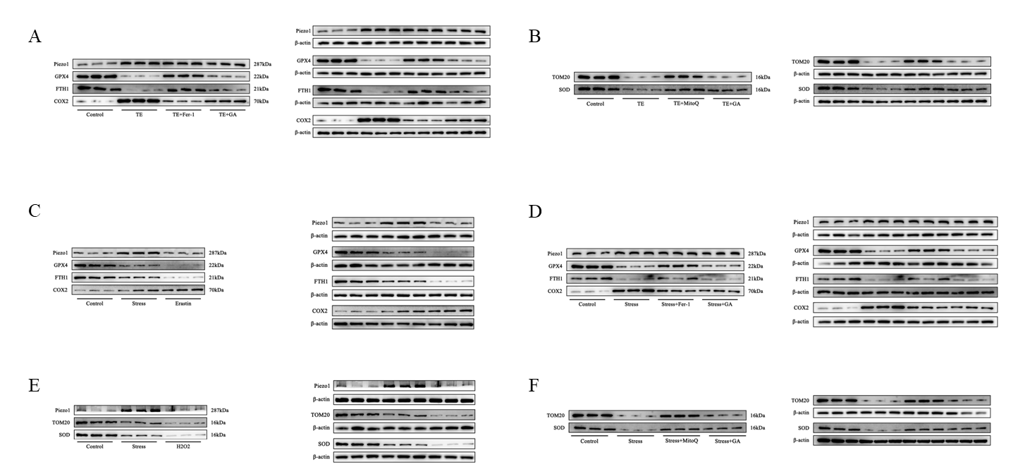
Fig. S5 Western blot images in each figure
A. Fig. 1D corresponding Western blot image
B. Fig. 2D corresponding Western blot image
C. Fig. 3I corresponding Western blot image
D. Fig. 4H corresponding Western blot image
E. Fig. 5J corresponding Western blot image
F. Fig. 6F corresponding Western blot image

TableS1 List of Abbreviations
Abbreviation | Full Term
EIMD | exercise-induced muscle damage
GA | Gallic acid
TE | Treadmill Exercise
CK | creatine kinase
LDH | lactate dehydrogenase
IL | interleukin
TNF-α | tumour necrosis factor-alpha
ROS | reactive oxygen species
GPX4 | Glutathione peroxide reductase
GSH | glutathione
Fer-1 | Ferrostatin-1
Mito Q | Mitoquinone
MDA | Malondialdehyde
COX2 | cyclooxygenase-2
GSSG | Glutathione oxidized
SOD | superoxide dismutase
FTH1 | Ferritin Heavy Chain 1
Fe²⁺ | ferrous iron
DAMP | damage-associated molecular patterns

