Supplementary Figure 1. Determination of the optimal DSS concentration for inducing moderate colitis in C57BL/6 mice. A. Body weight changes (% of day 0) in mice treated with 2%, 2.5%, or 3% DSS over 7 days. n=6. B. Survival probability of mice during DSS treatment. n=6. C. Representative H&E-stained colon sections showing histopathological changes in mice treated with 2%, 2.5%, or 3% DSS. Scale bars: 100 μm. The 2.5% DSS concentration was selected as it induced moderate colitis with significant weight loss and histological damage, without excessive mortality.
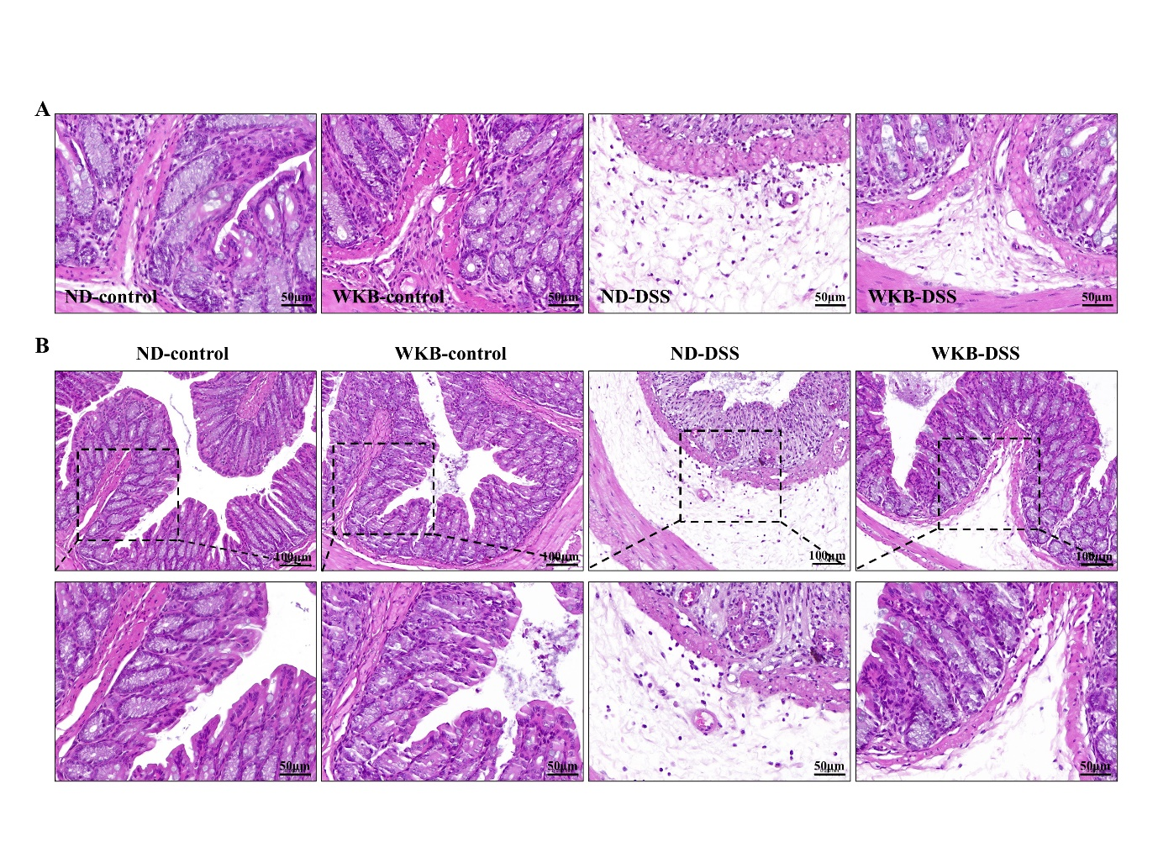

Supplementary Figure 2. WKB diet mitigated colon tissue damage in DSS-induced colitis, with additional histological details. A. Representative H&E-stained image of colon tissue at 400x magnification, showing a higher magnification of the region presented in Figure 2D. Scale bars: 50 μm. B. Representative H&E-stained images of colon tissue at 200x and 400x magnifications. Scale bars: 100 μm and 50 μm, respectively.
Supplementary Figure 3. WKB diet increased the expression of tight junction proteins in mice with colitis. A. Representative immunofluorescence images of colon tissue showing single channels for claudin-1, occludin and ZO-1 (green) and nuclei (DAPI, blue) at 200x magnification. Scale bars: 75 µm. B. Quantification of claudin-1⁺, occludin⁺ and ZO-1⁺ mean pixel density under 400x magnification. n=3. C. Representative western blot images and corresponding quantification histograms showing the expression levels of ZO-1, occludin, and claudin-1 proteins in colonic tissue. GAPDH was used as an internal control. n=6. Data are shown as mean ± SEM, P values were calculated using One-way ANOVA with Tukey’s test. **P<0.01, ***P<0.001 and ****P<0.0001.
Supplementary Figure 4. Expression of GFAP and TL1A. A. The expression distribution of GFAP gene in healthy control, CD uninflamed area and CD inflamed area. B. Gating strategy for identifying GFAP-positive EGCs. Doublets are first excluded, followed by the removal of dead cells using Fixable Viability Dye (FVD) staining. Finally, EGCs are identified as GFAP-positive cells. C. Relative cycle threshold (Ct) value of the TL1A in EGCs isolated by flow cytometric sorting. n=6. Data are expressed as mean ± SEM. Significance difference of three groups was tested using the Kruskal-Wallis test. *P<0.05, **P<0.01 and ***P<0.001.

Supplementary Figure 5. Gating strategy for flow cytometry of immune cell populations in figure 5. A. Initial gating to exclude debris based on FSC and SSC. B. Selection of single cells using FSC-A vs. FSC-H. C. Live cells were gated using Zombie dye (Alexa Fluor 430) to exclude dead cells. D. CD45⁺ leukocytes were identified from live cells. E. CD4⁺IFN-γ⁺ T cells were gated to assess Th1 responses. F. CD4⁺IL-17A⁺ T cells were gated to evaluate Th17 responses. G. CD4⁺ T cells were gated from the CD45⁺ population. H. CD4⁺CD25⁺FOXP3⁺ T cells were gated to identify regulatory T cells (Tregs). Percentages in each plot represent the proportion of cells in the respective gate.

Supplementary Figure 6. WKB diet modulated the gut microbiota and influenced the covariance between clinical parameters and the gut microbiome. A. Distributions of the gut microbiota at the order, family, and species levels. n=3. B. Bar charts of CAZy pathways showing 5 significant differences. n=3. C. A correlation heatmap depicting the Spearman’s rank correlation coefficients between differentially abundant taxa and various parameters. n=3. Signifcance was determined using the Kruskal–Wallis test. *P<0.05, **P<0.01 and ***P<0.001.

