Supplementary Material

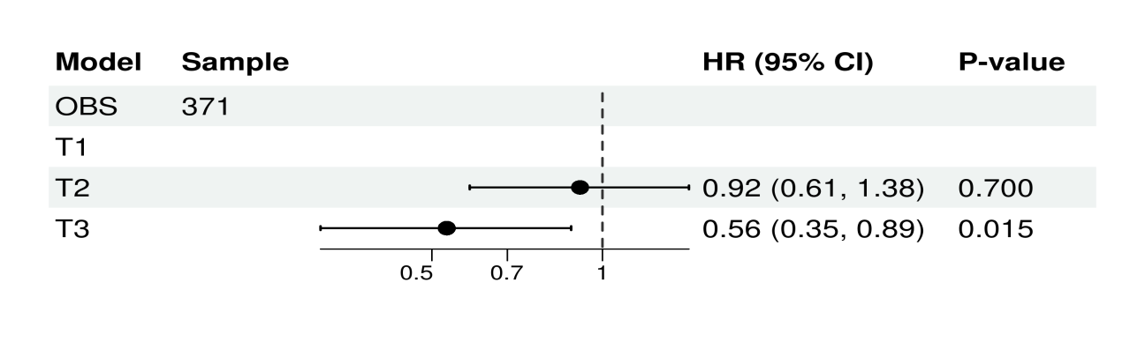
eFigure 1 Relationship between Oxidative Balance Score and Death in Retinopathy Patients, no covariates were adjusted
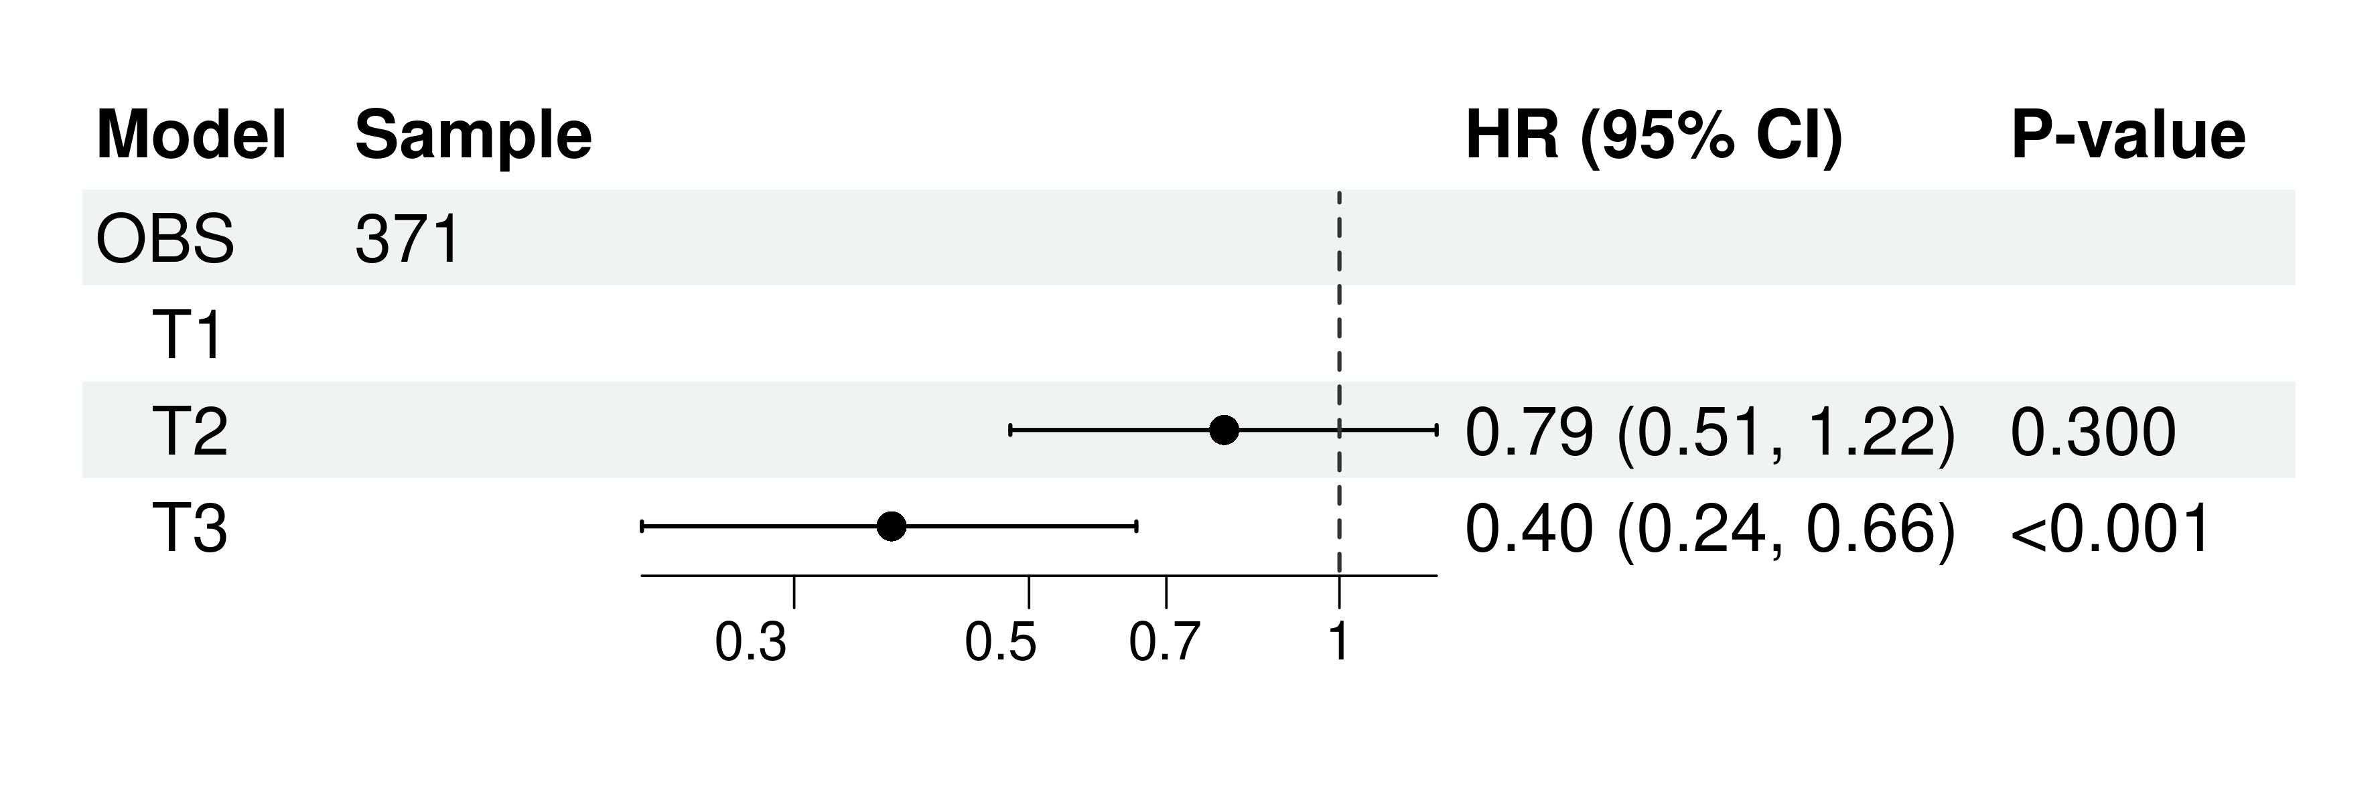

eFigure 2 Relationship between Oxidative Balance Score and Death in Retinopathy Patients, age, sex, race/ethnicity, education level, diabetes, BMI, smoking status, drinking status and hypertension were adjusted

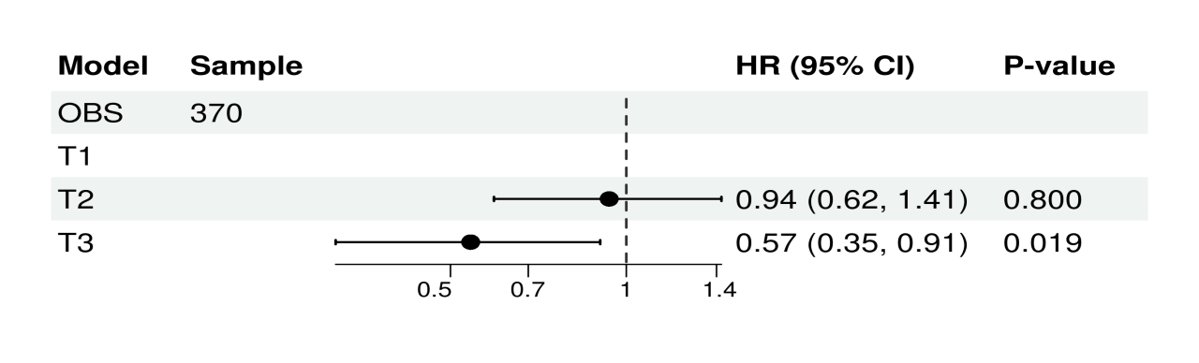
eFigure 3 Relationship between Oxidative Balance Score and Death in Retinopathy Patients, no covariates were adjusted (Death time <90 days were deleted)

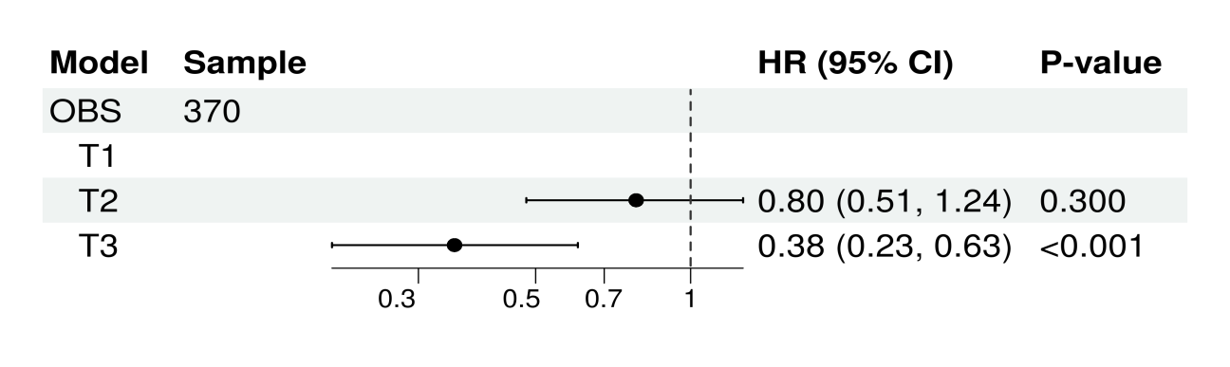
eFigure 4 Relationship between Oxidative Balance Score and Death in Retinopathy Patients, age, sex, race/ethnicity, education level, diabetes, BMI, smoking status, drinking status and hypertension were adjusted (Death time <90 days were deleted)

eTable 1 Oxidative balance score assignment scheme
OBS components | Property | 0 | Male  1 | 2 | 0 | Female  1 | 2
Dietary OBS components
Dietary iber (g/d) | A | <12.56 | 12.56-19.65 | ≥19.65 | <10.05 | 10.05-16.30 | ≥16.30
Carotene (mcg/d) | A | <649.00 | 649.00-1225.50 | ≥1225.50 | <488.00 | 488.00-1627.50 | ≥1627.50
Riboﬂavin (mg/d) | A | <1.79 | 1.79-2.69 | ≥2.69 | <1.34 | 1.34-2.02 | ≥2.02
Niacin (mg/d) | A | <20.65 | 20.65-29.75 | ≥29.75 | <14.52 | 14.52-21.86 | ≥21.86
Vitamin B6 (mg/d) | A | <1.59 | 1.59-2.40 | ≥2.40 | <1.13 | 1.13-1.77 | ≥1.77
Total folate (mcg/d) | A | <316.00 | 316.00-492.00 | ≥492.00 | <251.00 | 251.00-388.96 | ≥388.96
Vitamin B12 (mcg/d) | A | <3.36 | 3.36-6.20 | ≥6.20 | <2.22 | 2.22-4.22 | ≥4.22
Vitamin C (mg/d) | A | <42.44 | 42.44-113.21 | ≥113.21 | <38.01 | 38.01-98.49 | ≥98.49
Vitamin E (ATE) (mg/d) | A | <5.82 | 5.82-9.42 | ≥9.42 | <4.53 | 4.53-7.52 | ≥7.52
Calcium (mg/d) | A | <646.00 | 646.00-1072.00 | ≥1072.00 | <499.24 | 499.24-849.00 | ≥849.00
Magnesium (mg/d) | A | <257.00 | 257.00-361.28 | ≥361.28 | <187.00 | 187.00-283.43 | ≥283.43
Zinc (mg/d) | A | <9.75 | 9.75-15.10 | ≥15.10 | <6.73 | 6.73-10.75 | ≥10.75
Copper (mg/d) | A | <1.12 | 1.12-1.57 | ≥1.57 | <0.85 | 0.85-1.28 | ≥1.28
Selenium (mcg/d) | A | <94.94 | 94.94-141.80 | ≥141.80 | <67.79 | 67.79-99.50 | ≥99.50
Total fat (g/d) | P | ≥69.83 | 69.83-107.43 | <107.43 | ≥50.98 | 50.98-75.79 | <75.79
Iron (mg/d) | P | ≥12.88 | 12.88-19.17 | <19.17 | ≥9.65 | 9.65-14.32 | <14.32
Lifestyle OBS components
Physical activity (MET-minute/week) | A | <417.86 | 417.86-1135.71 | ≥1135.71 | <270.00 | 270.00-845.71 | ≥845.71
Alcohol (g/d) | P | ≥30.00 | 0.00-30.00 | None | ≥15.00 | 0.00-15.00 | None
Body mass index (kg/m2) | P | ≥25.54 | 25.54-29.17 | <29.17 | ≥23.74 | 23.74-28.64 | <28.64
Cotinine (ng/mL) | P | ≥0.038 | 0.04-1.13 | <1.13 | ≥0.035 | 0.035-0.172 | <0.17

OBS: oxidative balance score; A: antioxidant; P: prooxidant; ATE: alpha-tocopherol equivalent; RE: retinol equivalent; MET: metabolic equivalent

