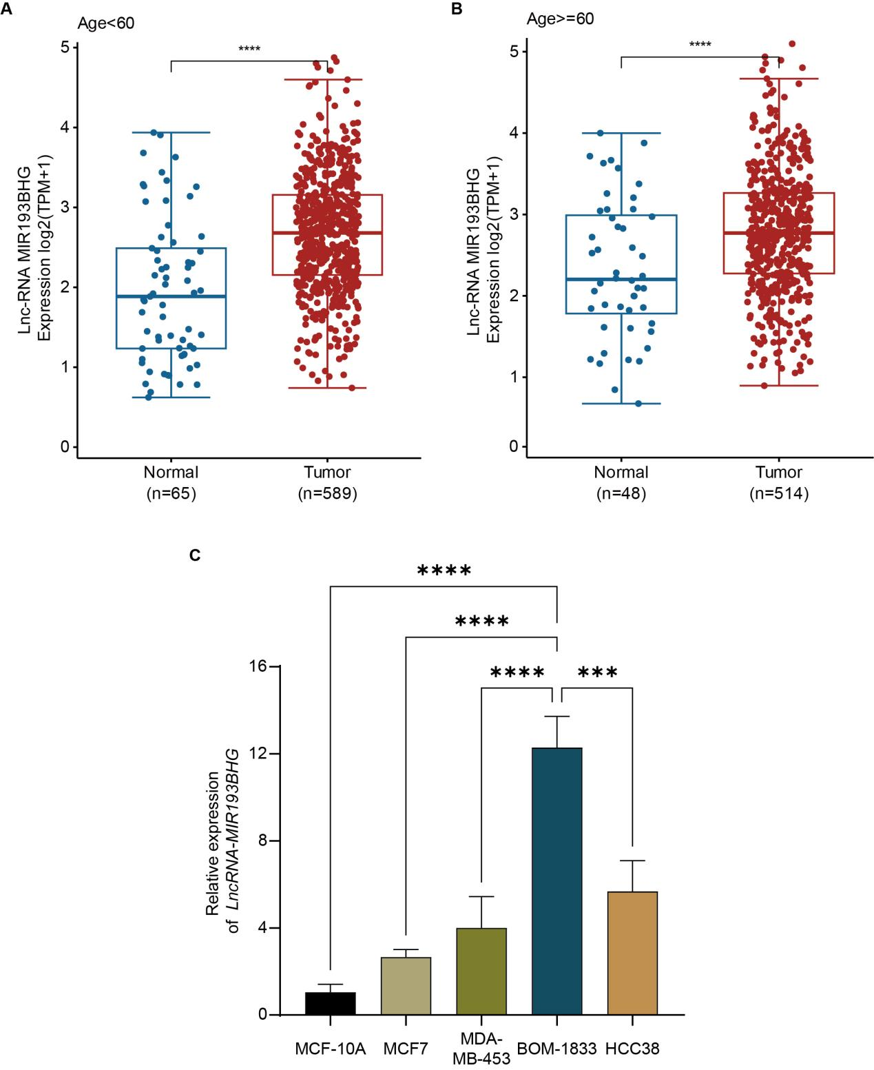
Figure S1. Expression differences of lncRNA MIR193BHG in tumor tissues and breast cancer cell lines across different age groups.
A-B: Expression levels of lncRNA MIR193BHG in normal and tumor tissues of patients aged <60 years and ≥60 years.
C: Expression of lncRNA MIR193BHG in normal breast epithelial cells and various breast cancer cell lines.(*P < 0.05, **P < 0.01, ***P < 0.001)
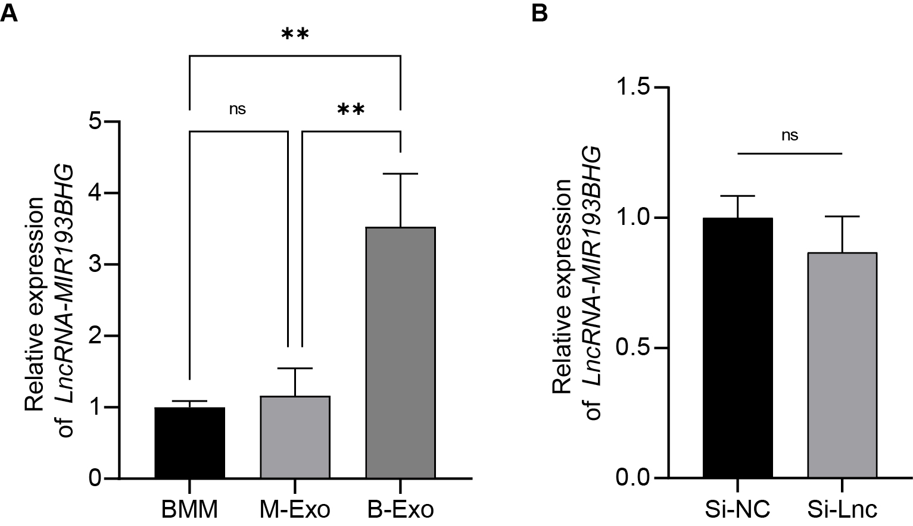

Figure S2. Expression levels of lncRNA MIR193BHG in exosomes derived from various sources and its expression changes under RAW264.7 cell knockout conditions.(ns:P＞0.05,*P < 0.05, **P < 0.01, ***P < 0.001)

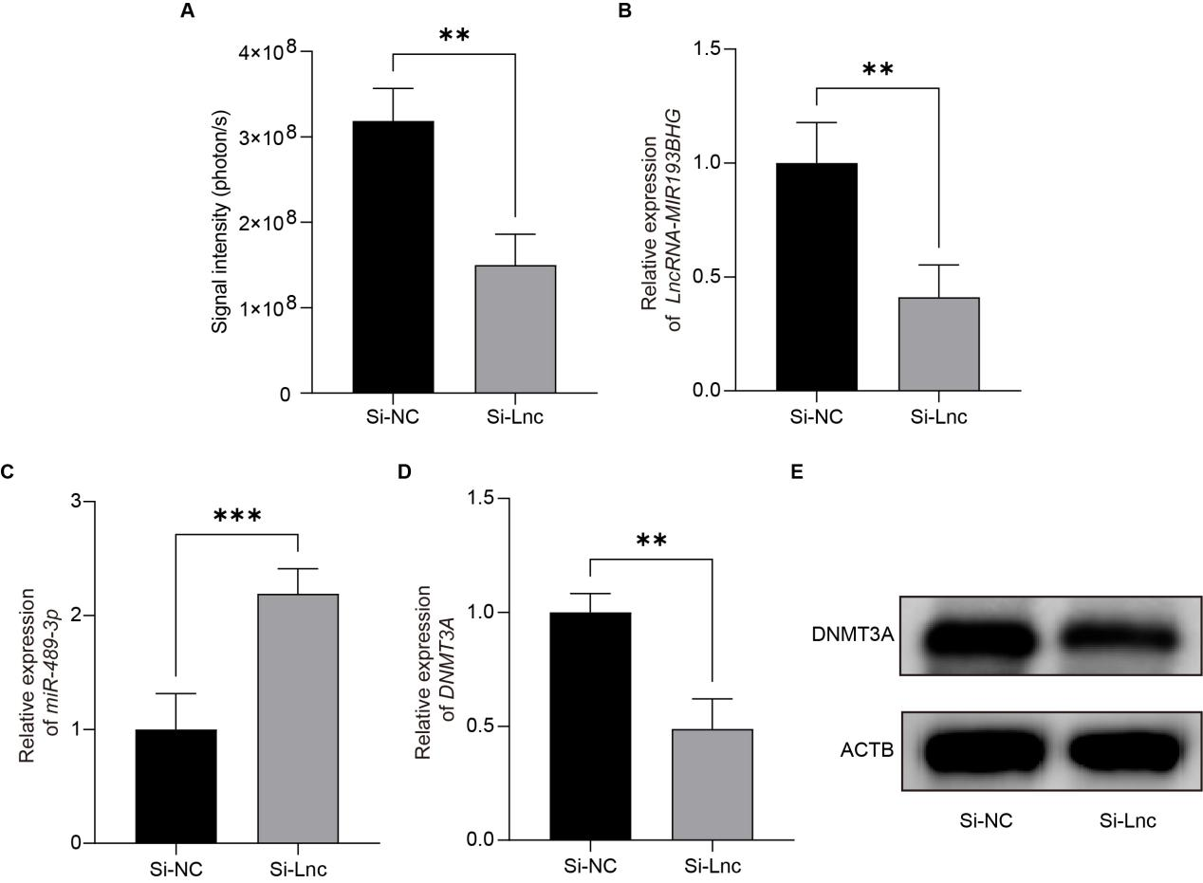

Figure S3. Validation experiments of lncRNA MIR193BHG-mediated regulation of DNMT3A via miR-489-3p in an in vivo tumor model.
A: Impact of lncRNA MIR193BHG knockdown on tumor growth in the in vivo tumor model.
B: Expression levels of lncRNA MIR193BHG in murine tumor tissues.
C: Impact of lncRNA MIR193BHG knockdown on miR-489-3p expression.
D-E: Representative western blot images and their quantitative analysis illustrating the effects of lncRNA MIR193BHG knockdown on DNMT3A mRNA and protein expression levels.(ns:P＞0.05,*P < 0.05, **P < 0.01, ***P < 0.001)

