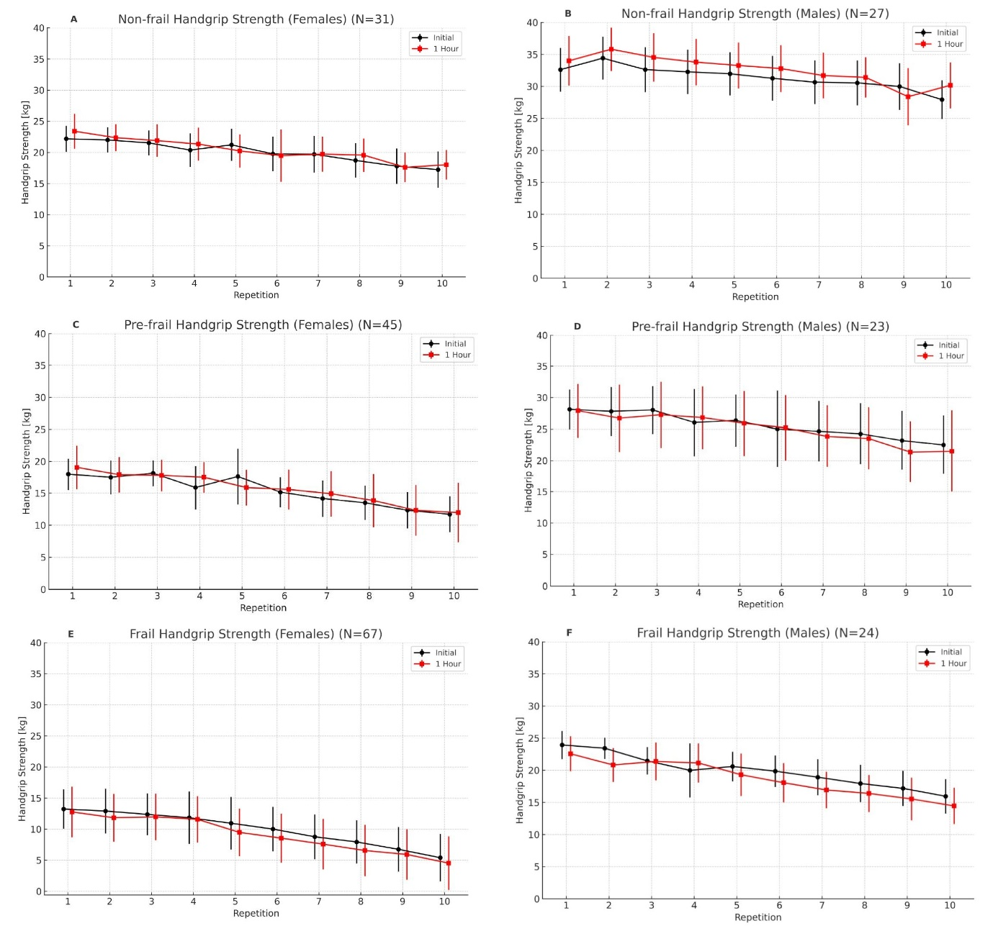
Appendix Figure A. Hand strength progression by gender

Appendix Table A. Results of different grip strength conditions (Fmax, Fmean, fatigue and recovery) by gender
Female
Variables | Non-frail  Median (IQR) | p-value  within Groups | Pre-frail  Median (IQR) | p-value  within Groups | Frail  Median (IQR) | p-value  within Groups | p-value  between Groups
Fmax 1 | 23.60 (21.90 - 24.40) | 0.011 | 20.10 (16.90 - 22.90) | 0.126 | 14.30 (12.20 - 16.70) | < 0.001 | < 0.001
Fmax 2 | 24.50 (22.50 - 26.20) | 0.011 | 18.80 (17.50 - 21.80) | 0.126 | 12.60 (10.90 - 13.90) | < 0.001 | < 0.001
Fmean 1 | 20.77 (18.33 - 21.69) | 0.030 | 14.74 (13.57 - 17.01) | 0.111 | 9.22 (7.97 - 11.58) | < 0.001 | < 0.001
Fmean 2 | 20.66 (19.00 - 21.80) | 0.030 | 15.69 (13.13 - 17.74) | 0.111 | 7.90 (6.89 - 9.77) | < 0.001 | < 0.001
Fatigue Ratio 1 | 1.14 (1.12 - 1.21) | 0.151 | 1.27 (1.24 - 1.40) | 0.058 | 1.48 (1.35 - 1.68) | 0.038 | < 0.001
Fatigue Ratio 2 | 1.18 (1.12 - 1.24) | 0.151 | 1.26 (1.17 - 1.36) | 0.058 | 1.51 (1.40 - 1.71) | 0.038 | < 0.001
Recovery Ratio | 1.02 (1.00 - 1.05) |  | 1.01 (0.92 - 1.06) |  | 0.88 (0.77 - 0.94) |  | < 0.001
Men
Fmax 1 | 35.46 (31.49 - 36.77) | < 0.001 | 27.40 (24.10 - 31.56) | 0.188 | 24.60 (20.60 - 26.20) | < 0.001 | < 0.001
Fmax 2 | 37.00 (32.00 - 38.00) | < 0.001 | 26.80 (22.50 - 33.00) | 0.188 | 22.85 (17.00 - 28.60) | < 0.001 | < 0.001
Fmean 1 | 31.69 (28.46 - 33.62) | < 0.001 | 24.66 (21.76 - 29.05) | 0.158 | 20.48 (14.79 - 24.46) | < 0.001 | < 0.001
Fmean 2 | 33.48 (29.20 - 34.99) | < 0.001 | 22.75 (20.63 - 30.44) | 0.158 | 19.04 (13.42 - 24.13) | < 0.001 | < 0.001
Fatigue Ratio 1 | 1.09 (1.07 - 1.12) | 0.188 | 1.11 (1.09 - 1.18) | 0.290 | 1.23 (1.18 - 1.28) | 0.013 | < 0.001
Fatigue Ratio 2 | 1.10 (1.09 - 1.12) | 0.188 | 1.15 (1.09 - 1.18) | 0.290 | 1.26 (1.19 - 1.35) | 0.013 | < 0.001
Recovery Ratio | 1.04 (1.00 - 1.06) |  | 0.99 (0.88 - 1.05) |  | 0.92 (0.89 - 1.00) |  | < 0.001

