Dear Editor,
I have recently received an email pertaining to our manuscript titled "YAP1 Activated CAFs Upregulate Cancer Matrix Hardness to Mediate Hepatocellular Carcinoma Progression" (JTRM-D-24-16335), granting us the invaluable opportunity to proceed with major revisions. We are both deeply appreciative and eagerly enthusiastic about this chance to refine our work.
In accordance with the reviewer's suggestions, we have meticulously revised the manuscript, addressing each point raised. The amendments have been conspicuously highlighted within the document. We sincerely hope that our revised manuscript now meets the standards and expectations of the journal and its esteemed reviewers.
Should you have any queries or require further clarification, please do not hesitate to reach out to us at your earliest convenience.
Sincerely yours,
Kuan-hou Mou
The First Affiliated Hospital of Xi'an Jiaotong University, Xi'an, Shaanxi 710061, P.R. China.
Email: mkhn001@163.com
Dr. Yan Wei
The First Affiliated Hospital of Xi'an Jiaotong University, Xi'an, Shaanxi 710061, P.R. China.
Email: 2277412717@qq.com
Letters to each of the reviewers/Point-by-point response
Referee #1:
1.The extended full name of genes, proteins, transcription factors, and co-regulators must be indicated when they are mentioned for the first time in the text. Moreover, gene names and abbreviations should be italicized.
Response: Thank you for highlighting the need for full gene/protein names and italicization. We have revised the text, italicizing names/abbreviations and highlighting first mentions with full details.

2.The quality and resolution of all figures should be improved to facilitate the visualization of the reported data, especially for the figure legends.
Response: Thank you for your feedback on figure quality. We've enhanced all figures, including legends, and uploaded them.

3.The relationship between YAP1 and CAFs should be more thoroughly described in the introduction section. The authors should discuss previous findings on the regulatory role of YAP1 in the conversion of normal fibroblast into CAFs, which contributes to the initiation and progression of other cancer types besides liver cancer. Furthermore, the scientific background on YAP1 function, currently presented in Results Section 2.7 "YAP1-activated CAFs upregulate the stiffness of the liver cancer stroma", could be relocated to the introduction section for better contextualization.
Response: Based on the reviewer's suggestions, we have added relevant content to the introduction section (lines 78-85, pages 3). The specific content is as follows:
YAP1, a core component of the Hippo signaling pathway, plays a role in the transcriptional regulation of diverse downstream genes [15]. Reduced Hippo pathway activity triggers the nuclear translocation of YAP1/ Transcriptional co-activator with PDZ-binding motif (TAZ), which subsequently interacts with TEA domain transcription factor (TEAD) to induce target gene expression. Unrestrained YAP1/TAZ activity can lead to rapid tumor growth and tumorigenesis [16]. Multiple studies have indicated that YAP1 participates in the activation of CAFs, maintains their functions, and can serve as a marker for CAF activation [17]. During the progression from liver fibrosis to hepatocellular carcinoma and the advancement of liver cancer, YAP1 in CAFs plays a significant role [18]. Moreover, studies have shown that YAP1 activity can modulate the CAF phenotype to promote the progression of prostate cancer [19]. Nevertheless, it is still unclear whether YAP1 can affect matrix stiffness and ultimately promote HCC progression by regulating CAF function.

4.By searching single-cell RNA-sequencing datasets on GEO database related to liver cancer you can obtain multiple results. Therefore, the authors should describe the inclusion and exclusion criteria adopted in their selection.
Response: We acknowledge the importance of clearly describing the inclusion and exclusion criteria used in selecting the single-cell RNA sequencing datasets related to cancer from the GEO database. We have revised the manuscript accordingly and hope that this clarification addresses your concerns (lines 94-102, pages 4).
The specific content is as follows:
Inclusion Criteria: ① The dataset must contain single-cell RNA sequencing data from liver cancer tissues. ② The dataset must provide sufficient metadata to allow us to understand the sample origin, processing methods, and sequencing platform. ③ The dataset must have undergone quality control, and the cell classification results must be clear and reliable.
Exclusion Criteria: ① The dataset contains RNA sequencing data from non-liver cancer tissues or cells. ② The dataset lacks critical metadata, or the metadata is unclear or incomplete. ③ The dataset has significant quality control issues, such as a high percentage of noise cells, low-quality sequencing data, etc. Based on these criteria, we ultimately selected dataset (GSE149614) from the Gene Expression Omnibus (GEO) database for analysis. The dataset encompasses scRNA-seq data from 21 samples collected from 10 patients with HCC, spanning four distinct anatomical sites: primary tumors, portal vein tumor thrombus (PVTT), metastatic lymph nodes, and non-tumor liver tissue. Specifically, it includes data from 8 samples of non-tumor liver tissue, 10 samples of liver cancer tissue, 1 sample of metastatic lymph node tissue, and 2 samples of PVTT metastatic tissue, all derived from the 10 HCC patients, providing a comprehensive view of the disease across its various manifestations.

5.In result section 2.2 "Screening and clustering of CAFs in scRNA-seq samples", the authors stated "To further elucidate the functions of CAFs, we conducted a clustering analysis based on four marker genes: ACTA2, FAP, PDGFRB, and NOTCH3, informed by relevant literature". At this regard. The authors should provide consistent and specific references to justify the selection of these marker genes for their analysis.
Response: Thank you for bringing this to our attention. We have accordingly revised the relevant sections of the manuscript by providing specific references (lines 139-144, pages 5).
The specific content is as follows:
To elucidate the functions of CAFs, we first conducted CAFs screening based on four marker genes: ACTA2, Fibroblast Activation Protein (FAP), Platelet-Derived Growth Factor Receptor Beta Polypeptide (PDGFRB), and Notch Receptor 3 (NOTCH3) Our selection of these markers was informed by relevant literature reports, which indicate that when used in combination, they can effectively distinguish CAFs from other cell types [20-23].

Referee #2:
Reviewer #2: The Authors explored the relationship between some CAFs subsets and hepatic cancer matrix stiffness, aiming to identify novel therapeutic targets for HCC patients. However, the text should be revised in concepts and writing. The Authors used a bioinformatic analysis approach to evaluate the role of specific CAFs subsets in HCC progression regulating matrix stiffness, it would be necessary improve cellular experiments and in vivo studies to strengthen the level of evidence and to identify effective therapeutic targets and develop potential treatment strategies for hepatic cancer patients. In particular could be performed:
Response: Thank you for the reviewer's suggestions. In fact, following the submission of this draft, we have already initiated cellular and animal experiments. To more accurately reflect the interaction between CAFs and tumors, we selected the C57-derived hepatocellular carcinoma cell line Hep1-6 for xenograft experiments, ensuring that both the fibroblasts that differentiate into CAFs and the tumor cells are of the same species origin. We chose Verteporfin and K-975 as inhibitors of YAP1, both of which effectively inhibited tumor cell growth, with K-975 exhibiting a more pronounced effect. To investigate whether inhibiting YAP1 in CAFs affects the expression of genes related to matrix stiffness, we isolated CAFs from the tumors for cellular experiments. In the following responses, we present the results of our cellular experiments.

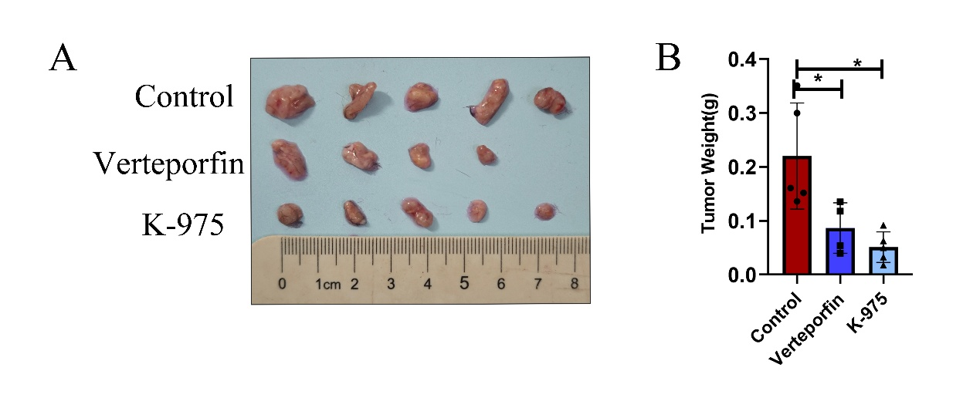

1. RNA and Protein analysis of COL1A1, COL1A2, COL3A1 and LOX in CAFs derived from hepatic cancer tissues and treated with the inhibitor of YAP/TEAD pathway VT3989 or the YAP disruptor Verteporfin in order to strengthen the involvement of this transcription coregulator in HCC progression.
Response: Eight days post YAP1 inhibitor treatment, the mice were euthanized in a humane manner, and the tumor tissues were surgically excised. Subsequently, we successfully isolated the corresponding CAFs from the tumor tissues of all three groups. One aliquot of these isolated cells is reserved for the extraction of RNA and proteins, while the remaining aliquot is utilized for cell culture experiments.
After extracting total RNA and proteins, we further conducted qPCR and Western blot experiments to ascertain the changes in the levels of YAP1, COL1A1, COL1A2, COL3A1, and LOX following the use of a YAP1 inhibitor. The specific results are shown in the figure below. After treatment with the YAP1 inhibitor, the levels of YAP1, COL1A1, COL1A2, COL3A1, and LOX were all downregulated, with the most pronounced effect observed in the K-975 group.

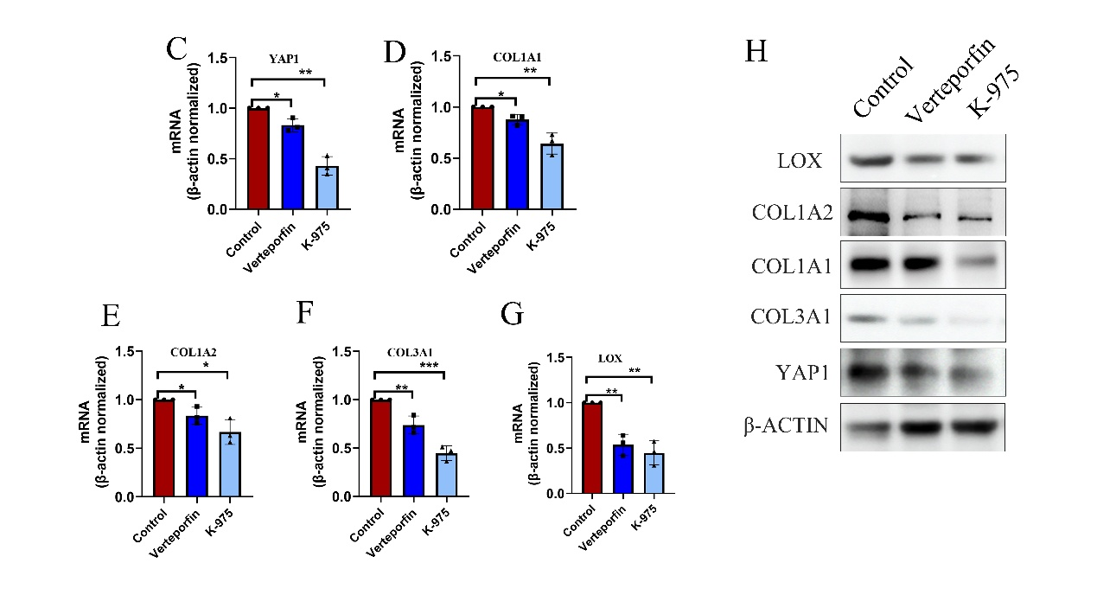
2. The concentrations of COL1A1, COL1A2, COL3A1 and LOX in supernatants of CAFs derived from hepatic cancer tissues and treated with the inhibitor of YAP/TEAD pathway VT3989 or the YAP disruptor Verteporfin.
Response: As mentioned in the previous question, we isolated CAF cells from the tumors in the control group and subsequently cultured the isolated CAF cells in a six-well plate. After the cells adhered to the plate, they were randomly divided into two groups: one group served as the control, and the other group was treated with the YAP1 inhibitor K-975 (based on the results in Figure 9, we know that K-975 has a better inhibitory effect on YAP1 compared to Verteporfin). After 48 hours, supernatants were collected from both groups and assayed for COL1A1 and COL1A2 levels using the ELISA method. The results, as shown in Figure 9I-J, indicate that compared to the control group, the levels of COL1A1 and COL1A2 were significantly reduced in the group treated with the YAP1 inhibitor K-975.

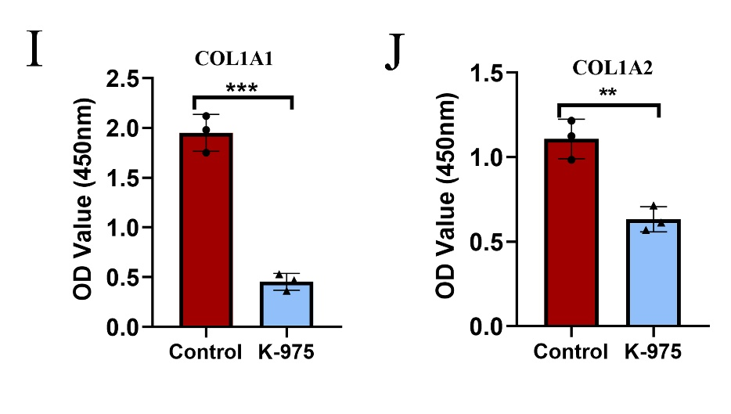
3. ChIP-Seq to identify DNA binding sites for YAP1/TEAD in hepatic cancer derived CAFs in order to categorize all YAP1 target genes and analyze the involvement in matrix stiffness.
Response: To tackle this issue, we employed the ChIPBase v3.0 database (https://rnasysu.com/chipbase3/index.php) to pinpoint genes regulated by YAP1. The findings revealed that 1,818 genes modulated by YAP1 were filtered from the database, whereas our earlier single-cell analysis distinguished 10,705 differential genes between YAP1-positive and YAP1-negative CAF groups. By intersecting these two gene sets, we uncovered 907 common genes, which we hypothesize are regulated by YAP1 within CAFs. Notably, many of these genes are implicated in the establishment of matrix stiffness, particularly LOX, COL12A1, COL4A1, COL5A3, COL6A3, COL9A3 and so on. These genes are pivotal in the creation and preservation of matrix stiffness. This content has been included in the discussion section of the newly submitted manuscript. Undoubtedly, we aim to extend this investigation in the future to directly identify YAP1's target genes in CAFs, thus refining our understanding of its underlying mechanisms.

4. Cytoskeleton protein, Focal adhesion assays and hydrogel stiffness culture system to measure matrix rigidity in co-culture CAFs/HCC cells, as well as 3D migration and invasion assays using the inhibitor of YAP/TEAD pathway VT3989 or the YAP disruptor Verteporfin.
Response: We deeply regret that, owing to constraints on time and resources, we are currently unable to finalize this experiment. However, we have conducted animal experiments, and the results, depicted in Figure 9, reveal that upon administration of YAP1 inhibitors, the expression levels of matrix stiffness-related genes COL1A1, COL1A2, COL3A1, and LOX were downregulated, resulting in a significant reduction in liver cancer volume. Furthermore, our experiments on isolated CAFs treated with a YAP1 inhibitor showed a notable downregulation of COL1A1 and COL1A2 levels in the supernatant. These findings indirectly corroborate our hypothesis, which suggests that by interfering with the expression of YAP1 in CAFs, collagen secretion diminishes, the expression of genes linked to matrix stiffness decreases, and the growth of liver cancer is suppressed. We are committed to further exploring this issue in our future research endeavors and will supplement our study with additional experimental data, which we anticipate presenting in our next paper.
5. The Authors should better specify the characteristics and markers of five distinct CAF subpopulations they found. Furthermore, they should describe the biological role of genes like RERGL, KCNA5, CASQ2, and MUSTN1…. (Figure 2 E-J) and not just as a list of genes.
Response: To address this, we have revised the relevant sections of the manuscript to provide a more detailed description of the markers that define each CAF subset (lines 283-287, pages 10).
The specific content is as follows:
The markers for these five different CAF subsets are as follows: cluster0-CAF (marked by CD36, THBS4, LPL and ITGLC2), cluster1-CAF (marked by RERGL, KCNA5, CASQ2, and MUSTN1), cluster2-CAF (marked by ITGBL1, MOXD1, SFRP4 and PTGDS), cluster3-CAF (marked by COLEC10, TMEM56, IGFBP3 and CXCL12), and cluster4-CAF (marked by IGLC3, XIST, HLA-DRA and RGS1).
Furthermore, we have expanded our discussion on the biological roles of genes such as ITGBL1, MOXD1, SFRP4, and PTGDS, drawing on recent research findings and their implications for CAF biology and cancer progression (lines 303-308, pages 11).
The specific content is as follows:
Through literature review, it has been found that the molecules ITGBL1, MOXD1, SFRP4, and PTGDS are closely associated with fibroblast function, fibrosis generation, maintenance of matrix stiffness, the remodeling process of the extracellular matrix and cancer progression [27-33]. In contrast, there are currently limited research reports on the roles of RERGL, KCNA5, CASQ2, and MUSTN1 in the aforementioned physiological or pathological activities. Therefore, we hypothesize that the Cluster2-CAF subpopulation is more closely related to the formation of matrix stiffness.

6. The Authors should highlight in Figure 7 YAP1, a core protein in the Hippo signaling pathway, as one of the main transcriptional regulators involved in tumor mechanical stress. In Figure 7 YAP1 does not appear among the transcriptional factors analyzed, nevertheless in Figure 8 the Authors emphasize YAP1 pathway as one of the main upregulated in CAFs and involved in the stiffness of the hepatic cancer stroma.
Response: By checking the list of differentially expressed transcription factors, we determined that YAP1-TEAD1 is a differential transcription factor between different CAF subgroups. Furthermore, we normalized the data and regenerated the graph, as shown in Figure 7A. When compared to other CAF subsets, the expression levels of YAP1-TEAD are notably elevated in the cluster 2 and cluster 3 CAF subsets. Taking this observation into account, and by further integrating insights from existing literature reports, we hypothesize that CAFs exhibiting varying levels of YAP1 exert considerable influence on the survival outcomes of liver cancer.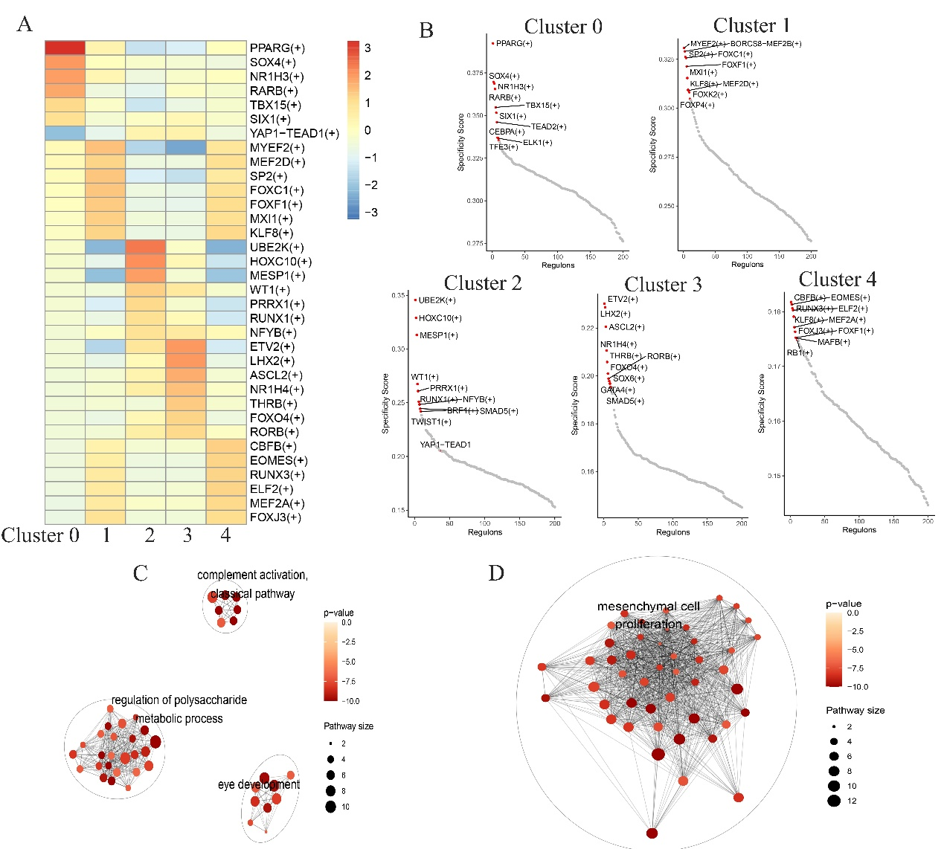

7. Although the manuscript offers critical insights into how CAFs influence the matrix rigidity involved in hepatic cancer metastatic phenotype, it is necessary to argue better and reorganize the concepts in a less confusing way. In particular, the Authors should revise all Discussion and Results sections. The whole manuscript should be more connected in concepts and information.
Response: Based on the reviewer's suggestions, we have rearranged the Results and Discussion sections of the article and made adjustments to some content to make the article more coherent and easier to understand. We hope our revisions can meet your requirements. Please let us know if you have any further questions or require additional information.

8. panels A-B of the Figure 3 and panels B-C of the Figure 6 should be enlarged.
Response: We appreciate your constructive feedback, which is crucial for improving the quality of our work. Based on your suggestion, we have revised Figure 3 and Figure 6.
The modified figures are shown below:
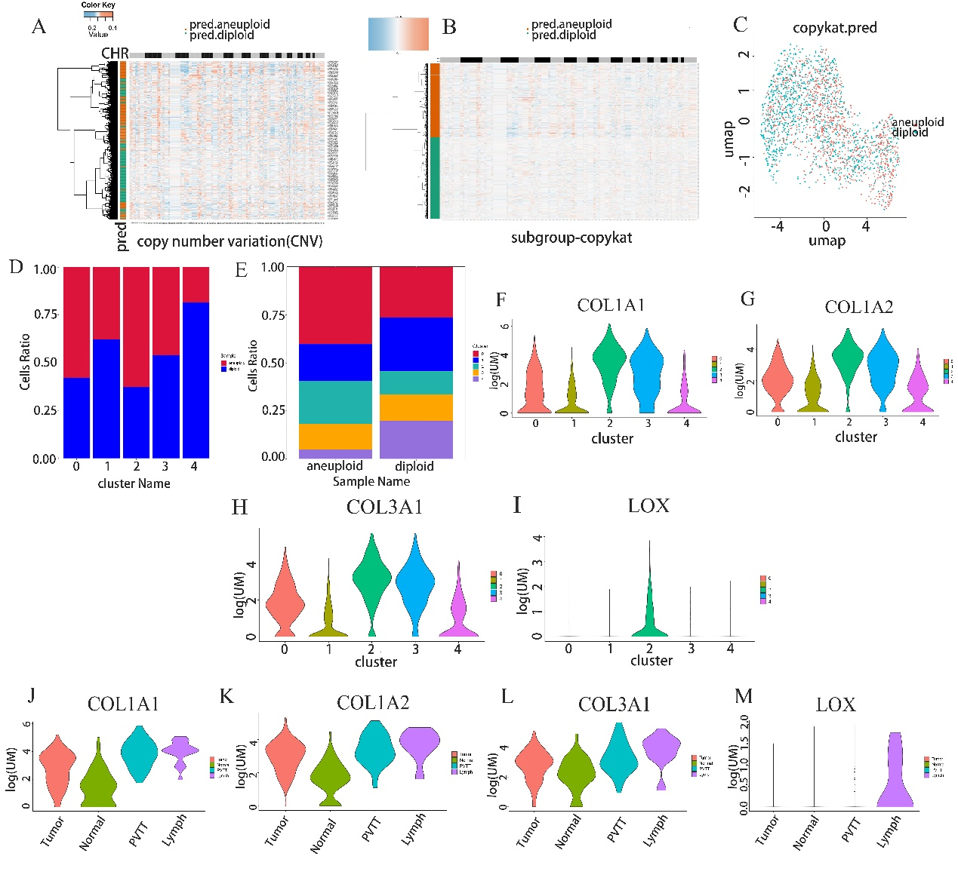
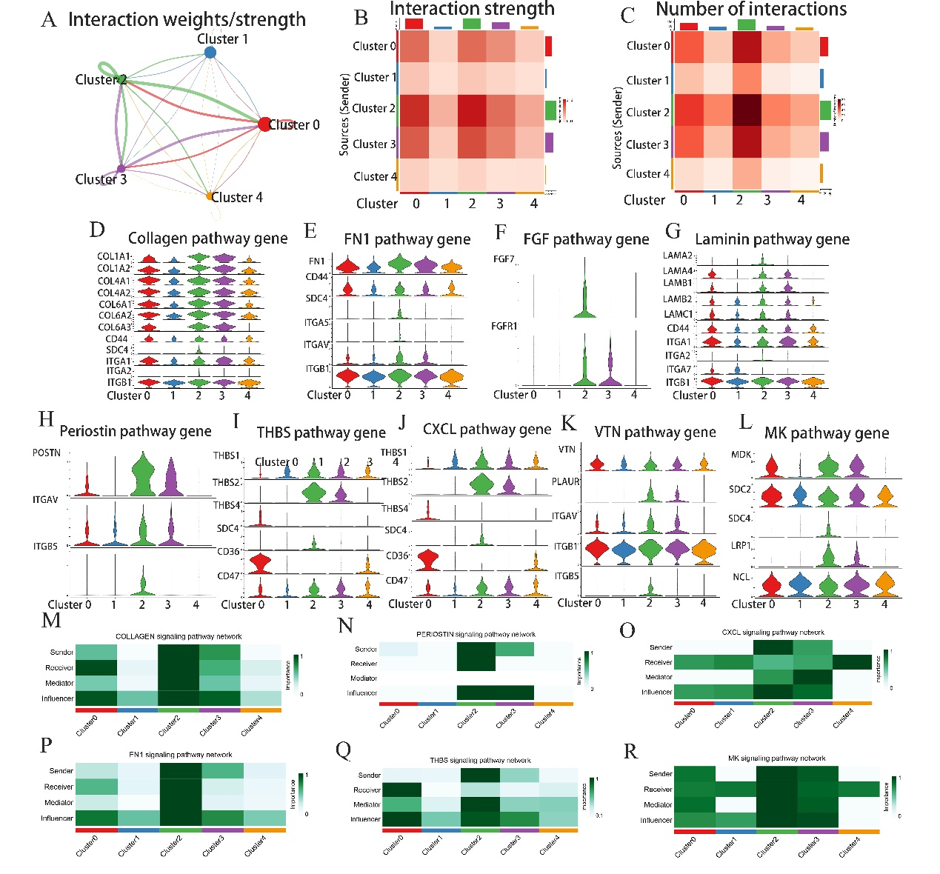

9. Finally, the manuscript should be revised to be suitable for the publication in JTM journal.
Response: We have conducted comprehensive revisions to the article based on the reviewer's suggestions and the journal's requirements to ensure that our manuscript meets all the standards and guidelines set by the JTM journal.
To sum up, it is a reply to the comments of the two reviewers one by one. Once again, thank the reviewers for their suggestions and questions. We hope our modifications can meet your requirements. If any questions, please feel free to contact us. Thanks a lot!

