Supplementary Material

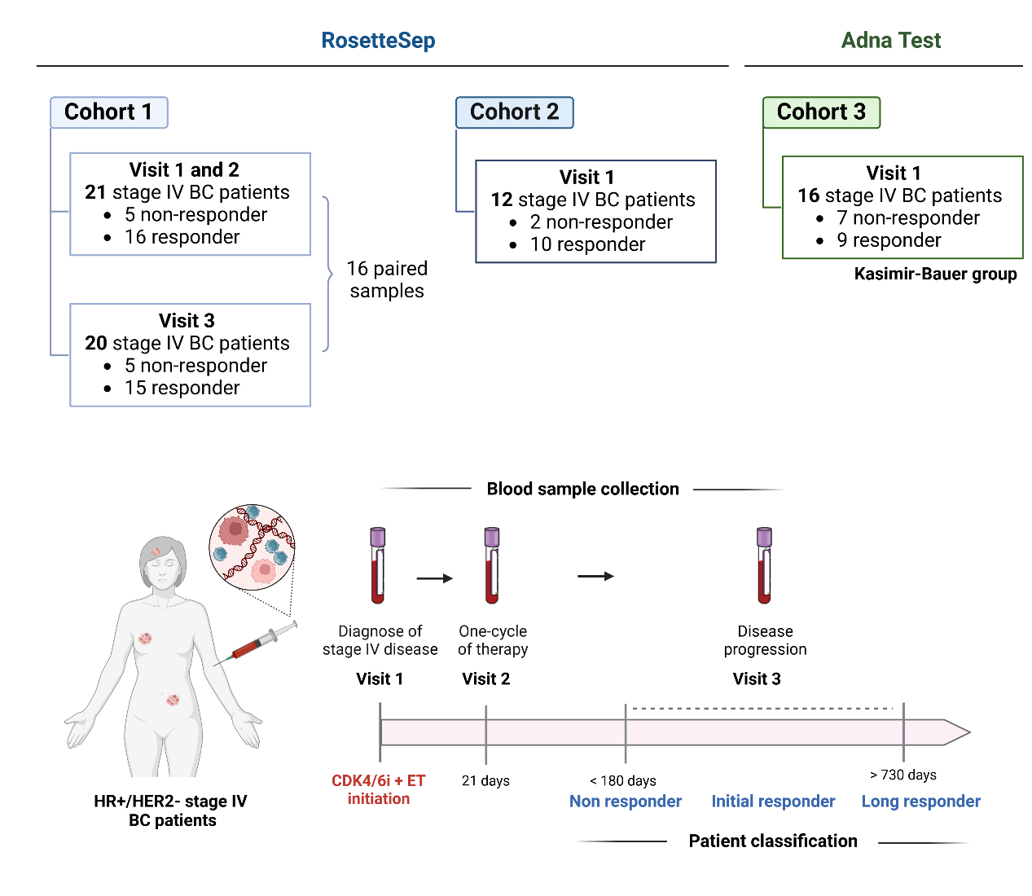
Figure S1. Patients and samples. A) Scheme of the three HR+/HER2- stage IV BC patient’s cohorts. A total of 53 patients were included. The cohort 1 included 25 HR+/HER2- stage IV BC patients. The cohort 2 is an internal validation cohort formed by 12 HR+/HER2-stage IV BC patients. The cohort 3 is an external validation cohort that includes 16 patients whose CTCs were isolated with Adna Test instead of RosetteSep. B) Blood sample collection and patient classification considering progression-free survival. Blood samples were collected when the stage IV disease was diagnosed (visit 1), after one cycle of therapy (visit 2) and at progression (visit 3). Patients with a PFS < 180 days were defined as non-responders, patients with a PFS between 180 and 730 days as initial responders and patients with a PFS >730 days as long responders.

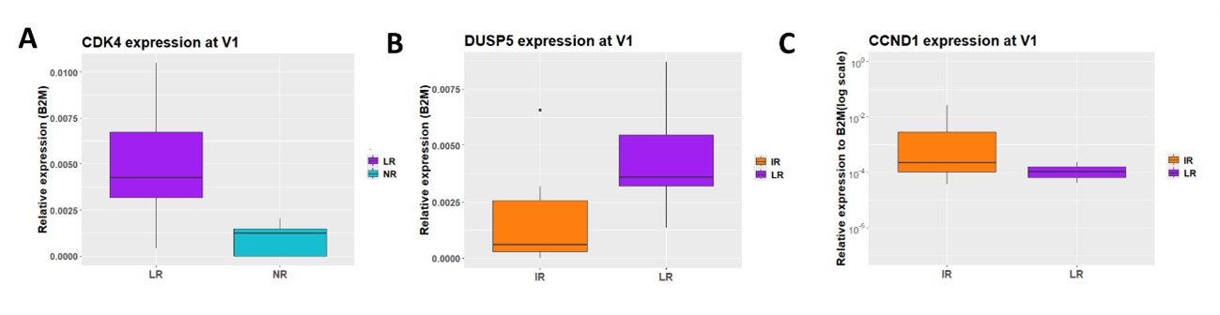
Figure S2. Normalized gene expression in CTCs of the depicted genes analysed by RT-qPCR at visit 1. A) CDK4 expression from non-responder (NR, n=5) and long responder (LR, n=7) patients. B) CCND1 expression from initial (IR, n=9) and long responder (LR, n=7) patients. C) DUSP5 expression from initial (IR, n=9) and long responder (LR, n=7) patients. CTC gene expression was analysed by RT-qPCR and normalized to B2M and matched PBMCs (Wilcoxon test (p-value < 0.05 (*)).
STAT-3 induction in luminal breast cancer cells
To simulate the increased gene expression of STAT-3 in CTCs from patients with luminal metastatic breast cancer resistant to combined therapy with CDK4/6 inhibitors, we aimed to obtain a cellular model that presents the activated STAT-3 gene. IL-6 is a key cytokine involved in the activation of the oncogenic STAT-3 pathway. Therefore, to induce STAT-3 activation, the luminal breast cancer cell line MCF7 was treated with IL-6. MCF7 cells were treated with IL-6 at 20 ng/mL for 4 and 8 days, with dose renewal every 2 days, at concentrations previously described in the literature(1). Untreated MCF7 cells were also used as a negative control at the same time points, and MDA-MB-231 cells were used as a positive control. After 4 and 8 days, total protein was extracted from each of the cellular conditions, and Western Blot analyzed STAT-3 and p-STAT-3. The results confirm that IL-6 activates the phosphorylation of STAT-3 through the IL-6/STAT-3 pathway in the treated tumor cells (Figure S3A).
Subsequently, we wanted to verify if STAT-3 induction affected cell proliferation. To assess the effect of IL-6 on the proliferation of MCF7 cell line cells, they were treated with IL-6 at 20 ng/mL for 4 and 8 days, renewing the dose every 2 days. Cell viability was determined using an MTT assay, and was observed an increase in cell viability of 26% at 8 days (Figure S3B) compared to control MCF7 cells (p-value= 0.028).

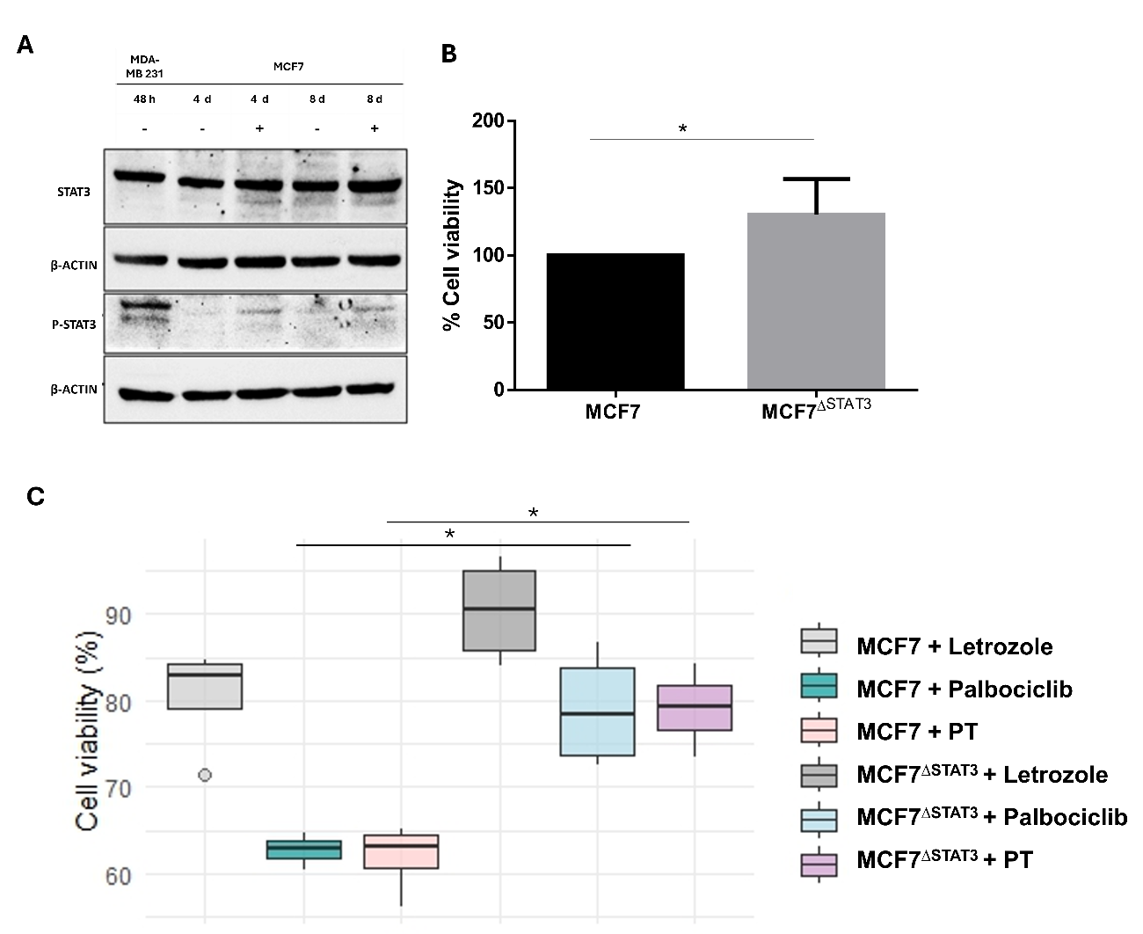
Figure S3. Induction of STAT3 in MCF7 tumor cells by IL-6. A) Detection of STAT-3 and p-STAT-3 in treated (+) MCF7 cells for 4 and 8 days with IL-6 20 ng/mL and untreated cells (-). A sample from the MDA-MB-231 line was included as a positive control. B) Effect of IL-6 on the cell viability of MCF7. Representation of the cell viability (%) in the MCF7^{∆STAT3} (treated for 8 days with IL-6 at 20 ng/mL) and MCF7 cell line (n=4). C) Cell viability (%) of MCF7 and MCF7^{ΔSTAT-3} cells (induced for 8 days with IL-6 at 20 ng/mL) treated with Letrozole (p-value = 0.11), Palbociclib (p-value =0.028) or polytherapy (PT: Letrozole plus Palbociclib) (p-value = 0.028) (n=4) normalized to cells without treatment. Wilcoxon test, p-value < 0.05 (*).
Supplementary methods
Protein Extraction and Western Blot
Cell pellets were thawed, and a cocktail containing 1X RIPA Buffer (150mM NaCl, 10mM Tris-HCl pH 7.5, 0.1% SDS, 1% Triton X100, 5mM EDTA pH 8.0, deoxycholate, and sodium salt 1%) and protease inhibitors (1mM sodium orthovanadate, 1mM PMSF, 1mM DTT, and 4mM NaF) was added, homogenized with a vortex for 30 seconds and shaken on a rotary shaker for 30 minutes at 4ºC. Next, it was centrifuged for 10 minutes at 14,000 rpm, and the supernatant was collected. Quantification was performed using the Micro BCA kit (Thermo Scientific) following the manufacturer's instructions. The samples were stored at -80ºC for further experiments.
Protein samples (30 µg/µL) was mixed with 6X Sample Buffer (Thermo Scientific) and were heated to 95ºC for 5 minutes. Electrophoresis was performed using 10 % bisacrylamide (Bio-Rad) Running gels and then were transferred to nitrocellulose membranes. The membranes were washed with TBST and blocked with 5% Skim Milk Powder (Sigma Aldrich) for 1 hour and incubated with primary antibodies overnight at 4ºC with shaking (Anti-STAT3 [ARC0045] (A306989), 1:200 (Antibodies); Anti-Phospho-Stat3 (Tyr705) (D3A7), 1:100 (Cell signalling); Anti-β-Actin, 1:1000 (abcam)). The next day, the membranes were washed with TBST and incubated with secondary antibodies for 1 hour (Anti-Mouse-HRP or Anti-Rabbit-HRP, 1:5000 (Jackson)). After membranes were washed four times with TBST for 10 minutes, a 1:1 mixture of Peroxide Solution (Thermo Scientific) and Luminol Enhancer Solution (Thermoscientific) was added and incubated for 5 min. The membranes were then developed using a chemiluminescence detection system (ChemiDoc).

Obtaining a CDK4/6i resistant cell line

Two luminal cell lines were cultured with CDK4/6 inhibitors (CDK4/6i) (Selleckchem) to generate resistant cell lines. The MCF7 cell line was cultured in DMEM with Palbociclib, while the T47D cell line was cultured in RPMI with Ribociclib.

IC50 concentration calculation: The IC50 concentration of both drugs was evaluated using the proliferative assays Thiazolyn Blue Tetrazolium Bromide (MTT) (Sigma). MCF7 cells (5000 cells per well) and T47D cells (10000 cells per well) were plated in 96-well plates. After 24 hours, escalating concentrations of Palbociclib (0.05 µM, 0.1 µM, 0.2 µM, 0.5 µM, and 0.7 µM) and Ribociclib (0.5 µM, 1 µM, 2 µM, 4 µM, and 6 µM) were added to each well. In both cases, CDK4/6i was refreshed every 2 days. After 15 days, drugs were removed and cell proliferation was measured using an MTT assay, following the manufacturer’s instructions. The IC50 was 0.2 μM for Palbociclib and 4 μM for Ribociclib.

Generation of CDK4/6i-resistant cell line: MCF7 and T47D cell lines were treated with the corresponding CDK4/6i for 5 months to generate resistant cell lines as depicted below.
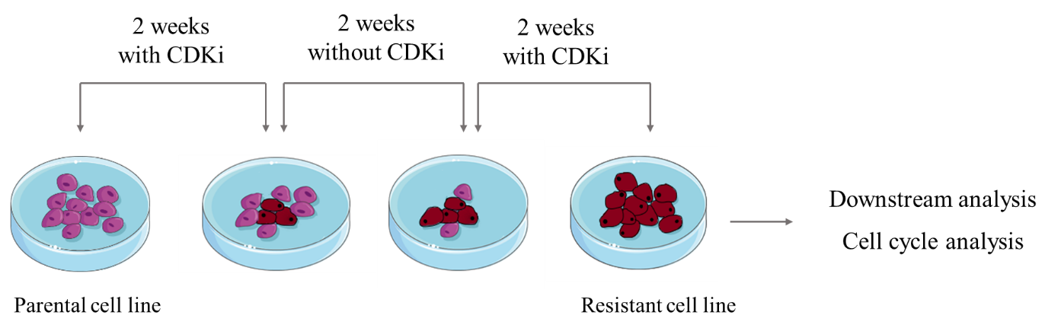

Workflow to generate cell lines resistant to CDK4/6i. Cell lines were treated with the IC50 of CDK4/6i for 2 weeks. Then, cells were cultured with fresh-DMEM for another 2 weeks to avoid senescence phenotype. After recovery, cell lines were treated again with the IC50 of CDK4/6i for 2 weeks. This process was repeated once the CDK4/6i dose was escalated to double the value of the IC50.
These cells were seeded in 150 cm² plates (3.5-4x10⁶ cells per plate). After 24 hours, when cells were over 60-70 % confluence, Palbociclib or Ribociclib was added for 2 weeks, being refreshed every 2 days. Then, cells were cultured without the drug for the other 2 weeks. This process was repeated with the IC50 value and then, with the double of the IC50 to generate a stable population of cells growing with CDK inhibitors. Parental cells were grown in parallel and exposed to DMSO as a control, mimicking the amount of CDK4/6i used in the treated plates.
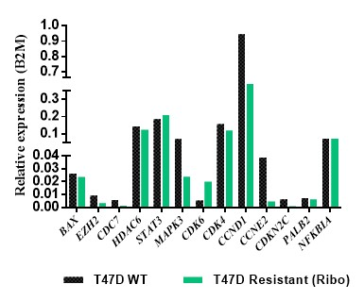
Figure S4. Gene expression of the depicted genes in T47D luminal parental (black) and resistant to Ribociclib (green) cell lines.
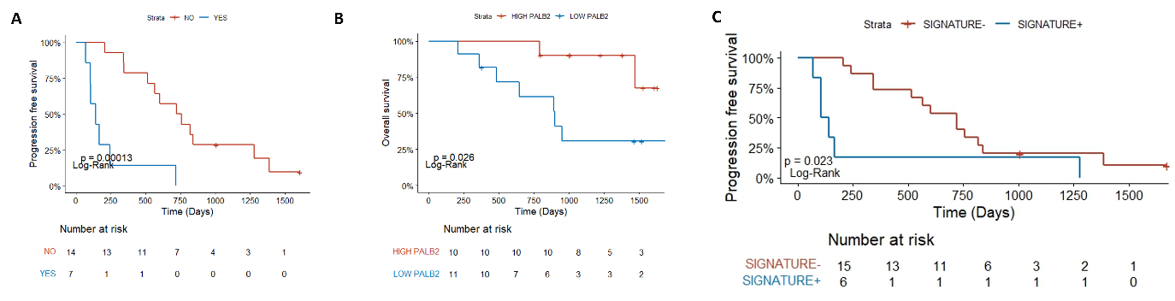
Figure S5. CTC gene expression associated with patients’ outcomes (n=21). Kaplan-Meier plot for A) Progression-Free Survival of patients categorized by their CTC CDK4^{low}STAT3^{high} status at visit 1. Patients exhibiting this expression (Yes) are denoted in blue, while those not manifesting it (No) are depicted in red. B) Overall Survival of patients regarding CTC PALB2 expression at visit 1.C) Progression-free survival based on CTC signature (STAT3^{high}PRKCB^{high}CDK6^{low}) status comparing signature-positive versus signature-negative patients. Statistics were performed by log-rank test. Stratification was performed considering the median expression value for each gene to define high/low levels.
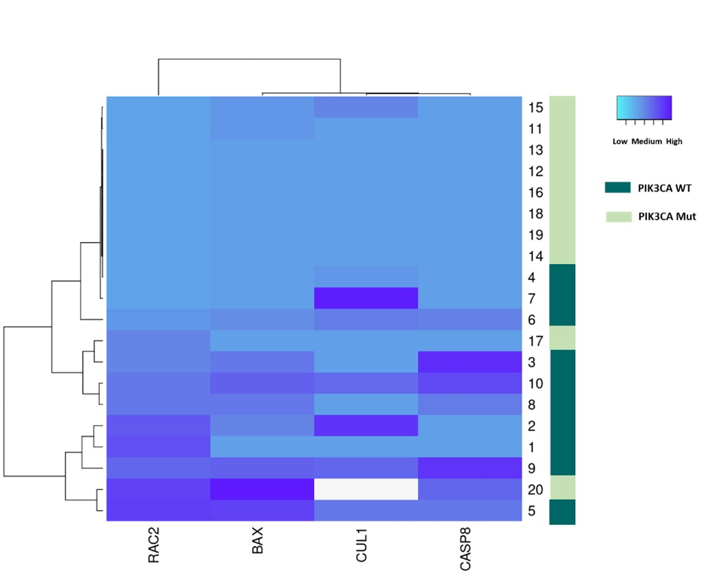
Figure S6. PIK3CA mutational status at visit 3 associates with expression levels of CTC at disease progression. The heatmap shows the gene expression profiles of the depicted genes analyzed by RT-qPCR (normalized to B2M and matched PBMCs, n=20). Mutant PIK3CA status is depicted in light green, while wild-type status is indicated in dark green. White box refers to not available data. The Heatmapper tool was utilized to generate the heatmap.
References
1. Raynard C, Ma X, Huna A, Tessier N, Massemin A, Zhu K, et al. NF-κB-dependent secretome of senescent cells can trigger neuroendocrine transdifferentiation of breast cancer cells. Aging Cell. 2022;21(7).

