Supplementary Materials

Figure S1
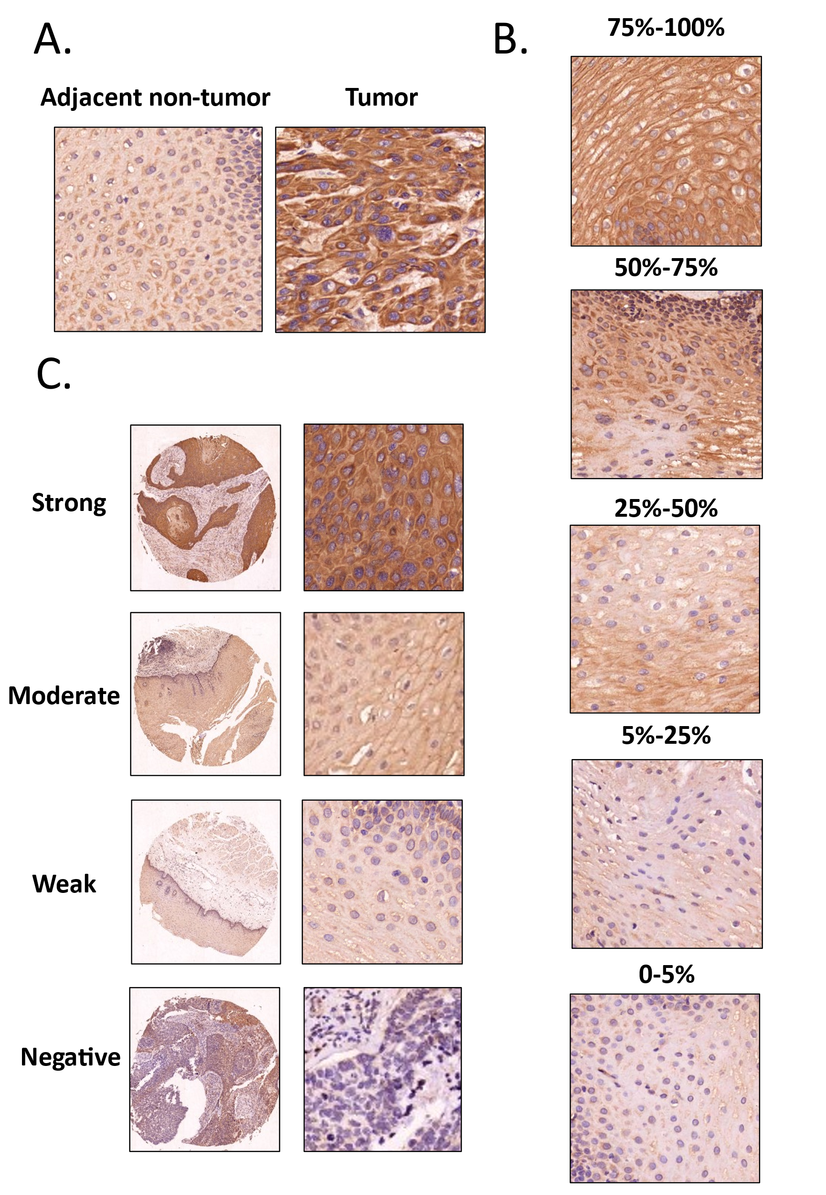
Fig. S1 Scoring criteria for immunohistochemical findings in TMA of ESCC
A. Example of ESCC tumour tissue and adjacent normal paracancerous epithelial tissue.
B. The percentage of positively stained cells was divided into five categories: <5% was 0, 6-25% was 1, 26-50% was 2, 51-75% was 3, and >75% was 4. C.The intensity of immunohistochemical staining was divided into five categories according to conventional criteria: negative was 0; weak was 1; moderate was 2; or strong was 3.

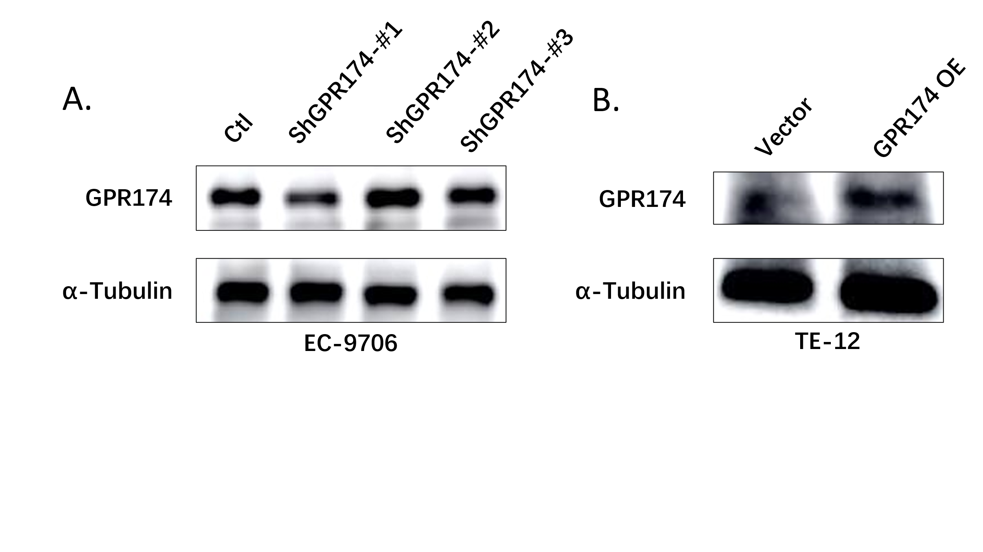
Figure S2
Fig. S2 Overexpression and knockdown of ESCC cell lines infected with GPR174 lentivirus

Table S1 Core sequences of lentivirus about shGPR174
Target gene | Sequences
Ctl | 5’-TTCTCCGAACGTGTCACGT-3’
shGPR174-#1 | 5’-CCACCATGACACCTGAATTAT-3’
shGPR174-#2 | 5’-CGCTTCTGATTGTCCTATATT-3’
shGPR174-#3 | 5’-GCTGACTTACTACAAGTTCTT-3’

Table S2 Primers used for GPR174 genes amplification
Target gene | Sequence(5’-3’)
GPR174 | FW:CCAACTTTGTGCCAACCGGTCGCCACCATGCCTGCTAATTACACGTGTACCAGG  REV:CACACATTCCACAGGAATTTTAGCATAATTCAGGTGTCATGG

