Supplemental Table 9. List of the suggested drugs for proliferative diabetic retinopathy.
Name | Score | Description | Chemical Formula | Structure
Altizide | -99.93 | Thiazide diuretic | C₁₁H₁₄ClN₃O₄S₃ | 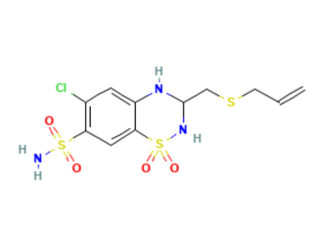
Practolol | -99.93 | Adrenergic receptor antagonist | C₁₄H₂₂N₂O₃ | 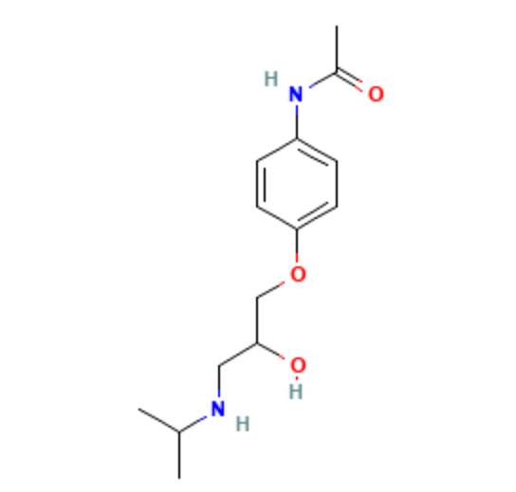
CAY-10578 | -99.93 | Casein kinase inhibitor | C₁₀H₃I₄NO₄ | 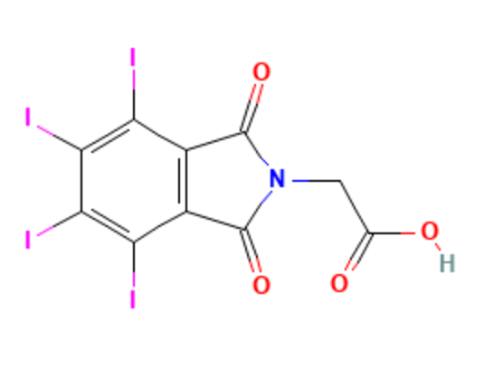
TER-14687 | -99.89 | Inhibitor of translocation of PKCq in T cells | C₁₂H₁₅NO.HCl | 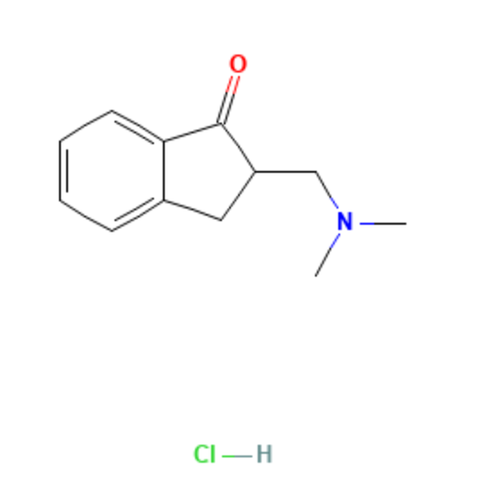
Triciribine | -99.86 | AKT inhibitor | C₁₃H₁₆N₆O₄ | 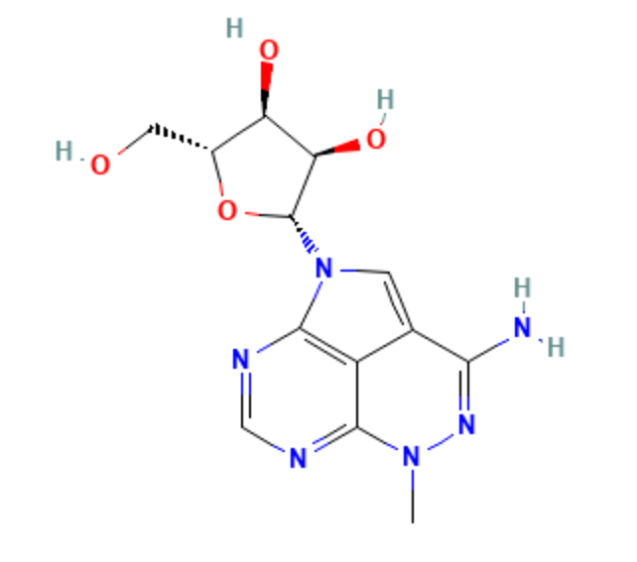
Altanserin | -99.82 | Serotonin receptor antagonist | C₂₂H₂₂FN₃O₂S | 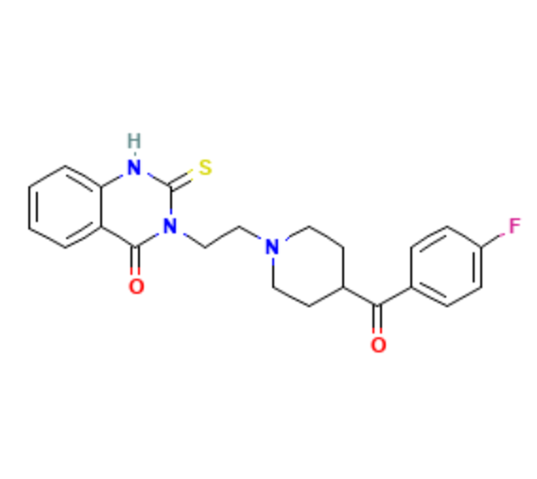
Vecuronium | -99.82 | Acetylcholine receptor antagonist | C₃₄H₅₇N₂O₄ | 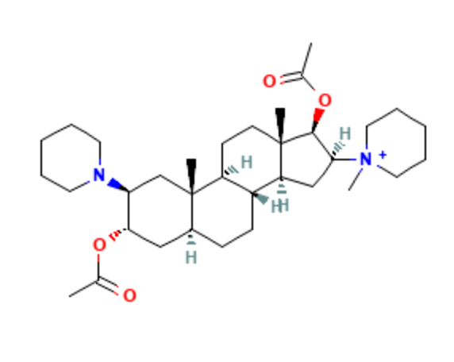
CAY-10577 | -99.61 | Casein kinase inhibitor | C₁₀H₅Cl₂NO₃ | 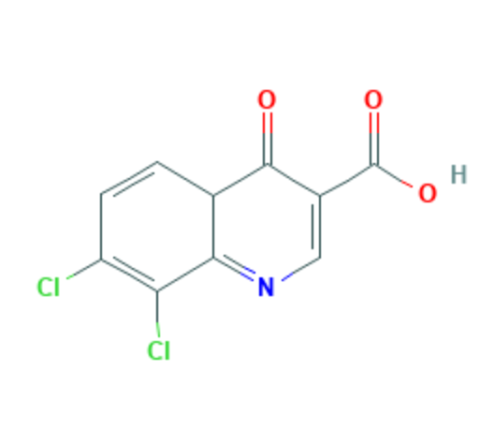
RO-60-0175 | -99.58 | Serotonin receptor agonist | C₁₁H₁₂ClFN₂ ·C₄H₄O₄ | 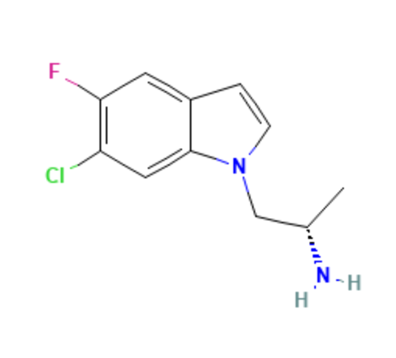
Topiramate | -99.47 | Carbonic anhydrase inhibitor | C₁₂H₂₁NO₈S | 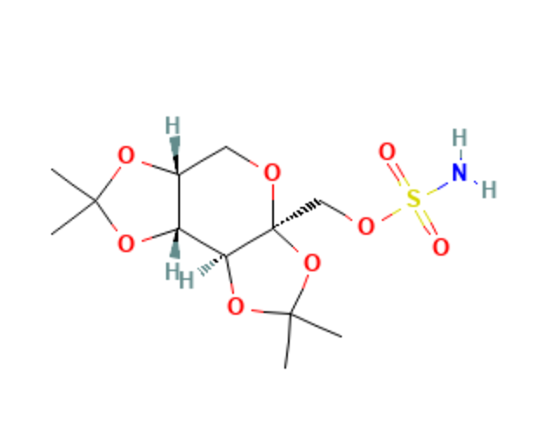
VU-0420363-1 | -99.44 | SARS coronavirus 3C-like protease inhibitor | C₁₉H₁₈N₄OS₂ | 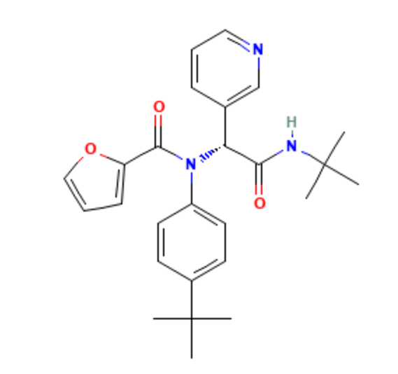
LY-341495 | -99.37 | Glutamate receptor antagonist | C₂₀H₁₉NO₅ | 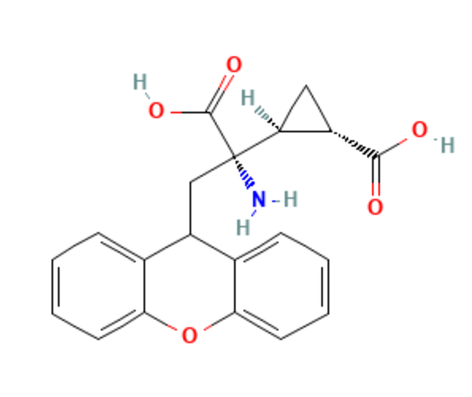
Ecopipam | -99.37 | Dopamine receptor antagonist | C₁₉H₂₀ClNO | 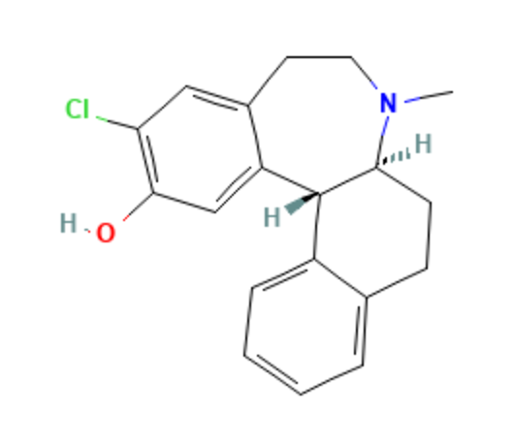
Esmolol | -99.37 | Adrenergic receptor antagonist | C₁₆H₂₅NO₄ | 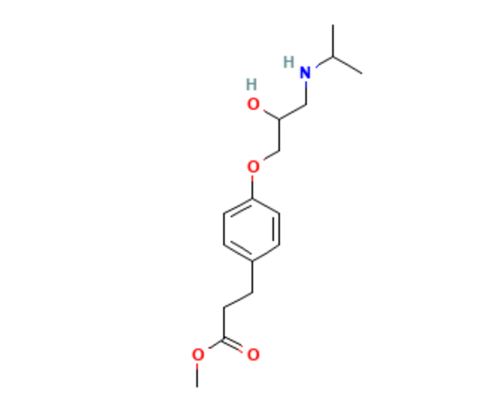
O-1918 | -99.35 | Cannabinoid receptor antagonist | C₁₉H₂₆O₂ | 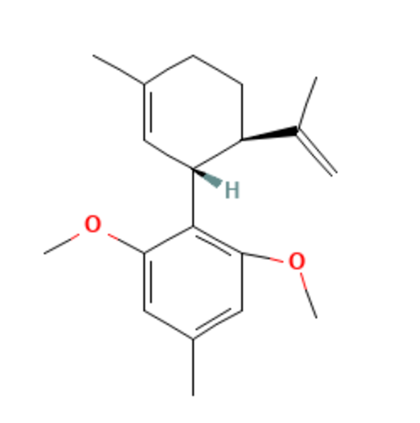
* Chemical formulas and structures are sourced from the PubChem database.

