Table of Contents
Table S1 STROBE Statement 1
Table S2 Abbreviation of variables. 4
Figure S1 6
Figure S2 7
Figure S3 8
Figure S4 9
Table S3 Correlation analysis. 10
Table S4 Row percentage distribution. 10
Table S5 Chi-square test results. 10
Table S6 Fisher's exact test results. 10
Table S7 Logistic regression model. 10
Table S8 Univariate analysis using HAMA continuous as the outcome variable. 11
Table S9 Single factor analysis using HAMA Binary classification as the outcome variable. 13
Table S10 Summary statistics for three metals. 15
Table S11 Bimetallic and polymetallic models for heavy metals, weighted. 15
Table S12 Stratified analysis of Hg (μg/L) and anxiety. 16
Table S13 Stratified analysis of Pb (μg/dL) and anxiety. 18
Table S14 Stratified analysis of Cd (μg/L) and anxiety. 20
Table S15 Gene molecular functions and related diseases. 22
Table S16 Sensitivity analysis of protein models and clinical models in each subgroup. 24

Table S1 STROBE Statement
—checklist of items that should be included in reports of observational studies.
 | Item No | Recommendation
Title and abstract | 1 | (a) Indicate the study’s design with a commonly used term in the title or the abstract
Title and abstract | 1 | (b) Provide in the abstract an informative and balanced summary of what was done and what was found
Introduction
Background/rationale | 2 | Explain the scientific background and rationale for the investigation being reported
Objectives | 3 | State specific objectives, including any prespecified hypotheses
Methods
Study design | 4 | Present key elements of study design early in the paper
Setting | 5 | Describe the setting, locations, and relevant dates, including periods of recruitment, exposure, follow-up, and data collection
Participants | 6 | (a) Cohort study—Give the eligibility criteria, and the sources and methods of selection of participants. Describe methods of follow-up  Case-control study—Give the eligibility criteria, and the sources and methods of case ascertainment and control selection. Give the rationale for the choice of cases and controls  Cross-sectional study—Give the eligibility criteria, and the sources and methods of selection of participants
Participants | 6 | (b) Cohort study—For matched studies, give matching criteria and number of exposed and unexposed  Case-control study—For matched studies, give matching criteria and the number of controls per case
Variables | 7 | Clearly define all outcomes, exposures, predictors, potential confounders, and effect modifiers. Give diagnostic criteria, if applicable
Data sources/ measurement | 8* | For each variable of interest, give sources of data and details of methods of assessment (measurement). Describe comparability of assessment methods if there is more than one group
Bias | 9 | Describe any efforts to address potential sources of bias
Study size | 10 | Explain how the study size was arrived at
Quantitative variables | 11 | Explain how quantitative variables were handled in the analyses. If applicable, describe which groupings were chosen and why
Statistical methods | 12 | (a) Describe all statistical methods, including those used to control for confounding
Statistical methods | 12 | (b) Describe any methods used to examine subgroups and interactions
Statistical methods | 12 | (c) Explain how missing data were addressed
Statistical methods | 12 | (d) Cohort study—If applicable, explain how loss to follow-up was addressed  Case-control study—If applicable, explain how matching of cases and controls was addressed  Cross-sectional study—If applicable, describe analytical methods taking account of sampling strategy
Statistical methods | 12 | (e) Describe any sensitivity analyses
Participants | 13* | (a) Report numbers of individuals at each stage of study—eg numbers potentially eligible, examined for eligibility, confirmed eligible, included in the study, completing follow-up, and analysed
 |  | (b) Give reasons for non-participation at each stage
 |  | (c) Consider use of a flow diagram
Descriptive data | 14* | (a) Give characteristics of study participants (eg demographic, clinical, social) and information on exposures and potential confounders
 |  | (b) Indicate number of participants with missing data for each variable of interest
 |  | (c) Cohort study—Summarise follow-up time (eg, average and total amount)
Outcome data | 15* | Cohort study—Report numbers of outcome events or summary measures over time
 |  | Case-control study—Report numbers in each exposure category, or summary measures of exposure
 |  | Cross-sectional study—Report numbers of outcome events or summary measures
Main results | 16 | (a) Give unadjusted estimates and, if applicable, confounder-adjusted estimates and their precision (eg, 95% confidence interval). Make clear which confounders were adjusted for and why they were included
 |  | (b) Report category boundaries when continuous variables were categorized
 |  | (c) If relevant, consider translating estimates of relative risk into absolute risk for a meaningful time period
Other analyses | 17 | Report other analyses done—eg analyses of subgroups and interactions, and sensitivity analyses
Discussion
Key results | 18 | Summarise key results with reference to study objectives
Limitations | 19 | Discuss limitations of the study, taking into account sources of potential bias or imprecision. Discuss both direction and magnitude of any potential bias
Interpretation | 20 | Give a cautious overall interpretation of results considering objectives, limitations, multiplicity of analyses, results from similar studies, and other relevant evidence
Generalisability | 21 | Discuss the generalisability (external validity) of the study results
Other information
Funding | 22 | Give the source of funding and the role of the funders for the present study and, if applicable, for the original study on which the present article is based
*Give information separately for cases and controls in case-control studies and, if applicable, for exposed and unexposed groups in cohort and cross-sectional studies.
Note: An Explanation and Elaboration article discusses each checklist item and gives methodological background and published examples of transparent reporting. The STROBE checklist is best used in conjunction with this article (freely available on the Web sites of PLoS Medicine at http://www.plosmedicine.org/, Annals of Internal Medicine at http://www.annals.org/, and Epidemiology at http://www.epidem.com/). Information on the STROBE Initiative is available at www.strobe-statement.org.

Table S2 Abbreviation of variables.
 | Variable name | Data type
HAMD | Hamilton Depression Scale | Quantitative data
Gender | - | Categorical information
Age | - | Quantitative data
Education | - | Quantitative data
BMI | Body Mass Index | Quantitative data
Smoking | - | Categorical information
Hypertension | - | Categorical information
DM | Diabetes Mellitus | Categorical information
Hyperlipidemia | - | Categorical information
VRF | Vascular Risk Factors | Quantitative data
HAMA | Hamilton Anxiety Scale | Quantitative data
MMSE | Mini-mental State Examination | Quantitative data
VFT | Verbal Fluency Test | Quantitative data
TMT-A | Trail Making Test A | Quantitative data
TMT-B | Trail Making Test B | Quantitative data
Stroop word | Stroop Word Test | Quantitative data
Stroop-color | Stroop Color Test | Quantitative data
Stroop-color-word | Stroop Color Word Test | Quantitative data
VST | Victoria Stroop Test | Quantitative data
IADL | Instrumental Activities of Daily Living Scale | Quantitative data
GLU | Blood Glucose | Quantitative data
TC | Total Cholesterol | Quantitative data
TG | Triglyceride | Quantitative data
LDL-C | Low-Density Lipoprotein Cholesterol | Quantitative data
HDL-C | High-Density Lipoprotein Cholesterol | Quantitative data
Hg | Mercury | Quantitative data
Pb | Lead | Quantitative data
Cd | Cadmium | Quantitative data
ApoE4 | Apolipoprotein E4 | Categorical information
ApoE3 | Apolipoprotein E3 | Categorical information

Figure S1
Forest plot showing the correlation between clinical factors and anxiety in the study population.

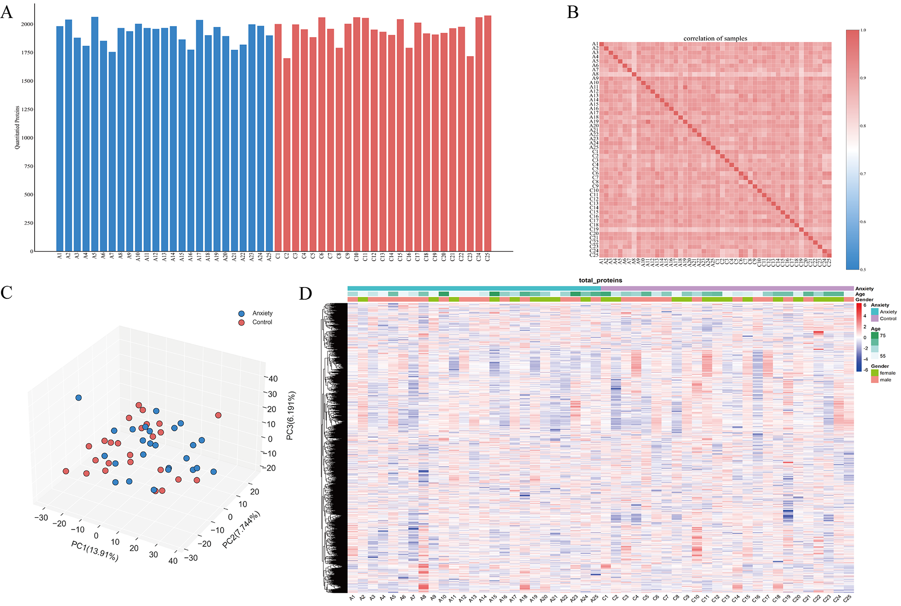

Figure S2
(A) Quantitative protein distribution plot illustrating the amount of protein detected in each sample. Blue samples represent individuals with anxiety, and red samples represent individuals without anxiety. (B) Heatmap depicting correlations between samples. (C) PCA (Principal Component Analysis) plot of detected proteins, where each point represents a sample; blue represents the anxiety group and red represents the no-anxiety group. (D) Quantitative heatmap of detected proteins.

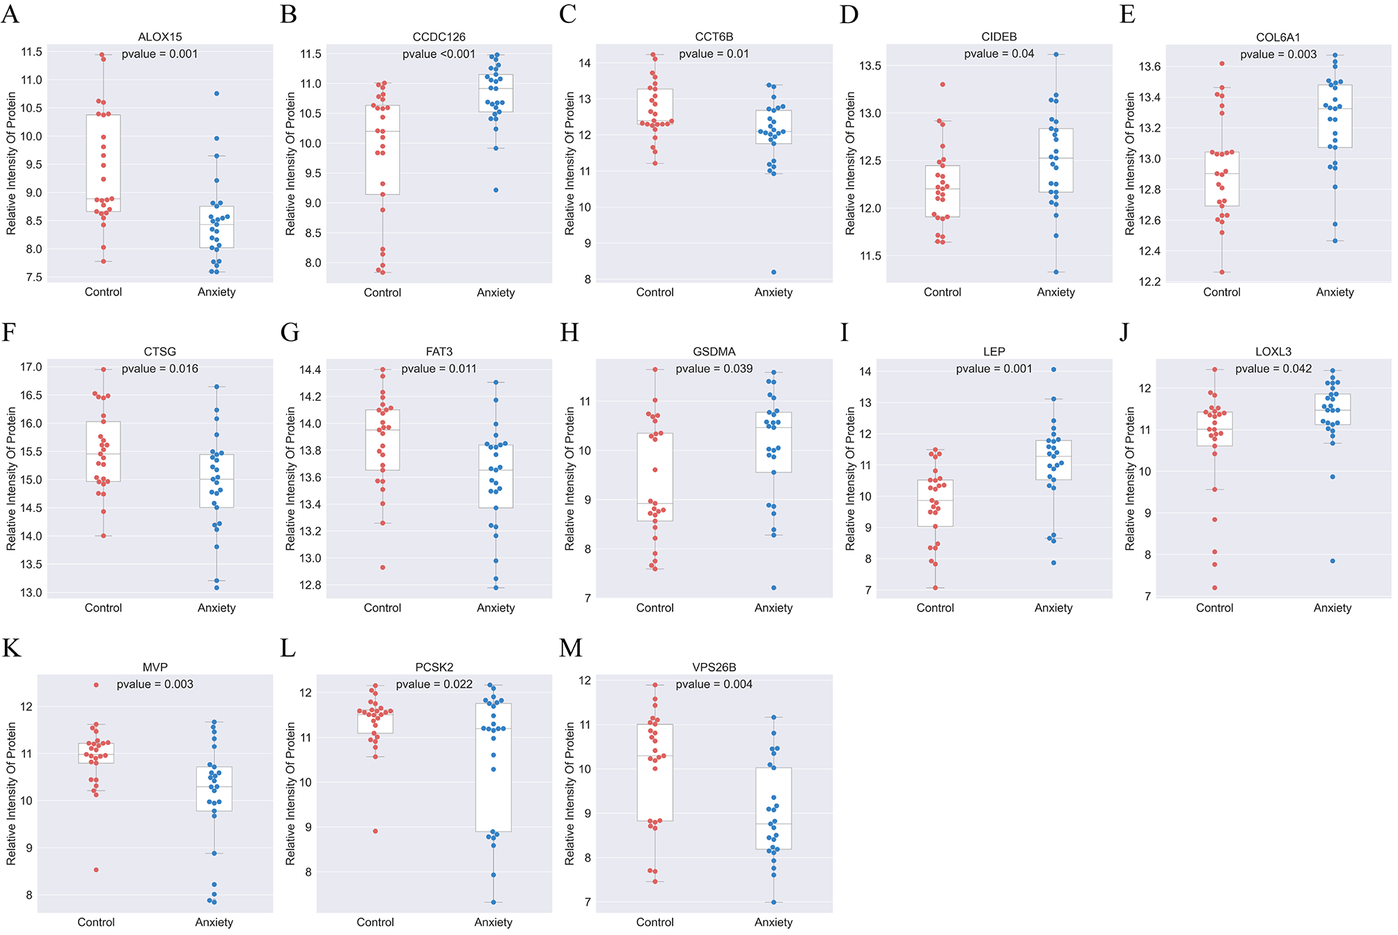

Figure S3
Expression levels of 13 proteins screened by LASSO (Least Absolute Shrinkage and Selection Operator) regression in samples.

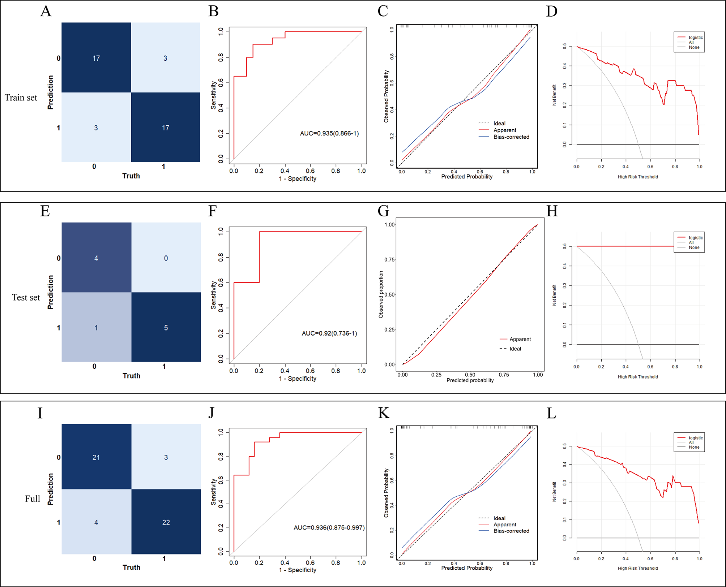

Figure S4
Evaluation results of protein models selected by random combination.
Training set (A) Confusion matrix (B) ROC curve (C) Calibration curve (D) Decision curve.
Test set (E) Confusion matrix (F) ROC curve (G) Calibration curve (H) Decision curve.
Full set (I) Confusion matrix (J) ROC curve (K) Calibration curve (L) Decision curve.

Table S3 Correlation analysis.
Var 1 | Var 2 | Correlation | 95%CI low | 95%CI up | P value | t | df | Method
MMSE.CONT: MMSE continuous | HAMA.CONT: HAMA continuous | -0.4123 | -0.6196 | -0.1513 | 0.0029 | -3.1356 | 48 | Pearson

Table S4 Row percentage distribution.
AN | CI: 0 | CI: 1 | Total
0 | 19 (76.00%) | 6 (24.00%) | 25 (100%)
1 | 6 (24.00%) | 19 (76.00%) | 25 (100%)

Table S5 Chi-square test results.
Chi-square | df | P .value | Method
13.52 | 1 | 0.0002 | Pearson's Chi-squared test
11.52 | 1 | 0.0007 | Pearson's Chi-squared test with Yates' continuity correction

Table S6 Fisher's exact test results.
Odds ratio | 95% CI low | 95% CI high | P value | Method
9.4704 | 2.3487 | 45.2155 | 0.0005 | two.sided
9.4704 | 0.0000 | 35.8344 | 1.0000 | less
9.4704 | 2.8208 | Inf | 0.0003 | greater

Table S7 Logistic regression model.
Exposure | AN
CI
0 | 1
1 | 11.47 (1.03, 127.47) 0.0470
Data in the table: OR (95%CI)
P-value Outcome variable: AN
Exposure variable: CI.
Adjust model adjust for: GENDER; AGE continuous; EDUCATION continuous; SMOKING; BMI; HYPERTENSION; DM; HYPERLIPIDEMIA; HG; PB; CD

Table S8 Univariate analysis using HAMA continuous as the outcome variable.
 |  | HAMA continuous
Variables class | Statistics | β (95%CI） | P value
AGE | 62.60 ± 6.07 | 0.02 (-0.22, 0.25) | 0.8928
EDUCATION | 11.92 ± 2.78 | -0.02 (-0.53, 0.49) | 0.9522
BMI | 23.98 ± 2.76 | -0.28 (-0.79, 0.23) | 0.2839
HAMD | 8.68 ± 6.83 | 0.47 (0.31, 0.63) | <0.0001
MMSE | 23.96 ± 3.73 | -0.56 (-0.90, -0.21) | 0.0029
VRF | 9.32 ± 3.85 | 0.18 (-0.18, 0.55) | 0.3273
IADL | 16.32 ± 8.70 | 0.05 (-0.11, 0.22) | 0.5256
VFT | 30.86 ± 9.97 | -0.12 (-0.26, 0.02) | 0.0917
TMT_A | 71.75 ± 38.08 | 0.07 (0.03, 0.10) | 0.0002
TMT_B | 138.56 ± 88.73 | 0.01 (-0.01, 0.02) | 0.4778
STROOP_WORD | 30.17 ± 25.49 | 0.05 (-0.01, 0.10) | 0.0970
STROOP_COLOR | 36.63 ± 29.51 | 0.04 (-0.01, 0.09) | 0.0982
STROOP_COLOR_WORD | 57.93 ± 40.15 | 0.03 (-0.01, 0.06) | 0.1464
VST | 24.58 ± 26.56 | 0.01 (-0.04, 0.07) | 0.6313
GLU | 5.78 ± 2.40 | -0.00 (-0.60, 0.59) | 0.9890
TC | 4.13 ± 1.12 | 1.43 (0.23, 2.64) | 0.0241
TG | 1.55 ± 0.76 | 0.69 (-1.16, 2.55) | 0.4673
LDL_C | 2.39 ± 0.80 | 1.99 (0.30, 3.67) | 0.0253
HDL_C | 1.10 ± 0.49 | 1.58 (-1.27, 4.43) | 0.2838
Hg | 4.04 ± 1.85 | 0.40 (-0.37, 1.16) | 0.3126
Pb | 5.41 ± 2.82 | -0.49 (-0.98, -0.01) | 0.0505
Cd | 4.89 ± 3.12 | 0.50 (0.07, 0.93) | 0.0285
GENDER
Female | 28 (56.00%) | 0
Male | 22 (44.00%) | -0.63 (-3.45, 2.20) | 0.6660
Age(≥65years)
No | 30 (60.00%) | 0
Yes | 20 (40.00%) | -0.77 (-3.63, 2.10) | 0.6020
SMOKING
No | 35 (70.00%) | 0
Yes | 15 (30.00%) | 0.49 (-2.58, 3.55) | 0.7575
HYPERTENSION
No | 16 (32.00%) | 0
Yes | 34 (68.00%) | 3.78 (0.96, 6.60) | 0.0114
HYPERLIPIDEMIA
No | 33 (66.00%) | 0
Yes | 17 (34.00%) | -3.16 (-5.99, -0.33) | 0.0338
DM
No | 35 (70.00%) | 0
Yes | 15 (30.00%) | -1.13 (-4.19, 1.92) | 0.4703
Hg(>5.8μg/L)
No | 41 (82.00%) | 0
Yes | 9 (18.00%) | 1.58 (-2.05, 5.21) | 0.3983
Pb((>5μg/dL)
No | 23 (46.00%) | 0
Yes | 27 (54.00%) | -2.58 (-5.30, 0.15) | 0.0699
Cd(＞5μg/L)
No | 28 (56.00%) | 0
Yes | 22 (44.00%) | 2.38 (-0.38, 5.13) | 0.0970
APOE4
No | 20 (40.00%) | 0
Yes | 30 (60.00%) | 4.02 (1.38, 6.65) | 0.0044
APOE3
No | 23 (46.00%) | 0
Yes | 27 (54.00%) | -2.90 (-5.60, -0.20) | 0.0405
HAMD (n, %)
No | 25 (50.00%) | 0
Yes | 25 (50.00%) | 6.59 (4.48, 8.70) | <0.0001
MMSE (n, %)
No | 25 (50.00%) | 0
Yes | 25 (50.00%) | 5.64 (3.32, 7.96) | <0.0001

Table S9 Single factor analysis using HAMA Binary classification as the outcome variable.
 |  | HAMA Binary classification
Variables class | Statistics | OR (95%CI) | P value
AGE | 62.60 ± 6.07 | 0.98 (0.90, 1.08) | 0.7066
EDUCATION | 11.92 ± 2.78 | 1.09 (0.89, 1.34) | 0.4142
BMI | 23.98 ± 2.76 | 0.96 (0.78, 1.18) | 0.7049
HAMD | 8.68 ± 6.83 | 1.20 (1.07, 1.35) | 0.0021
MMSE | 23.96 ± 3.73 | 0.80 (0.67, 0.97) | 0.0215
VRF | 9.32 ± 3.85 | 1.07 (0.92, 1.24) | 0.3761
IADL | 16.32 ± 8.70 | 1.04 (0.97, 1.12) | 0.2567
VFT | 30.86 ± 9.97 | 0.94 (0.89, 1.00) | 0.0569
TMT_A | 71.75 ± 38.08 | 1.02 (1.00, 1.04) | 0.0345
TMT_B | 138.56 ± 88.73 | 1.00 (0.99, 1.01) | 0.7562
STROOP_WORD | 30.17 ± 25.49 | 1.04 (0.99, 1.09) | 0.1396
STROOP_COLOR | 36.63 ± 29.51 | 1.02 (0.99, 1.05) | 0.1832
STROOP_COLOR_WORD | 57.93 ± 40.15 | 1.01 (0.99, 1.02) | 0.3311
VST | 24.58 ± 26.56 | 1.00 (0.98, 1.02) | 0.9082
GLU | 5.78 ± 2.40 | 0.86 (0.64, 1.16) | 0.3284
TC | 4.13 ± 1.12 | 1.17 (0.71, 1.94) | 0.5367
TG | 1.55 ± 0.76 | 0.86 (0.41, 1.81) | 0.6970
LDL_C | 2.39 ± 0.80 | 1.37 (0.67, 2.80) | 0.3819
HDL_C | 1.10 ± 0.49 | 0.98 (0.31, 3.06) | 0.9722
Hg | 4.04 ± 1.85 | 1.16 (0.85, 1.58) | 0.3428
Pb | 5.41 ± 2.82 | 0.80 (0.64, 0.99) | 0.0438
Cd | 4.89 ± 3.12 | 1.32 (1.07, 1.62) | 0.0091
GENDER
Female | 28 (56.00%) | 1
Male | 22 (44.00%) | 0.52 (0.17, 1.61) | 0.2567
Age(≥65years)
No | 30 (60.00%) | 1
Yes | 20 (40.00%) | 0.72 (0.23, 2.23) | 0.5642
SMOKING
No | 35 (70.00%) | 1
Yes | 15 (30.00%) | 1.78 (0.52, 6.09) | 0.3570
HYPERTENSION
No | 16 (32.00%) | 1
Yes | 34 (68.00%) | 7.94 (1.88, 33.50) | 0.0048
HYPERLIPIDEMIA
No | 33 (66.00%) | 1
Yes | 17 (34.00%) | 0.40 (0.12, 1.35) | 0.1401
DM
No | 35 (70.00%) | 1
Yes | 15 (30.00%) | 0.83 (0.25, 2.78) | 0.7578
Hg(>5.8μg/L)
No | 41 (82.00%) | 1
Yes | 9 (18.00%) | 2.32 (0.51, 10.54) | 0.2775
Pb((>5μg/dL)
No | 23 (46.00%) | 1
Yes | 27 (54.00%) | 0.31 (0.10, 1.00) | 0.0502
Cd(＞5μg/L)
No | 28 (56.00%) | 1
Yes | 22 (44.00%) | 3.86 (1.18, 12.61 | 0.0255
APOE4
No | 20 (40.00%) | 1
Yes | 30 (60.00%) | 2.79 (0.86, 9.01) | 0.0871
APOE3
No | 23 (46.00%) | 1
Yes | 27 (54.00%) | 0.31 (0.10, 1.00) | 0.0502
HAMD (n, %)
No | 25 (50.00%) | 1
Yes | 25 (50.00%) | 21.00 (4.92, 89.56) | <0.0001
MMSE (n, %)
No | 25 (50.00%) | 1
Yes | 25 (50.00%) | 10.03 (2.74, 36.72) | 0.0005

Table S10 Summary statistics for three metals.
Blood metal | Mean±SD | Q25-Q75
Cadmium(ug/L) | 4.04 ± 1.85 | 1.830-8.135
Lead(ug/dL) | 5.41 ± 2.82 | 2.060-7.075
Mercury(ug/L) | 4.89 ± 3.12 | 1.860-5.875

Table S11 Bimetallic and polymetallic models for heavy metals, weighted.
 | Q1 | Q2 | Q3 | Q4
Cd+Pb
Cd | Ref | 0.49 (0.06, 4.13) | 5.85 (0.61, 55.87) | 16.31 (1.25, 212.21) *
Pb | Ref | 0.18 (0.01, 3.11) | 0.11 (0.01, 1.22) | 0.13 (0.01, 1.58)
Cd+Hg
Cd | Ref | 1.19 (0.15, 9.48) | 8.64 (0.77, 96.53) | 33.87 (1.58, 727.33) *
Hg | Ref | 1.86 (0.21, 16.56) | 1.93 (0.22, 16.96) | 8.23 (0.66, 102.63)
Pb+Hg
Pb | Ref | 0.75 (0.06, 9.17) | 0.28 (0.04, 2.05) | 0.21 (0.02, 1.93)
Hg | Ref | 2.58 (0.33, 20.09) | 2.47 (0.33, 18.33) | 4.04 (0.55, 29.84)
Cd+Pb+Hg
Cd | Ref | 0.72 (0.07, 7.39) | 10.32 (0.76, 140.31) | 37.61 (1.48, 958.89) *
Pb | Ref | 0.30 (0.01, 6.29) | 0.15 (0.01, 1.67) | 0.11 (0.01, 1.71)
Hg | Ref | 1.58 (0.13, 19.07) | 1.97 (0.19, 20.77) | 9.53 (0.54, 167.16)
*:p<0.05;**:p<0.01;***:p<0.001;
Cd: Cadmium; Pb: Lead; Hg: Mercury
Adjusted for age, gender, educational, BMI, APOE3

Table S12 Stratified analysis of Hg (μg/L) and anxiety.
Variables class | N | Y= HAMA continuous | P interaction | Y=HAMA Binary classification | P interaction
Variables class | N | β (95%CI) P value | P interaction | OR (95%CI) P value | P interaction
Age (³65 years)
No | 30 | 0.31 (-0.71, 1.34) 0.5526 | 0.7857 | 1.08 (0.72, 1.61) 0.7129 | 0.5611
Yes | 20 | 0.52 (-0.66, 1.71) 0.3931 |  | 1.30 (0.79, 2.14) 0.2972
BMI (³24 kg/m2)
No | 24 | 0.39 (-0.72, 1.51) 0.4924 | 0.9770 | 1.38 (0.85, 2.24) 0.1982 | 0.4147
Yes | 26 | 0.37 (-0.76, 1.51) 0.5251 |  | 1.05 (0.67, 1.64) 0.8302
Education (>9 years)
No | 36 | 0.38 (-0.49, 1.26) 0.3933 | 0.9331 | 1.18 (0.83, 1.68) 0.3464 | 0.8265
Yes | 14 | 0.46 (-1.25, 2.18) 0.5987 |  | 1.09 (0.56, 2.13) 0.8088
Gender
Female | 28 | 0.25 (-0.82, 1.32) 0.6444 | 0.5649 | 1.10 (0.71, 1.68) 0.6767 | 0.4000
Male | 22 | 0.70 (-0.47, 1.88) 0.2478 |  | 1.48 (0.84, 2.60) 0.1798
Smoking
No | 35 | 0.44 (-0.56, 1.44) 0.3936 | 0.9930 | 1.36 (0.89, 2.08) 0.1526 | 0.3712
Yes | 15 | 0.43 (-0.85, 1.72) 0.5120 |  | 1.01 (0.60, 1.68) 0.9812
Hypertension
No | 16 | -0.35 (-1.63, 0.94) 0.5991 | 0.1992 | 0.98 (0.49, 1.96) 0.9521 | 0.6090
Yes | 34 | 0.63 (-0.23, 1.50) 0.1588 |  | 1.21 (0.82, 1.78) 0.3437
Hyperlipidemia
No | 33 | 0.12 (-0.81, 1.05) 0.8057 | 0.4481 | 1.01 (0.69, 1.49) 0.9485 | 0.2758
Yes | 17 | 0.69 (-0.54, 1.93) 0.2778 |  | 1.49 (0.81, 2.73) 0.1962
DM
No | 35 | 0.28 (-0.61, 1.18) 0.5350 | 0.6552 | 1.12 (0.79, 1.60) 0.5242 | 0.7175
Yes | 15 | 0.68 (-0.88, 2.23) 0.3976 |  | 1.28 (0.68, 2.43) 0.4454
TC
No | 42 | 0.47 (-0.34, 1.27) 0.2601 | 0.2936 | 1.29 (0.92, 1.81) 0.1362 | 0.0348
Yes | 8 | -0.85 (-3.28, 1.57) 0.4943 |  | 0.22 (0.01, 3.56) 0.2832
TMT-A
No | 35 | 0.06 (-0.80, 0.92) 0.8933 | 0.7271 | 0.97 (0.66, 1.42) 0.8760 | 0.7847
Yes | 15 | -0.26 (-1.92, 1.40) 0.7599 |  | 1.10 (0.48, 2.55) 0.8155
LDL-C
No | 32 | 0.47 (-0.44, 1.38) 0.3155 | 0.9242 | 1.20 (0.83, 1.75) 0.3305 | 0.7472
Yes | 18 | 0.55 (-0.86, 1.96) 0.4499 |  | 1.08 (0.61, 1.90) 0.7982
Cd(>5μg/L)
No | 41 | 0.05 (-0.95, 1.06) 0.9182 | 0.3402 | 1.05 (0.68, 1.60) 0.8390 | 0.4773
Yes | 9 | 0.76 (-0.37, 1.90) 0.1940 |  | 1.33 (0.80, 2.20) 0.2729
Pb (>5μg/dL)
No | 23 | 0.62 (-0.42, 1.66) 0.2479 | 0.6051 | 1.13 (0.72, 1.76) 0.5984 | 0.6812
Yes | 27 | 0.24 (-0.84, 1.32) 0.6655 |  | 1.29 (0.80, 2.10) 0.3002
APOE4
No | 20 | 0.13 (-1.01, 1.27) 0.8237 | 0.5697 | 0.97 (0.59, 1.61) 0.9126 | 0.3747
Yes | 30 | 0.54 (-0.38, 1.45) 0.2556 |  | 1.31 (0.86, 1.98) 0.2039
ApoE3
No | 23 | 0.42 (-0.57, 1.42) 0.4091 | 0.7422 | 1.11 (0.72, 1.69) 0.6408 | 0.8487
Yes | 27 | 0.18 (-0.96, 1.32) 0.7586 |  | 1.18 (0.72, 1.93) 0.5152
HAMD
No | 24 | 0.29 (-0.61, 1.20) 0.5266 | 0.5138 | 1.20 (0.62, 2.31) 0.5962 | 0.5866
Yes | 26 | -0.09 (-0.88, 0.70) 0.8240 |  | 0.95 (0.56, 1.61) 0.8444
MMSE
No | 25 | -0.02 (-0.97, 0.92) 0.9654 | 0.7434 | 0.89 (0.53, 1.50) 0.6592 | 0.7589
Yes | 25 | -0.24 (-1.23, 0.75) 0.6369 |  | 1.00 (0.58, 1.73) 0.9980

Table S13 Stratified analysis of Pb (μg/dL) and anxiety.
Variables class | N | Y= HAMA continuous | P interaction | Y=HAMA Binary classification | P interaction
Variables class | N | β (95%CI) Pvalue | P interaction | OR (95%CI) Pvalue | P interaction
Age (³65 years)
No | 30 | -0.46 (-1.16, 0.24) 0.2034 | 0.8896 | 0.81 (0.60, 1.10) 0.1712 | 0.9062
Yes | 20 | -0.53 (-1.22, 0.17) 0.1428 |  | 0.79 (0.57, 1.08) 0.1375
BMI (³24 kg/m2)
No | 24 | 0.37 (-0.46, 1.21) 0.3861 | 0.0134 | 1.36 (0.91, 2.04) 0.1367 | 0.0002
Yes | 26 | -0.88 (-1.44, -0.32) 0.0034 |  | 0.50 (0.30, 0.82) 0.0062
Education (>9 years)
No | 36 | -0.44 (-0.99, 0.12) 0.1285 | 0.6332 | 0.79 (0.62, 1.02) 0.0685 | 0.9795
Yes | 14 | -0.73 (-1.83, 0.37) 0.2020 |  | 0.80 (0.49, 1.31) 0.3720
Gender
Female | 28 | -0.55 (-1.21, 0.11) 0.1095 | 0.7971 | 0.82 (0.62, 1.10) 0.1845 | 0.7000
Male | 22 | -0.42 (-1.16, 0.32) 0.2671 |  | 0.75 (0.53, 1.08) 0.1200
Smoking
No | 35 | -0.74 (-1.36, -0.11) 0.0251 | 0.2006 | 0.81 (0.61, 1.07) 0.1455 | 0.8952
Yes | 15 | -0.10 (-0.89, 0.69) 0.8014 |  | 0.79 (0.55, 1.12) 0.1891
Hypertension
No | 16 | -0.49 (-1.23, 0.26) 0.2084 | 0.8294 | 0.71 (0.43, 1.17) 0.1775 | 0.5928
Yes | 34 | -0.38 (-0.99, 0.22) 0.2155 |  | 0.83 (0.63, 1.09) 0.1836
Hyperlipidemia
No | 33 | -0.36 (-0.99, 0.27) 0.2687 | 0.7245 | 0.84 (0.64, 1.11) 0.2228 | 0.6469
Yes | 17 | -0.53 (-1.26, 0.20) 0.1643 |  | 0.75 (0.52, 1.10) 0.1419
DM
No | 35 | -0.27 (-0.84, 0.30) 0.3647 | 0.1210 | 0.82 (0.64, 1.06) 0.1334 | 0.5453
Yes | 15 | -1.17 (-2.20, -0.14) 0.0307 |  | 0.70 (0.42, 1.14) 0.1530
TC
No | 42 | -0.63 (-1.17, -0.09) 0.0277 | 0.4260 | 0.77 (0.60, 1.00) 0.0468 | 0.6125
Yes | 8 | -0.16 (-1.22, 0.89) 0.7647 |  | 0.88 (0.56, 1.39) 0.5956
TMT-A
No | 35 | -0.46 (-0.97, 0.06) 0.0902 | 0.7249 | 0.78 (0.59, 1.02) 0.0702 | 0.6807
Yes | 15 | -0.27 (-1.23, 0.69) 0.5879 |  | 0.89 (0.51, 1.54) 0.6690
LDL-C
No | 32 | -0.39 (-0.97, 0.18) 0.1890 | 0.2176 | 0.88 (0.69, 1.14) 0.3354 | 0.1150
Yes | 18 | -1.01 (-1.86, -0.17) 0.0233 |  | 0.57 (0.34, 0.98) 0.0408
Hg (>5.8μg/L)
No | 41 | -0.71 (-1.25, -0.17) 0.0128 | 0.0263 | 0.69 (0.52, 0.92) 0.0115 | 0.0040
Yes | 9 | 0.79 (-0.45, 2.03) 0.2155 |  | 2.21 (0.71, 6.90) 0.1715
Cd (>5μg/L)
No | 23 | -0.50 (-1.07, 0.06) 0.0869 | 0.7737 | 0.82 (0.63, 1.07) 0.1404 | 0.7133
Yes | 27 | -0.35 (-1.28, 0.58) 0.4650 |  | 0.74 (0.47, 1.16) 0.1932
APOE4
No | 20 | -0.16 (-0.85, 0.52) 0.6422 | 0.3111 | 0.88 (0.64, 1.22) 0.4456 | 0.4714
Yes | 30 | -0.62 (-1.23, -0.01) 0.0529 |  | 0.75 (0.55, 1.02) 0.0697
ApoE3
No | 23 | 0.31 (-0.59, 1.21) 0.4999 | 0.0750 | 0.95 (0.64, 1.42) 0.8065 | 0.4647
Yes | 27 | -0.66 (-1.28, -0.03) 0.0449 |  | 0.79 (0.58, 1.07) 0.1239
HAMD
No | 24 | -0.14 (-0.68, 0.39) 0.6018 | 0.2135 | 0.93 (0.64, 1.35) 0.7028 | 0.5541
Yes | 26 | 0.40 (-0.30, 1.10) 0.2715 |  | 1.11 (0.69, 1.79) 0.6536
MMSE
No | 25 | -0.14 (-0.74, 0.45) 0.6367 | 0.8616 | 0.84 (0.60, 1.18) 0.3216 | 0.5311
Yes | 25 | -0.06 (-0.79, 0.67) 0.8652 |  | 1.00 (0.67, 1.49) 0.9855

Table S14 Stratified analysis of Cd (μg/L) and anxiety.
Variables class | N | Y= HAMA continuous | P interaction | Y=HAMA Binary classification | P interaction
Variables class | N | β (95%CI) P value | P interaction | OR (95%CI) P value | P interaction
Age (³65 years)
No | 30 | 0.59 (0.01, 1.18) 0.0530 | 0.5960 | 1.24 (0.96, 1.61) 0.1033 | 0.4503
Yes | 20 | 0.35 (-0.36, 1.07) 0.3380 |  | 1.48 (1.00, 2.19) 0.0489
BMI (³24 kg/m2)
No | 24 | 0.63 (-0.04, 1.30) 0.0712 | 0.6780 | 1.42 (1.02, 1.99) 0.0404 | 0.5470
Yes | 26 | 0.45 (-0.15, 1.04) 0.1485 |  | 1.25 (0.95, 1.63) 0.1105
Education (>9 years)
No | 36 | 0.59 (0.06, 1.12) 0.0349 | 0.5458 | 1.43 (1.08, 1.88) 0.0124 | 0.3807
Yes | 14 | 0.30 (-0.51, 1.11) 0.4678 |  | 1.17 (0.83,1.65) 0.3802
Gender
Female | 28 | 0.68 (0.09, 1.27) 0.0295 | 0.4093 | 1.49 (1.06, 2.08) 0.0200 | 0.4473
Male | 22 | 0.32 (-0.34, 0.98) 0.3502 |  | 1.25 (0.93, 1.69) 0.1435
Smoking
No | 35 | 0.56 (0.02, 1.11) 0.0496 | 0.6699 | 1.35 (1.04, 1.75) 0.0259 | 0.7511
Yes | 15 | 0.37 (-0.38, 1.12) 0.3396 |  | 1.26 (0.89, 1.77) 0.1938
Hypertension
No | 16 | 0.01 (-0.95, 0.97) 0.9794 | 0.3543 | 1.00 (0.59, 1.71) 0.9876 | 0.2718
Yes | 34 | 0.50 (0.03, 0.97) 0.0429 |  | 1.39 (1.06, 1.82) 0.0171
Hyperlipidemia
No | 33 | 0.39 (-0.11, 0.90) 0.1348 | 0.6728 | 1.24 (0.98, 1.58) 0.0777 | 0.4037
Yes | 17 | 0.59 (-0.21, 1.39) 0.1566 |  | 1.53 (0.98, 2.38) 0.0634
DM
No | 35 | 0.52 (0.02, 1.02) 0.0467 | 0.7634 | 1.32 (1.04, 1.67) 0.0207 | 0.9658
Yes | 15 | 0.36 (-0.62, 1.34) 0.4786 |  | 1.31 (0.84, 2.04) 0.2379
TC
No | 42 | 0.30 (-0.16, 0.75) 0.2047 | 0.0250 | 1.20 (0.97, 1.49) 0.0868 | 0.0119
Yes | 8 | 1.50 (0.53, 2.47) 0.0039 |  | 1428.00 (0.00, Inf) 0.9923
TMT-A
No | 35 | 0.31 (-0.18, 0.80) 0.2148 | 0.9725 | 1.25 (0.99, 1.57) 0.0638 | 0.9879
Yes | 15 | 0.33 (-0.63, 1.30) 0.5030 |  | 1.25 (0.72, 2.17) 0.4238
LDL-C
No | 32 | 0.36 (-0.18, 0.89) 0.1999 | 0.2608 | 1.28 (0.99, 1.66) 0.0558 | 0.7041
Yes | 18 | 0.84 (0.15, 1.53) 0.0208 |  | 1.40 (0.97, 2.01) 0.0716
Hg (>5.8μg/L)
No | 41 | 0.40 (-0.11, 0.91) 0.1308 | 0.5049 | 1.23 (0.98, 1.54) 0.0716 | 0.0065
Yes | 9 | 0.73 (-0.15, 1.61) 0.1092 |  | inf. (0.00, Inf) 0.9923
Pb (>5μg/dL)
No | 23 | 0.26 (-0.41, 0.94) 0.4499 | 0.4646 | 1.41 (0.98, 2.04) 0.0677 | 0.5985
Yes | 27 | 0.58 (0.02, 1.14) 0.0485 |  | 1.25 (0.97, 1.62) 0.0893
APOE4
No | 20 | 0.53 (-0.11, 1.18) 0.1124 | 0.5407 | 1.38 (0.99, 1.92) 0.0576 | 0.6382
Yes | 30 | 0.28 (-0.28, 0.83) 0.3304 |  | 1.24 (0.94, 1.64) 0.1220
ApoE3
No | 23 | 0.53 (-0.11, 1.17) 0.1103 | 0.4567 | 1.32 (0.96, 1.80) 0.0829 | 0.7203
Yes | 27 | 0.19 (-0.50, 0.88) 0.5975 |  | 1.22 (0.90, 1.65) 0.2059
HAMD
No | 24 | -0.13 (-0.80, 0.53) 0.6947 | 0.8342 | 0.96 (0.59, 1.55) 0.8551 | 0.5216
Yes | 26 | -0.05 (-0.56, 0.47) 0.8543 |  | 1.15 (0.82, 1.62) 0.4094
MMSE
No | 25 | 0.01 (-0.57, 0.60) 0.9602 | 0.3527 | 1.03 (0.75, 1.42) 0.8609 | 0.0955
Yes | 25 | 0.38 (-0.17, 0.93) 0.1818 |  | 1.56 (1.03, 2.38) 0.0363

Table S15 Gene molecular functions and related diseases.
Gene | Uniprot accession | Description | Type | Molecular function | Related diseases | Reports related to Anxiety
ALOX15 | P16050 | Polyunsaturated fatty acid lipoxygenase ALOX15 | Protein modeling | Non-heme iron-containing dioxygenase that catalyzes the stereo-specific peroxidation of free and esterified polyunsaturated fatty acids generating a spectrum of bioactive lipid mediators (PubMed: 32404334). | Hypertension (PMID: 36423907) Esophageal Neoplasms (PMID: 22842564) | ALOX15 is associated with Anxiety (PMID: 29235036) (PMID: 27696115). However, there is no report on the role of IALOX15 in Cd-induced Anxiety.
CCDC126 | Q96EE4 | Coiled-coil domain-containing protein 126 | Protein modeling、Clinical modeling | We identified three human retinal disease loci mapped in close proximity to certain down-regulated genes in the Otx2 CKO retina including Ccdc126, Tnfsf13 and Pitpnm1(PMID: 21602925). | Eye diseases (PMID: 21602925) | No Report?
FAT3 | Q8TDW7 | Protocadherin Fat 3 | Protein modeling | May play a role in the interactions between neurites derived from specific subsets of neurons during development (PMID: 17131403) | Esophageal Squamous Cell Carcinoma (PMID: 25151357) | No Report?
CCT6B | Q92526 | T-complex protein 1 subunit zeta-2 | Protein modeling、Clinical modeling | Component of the chaperonin-containing T-complex (TRiC), a molecular chaperone complex that assists the folding of proteins upon ATP hydrolysis. (PMID: 8812458) | Burkitt Lymphoma (PMID: 23143597) | No Report?
The genes presented in the table are differentially expressed proteins identified between anxious and non-anxious patients. The table also delineates the functional roles of these proteins in both protein modeling and clinical contexts. The data for this table were sourced from the GeneCards database (https://www.genecards.org/), the UniProt database (https://www.uniprot.org/), and the Comparative Toxicogenomics Database (CTD) (https://ctdbase.org/). Diseases associated with these genes are prioritized based on their potential as biomarkers or etiological factors, as indicated by the presence of markers/mechanism signatures in the 'Direct Evidence' section of the CTD database. Where there is no relevant disease associated with the marker/mechanism signature in the CTD database, further investigation is warranted to identify other significant diseases.

Table S16 Sensitivity analysis of protein models and clinical models in each subgroup.
Hierarchical variables | Number | AUC (95%CI) of protein prediction model | AUC (95%CI) of clinical prediction model
Age (>=65 years)
No | 30 | 0.867(0.693,0.962) | 0.833(0.653,0.944)
Yes | 20 | Ref | Ref
BMI (>=24 kg/m2)
No | 24 | Ref | 0.833(0.626,0.953)
Yes | 26 | 0.885(0.698,0.976) | Ref
Gender
Female | 28 | 0.893(0.718,0.977) | 0.929(0.765,0.991)
Male | 22 | Ref | 0.909(0.708,0.989)
Smoking
No | 35 | 0.857(0.607,0.952) | 0.914(0.769,0.982)
Yes | 15 | Ref | 0.867(0.595,0.983)
Hyperlipidemia
No | 35 | 0.848(0.681,0.949) | 0.848(0.681,0.949)
Yes | 15 | 0.882(0.636,0.985) | Ref
Diabetes Mellitus
No | 33 | 0.914(0.769,0.982) | 0.800(0.631,0.916)
Yes | 17 | Ref | 0.800(0.519,0.957)
ApoE3
No | 23 | 0.826(0.612,0.950) | 0.870(0.664,0.972)
Yes | 27 | Ref | 0.889(0.708,0.976)
In the subgroups divided by important variables, the AUCs of the protein model and the clinical model are both greater than 0.80, indicating that the models perform well in different subgroups; and the AUCs of each subgroup are not much different, indicating that the models perform well in different subgroups. There is stability in the group. The model has AUC overfitting in some subgroups, which is considered to be because the sample size in the subgroups is small after being divided by important variables. For example, in the subgroup divided by the age of 65, compared with the subgroup of people younger than 65 years old (sample size is 30), the AUC of the protein model is 0.867 [95% CI: (0.693, 0.962)], and the AUC of the clinical model is 0.833 [95%CI: (0.653, 0.944)] In comparison, the sample size of the subgroup of people aged 65 and above is 20, and the AUC of both the protein model and the clinical model is 1.

