Supplementary appendix

Part I. Supplementary Figure
Figure S1: Example images of two patients.
Figure S2: Datasets of the study.

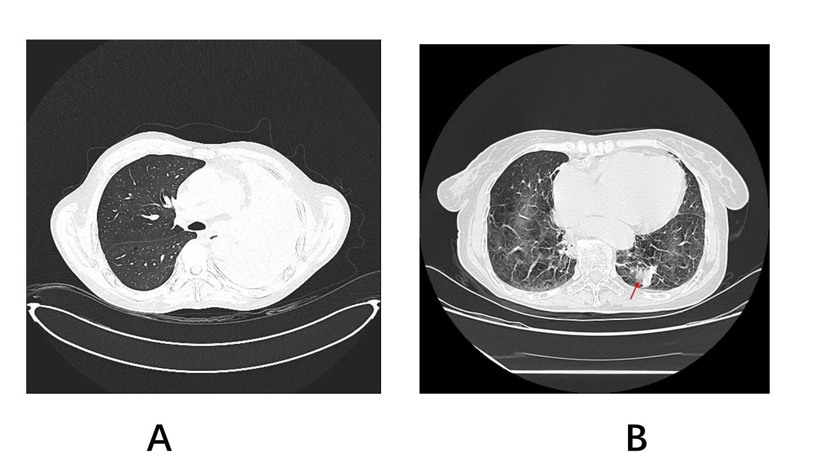
Figure S1: Example images of two patients.
A: Male , 45 years old，An irregular soft tissue density shadow is observed at the left hilum of the lung, with unclear demarcation from normal lung tissue. The corresponding bronchus is truncated, and the left lung is completely atelectatic. In this case, it is impossible to differentiate the tumor tissue from the surrounding lung tissue.
B: Female, 76 years old. A soft tissue mass shadow is seen in the lower lobe of the left lung. The image is heavily affected by respiratory motion artifacts, and it is impossible to determine whether this part is tumor tissue or caused by the artifacts (Red arrow).

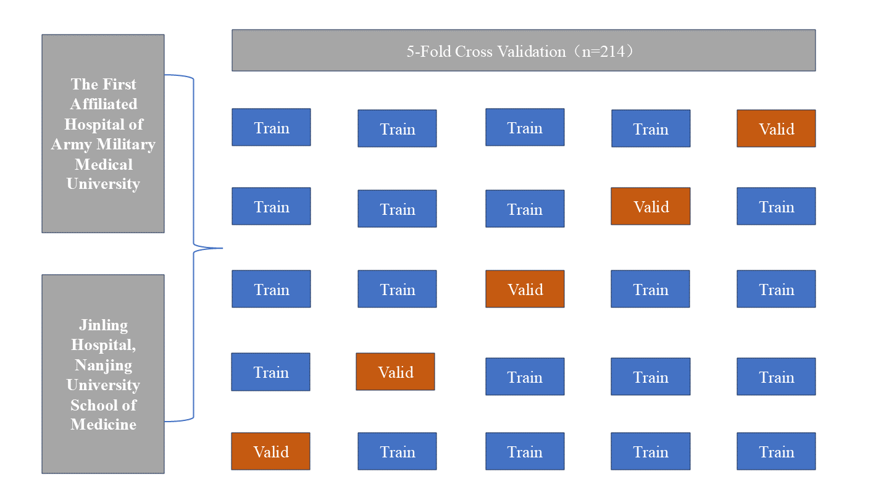
Figure S2: Datasets of the study.

