Notes:
- The tobacco exposure questionnaire includes the following items: SMQ020 - "Smoked at least 100 cigarettes in life," SMD030 - "Age started smoking cigarettes regularly," SMQ120 - "Smoked a pipe at least 20 times in life," SMD130 - "Age started pipe smoking regularly," SMQ150 - "Smoked cigars at least 20 times in life," SMD160 - "Age started cigar smoking regularly," SMQ180 - "Used snuff at least 20 times in life," SMD190 - "Age started using snuff regularly," SMQ210 - "Used chewing tobacco at least 20 times in life," SMD220 - "Age started chewing tobacco regularly," SMD410 - "Does anyone smoke in the home?" If there is a conflict between the result for age of smoking initiation and smoking status, the result for age of smoking initiation is prioritized.
- When ASI was included in the model as a continuous variable, assigning a value of 0 to never-smokers in the original NHANES data was deemed inappropriate. In the NHANES study design, individuals aged 85 or older were assigned an age value of 85. Therefore, in our analysis, never-smokers were assigned a value of 86 (except in the ASI data distribution graph, where never-smokers were assigned a value of 0 for display purposes).
- To improve the interpretability and presentation of effect sizes, the units of continuous variables are sometimes scaled up or down when included in the model. For example, in Table 2, since the values of DunedinPoAm are relatively small, a 0.1 unit change was used to evaluate the effect size. Similar methods were used in other instances as well, but they are not listed exhaustively here.

Supplemental figures and tables

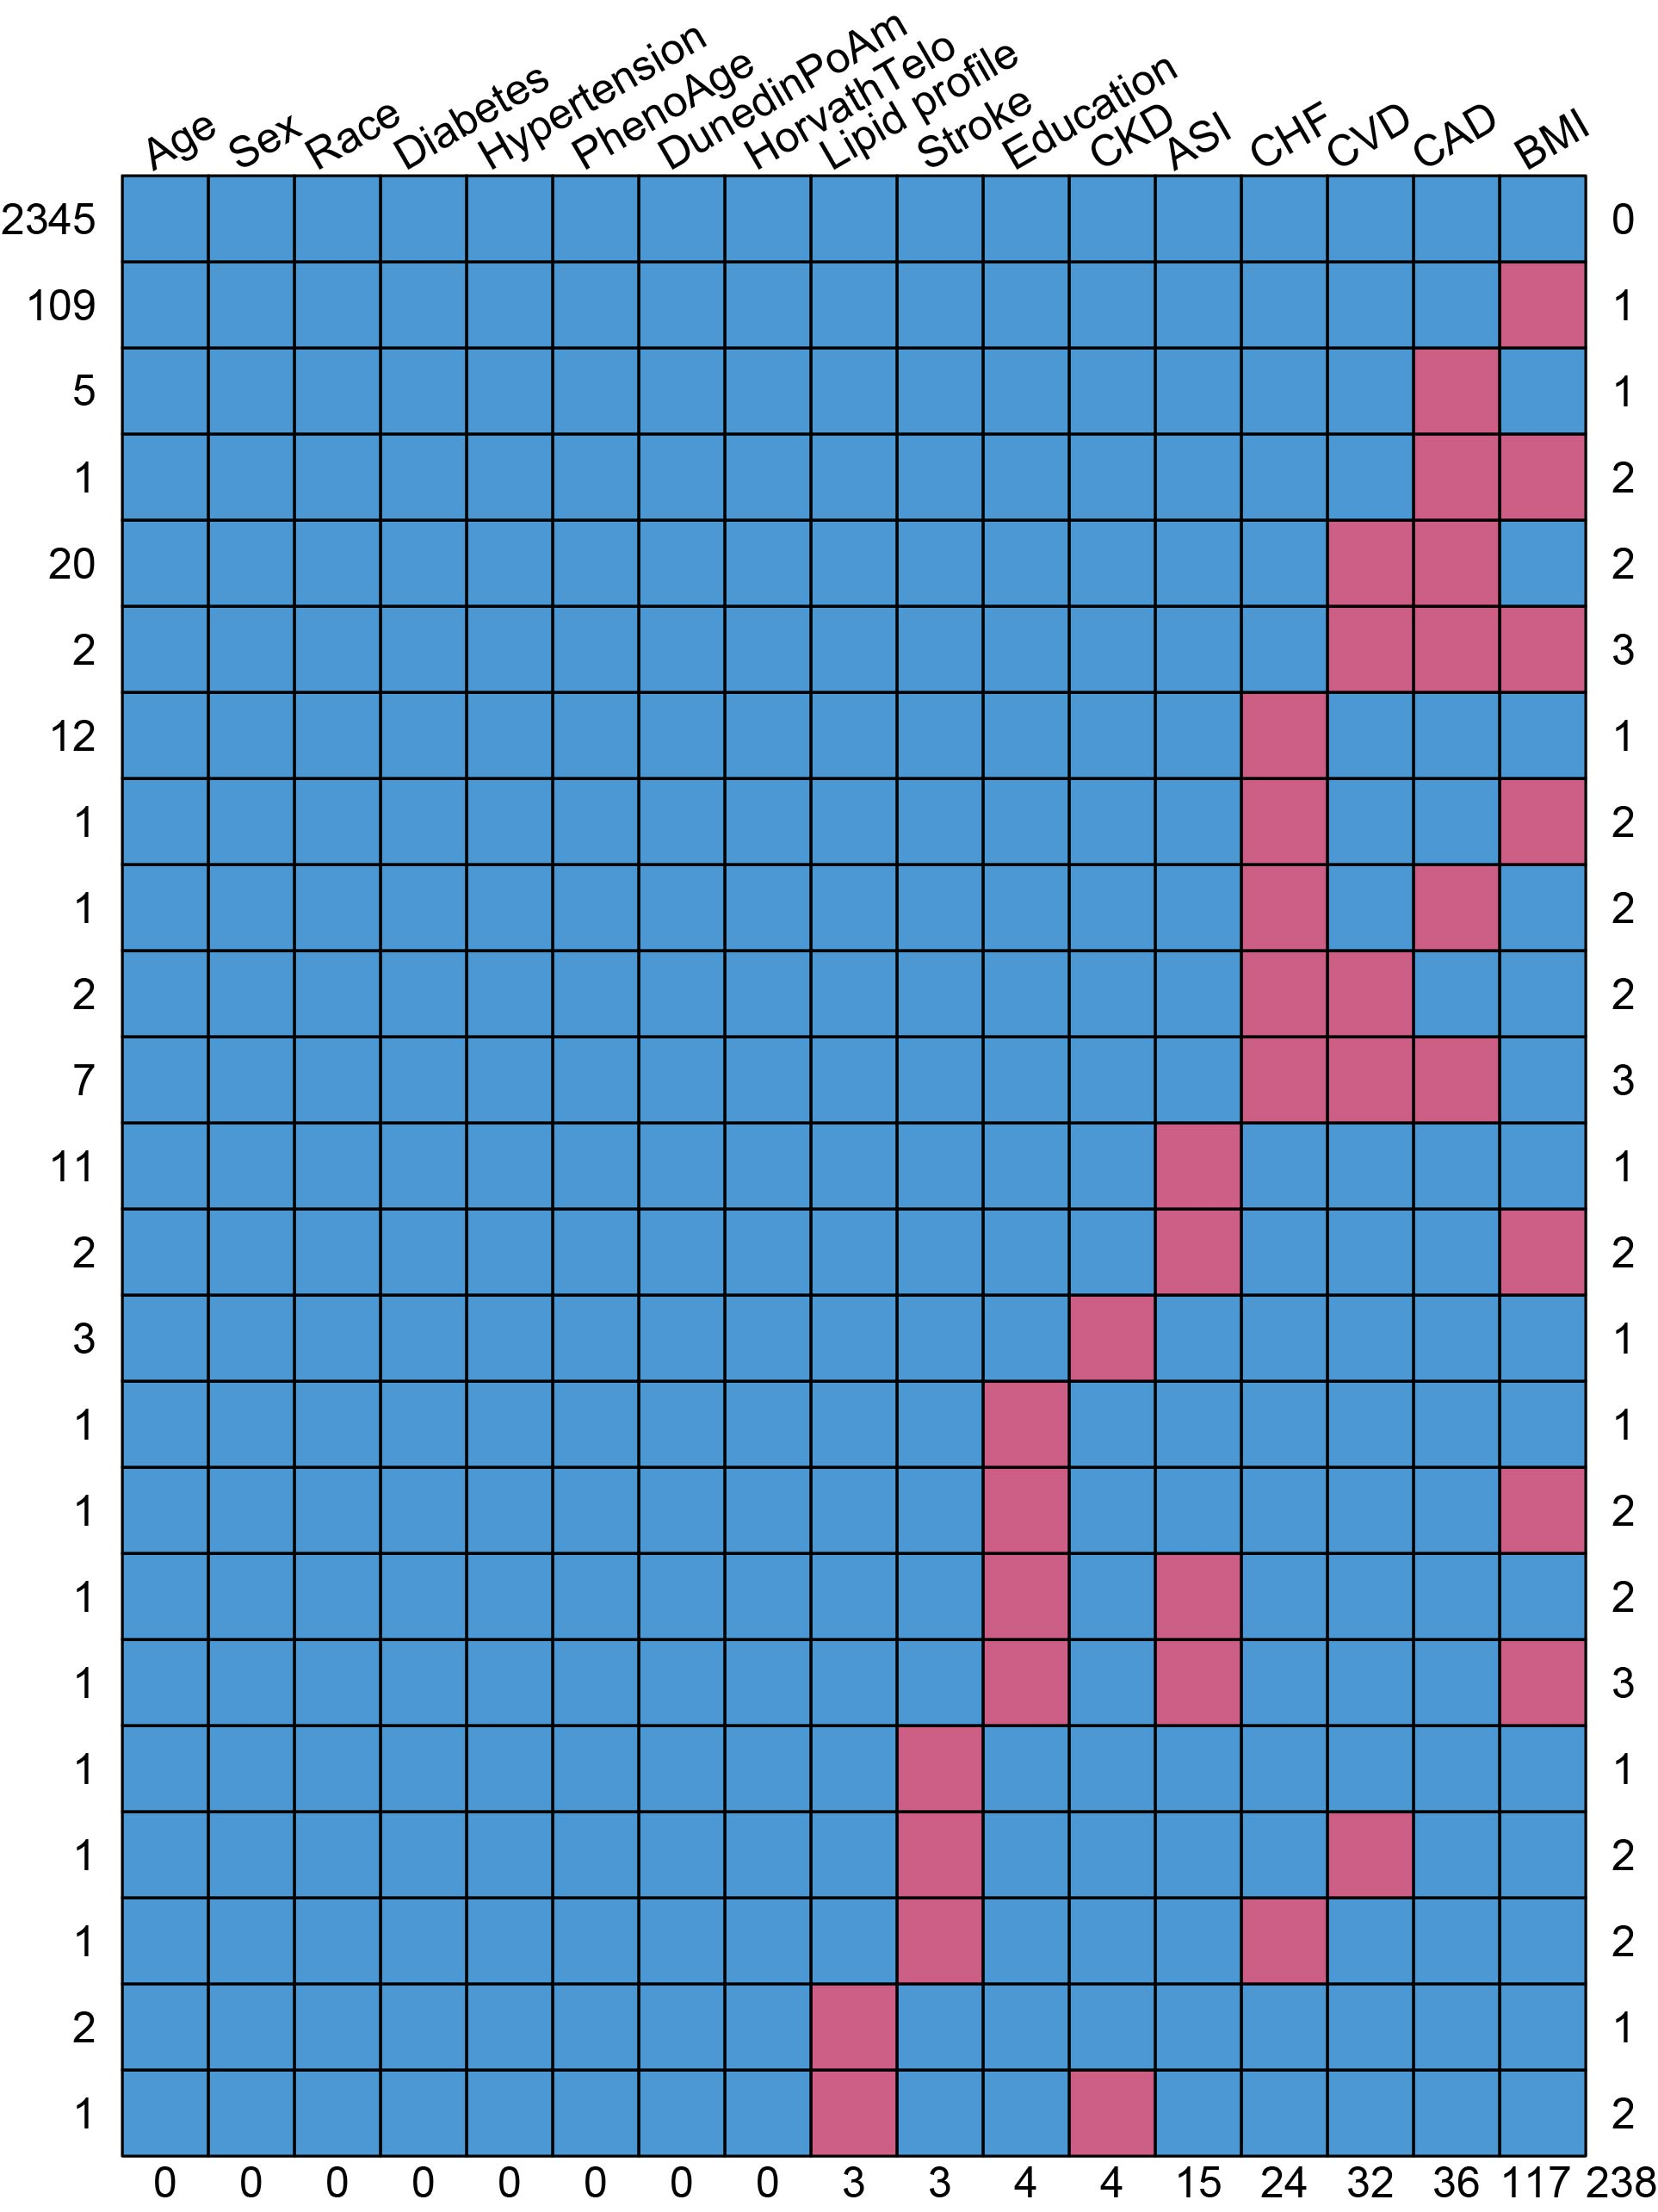
Supplemental Figure S1. Frequency of missing data for variables in the original dataset. The horizontal axis below indicates the number of missing values for each variable, while the top axis provides the variable names. The left vertical axis represents the number of individuals, and the right vertical axis shows the number of individuals with missing variables. Abbreviation: CVD = cardiovascular disease, CHF= congestive heart failure, CAD= coronary artery disease, BMI = body mass index, ASI = age of smoking initiation, DNAm PhenoAge = DNA-methylation phenotypic age, DunedinPoAm = DNA-methylation predictor of Pace-of-Aging, HorvathTelo = DNA-methylation predictor of telomere length, CKD = chronic kidney disease.

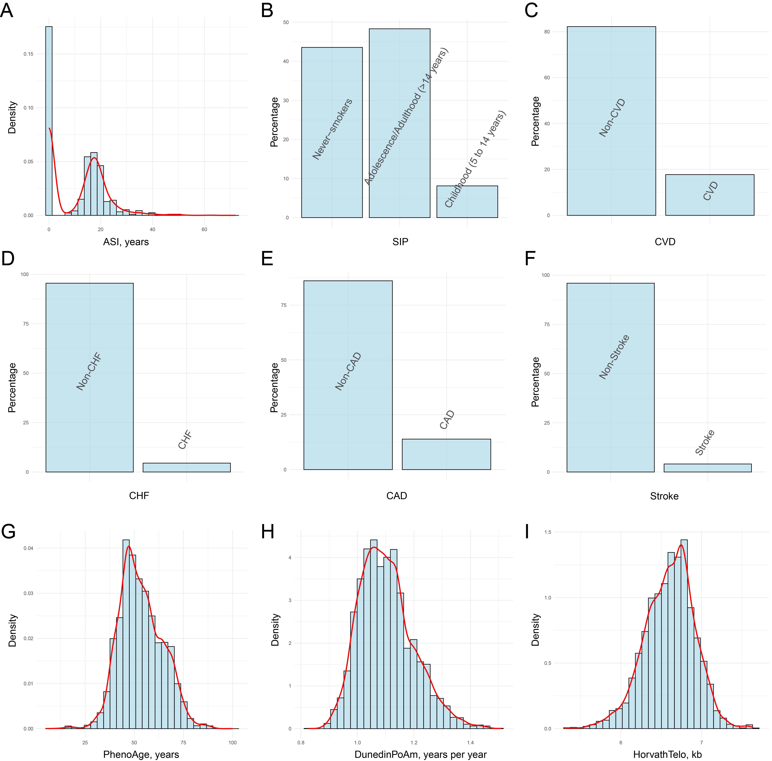
Supplemental Figure S2. Data distribution of key variables, including ankle-brachial index, age of smoking initiation, smoking initiation period, DNA methylation phenotypic age, DNA methylation predictor of pace of aging, and DNA methylation predictor of telomere length. The vertical axis represents density or percentage. In Figure A, 0 represents never-smokers. Abbreviation: CVD = cardiovascular disease, CHF= congestive heart failure, CAD= coronary artery disease, SIP = smoking initiation period, ASI = age of smoking initiation, DNAm PhenoAge = DNA-methylation phenotypic age, DunedinPoAm = DNA-methylation predictor of Pace-of-Aging, HorvathTelo = DNA-methylation predictor of telomere length.

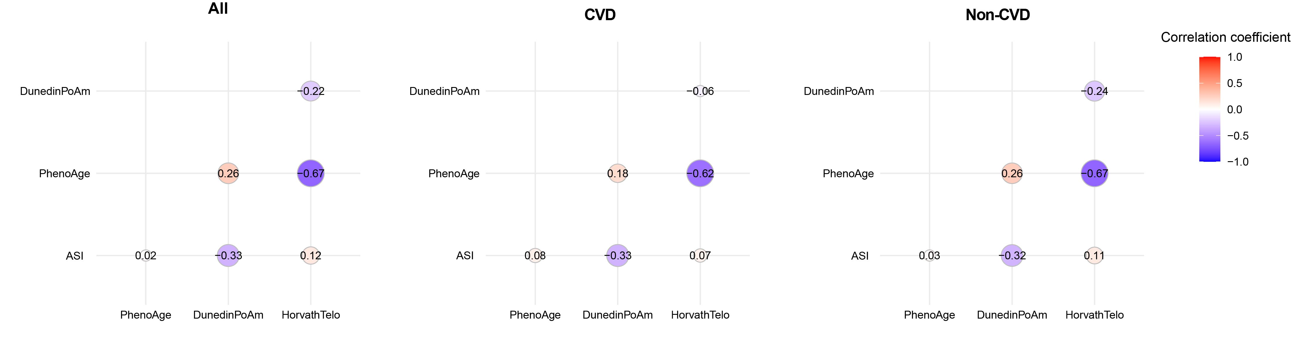
Supplemental Figure S3. Scatter plot of correlation coefficients between key variables, including age of smoking initiation, DNA methylation phenotypic age, DNA methylation predictor of pace of aging, and DNA methylation predictor of telomere length. The size and color intensity of the circles represent the magnitude of the correlation coefficients. Abbreviation: ASI = age of smoking initiation, DNAm PhenoAge = DNA-methylation phenotypic age, DunedinPoAm = DNA-methylation predictor of Pace-of-Aging, HorvathTelo = DNA-methylation predictor of telomere length.

Table S1. Association of the ASI/SIP and DNA-methylation aging biomarkers with congestive heart failure (CHF).
 | Model 1 |  | Model 2 |  | Model 3
 | OR (95% CI) | P Value | OR (95% CI) | P Value | OR (95% CI) | P Value
ASI, per 10 | 0.98 (0.91, 1.06) | 0.672 | 0.95 (0.88, 1.04) | 0.283 | 0.95 (0.87, 1.04) | 0.279
SIP |  | 0.677 |  | 0.374 |  | 0.330
Never-smokers | Reference |  | Reference |  | Reference
Adolescence/Adulthood (>14 years) | 1.09 (0.63, 1.88) | 0.753 | 1.30 (0.73, 2.32) | 0.368 | 1.31 (0.71, 2.44) | 0.385
Childhood (5-14 years) | 1.40 (0.66, 2.98) | 0.386 | 1.78 (0.79, 4.02) | 0.163 | 1.83 (0.82, 4.07) | 0.137
DNAm PhenoAge | 1.07 (1.04, 1.11) | < 0.001 | 1.07 (1.03, 1.11) | < 0.001 | 1.06 (1.02, 1.10) | < 0.001
DunedinPoAm, per 0.1 | 1.76 (1.42, 2.17) | < 0.001 | 1.73 (1.41, 2.14) | < 0.001 | 1.65 (1.33, 2.04) | < 0.001
HorvathTelo | 0.35 (0.12, 1.05) | 0.061 | 0.30 (0.10, 0.91) | 0.033 | 0.28 (0.08, 0.90) | 0.033

Data are presented as OR, 95% CI, and P value. When DNA-methylation aging biomarkers were used as the exposure, age was adjusted for in Model 1.
Model 1 was adjusted for none.
Model 2 was adjusted for age, sex, race, education, and BMI.
Model 3 was adjusted for age, sex, race, education, BMI, lipid profile, hypertension, diabetes, and CKD.
Abbreviation: ASI = age of smoking initiation, SIP = smoking initiation period, DNAm PhenoAge = DNA-methylation phenotypic age, DunedinPoAm = DNA-methylation predictor of Pace-of-Aging, HorvathTelo = DNA-methylation predictor of telomere length, OR = odds ratio, CI = confidence interval.

Table S2. Association of the ASI/SIP and DNA-methylation aging biomarkers with coronary artery disease (CAD).
 | Model 1 |  | Model 2 |  | Model 3
 | OR (95% CI) | P Value | OR (95% CI) | P Value | OR (95% CI) | P Value
ASI, per 10 | 0.93 (0.89, 0.97) | < 0.001 | 0.94 (0.90, 0.98) | 0.002 | 0.93 (0.89, 0.97) | 0.002
SIP |  | 0.005 |  | 0.004 |  | 0.007
Never-smokers | Reference |  | Reference |  | Reference
Adolescence/Adulthood (>14 years) | 1.57 (1.15, 2.15) | 0.004 | 1.50 (1.09, 2.06) | 0.012 | 1.50 (1.10, 2.05) | 0.011
Childhood (5-14 years) | 1.77 (1.04, 3.02) | 0.036 | 1.76 (1.06, 2.91) | 0.029 | 1.75 (1.00, 3.04) | 0.048
DNAm PhenoAge | 1.03 (1.00, 1.05) | 0.027 | 1.02 (1.00, 1.04) | 0.056 | 1.02 (0.99, 1.04) | 0.134
DunedinPoAm, per 0.1 | 1.24 (1.03, 1.49) | 0.021 | 1.17 (0.97, 1.43) | 0.104 | 1.16 (0.95, 1.42) | 0.146
HorvathTelo | 0.44 (0.28, 0.71) | < 0.001 | 0.63 (0.40, 0.97) | 0.036 | 0.62 (0.40, 0.96) | 0.033

Data are presented as OR, 95% CI, and P value. When DNA-methylation aging biomarkers were used as the exposure, age was adjusted for in Model 1.
Model 1 was adjusted for none.
Model 2 was adjusted for age, sex, race, education, and BMI.
Model 3 was adjusted for age, sex, race, education, BMI, lipid profile, hypertension, diabetes, and CKD.
Abbreviation: ASI = age of smoking initiation, SIP = smoking initiation period, DNAm PhenoAge = DNA-methylation phenotypic age, DunedinPoAm = DNA-methylation predictor of Pace-of-Aging, HorvathTelo = DNA-methylation predictor of telomere length, OR = odds ratio, CI = confidence interval.

Table S3. Association of the ASI/SIP and DNA-methylation aging biomarkers with stroke.
 | Model 1 |  | Model 2 |  | Model 3
 | OR (95% CI) | P Value | OR (95% CI) | P Value | OR (95% CI) | P Value
ASI, per 10 | 0.99 (0.90, 1.09) | 0.915 | 0.98 (0.88, 1.08) | 0.651 | 0.97 (0.88, 1.07) | 0.561
SIP |  | 0.529 |  | 0.342 |  | 0.306
Never-smokers | Reference |  | Reference |  | Reference
Adolescence/Adulthood (>14 years) | 0.91 (0.47, 1.76) | 0.783 | 1.03 (0.49, 2.15) | 0.937 | 1.07 (0.53, 2.18) | 0.847
Childhood (5-14 years) | 1.54 (0.60, 3.97) | 0.367 | 1.85 (0.75, 4.59) | 0.182 | 1.95 (0.81, 4.70) | 0.138
DNAm PhenoAge | 1.02 (0.99, 1.06) | 0.144 | 1.02 (0.99, 1.05) | 0.299 | 1.01 (0.98, 1.04) | 0.369
DunedinPoAm, per 0.1 | 0.98 (0.78, 1.23) | 0.830 | 0.92 (0.73, 1.16) | 0.457 | 0.91 (0.73, 1.14) | 0.397
HorvathTelo | 0.63 (0.31, 1.26) | 0.189 | 0.67 (0.33, 1.37) | 0.275 | 0.68 (0.32, 1.45) | 0.318

Data are presented as OR, 95% CI, and P value. When DNA-methylation aging biomarkers were used as the exposure, age was adjusted for in Model 1.
Model 1 was adjusted for none.
Model 2 was adjusted for age, sex, race, education, and BMI.
Model 3 was adjusted for age, sex, race, education, BMI, lipid profile, hypertension, diabetes, and CKD.
Abbreviation: ASI = age of smoking initiation, SIP = smoking initiation period, DNAm PhenoAge = DNA-methylation phenotypic age, DunedinPoAm = DNA-methylation predictor of Pace-of-Aging, HorvathTelo = DNA-methylation predictor of telomere length, OR = odds ratio, CI = confidence interval.

Table S4. Baseline characteristics of participants in sensitivity analysis.
Characteristics | Total (n = 2235) | Non-CVD (n = 1824) | CVD (n = 411) | P value
Age, years | 63.52 (10.13) | 62.47 (9.83) | 68.38 (10.09) | <0.001
Age strata, % |  |  |  | <0.001
40-59 | 29,560,828.05 (42.64%) | 26,738,025.43 (46.85%) | 2,822,802.62 (23.04%)
60+ | 39,761,034.08 (57.36%) | 30,332,750.66 (53.15%) | 9,428,283.42 (76.96%)
Sex, % |  |  |  | 0.046
Male | 32,095,915.56 (46.30%) | 25,700,702.32 (45.03%) | 6,395,213.24 (52.20%)
Female | 37,225,946.57 (53.70%) | 31,370,073.77 (54.97%) | 5,855,872.80 (47.80%)
Race, % |  |  |  | 0.030
Non-Hispanic White | 55,061,696.35 (79.43%) | 44,876,568.26 (78.63%) | 10,185,128.09 (83.14%)
Minority | 14,260,165.78 (20.57%) | 12,194,207.83 (21.37%) | 2,065,957.95 (16.86%)
Education level, % |  |  |  | <0.001
High school degree/equivalency or less | 36,330,174.21 (52.41%) | 28,389,624.96 (49.74%) | 7,940,549.24 (64.82%)
Some college or associates degree | 16,617,276.54 (23.97%) | 14,210,080.83 (24.90%) | 2,407,195.72 (19.65%)
College Graduate or above | 16,374,411.38 (23.62%) | 14,471,070.30 (25.36%) | 1,903,341.08 (15.54%)
BMI, kg/m² |  |  |  | 0.058
<25 | 20,838,885.67 (30.06%) | 17,995,831.92 (31.53%) | 2,843,053.75 (23.21%)
25 to <30 | 25,786,024.84 (37.20%) | 20,974,861.59 (36.75%) | 4,811,163.26 (39.27%)
≥30 | 22,696,951.62 (32.74%) | 18,100,082.58 (31.72%) | 4,596,869.03 (37.52%)
ASI, years | 48.13 (33.44) | 49.44 (33.54) | 42.00 (32.31) | 0.011
SIP, % |  |  |  | 0.023
Never-smokers | 30,014,054.52 (43.30%) | 25,778,958.70 (45.17%) | 4,235,095.82 (34.57%)
Adolescence/Adulthood (>14 years) | 33,783,276.23 (48.73%) | 27,051,437.21 (47.40%) | 6,731,839.02 (54.95%)
Childhood (5-14 years) | 5,524,531.38 (7.97%) | 4,240,380.18 (7.43%) | 1,284,151.20 (10.48%)
DNA-methylation derived aging markers
DNAm PhenoAge, years | 53.27 (10.89) | 52.07 (10.49) | 58.87 (10.96) | <0.001
DunedinPoAm | 1.10 (0.10) | 1.10 (0.10) | 1.12 (0.10) | 0.003
HorvathTelo, kb | 6.60 (0.31) | 6.63 (0.30) | 6.47 (0.31) | <0.001
Total cholesterol/HDL | 4.37 (1.53) | 4.32 (1.54) | 4.59 (1.50) | 0.013
Diabetes, % | 11,176,851.31 (16.12%) | 7,817,172.52 (13.70%) | 3,359,678.80 (27.42%) | <0.001
Hypertension, % | 32,073,863.42 (46.27%) | 23,845,883.45 (41.78%) | 8,227,979.97 (67.16%) | <0.001
CKD stage, % |  |  |  | <0.001
No CKD | 53,673,698.57 (77.43%) | 46,233,257.29 (81.01%) | 7,440,441.28 (60.73%)
Stages 1-2 | 6,879,493.75 (9.92%) | 5,466,127.49 (9.58%) | 1,413,366.26 (11.54%)
Stages 3 | 8,021,535.13 (11.57%) | 5,149,222.06 (9.02%) | 2,872,313.07 (23.45%)
Stages 4-5 | 747,134.68 (1.08%) | 222,169.25 (0.39%) | 524,965.43 (4.29%)
Alcohol Intake, % |  |  |  | 0.066
1 to <5 drinks/month | 29,294,388.54 (42.26%) | 23,287,360.87 (40.80%) | 6,007,027.67 (49.03%)
5 to <10 drinks/month | 12,562,449.16 (18.12%) | 11,073,171.14 (19.40%) | 1,489,278.02 (12.16%)
10+ drinks/month | 4,079,150.85 (5.88%) | 3,538,630.86 (6.20%) | 540,519.99 (4.41%)
Non-drinker | 23,385,873.58 (33.74%) | 19,171,613.22 (33.59%) | 4,214,260.36 (34.40%)
PA, % |  |  |  | 0.097
Level 1 | 18,636,133.69 (26.88%) | 14,386,564.53 (25.21%) | 4,249,569.16 (34.69%)
Level 2 | 37,335,495.22 (53.86%) | 31,394,107.42 (55.01%) | 5,941,387.80 (48.50%)
Level 3 | 10,822,081.99 (15.61%) | 9,238,404.60 (16.19%) | 1,583,677.38 (12.93%)
Level 4 | 2,528,151.24 (3.65%) | 2,051,699.54 (3.60%) | 476,451.70 (3.89%)

Data are presented as mean (SD), n (%), and P value.
Analysis conducted: Wilcoxon rank-sum test for complex survey samples; chi-squared test with Rao & Scott's second-order correction.
Abbreviation: CVD = cardiovascular disease, BMI = body mass index, ASI = age of smoking initiation, SIP = smoking initiation period, DNAm PhenoAge = DNA-methylation phenotypic age, DunedinPoAm = DNA-methylation predictor of Pace-of-Aging, HorvathTelo = DNA-methylation predictor of telomere length, HDL = high-density lipoprotein, CKD = chronic kidney disease, PA = physical activity.

Table S5. Association of the ASI/SIP with CVD/CHF/CAD/stroke in sensitivity analysis.
 | CVD (Model 4) |  | CHF (Model 4) |  | CAD (Model 4) |  | Stroke (Model 4)
 | OR (95% CI) | P Value | OR (95% CI) | P Value | OR (95% CI) | P Value | OR (95% CI) | P Value
ASI, per 10 | 0.92 (0.88, 0.97) | 0.002 | 0.94 (0.87, 1.03) | 0.202 | 0.94 (0.90, 0.98) | 0.003 | 0.97 (0.87, 1.09) | 0.608
SIP |  | 0.009 |  | 0.309 |  | 0.015 |  | 0.324
Never-smokers | Reference |  | Reference |  | Reference |  | Reference
Adolescence/Adulthood (>14 years) | 1.61 (1.11, 2.34) | 0.013 | 1.40 (0.78, 2.53) | 0.262 | 1.47 (1.09, 1.97) | 0.012 | 1.07 (0.50, 2.28) | 0.859
Childhood (5-14 years) | 1.97 (1.10, 3.50) | 0.022 | 1.93 (0.81, 4.60) | 0.140 | 1.71 (1.05, 3.24) | 0.019 | 2.01 (0.74, 5.47) | 0.169

The adjusted variables in Model 4 are based on Model 3, with the addition of alcohol intake and physical activity. Abbreviation: ASI = age of smoking initiation, SIP = smoking initiation period, CVD= cardiovascular disease, CHF = congestive heart failure, CAD = coronary artery disease.

Table S6. Subgroup analysis for the association between ASI and CVD in sensitivity analysis.
 | Characteristic | Numbers | OR (95% CI) | P Value | P for interaction
 | Gender |  |  |  | 0.557
 | Male | 1142 | 0.95 (0.89, 1.00) | 0.060
 | Female | 1093 | 0.91 (0.84, 1.00) | 0.040
BMI, kg/m² |  |  |  |  | 0.520
 | <25 | 606 | 0.99 (0.89, 1.10) | 0.852
25 to <30 |  | 876 | 0.92 (0.84, 0.99) | 0.038
 | ≥30 | 753 | 0.92 (0.86, 0.99) | 0.017
Diabetes |  |  |  |  | 0.070
 | Yes | 515 | 1.00 (0.93, 1.07) | 0.965
No |  | 1720 | 0.90 (0.85, 0.95) | < 0.001
 | Hypertension |  |  |  | 0.583
Yes |  | 1113 | 0.93 (0.88, 0.99) | 0.015
No |  | 1122 | 0.92 (0.86, 0.99) | 0.026
Household smoking |  |  |  |  | 0.046
Yes |  | 396 | 1.01 (0.85, 1.15) | 0.878
 | No | 1839 | 0.91 (0.85, 0.96) | 0.002

Abbreviation: BMI = body mass index.

Table S7. Mediation effects of DNAm PhenoAge on the associations between ASI/SIP and CVD in sensitivity analysis.
Exposure | Outcome | ACME, P Value | ADE, P Value | Total effect, P Value | Proportion of mediation, %
ASI | CVD | -0.0000728, 0.012 | -0.00136, 0.006 | -0.00144, 0.006 | 5 (1, 19), 0.018
SIP | CVD | 0.003593, 0.016 | 0.076023, 0.016 | 0.079616, 0.010 | 5 (0, 25), 0.026

All covariates were adjusted in this model. Abbreviation: ASI = age of smoking initiation, SIP = smoking initiation period, CVD= cardiovascular disease, ACME = average causal mediation effects, ADE = average direct effects.

