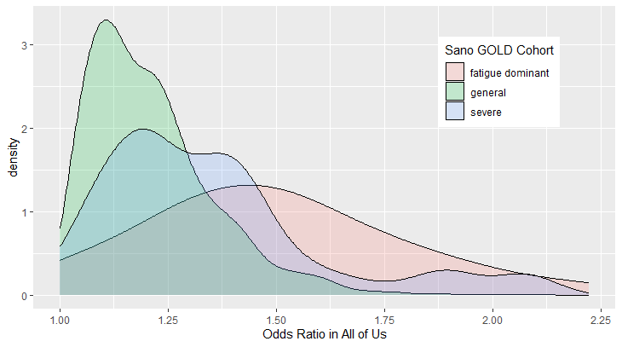
Supplemental Figure 1. Density plot showing distributions of odds ratios for high-frequency (>5%) signatures that reproduce (i.e., odds ratio > 1) in All of Us, for the Severe, Fatigue Dominant, and General cohorts.

Supplemental Figure 2 Density plots showing distributions of signature frequencies in the Sano GOLD cohort for signatures included in the replication study (‘tested’) and signatures that we excluded because at least one of their component SNPs was not included in the All of Us genotype data (‘untested’). Separate plots are shown for signatures from the Severe cohort (top), Fatigue Dominant cohort (middle), and General cohort (bottom)
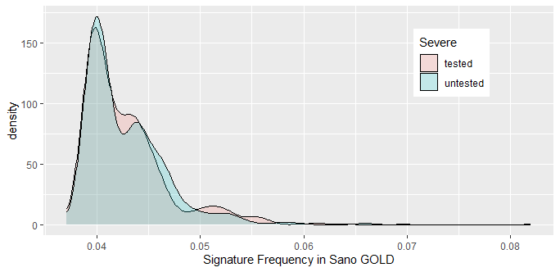
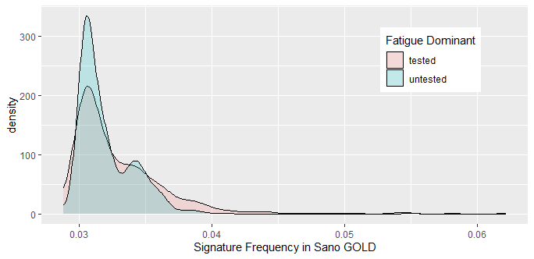
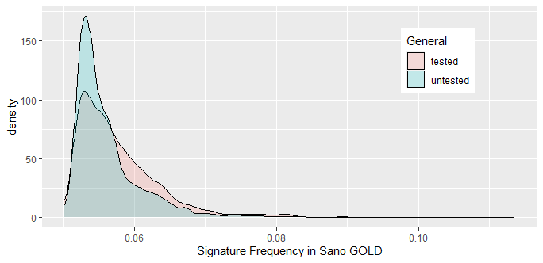

Supplemental Table 1. Principal component analysis (PCA) eigenvalue for All of Us long COVID dataset and self-reported ancestry sub-cohorts. Top 5 PCs were selected to represent population substructure in all datasets.
Principal Component | Full Cohort Eigenvalues | Self-reported White Eigenvalues | Self-reported Black / African-American Eigenvalues | Self-reported Hispanic / Latino Eigenvalues
PC1 | 291.96 | 8.15 | 5.72 | 24.96
PC2 | 50.52 | 4.00 | 1.55 | 9.10
PC3 | 7.40 | 2.35 | 1.52 | 1.55
PC4 | 2.42 | 2.03 | 1.39 | 1.49
PC5 | 2.14 | 1.60 | 1.38 | 1.44
PC6 | 1.82 | 1.55 | 1.37 | 1.40
PC7 | 1.78 | 1.48 | 1.36 | 1.40
PC8 | 1.72 | 1.47 | 1.35 | 1.37
PC9 | 1.72 | 1.44 | 1.35 | 1.36
PC10 | 1.70 | 1.42 | 1.34 | 1.36
PC11 | 1.69 | 1.41 | 1.33 | 1.34
PC12 | 1.69 | 1.41 | 1.32 | 1.34
PC13 | 1.68 | 1.41 | 1.31 | 1.34
PC14 | 1.67 | 1.41 | 1.31 | 1.33
PC15 | 1.66 | 1.41 | 1.31 | 1.32
PC16 | 1.65 | 1.41 | 1.30 | 1.32
PC17 | 1.64 | 1.40 | 1.30 | 1.31
PC18 | 1.63 | 1.40 | 1.29 | 1.31
PC19 | 1.63 | 1.40 | 1.29 | 1.30
PC20 | 1.62 | 1.40 | 1.28 | 1.30

Supplemental Table 2. Summary of long COVID SNPs and disease signatures from the Sano GOLD study that could be mapped to All of Us (AoU) long COVID genotype array data.
Long COVID cohort derived from GOLD study | Total number of disease signatures | SNP count in disease signatures | Count of SNPs missing in AoU genotype dataset | % SNPs mapped in AoU genotype dataset | No. of disease signatures with missing SNPs | No. of disease signatures mapped in AoU | % of disease signatures mapped in AoU
Severe | 1,188 | 2,321 | 158 | 93.2% | 520 | 668 | 56.2%
Fatigue Dominant | 1,435 | 2,679 | 224 | 91.6% | 695 | 740 | 51.6%
General | 6,445 | 7,556 | 663 | 91.2% | 2,510 | 3,935 | 61.1%

Supplemental Table 3. Exclusionary criteria for long COVID controls. Any patient that was assigned to one or more of the following All of Us (AoU) “concepts” (accessed on 10th December 2024 from CDR v7) was excluded from the list of potential controls. Participant counts below 20 are displayed as 20.
Searchable AoU Concept | AoU participant count
Post COVID-19 condition (ICD-10 U09.9) | 520
Fatigue | 60,860
Chronic fatigue syndrome | 8,600
Malaise or fatigue | 7,300
Postviral fatigue syndrome | 380
Postural orthostatic tachycardia syndrome (POTS) | 80
Muscle fatigue | 40
Accommodative fatigue | 20
Tinnitus | 17,660
Subjective tinnitus | 2,660
Noises in ear | 20
Tinnitus of vascular origin | 700
Leudet’s tinnitus | 20
Tinnitus arising from tensor tympani | 20
Tinnitus of muscular origin | 20

Supplemental Table 4. Demographic breakdown of cases and controls in the final All of Us long COVID cohort.
Category | Value | Cases  (n=413) | Controls (n=4,130)
 | Age [median (IQR)] | 60 (47-70) | 58 (43-69)
Sex | F | 69.7% | 68.3%
Sex | M | 30.3% | 31.7%
Self-reported race | Asian or None Indicated | 15.7% | 17.0%
Self-reported race | Black or African American | 18.6% | 19.5%
Self-reported race | White | 65.6% | 63.5%
Self-reported Ethnicity | Hispanic or Latino | 17.2% | 18.5%
Self-reported Ethnicity | Not Hispanic or Latino | 82.8% | 81.5%
Co-morbidities | Asthma (J45) | 39.0% | 19.0%
Co-morbidities | Chronic ischemic heart disease (I25) | 20.1% | 11.9%
Co-morbidities | Diabetes type 2 (E11) | 31.5% | 22.8%
Co-morbidities | Irritable bowel syndrome (K58) | 12.8% | 4.5%
Co-morbidities | Chronic kidney disease (N18) | 17.0% | 10.9%
Co-morbidities | Rheumatoid arthritis (M05 + M06) | 7.5% | 3.9%
Co-morbidities | Chronic fatigue syndrome (concept) | 14.3% | -

Supplemental Table 5. Comparison of self-reported demographic data with predicted genetic ancestry distribution¹ of individuals within the All of Us (AoU) long COVID cohort. The genetic ancestry predictions were only available for participants who had whole genome sequencing (WGS) data in AoU.
Self reported demographics | Demographic category | Total number of individuals with predicted genetic ancestry in AoU | Matching Predicted Genetic ancestry¹ | Individuals with matching predicted genetic ancestry | % of individuals with matching predicted genetic ancestry
Race | Asian/None Indicated | <=20 | - | <=20 | -
Race | Black or African American | 705 | African ancestry (AFR) | 701 | 99.4%
Race | White | 2,334 | European ancestry (EUR) | 2,263 | 97.0%
Ethnicity | Hispanic or Latino | 700 | Latino/admixed American ancestry (AMR) | 617 | 88.1%
Ethnicity | Not Hispanic or Latino | <=20 | - | <=20 | -

Supplemental Table 6. Summary of the three long COVID cohorts that were derived from GOLD study.
Long COVID cohort derived from GOLD study | Case Selection Criteria | Control Selection Criteria | Case count | Control count | Count of Disease signatures identified by combinatorial analysis
Severe | Total Change score was calculated using the difference in self-reported scores pre- and post-acute COVID-19 for three symptom groups –respiratory, fatigue and mental health.  Individuals with a ‘Total Change’ score greater than the upper quartile of the distribution | Individuals with a ‘Total Change’ score greater than or equal to 0 but below the median of the distribution | 459 | 864 | 1,188
Fatigue Dominant | Fatigue Change score was calculated using the difference in self-reported scores relating to fatigue symptoms pre- and post-acute COVID-19.  Individuals with a ‘Fatigue Change’ score greater than the upper quartile of the distribution. | Individuals with a ‘Fatigue Change’ score greater than or equal to 0 but below the median of the distribution. | 477 | 909 | 1,435
General | Individuals with recovery time more than 12 weeks since COVID-19 diagnosis | Individuals who recovered within 12 weeks since COVID-19 diagnosis | 703 | 698 | 6,455

Supplemental Table 7. Reproducibility statistics by signature complexity (i.e., number of SNP genotypes comprising signatures) in All of Us for moderate-high case-frequency (>4%) long COVID disease signatures derived from three Sano GOLD sub-cohorts.
# SNP-genotypes in signature | Cohort | # signatures tested | % signatures odds ratio > 1 in AoU | % signatures odds ratio > 1 in permutations  Mean (range) | p-value
2 | Severe | 1 | 100% | 35% (0% - 100%) | 0.35
2 | Fatigue Dominant | 12 | 58% | 47% (8% - 92%) | 0.35
2 | General | 15 | 40% | 45% (7% - 87%) | 0.69
3 | Severe | 37 | 32% | 43% (5% - 80%) | 0.89
3 | Fatigue Dominant | 40 | 65% | 42% (13% - 88%) | 0.02
3 | General | 1,040 | 62% | 45% (22% - 67%) | 0.06
4 | Severe | 70 | 73% | 41% (24% - 54%) | <0.01
4 | Fatigue Dominant | 14 | 86% | 42% (0% - 86%) | 0.02
4 | General | 597 | 63% | 43% (30% - 63%) | 0.01
5 | Severe | 136 | 73% | 41% (23% - 60%) | <0.01
5 | Fatigue Dominant | 19 | 79% | 41% (11% - 79%) | 0.01
5 | General | 1,122 | 57% | 42% (31% - 56%) | <0.01

Supplemental Table 8. Reproducibility statistics by signature complexity (i.e., number of SNP genotypes comprising signatures) in All of Us for all long COVID disease signatures derived from three Sano GOLD sub-cohorts.
# SNP-genotypes in signature | Cohort | # signatures tested | % signatures odds ratio > 1 in AoU | % signatures odds ratio > 1 in permutations  Mean (range) | p-value
2 | Severe | 2 | 50% | 43% (0% - 100%) | 0.66
2 | Fatigue Dominant | 21 | 33% | 44% (14% - 81%) | 0.84
2 | General | 15 | 40% | 45% (13% - 93%) | 0.66
3 | Severe | 58 | 24% | 43% (29% - 62%) | 1.00
3 | Fatigue Dominant | 152 | 35% | 44% (31% - 58%) | 0.87
3 | General | 1,118 | 58% | 42% (26% - 67%) | 0.12
4 | Severe | 163 | 37% | 41% (30% - 55%) | 0.77
4 | Fatigue Dominant | 117 | 30% | 47% (29% - 67%) | 0.99
4 | General | 878 | 44% | 42% (30% - 66%) | 0.35
5 | Severe | 136 | 73% | 36% (30% - 58%) | 1.00
5 | Fatigue Dominant | 19 | 79% | 34% (31% - 58%) | 0.95
5 | General | 1,122 | 57% | 36% (33% - 54%) | 0.93

Supplemental Table 9. Genes identified as repurposing candidates in the Sano GOLD long COVID study² that were reproduced in the All of Us (AoU) long COVID study.
Gene | Protein class | PHAROS target classification | Reproducibility in AoU Sub-Cohort (case frequency of signatures)
CETP | Transporter | Tchem | Severe (> 4%)
GUCY1A2 | Enzyme | Tclin | Severe (> 4%)
HPN | Enzyme | Tchem | Fatigue Dominant (> 4%)
MAPK9 | Enzyme | Tchem | Fatigue Dominant (> 4%)
PDE4D | Enzyme | Tclin | Severe (> 4%)
POR | Enzyme | Tbio | Fatigue Dominant (> 4%)
PRODH | Enzyme | Tbio | Severe (> 4%)
RRBP1 |  | Tbio | Fatigue Dominant (> 4%)
SLC12A1 | Transporter | Tclin | Fatigue Dominant (> 4%)
TLR4 | Enzyme, Transporter | Tchem | Severe (> 4%)
TNIK | Enzyme | Tchem | Fatigue Dominant (> 4%)

Supplemental Table 10. Effect of misphenotyping of patients with long COVID as ‘controls’ on reproduction rate analysis. Results represent the probability of a signature with a given true odds ratio and true frequency of cases being reported as a non-replicating false negative (i.e., observed Odds Ratio ≤ 1) under different rates of misphenotyping. Higher rates of misphenotyping generally increases the false negative rate, with stronger effects on replication of signatures with low frequencies or low odds ratios.
True Frequency in Cases | True Odds Ratio | Probability of observing non-reproduction  (observed odds ratio ≤ 1)
True Frequency in Cases | True Odds Ratio | 5% of controls have long COVID | 10% of controls have long COVID
5% | 1.5 | 3% | 5%
5% | 1.2 | 18% | 20%
5% | 1.1 | 27% | 39%
5% | 1.05 | 39% | 39%
4% | 1.5 | 4% | 7%
4% | 1.2 | 24% | 28%
4% | 1.1 | 36% | 39%
4% | 1.05 | 36% | 40%
1% | 1.5 | 16% | 16%
1% | 1.2 | 39% | 35%
1% | 1.1 | 39% | 35%
1% | 1.05 | 39% | 59%

References
- The All of Us Research Program Genomics Investigators. Genomic data in the All of Us Research Program. Nature 627, 340–346 (2024). https://doi.org/10.1038/s41586-023-06957-x
- Taylor, K., Pearson, M., Das, S., Sardell, J., Chocian, K. and Gardner, S., 2023. Genetic risk factors for severe and fatigue dominant long COVID and commonalities with ME/CFS identified by combinatorial analysis. Journal of Translational Medicine, 21(1), p.775.

