SUPPLEMENTAL INFORMATION
Patient characteristics | Total (n=56)
Median age，years (IQR) | 56 (51-61)
Male, No. (%) | 28 (50)
Median time since initial diagnosis to screening, months (IQR) | 37.1 (23.3-59.9)
Median lines of previous therapy (IRQ) | 5 (4-6)
Extramedullary disease/ Plasma cell leukaemia, No. (%) | 10 (17.9)
Median bone marrow plasma cell at enrollment (IQR) | 60 (16.3-80)
High Marrow Burden at enrollment (>= 50%) | 34 (60.7)
Median BCMA expression on plasma cells at baseline (IQR) | 82.9 (63.6-91.5)
ECOG performance status score at enrollment, n (%)
0 | 3 (5.4)
1 | 53 (94.6)
Myeloma subtype, n (%)
IgG | 28 (50)
IgA | 8 (14.3)
IgD | 3 (5.4)
Kappa | 8 (14.3)
Lambda | 9 (16.0)
Durie-Salmon stage, n (%)
I | 5 (8.9)
II | 5 (8.9)
III | 46 (82.1)
R-ISS staging, n (%)
I | 16 (28.5)
II | 35 (61.1)
III | 4 (7.4)
High-risk cytogenetic features, n (%)
0 | 34 (61.8)
1 | 11 (20.0)
2 | 10 (18.2)
Triple-exposure, n (%) | 10 (17.9)
Penta- exposure, n (%) | 7 (12.5)
Previous autologous stem cell transplantation, n (%) | 16 (28.5)
Previous CAR-T therapy, n (%) | 6 (10.7)
Bridging therapy, n (%) | 18 (32.1)
CAR-T cell dose
1×10⁶ | 48 (85.7)
3×10⁶ | 6 (10.7)
6×10⁶ | 2 (3.6)

Table S1. Baseline patient characteristics.
BCMA, B-cell maturation antigen; CAR, chimeric antigen receptor; ECOG, Eastern Cooperative Oncology Group; EMMR-ISS, Revised International Staging System; DS, Durie-Salmon; IQR, interquartile range; Spcl, secondary plasma cell leukaemia; sBCMA, plasma levels of soluble BCMA.

Characteristic | HR | 95%CI | p value
Age,>60 years | 0.893 | 0.372-2.142 | 0.800
Gender, male | 0.654 | 0.297-1.439 | 0.291
Previous lines,>6 lines | 0.418 | 0.165-1.056 | 0.065
Previous therapies
Monoclonal antibody | 4.472 | 1.667-11.998 | 0.003
Previous ASCT | 2.965 | 1.362-6.455 | 0.006
Previous CAR-T therapy | 1.118 | 0.317-3.943 | 0.863
Best Response, CR/sCR | 0.086 | 0.030-0.248 | <0.001
Table S2. Multivariate Cox regression models of predictors of DOR.
ASCT, autologous stem cell transplantation; CR, complete response; DOR, duration of response; sCR, stringent complete response.

Characteristic | HR | 95%CI | p value
Age,>60 years | 1.034 | 0.442-2.416 | 0.939
Gender, male | 0.787 | 0.367-1.689 | 0.539
Previous lines,>6 lines | 0.445 | 0.187-1.062 | 0.068
Previous therapies
Monoclonal antibody | 3.507 | 1.339-9.184 | 0.011
Previous ASCT | 2.687 | 1.257-5.744 | 0.011
Previous CAR-T therapy | 1.518 | 0.493-4.676 | 0.467
Best Response, CR/sCR | 0.081 | 0.03-0.218 | <0.001
Table S3. Multivariate Cox regression models of predictors of PFS.
ASCT, autologous stem cell transplantation; CR, complete response; PFS, progression-free survival; sCR, stringent complete response.

Characteristic | HR | 95%CI | p value
Age,>60 years | 0.655 | 0.222-1.929 | 0.442
Gender, male | 0.599 | 0.237-1.541 | 0.279
Previous lines,>6 lines | 1.002 | 0.396-2.535 | 0.997
Previous therapies
Monoclonal antibody | 5.787 | 1.931-17.338 | 0.002
Previous ASCT | 1.400 | 0.539-3.637 | 0.490
Previous CAR-T therapy | 0.325 | 0.073-1.455 | 0.142
Best Response, CR/sCR | 0.207 | 0.079-0.538 | <0.001
Table S4. Multivariate Cox regression models of predictors of OS.
ASCT, autologous stem cell transplantation; CR, complete response; OS, overall survival; sCR, stringent complete response.
Factors | Patients No.
CAR-T cell–related (e.g., limited expansion, T-cell exhaustion, short persistence) | 2003, 2013, 2015, 01-023
Patient-related (e.g., high-risk cytogenetics, prior extensive therapy, extramedullary disease) | 01-013, 2002, 2003, 2006, 2013, 2039, 2041, 2047
Tumor-intrinsic (e.g., antigen loss or downregulation) | 2016, 2013, 01-023

Table S5. Analysis of specific factors in patients who did not achieve CR.
Characteristic | HR | 95%CI |  | p value
Age,>60 years | 0.974 | 0.443 | 2.143 | 0.949
Gender, male | 1.174 | 0.561 | 2.458 | 0.670
R-ISS, III | 1.295 | 0.306 | 5.487 | 0.726
Previous lines,>6 lines | 1.108 | 0.507 | 2.423 | 0.797
Extramedullary disease | 0.584 | 0.284 | 1.374 | 0.218
Previous ASCT, yes | 0.646 | 0.310 | 1.348 | 0.244
Previous CAR-T therapy, yes | 0.674 | 0.230 | 1.979 | 0.473
Tripple-exposed, yes | 2.548 | 1.002 | 2.548 | 0.049
High-risk cytogenetic features | 1.569 | 0.743 | 3.313 | 0.237
Baseline sBCMA | 1.000 | 1.000 | 1.001 | 0.406
High marrow burden at enrollment | 2.423 | 1.051 | 5.581 | 0.038
Baseline BCMA expression | 1 | 0.982 | 1.019 | 0.969
ADA postive | 1.566 | 0.542 | 4.526 | 0.408
CAR-T persistent time ≥ 6 months | 0.231 | 0.096 | 0.556 | 0.001
First month response ≥ CR | 0.635 | 0.271 | 1.490 | 0.297
Third month response ≥ CR | 0.440 | 0.200 | 0.965 | 0.040
Table S6. Univariate Cox regression models of predictors of sustained MRD negative time.
ADA, Anti-drug antibodies; BCMA, B-cell maturation antigen; CAR, chimeric antigen receptor; CR, complete response; EMMR-ISS, Revised International Staging System; MRD, minimal residual disease; ASCT, autologous haematopoietic stem cell transplantation; sBCMA, Plasma levels of soluble BCMA.

Figure S1. Outcomes by time to early response.
(A, B) The Kaplan-Meier survival curves compare the progression-free survival and the overall survival rates between the patients who reached the CR or better and patients who not reached at the first month after CAR-T infusion. (C, D) The Kaplan-Meier survival curves compare the progression-free survival and the overall survival rates between the patients who reached the CR or better and patients who not reached at the third month after CAR-T infusion.
CR, complete response; PFS, progression-free survival, OS, overall survival.

Figure S2. Correlations between triple exposed, high-risk cytogenetic features and CAR-T cell persistence time and PFS and OS.
(A, B) The Kaplan-Meier survival curves compare the PFS and the OS by triple exposure. (C, D) The Kaplan-Meier survival curves compare the PFS and the OS by high-risk cytogenetic features. (E, F) The Kaplan-Meier survival curves compare the PFS and the OS by CAR-T cell persistence time.
CAR, chimeric antigen receptor; PFS, progression-free survival, OS, overall survival.

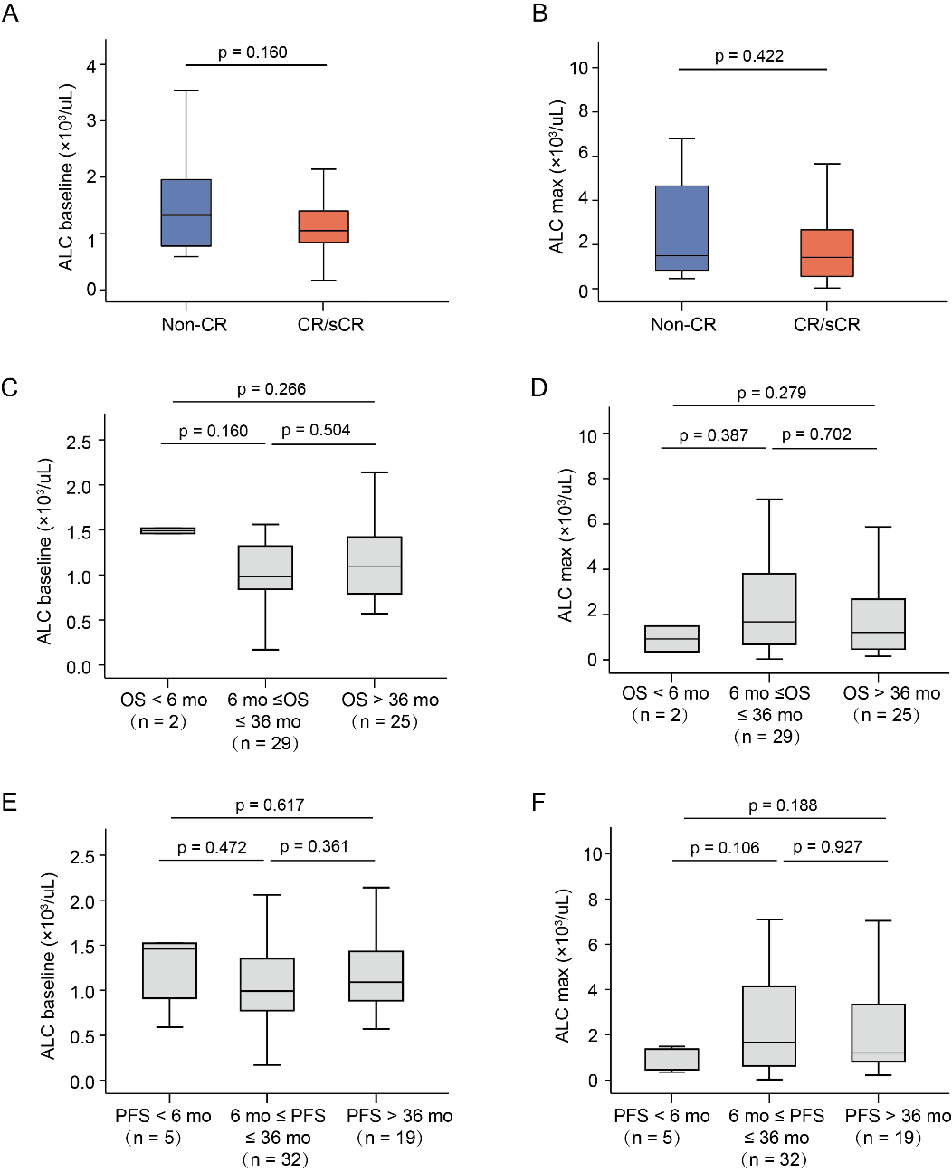
Figure S3. Correlations between ALC with response and clinical outcomes in RRMM patients. (A, B) ALC baseline and ALC max between different best response. (C, D) The relationship between the OS of patients and the extent of ALC baseline and ALC max observed. (D, E) The relationship between the PFS of patients and the extent of ALC baseline and ALC max observed.
CR, complete response; PFS, progression-free survival, OS, overall survival; sCR, stringent complete response;
Figure S4. Best response between triple-exposure and penta-exposure patients.
(A) ORR and best response in patients with or without triple-exposure status. (B) ORR and best response in patients with or without penta-exposure status.
CR, complete response; PR, partial response; ORR, overall response rate; sCR, stringent complete response; VGPR, very good partial response.

Figure S5. Correlations between CAR-T cell expansion with response and patient characteristics.
(A) Peak CAR-T cell expansion in patients with or without previous ASCT. (B) Univariate analysis of Cmax and bone marrow plasma cell at enrollment. (C, D) Peak CAR-T cell expansion in patients with or without prior CAR-T therapy and high-risk cytogenetic features. Spearman correlation coefficients (r) and corresponding p values are provided.
ASCT, autologous haematopoietic stem cell transplantation. CAR, chimeric antigen receptor.
Figure S6. Correlations between CRS grade with CAR-T cell expansion and response.
(A) Peak CAR-T cell expansion between CRS grades 0-1 and 2-3. (B) AUC for transgene levels from infusion to 28 days (AUC0–28d) between CRS grades 0-1 and 2-3. (C) CAR-T-cell persistence between CRS grades 0-1 and 2-3. (D) AUC for transgene levels from infusion to to the last recorded day (AUC 0–last day) between different CRS grade. (E) First month response between CRS grades 0-1 and 2-3. (F) Best response between CRS grades 0-1 and 2-3.
CAR, chimeric antigen receptor; CR, complete response; CRS, severe cytokine release syndrome; PR, partial response; sCR, stringent complete response; VGPR, very good partial response.

Figure S7. Comparison of CAR transgene kinetics between AND negativity and ADA positivity patients.
(A) Peak CAR-T cell expansion between AND negativity and ADA positivity patients. (B, C) Area under the curve of the transgene level from infusion to 28 days (AUC0–28d) and last days (AUC0-last day) between AND negativity and ADA positivity patients. (D) CAR-T cell persistence time between AND negativity and ADA positivity patients.
ADA, Anti-drug antibodies; CAR, chimeric antigen receptor.

