Appendix 1

Exclusion of patients who died, were lost to follow-up, or experienced new fatigue during the first 30 days after index date may have led to selection bias. This analysis here did not exclude patients due to being lost to follow-up, dying, or experiencing fatigue within the first 30 days of index date. The flowchart is shown in Figure A, patients characteristics are shown in Table A, and the results are shown in Figure B and Table B.

Figure A. Patient selection flowchart not excluding patients who experienced outcome, died, or were lost to follow-up within 30 days of index date.
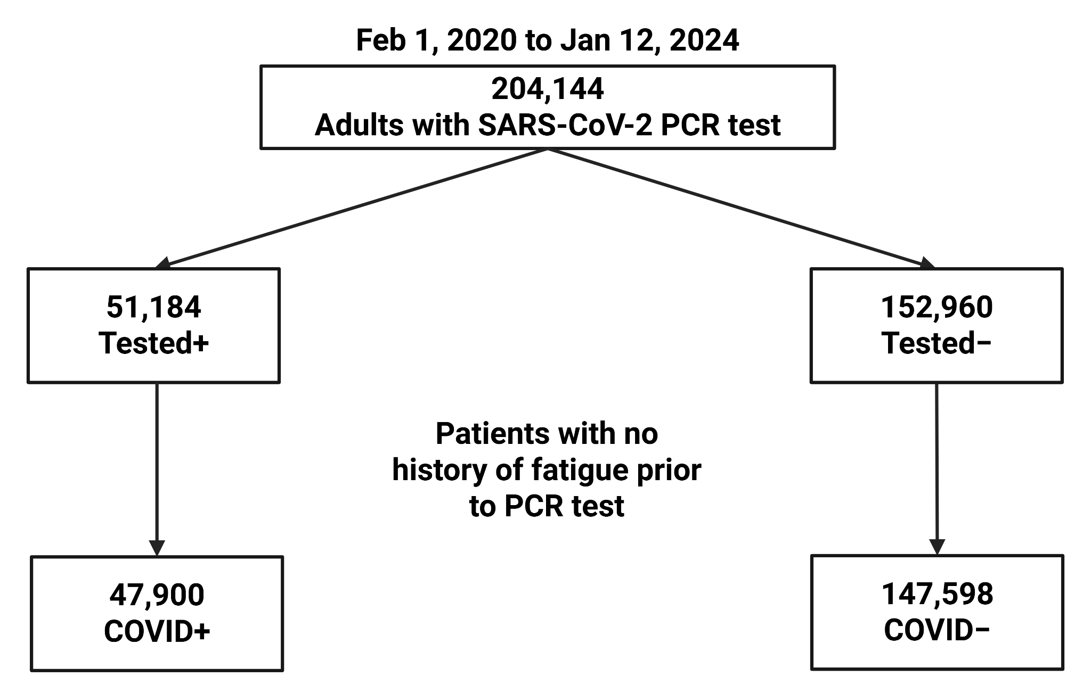

Table A. Characteristics of patients with no prior history of fatigue.
SD, standard deviation; ZIP, Zone Improvement Plan; COPD, chronic obstructive pulmonary disease; CFS/ME, chronic fatigue syndrome/myalgic encephalomyelitis
 | COVID+ (n=47900) | COVID– (n=147598) | p-value
Follow-Up Time (Years), mean ± SD | 1.29 ± 1.12 | 1.37 ± 1.17 | <0.005
Age at Index Date, mean ± SD | 53.00 ± 18.75 | 49.52 ± 17.28 | <0.005
Female, n (%) | 28172 (58.81%) | 86468 (58.58%) | 0.38
Race and Ethnicity, n (%)
Non-Hispanic White | 4938 (10.31%) | 15416 (10.44%) | 0.40
Black | 15639 (32.65%) | 43418 (29.42%) | <0.005
Asian | 2070 (4.32%) | 5306 (3.59%) | <0.005
Other Race | 25253 (52.72%) | 83458 (56.54%) | <0.005
Hispanic | 19400 (40.50%) | 56765 (38.46%) | <0.005
Pre-Existing Comorbidities, n (%)
Hypertension | 20409 (42.61%) | 45265 (30.67%) | <0.005
Type-2 Diabetes | 12300 (25.68%) | 23384 (15.84%) | <0.005
COPD | 1413 (2.95%) | 1209 (0.82%) | <0.005
Asthma | 8148 (17.01%) | 16635 (11.27%) | <0.005
Chronic Kidney Disease | 7010 (14.63%) | 9289 (6.29%) | <0.005
Liver Disease | 6458 (13.48%) | 12763 (8.65%) | <0.005
Cardiovascular Disease | 8644 (18.05%) | 12661 (8.58%) | <0.005
Autoimmune Disease | 3048 (6.36%) | 5895 (3.99%) | <0.005
Depressive Disorder | 6531 (13.63%) | 13550 (9.18%) | <0.005
Anxiety Disorder | 6565 (13.71%) | 13072 (8.86%) | <0.005
Insurance, n (%)
Medicaid | 16556 (34.56%) | 57327 (38.84%) | <0.005
Medicare | 9670 (20.19%) | 21124 (14.31%) | <0.005
Private | 16170 (33.76%) | 50508 (34.22%) | 0.060
Self Pay | 5504 (11.49%) | 18639 (12.63%) | <0.005
Income Group, n (%)
Lower 25th Percentile (<$38768) | 10160 (21.21%) | 35675 (24.17%) | <0.005
25th – 50th Percentile ($36730–$56327) | 11909 (24.86%) | 33832 (22.92%) | <0.005
50th – 75th Percentile ($56327–$63048) | 13938 (29.10%) | 40669 (27.55%) | <0.005
Top 25th Percentile (≥$63048) | 11893 (24.83%) | 37422 (25.35%) | 0.020
Hospitalized Due to COVID-19, n (%) | 14907 (31.12%) | – | –
Vaccinated for SARS-CoV-2 Prior to Index Date, n (%) | 16001 (33.41%) | 37815 (25.62%) | <0.005
New-Onset CFS/ME, n (%) | 186 (0.39%) | 369 (0.25%) | <0.005

Figure B. Cumulative incidence curve of new-onset chronic fatigue syndrome/myalgic encephalomyelitis after polymerase chain reaction SARS-CoV-2 test.
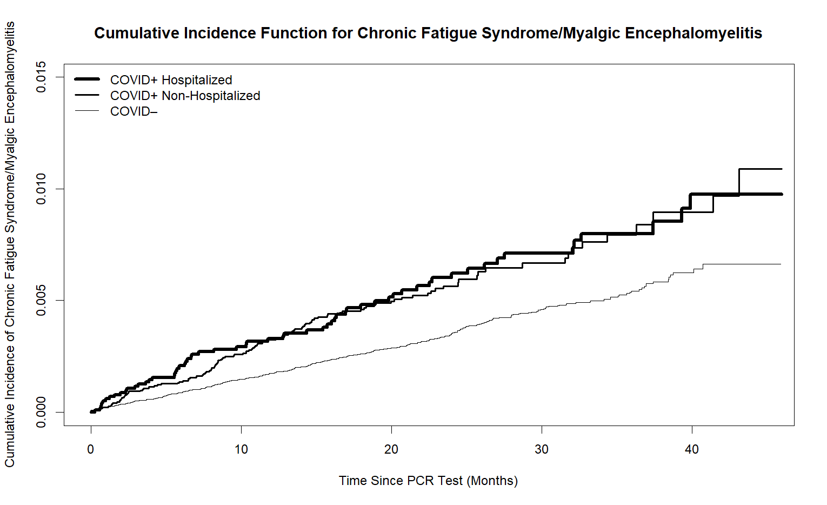

Table B. Multivariate Fine-Gray subdistribution hazards model showing adjusted hazard ratios (HR) for
developing new-onset chronic fatigue syndrome/myalgic encephalomyelitis post-index date.
COPD, chronic obstructive pulmonary disease
Covariate | Adjusted HR | p-value
SARS-CoV-2 Status
COVID+ Hospitalized vs COVID– | 1.55 [1.17, 2.07] | <0.005
COVID+ Non-Hospitalized vs COVID– | 1.46 [1.18, 1.80] | <0.005
Vaccinated for SARS-CoV-2 | 1.47 [1.22, 1.78] | <0.005
Age and Sex
Age at Index Date (Years) | 1.00 [1.00, 1.01] | 0.62
Female vs Male | 0.64 [0.53, 0.78] | <0.005
Race and Ethnicity
Black vs Non-Hispanic White | 0.69 [0.51, 0.92] | 0.012
Asian vs Non-Hispanic White | 1.01 [0.65, 1.57] | 0.97
Other Race vs Non-Hispanic White | 0.69 [0.50, 0.95] | 0.024
Hispanic vs Non-Hispanic | 1.13 [0.88, 1.45] | 0.33
Pre-Existing Comorbidities
Hypertension | 0.99 [0.80, 1.23] | 0.93
Type-2 Diabetes | 0.82 [0.66, 1.03] | 0.092
COPD | 0.89 [0.50, 1.59] | 0.69
Asthma | 1.09 [0.88, 1.35] | 0.45
Chronic Kidney Disease | 1.07 [0.81, 1.42] | 0.64
Liver Disease | 1.61 [1.30, 2.00] | <0.005
Cardiovascular Disease | 1.13 [0.87, 1.47] | 0.36
Autoimmune Disease | 1.50 [1.13, 1.98] | <0.005
Pre-Existing Psychiatric Disorders
Depressive Disorder | 1.18 [0.91, 1.53] | 0.21
Anxiety Disorder | 1.47 [1.14, 1.90] | <0.005
Insurance
Medicaid vs Private Insurance | 0.95 [0.78, 1.17] | 0.65
Medicare vs Private Insurance | 0.98 [0.76, 1.28] | 0.91
Self Pay vs Private Insurance | 0.81 [0.57, 1.15] | 0.24
ZIP Code Income Percentile
Lower 25th Percentile vs Top 25th Percentile | 0.89 [0.69, 1.15] | 0.37
25-50th Percentile vs Top 25th Percentile | 0.96 [0.75, 1.22] | 0.73
50-75th Percentile vs Top 25th Percentile | 0.95 [0.75, 1.19] | 0.63

