Supplementary methods

MSD – Meso Scale Discovery Assay
The levels of IL-23 in plasma from the orthotopic LNCaP model were quantified using a U4
plex custom panel (mouse) consisting of the following analytes: IFNgamma, IL-6, IL-10, IL-23, IP-10, MCP-1, MIP-1alpha, MIP-3alpha, TNFalpha and VEGFA-A, from MESO SCALE
Diagnostics (Rockville, MD, USA). Followed the protocol according to the manufacturer’s instructions and plates were analysed on a MESO QuickPlex SQ 120MM reader.

Supplementary figure legends

Supplementary Fig. S1 Beta-blocker treatment delayed the development of CRPC in CWR22 xenografts in mice. (A) Testosterone release pellets were implanted in nude Balb/c mice before the subcutaneous implantation of the hormone-sensitive CWR22 human prostate cancer model. Once the tumour was established, mice underwent castration and were subsequently treated with either placebo or propranolol release pellets for a duration of 60 days. Serum samples were collected weekly, and tumours were collected at time of termination. (B) Box plot showing the serum PSA levels from the placebo (n=9) and BB1/2 (Propranolol)(n=10) groups at different timepoints during the treatments period. (C) Kaplan-Meier plots depict the time to development of castration-resistant prostate cancer (CRPC) in castrated CWR22 mice treated with placebo or BB1/2. (D) Box plot illustrates tumour weight at termination for castrated CWR22 mice treated with either placebo or BB1/2 (Propranolol). Data were statistically analysed using Mann-Whitney U tests. (E) Spaghetti plot presenting change in tumour volume for each mouse (faint red (placebo) and blue (BB1/2) lines). The bold lines are the locally estimated scatterplot smoothing curves for each group and the grey areas indicate the 95% CI.

Supplementary Fig. S2 Beta-blocker treatment did not impact the mice’s weight, and the castration resistant tumours exhibited a larger volume. Box plots illustrating the change in mice weight from the start to the end of the study for each of the treatment groups for the subcutaneous CWR22 (A, left panel) and the orthotopic LNCaP (B, left panel) xenograft mice, respectively. The mice in the CWR22 model were treated with placebo pellets (Control, n=9) and propranolol (BB1/2, n=10), respectively. The mice in the LNCaP xenograft model were treated with vehicle (Control, n=7), propranolol (BB1/2, n=6) or propranolol and SR59230A (BB1/2/3, n=6), respectively. Box plot display the tumour volume relative to the beginning of the experiment in the subcutaneous CWR22 xenograft mice, distinguishing between those that did not develop (noCRPC) and those that did develop castration-resistant prostate cancer (CRPC) (A, middle panel). Similarly, the box plot illustrates tumour weight in orthotopic LNCaP xenograft mice, comparing those that did not develop (noCRPC) to those that progressed to CRPC (B, middle panel). The right panel in A are images of two representative tumours from each treatment group, whereas all tumours are shown for the mice in the orthotopic experiment (B, right panel). CWR22 data were statistically analysed using Mann-Whitney U tests, whereas Kruskal-Wallis test with Dunn’s as post hoc was used on data from the LNCaP model.

Supplementary Fig. S3 The androgen receptor protein level was reduced by beta-blocker treatment. Boxplot showing the results from Simple Western Immunoassay using an androgen receptor antibody. Five tumours from both the control and BB1/2/3 groups were analysed. GAPDH was used for normalization.
Supplementary Fig. S4 Charge profiles of the antibodies analysed with Peggy Sue Simple Western. The pherograms from all antibodies (AKT, pAKT, S6, pS6, mTOR, p-mTOR, SRC, AR and GADPH) and samples (control (n=5) and BB1/23 (n=5) groups) analysed are presented. The area below the peaks (coloured area) detected by chemiluminescence was used to calculate the protein expression levels. GAPDH was used for normalization.

Supplementary Fig. S5 Infiltration of CD68+ cells in an orthotopic LNCaP tumour from Balb/c mice. Formalin-fixed, paraffin embedded tumours collected from orthotopic LNCaP xenograft mice were stained immunohistochemically using an anti-CD68 antibody. A representative picture is shown. The relative number of CD68+ spots were determined and the Spearman’s rank correlation coefficient to the serum level of IL23 (Meso Scale Discovery assay), CXCL1 (OLINK proximity ligation assay) and CCL 20 (OLINK proximity ligation assay) were determined as shown below the image. p-values were determined using Kruskal-Wallis test with Dunn’s as post.doc test. * p< 0.05

Supplementary Fig. S6 Beta-blocker treatment up-regulated analytes linked to the IL23/IL17 axis in serum from orthotopic LNCaP xenograft mice. Box plots showing the level of interleukin 23 receptor (IL23R), interleukin 17A (IL17A), interleukin 17F (IL17F), chemokine (C-X-C motif) ligand 1 (CXCL1) and Granulocyte-macrophage colony-stimulating factor (GM-CSF), also known as colony-stimulating factor 2 (CSF2) in mice treated 50 with vehicle (Control, n=7), propranolol (BB1/2, n=6) or propranolol and SR59230A (BB1/2/3, n=6). The analytes were quantified using the OLINK proximity ligation assay and the results are presented as normalized protein expression values (NPX) on a log₂ scale. p-values were determined using Kruskal-Wallis test with Dunn’s as post.doc test.

Supplementary figures
Supplementary Fig. S1

Supplementary Fig. S2

Supplementary Fig. S3

Supplementary Fig. S4

Supplementary Fig. S5

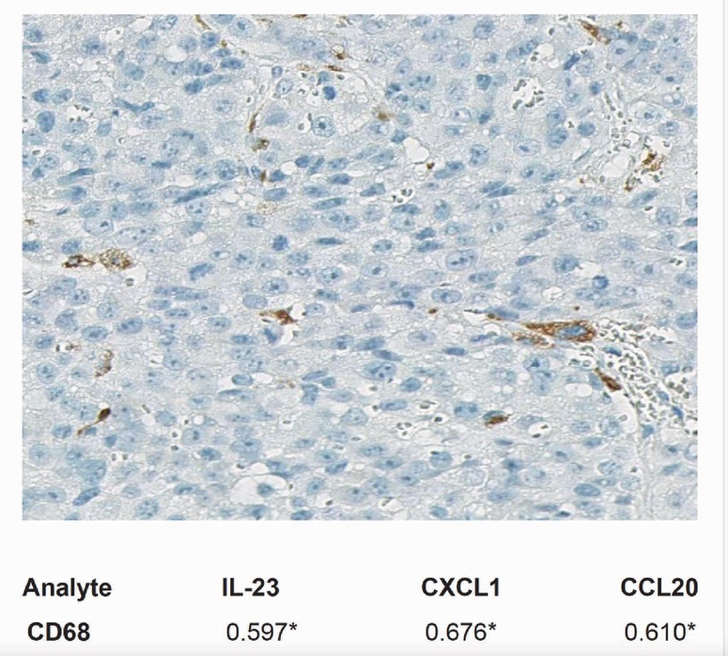

Supplementary Fig. S6

Supplementary Table S1: Baseline characterization of de novo metastatic prostate cancer cohort
Median (Q1, Q3); n (%)
1 Wilcoxon rank sum test; Pearson’s Chi-squared test; Fisher’s exact test

Supplementary Table S2: Multivariable sub-distribution hazard ratio for BB users with regard to start second-line treatment and prostate cancer specific mortality
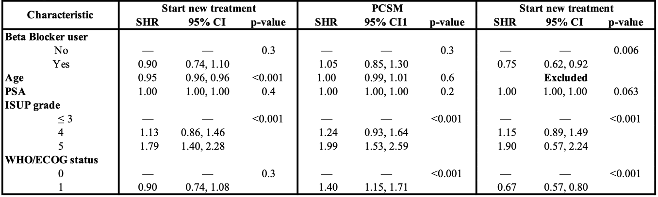
SHR: subdistribution hazard ratio
CI: confidence interval
PCSM: prostate cancer specific mortality

Supplementary Table S3: Spearman’s rank correlation coefficients between differentiation markers, tumor weight and signatures representing selected signaling and biological pathways
Characteristics | AR | NKX3-1 | EHF | ADRB2 | IL17A
Tumor weight | 0.27 | 0.58** | 0.66** | 0.57* | -0.59**
Senescence Signature | 0.92** | 0.79** | 0.93** | 0.77** | -0.67**
EP300 | 0.83** | 0.75** | 0.91** | 0.85** | -0.62**
SET7D | 0.79** | 0.82** | 0.94** | 0.78** | -0.74**
PI3K/AKT/MTOR | 0.76** | 0.82** | 0.93** | 0.85** | -0.69**
Fatty acid synthesis Signature | 0.65** | 0.72** | 0.87** | 0.83** | -0.73**
Proliferation Signature | -0.65** | -0.62** | -0.61** | -0.43 | 0.26
OXPHOS Signature | -0.79** | -0.82** | -0.93** | -0.84** | 0.67**

* p-value < 0.05, **p-value < 0.01

Supplementary Table S4: List of gene transcripts included in signatures
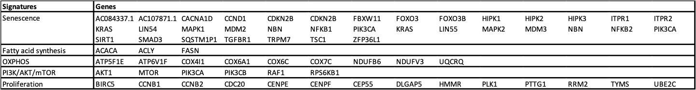

Supplementary Table S5: Pathway enrichment analyses of genes differentially expressed in LNCaP orthotophic xenograft mice treated with BB1/2 and BB1/2/3 compared to control

Direction | Relative to control | REACTOME | KEGG
DOWN | BB1/2 | Chromatin modeling enzymes / Chromation organization | Adherense junction
DOWN | BB1/2 | Role of phospholipids in phagocytosis | Neurotrophin signaling pathway
DOWN | BB1/2/3 | Chromatin modeling enzymes / Chromation organization | AMPK signaling pathway
DOWN | BB1/2/3 | Integration of energy metabolism | Endocrine resistant
UP | BB1/2 | Translation | Oxidative phosphorylation
UP | BB1/2 | Eukaryotic translation termination | Thermogenesis
UP | BB1/2/3 | Respiratory electron transport | Oxidative phosphorylation
UP | BB1/2/3 | The citric acid cycle | Prion disease

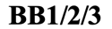
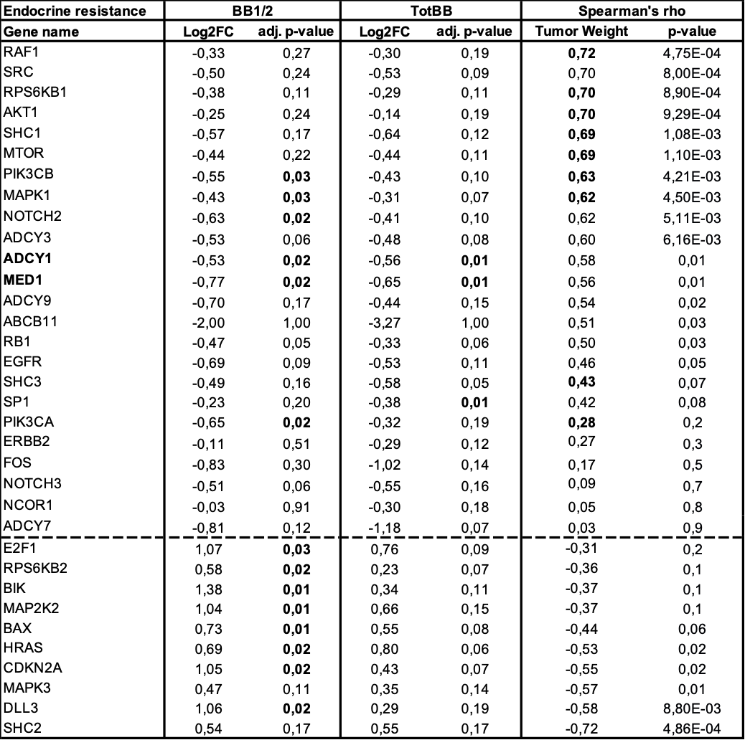
Supplementary Table S6: Endocrine resistance genes differentially expressed in non-selective BB-treated LNCaP orthotopic xenograft and correlation to tumor weight

Supplementary Table S7: OXPHOS genes differentially expressed in non-selective BB-treated LNCaP orthotopic xenograft and correlation to tumor weight
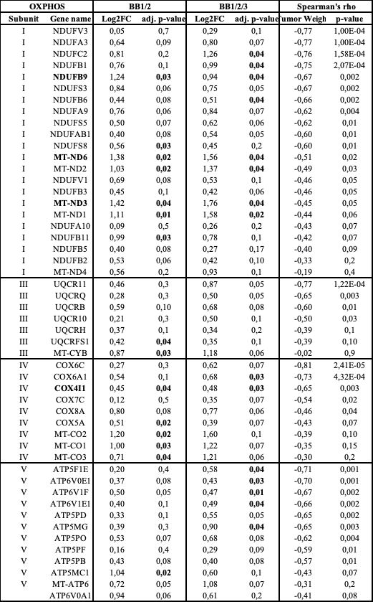
BB1/2: Propranolol
BB1/2/3: Propranolol + SR59230A
OXPHOS: Oxidative phosphorylation

Supplementary Table S8: OLINK analytes differentially expressed in non-selective BB-treated LNCaP orthotopic xenograft mice and correlation to tumor weight

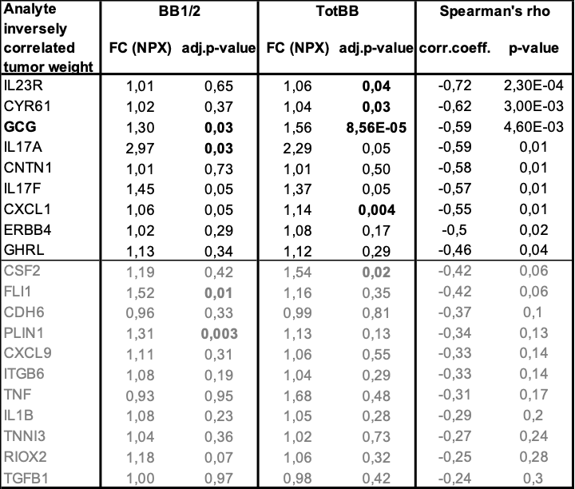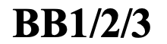
BB1/2: Propranolol
BB1/2/3: Propranolol + SR59230A

