SUPPLEMENTARY-
Part-I Five supplementary figures.
Part -II Full uncropped blots image.

Part-I Supplementary figures
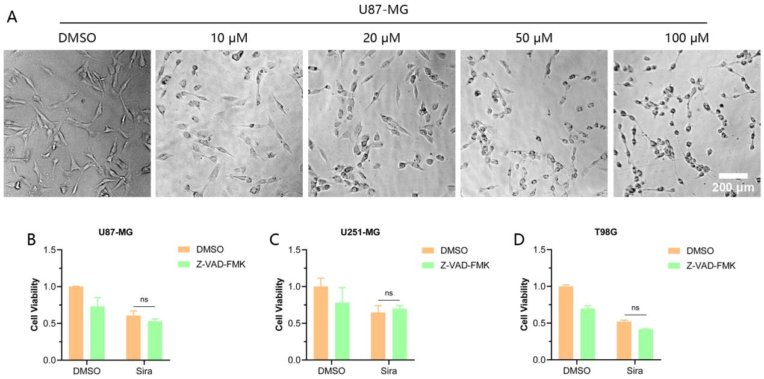
Fig. S1. Siramesine (Sira)-induced glioblastoma (GBM) cell death was not apoptosis. (A) The effect of different concentrations of Sira on the U87-MG cell morphology. (B-D) Viability of GBM cells was assessed with Sira combined with the apoptosis inhibitor Z-VAD-FMK treatment for 48 h. Data represented as mean ± standard deviation of at least three independent experiments. Scale bar = 200 μm. ns, not significant.

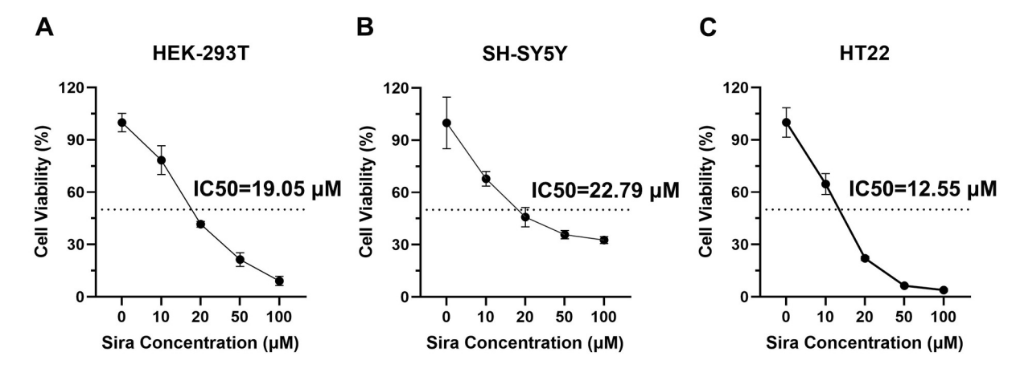
Fig. S2. Cytotoxicity evaluation of Siramesine (Sira) against HEK-293T, SH-SY5Y and HT22 cells. Dose-response curve and IC₅₀ determination of Sira in (A) HEK-293T cells, (B) SH-SY5Y cells and (C) HT22 cells following 48 h treatment. Data represented as mean ± standard deviation of at least three independent experiments.

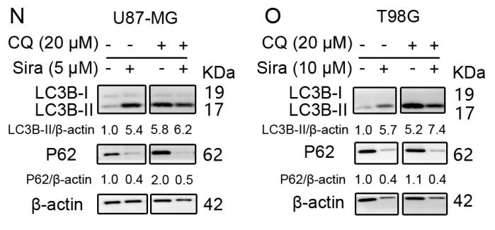

Fig. S3. Siramesine (Sira) treatment promoted autophagy in glioblastoma (GBM) cells. (A-B) The expressions of the autophagic proteins were assessed in GBM cells which were treated with the indicated concentration of Sira in combination with chloroquine (CQ) (20 μM).

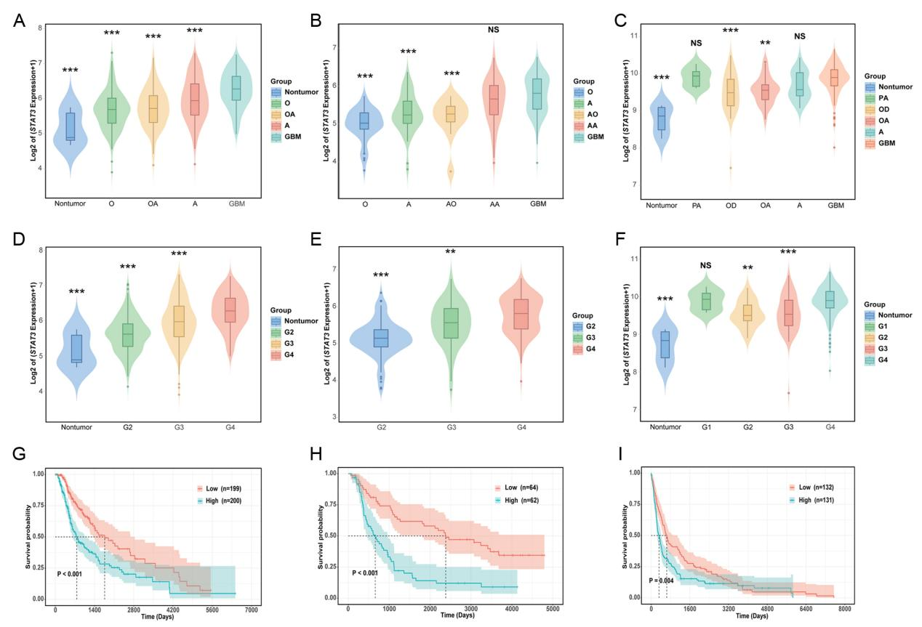
Fig. S4. STAT3 mRNA is highly expressed in glioma and negatively correlated with overall survival of patients of glioma. STAT3 mRNA expression in nontumor tissue versus glioma of different subtypes in the The Cancer Genome Atlas (TCGA) (A), Chinese Glioma Genome Atlas (CGGA) (B) and Gene Expression Omnibus (GSE16011) (C) datasets. STAT3 mRNA of different World Health Organization (WHO) grades in the TCGA (D), CGGA (E) and GSE16011 (F) datasets. Survival curves for glioma in TCGA (G), CGGA (H) and GSE16011 (I) datasets. A, astrocytoma; OA, oligodendroastrocytoma; O, oligodendroglioma; AA, anaplastic astrocytoma; AOA, anaplastic oligodendroastrocytoma; AO, anaplastic oligodendroglioma. Data represented as mean ± standard deviation. **P < 0.01, ***P < 0.001, NS, not significant.

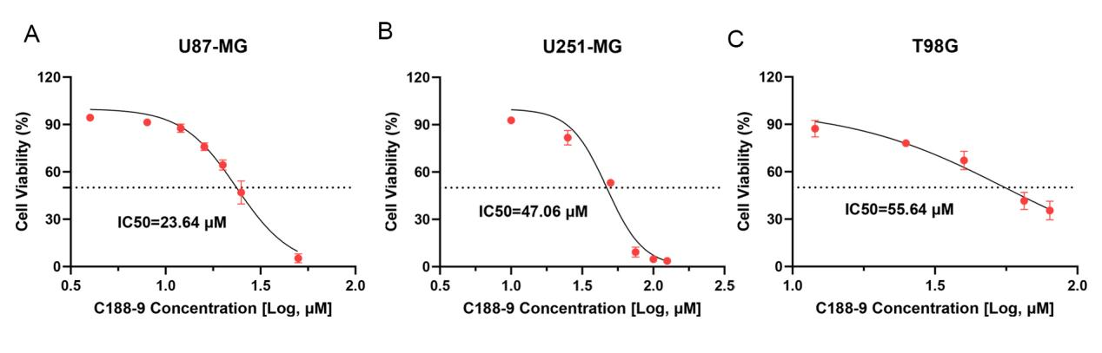
Fig. S5. Cytotoxicity evaluation of STAT3 inhibitor C188-9 against three glioma cell lines. (A) Dose-response curve and IC₅₀ determination of C188-9 in U87-MG cells following 48 h treatment. (B) Dose-response curve and IC₅₀ determination of C188-9 in U251-MG cells following 48 h treatment. (C) Dose-response curve and IC₅₀ determination of C188-9 in T98G cells following 48 h treatment. The data presented is the mean ± standard deviation of at least three independent experiments.

Fig. S6. Siramesine (Sira) modulates AKT signaling and induces DNA damage in glioblastoma (GBM) cells. (A) The expressions of phosphorylated AKT (p-AKT) and total AKT in U87-MG cells treated with increasing concentrations of Sira (0–10 µM) for 48 h. (B, C) Quantification of AKT and p-AKT levels normalized to β-ACTIN (n = 3). (D) STAT1 protein expression in Sira-treated U87-MG cells. (E) Quantification of STAT1 levels in U87-MG cells (n = 3). (F) The expressions of STAT1 and γ-H2AX (DNA damage marker) in T98G cells following Sira treatment. (G, H) Quantitative analysis of STAT1 and γ-H2AX levels in T98G cells (n=3). Data represent mean ± standard deviation. Statistical significance was determined by one-way ANOVA. *P < 0.05, **P < 0.01, ***P < 0.001.

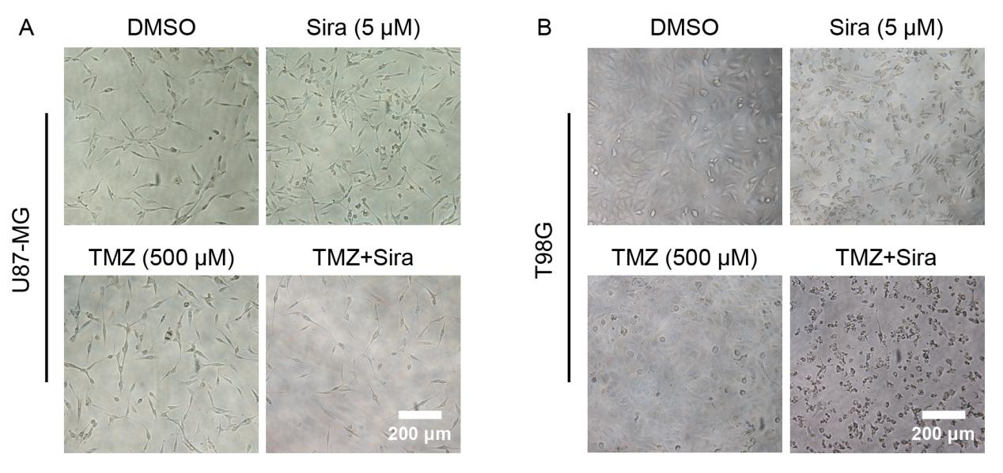
Fig. S7. Siramesine (Sira) combination with temozolomide (TMZ) augmented the gliblastoma (GBM) cell death. The morphology of GBM cells was assessed with the indicated drug treatment for 48 h. Scale bar = 200 μm.

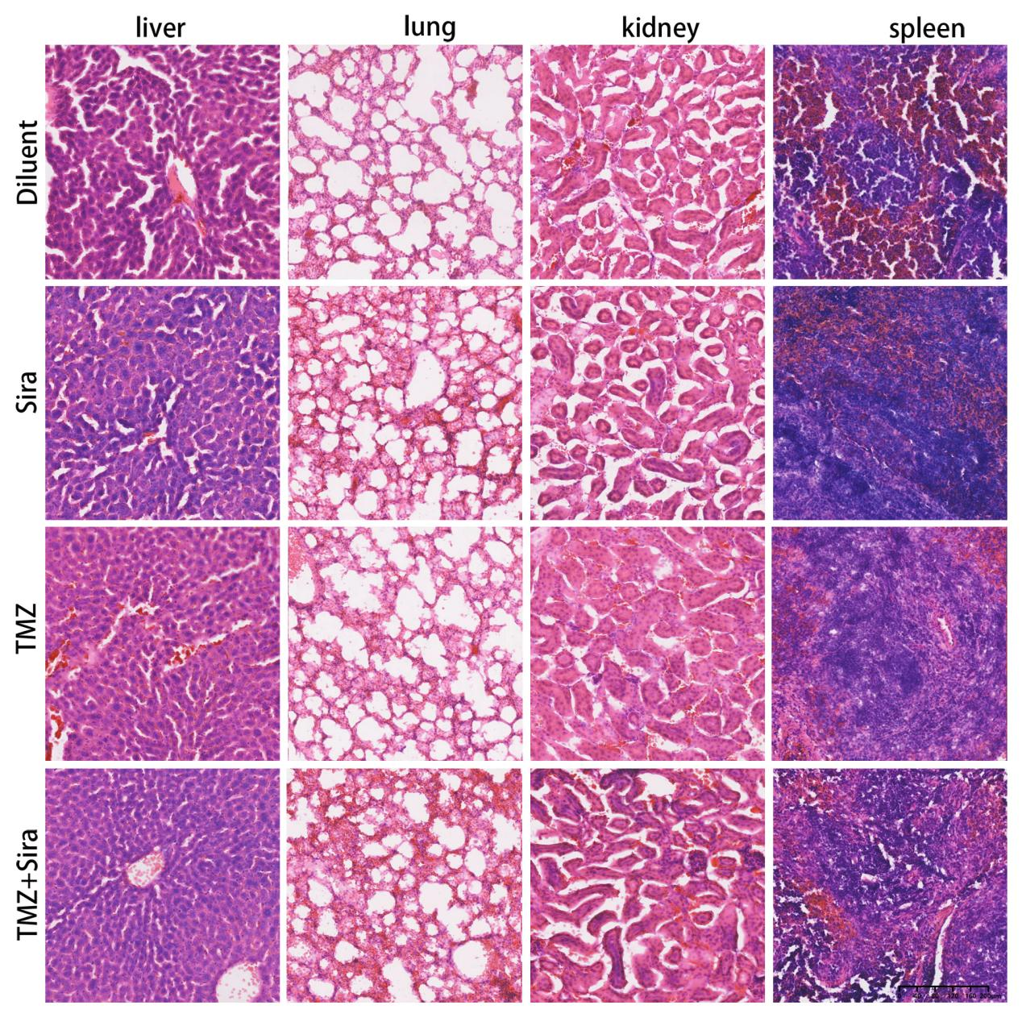
Fig. S8. H&E staining of the important organs to show the potential cytotoxicity of drug treatment. Scale bar = 200 μm.

Part-II Full uncropped blots image
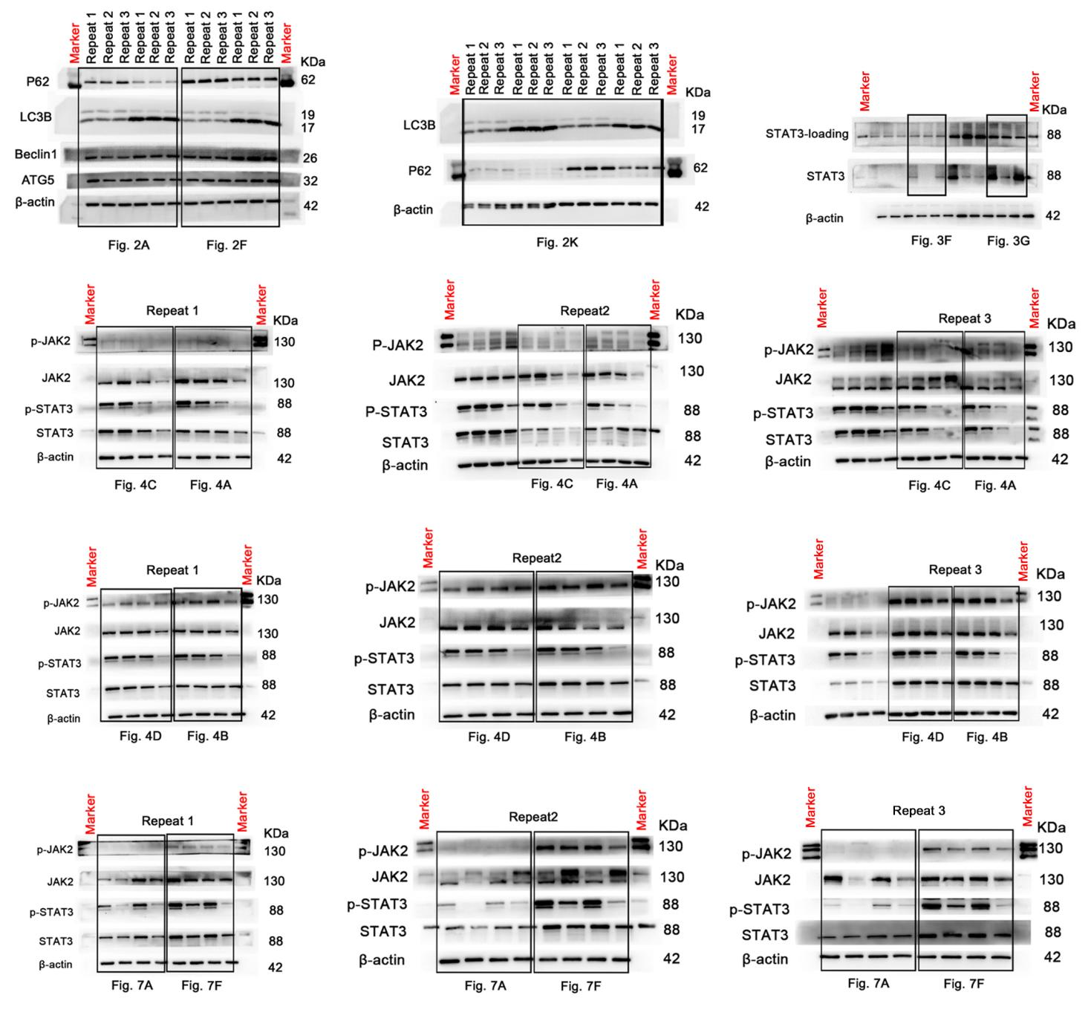
(1)

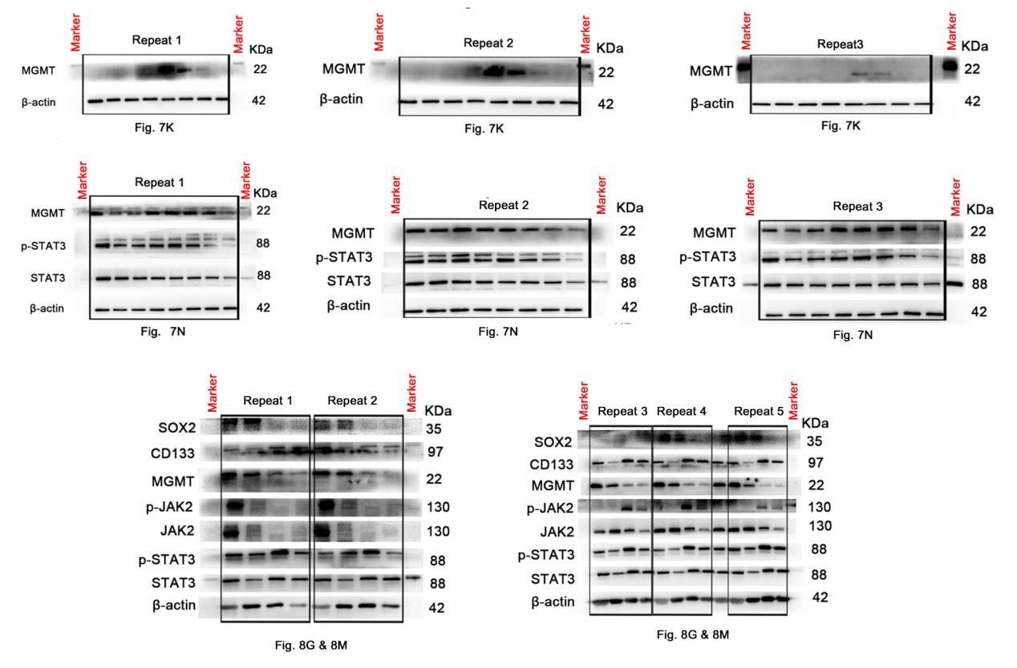
(2)

