Supplement material 3
eFigure 1: Risk of bias summary; the green indicates low risk, the yellow indicates unclear risk and the red indicates high risk.
eFigure 2: Forest plot for all grades of cardiac adverse events in immune checkpoint inhibitor (ICIs) compared with placebo group, grouped according to tumor type.
eFigure 3: Forest plot for myocarditis events in immune checkpoint inhibitor (ICIs) compared with placebo group, grouped according to type of ICI combination.
eFigure 4: Forest plot for myocarditis events in immune checkpoint inhibitor (ICIs) compared with placebo group, grouped according to tumor type.
eFigure 5: Forest plot for pericardial events in immune checkpoint inhibitor (ICIs) compared with placebo group, grouped according to ICI type.
eFigure 6: Forest plot for pericardial events in immune checkpoint inhibitor (ICIs) compared with placebo group, grouped according to type of ICI combination.
eFigure 7: Forest plot for pericardial events in immune checkpoint inhibitor (ICIs) compared with placebo group, grouped according to tumor type.
eFigure 8: Forest plot for arrhythmia events in immune checkpoint inhibitor (ICIs) compared with placebo group, grouped according to type of ICI combination.
eFigure 9: Forest plot for arrhythmia events in immune checkpoint inhibitor (ICIs) compared with placebo group, grouped according to tumor type.
eFigure 10: Funnel plots to assess the publication bias (A) all grades of all cardiac adverse events (B) all grades of myocarditis events (C) all grades of pericardial events (D) all grades of arrhythmia events.
eTable 1: The incidence of anti-PD-1, anti-PD-L1, anti-CTLA-4 and the total.
eTable 2: leave-one-out sensitivity analysis for all grades of cardiac adverse events in the immune checkpoint inhibitors (ICIs) group vs placebo group.
eTable 3: leave-one-out sensitivity analysis for myocarditis events in the immune checkpoint inhibitors (ICIs) group vs placebo group.
eTable 4: leave-one-out sensitivity analysis for pericardial events in the immune checkpoint inhibitors (ICIs) group vs placebo group.
eTable 5: leave-one-out sensitivity analysis for arrhythmia events in the immune checkpoint inhibitors (ICIs) group vs placebo group.
eTable 6: Meta-regression analysis results according to ICI types.
eTable 7: Association between the occurrence of cardiac adverse events and the use of ICIs.

eFigure 1: Risk of bias summary; the green indicates low risk, the yellow indicates unclear risk and the red indicates high risk.
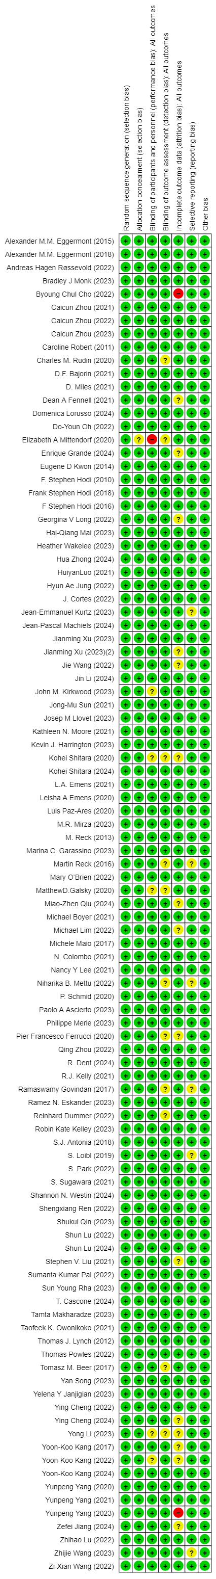
eFigure 2: Forest plot for all grades of cardiac adverse events in immune checkpoint inhibitor (ICIs) compared with placebo group, grouped according to tumor type.
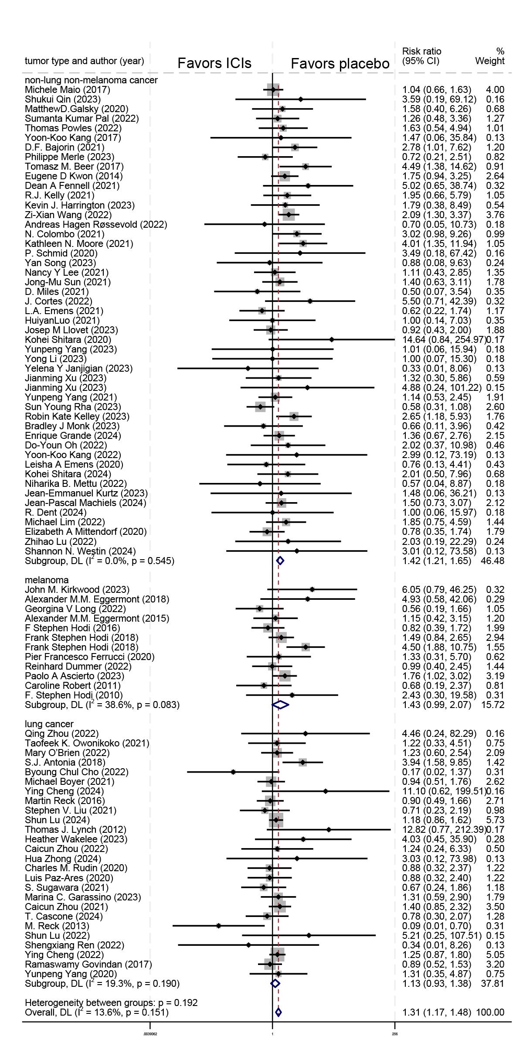
eFigure 3: Forest plot for myocarditis events in immune checkpoint inhibitor (ICIs) compared with placebo group, grouped according to type of ICI combination.
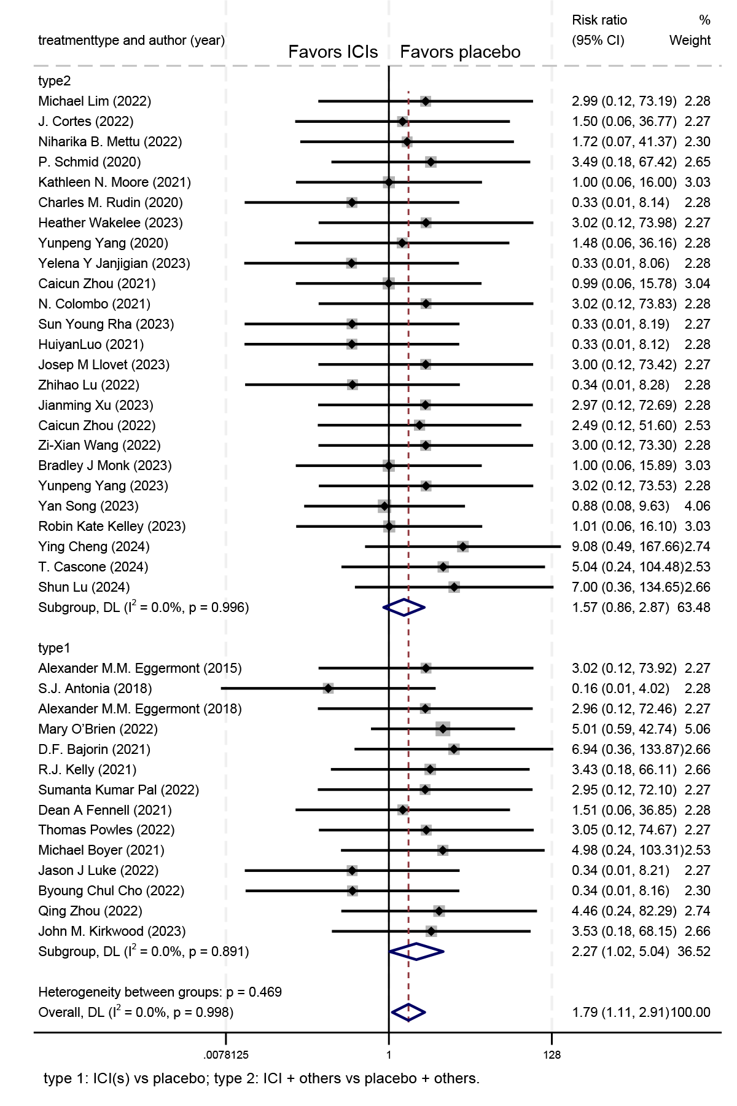
eFigure 4: Forest plot for myocarditis events in immune checkpoint inhibitor (ICIs) compared with placebo group, grouped according to tumor type.
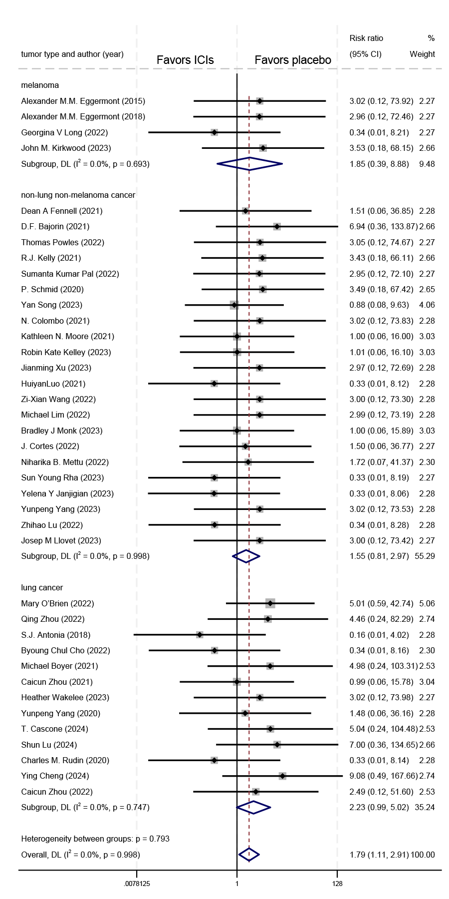
eFigure 5: Forest plot for pericardial events in immune checkpoint inhibitor (ICIs) compared with placebo group, grouped according to ICI type.
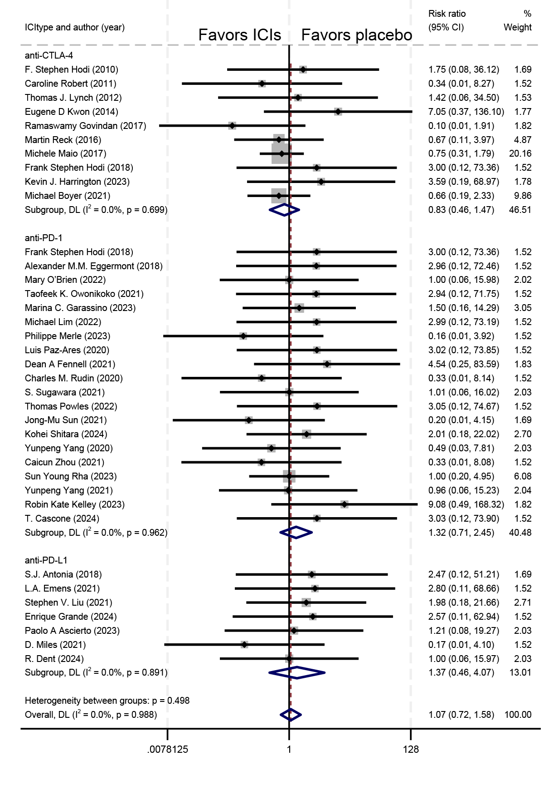
eFigure 6: Forest plot for pericardial events in immune checkpoint inhibitor (ICIs) compared with placebo group, grouped according to type of ICI combination.
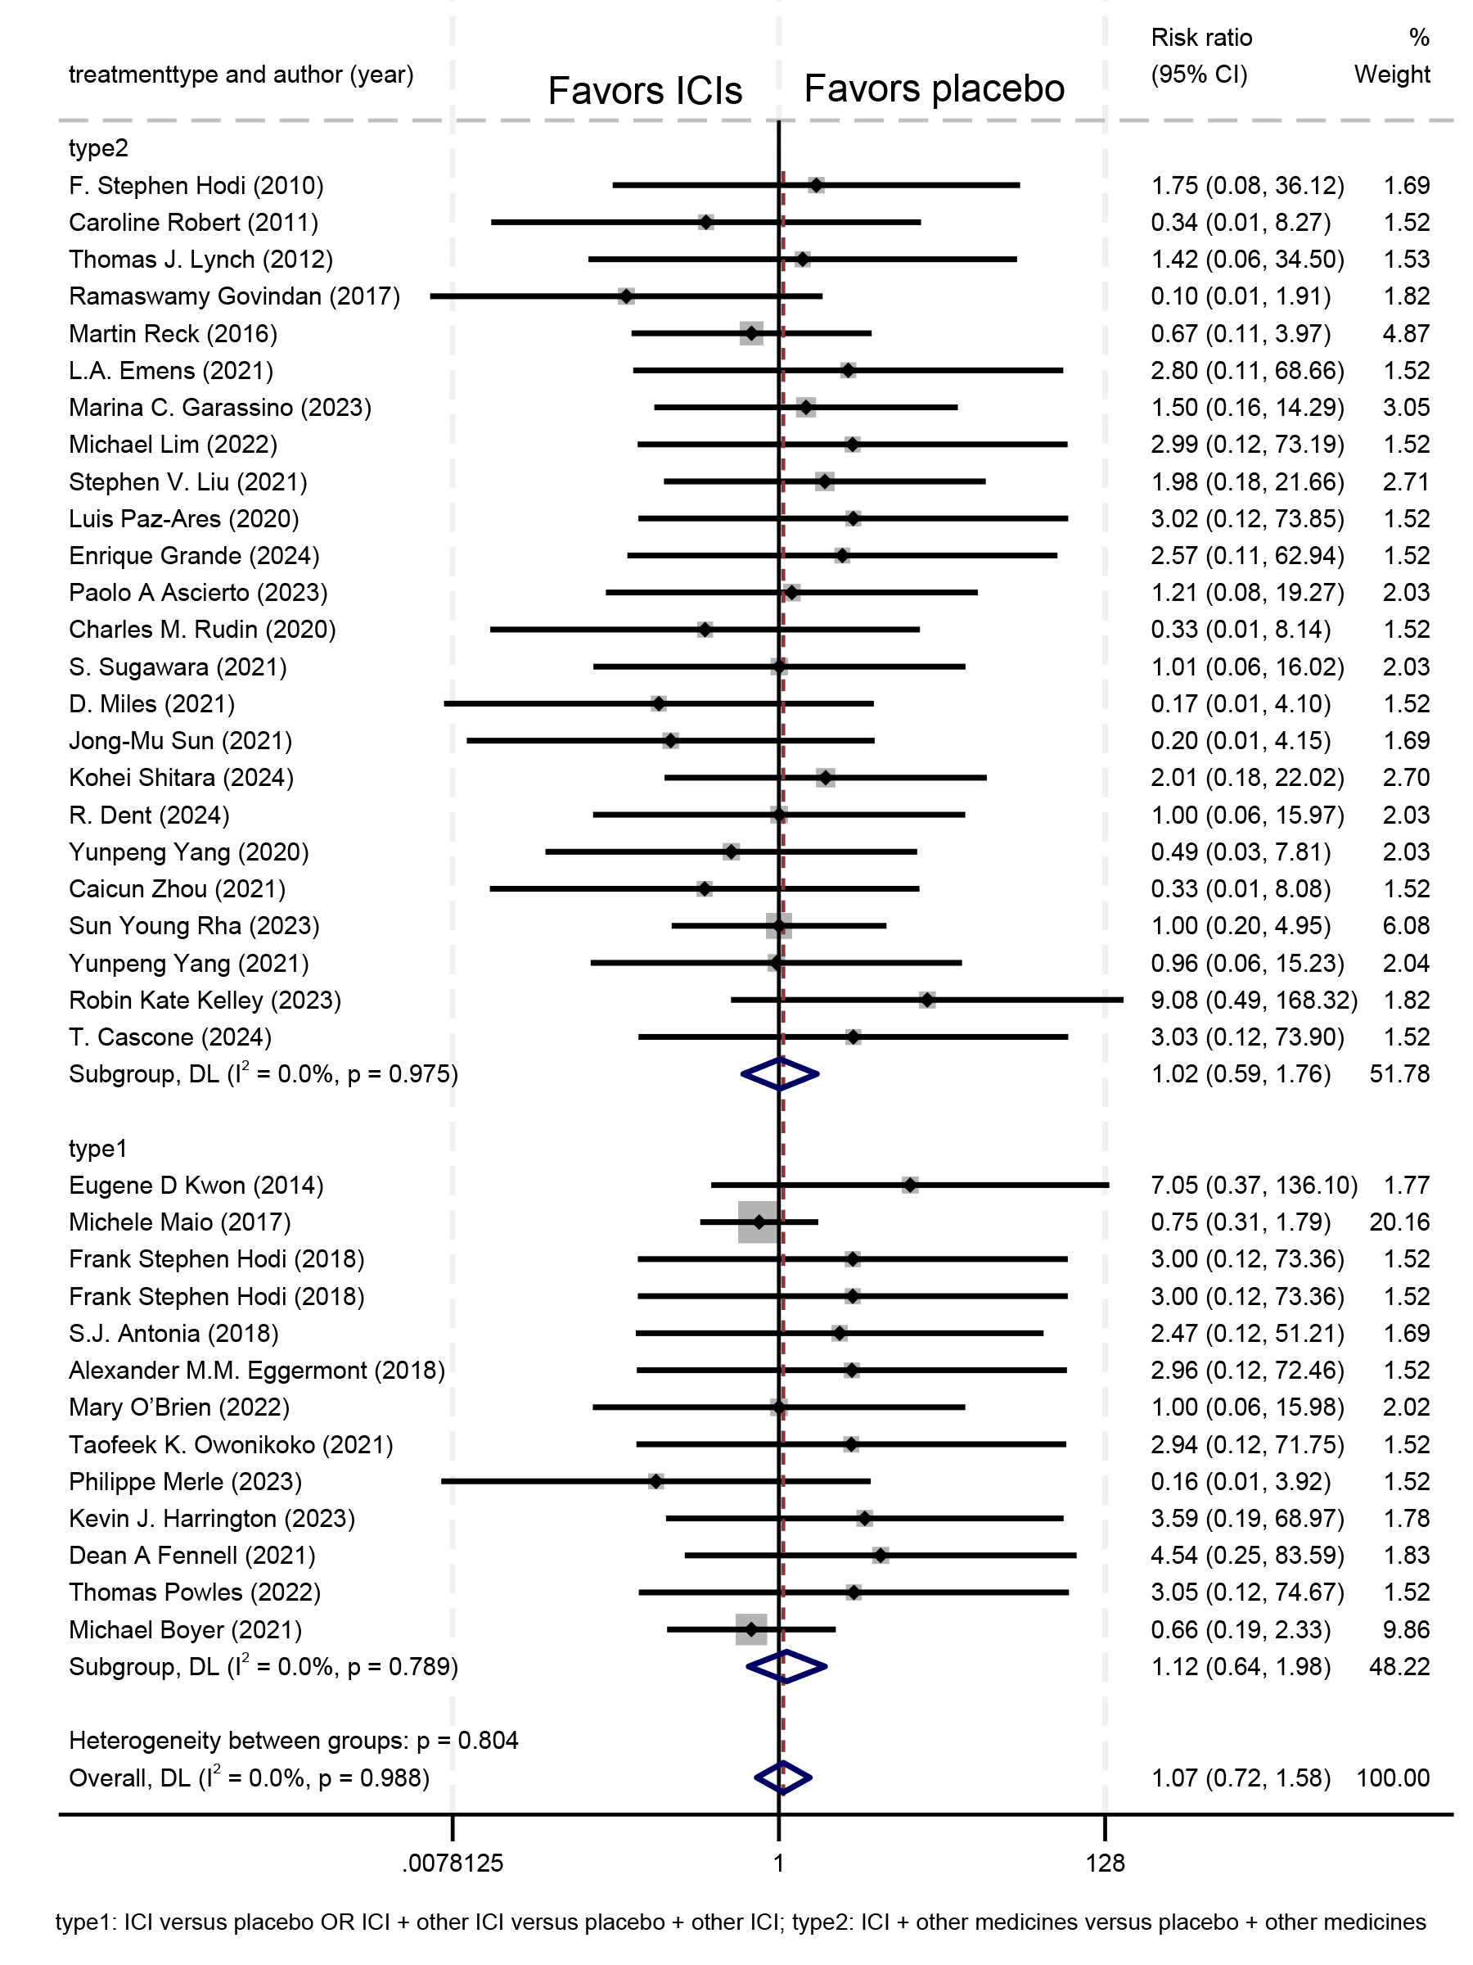

eFigure 7: Forest plot for pericardial events in immune checkpoint inhibitor (ICIs) compared with placebo group, grouped according to tumor type.
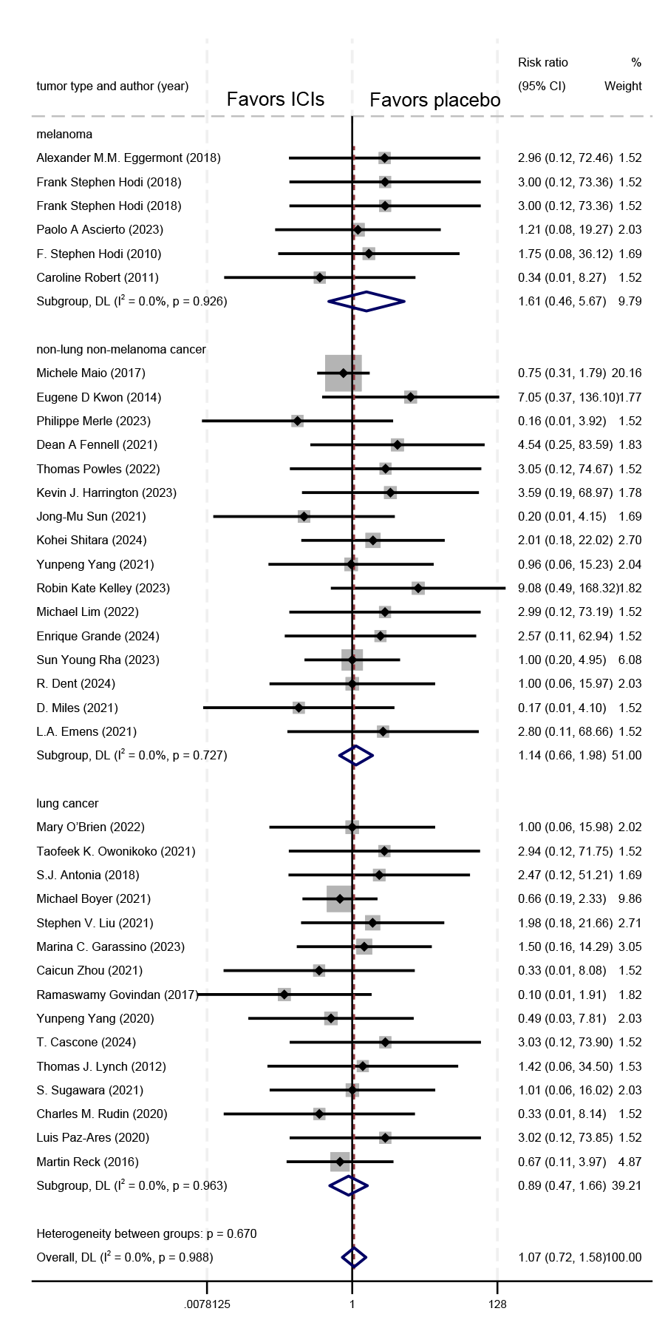
eFigure 8: Forest plot for arrhythmia events in immune checkpoint inhibitor (ICIs) compared with placebo group, grouped according to type of ICI combination.
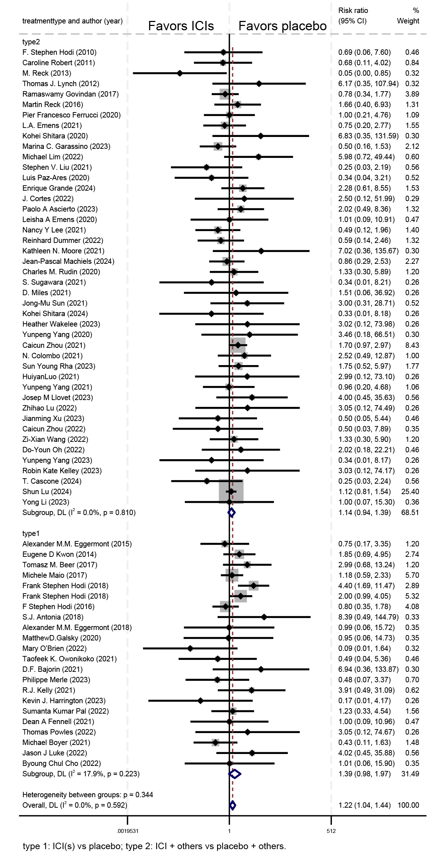
eFigure 9: Forest plot for arrhythmia events in immune checkpoint inhibitor (ICIs) compared with placebo group, grouped according to tumor type.
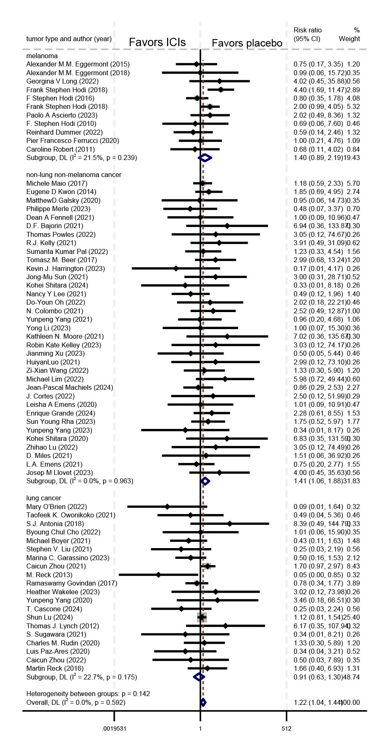
eFigure 10: Funnel plots to assess the publication bias (A) all grades of all cardiac adverse events (B) all grades of myocarditis events (C) all grades of pericardial events (D) all grades of arrhythmia events.
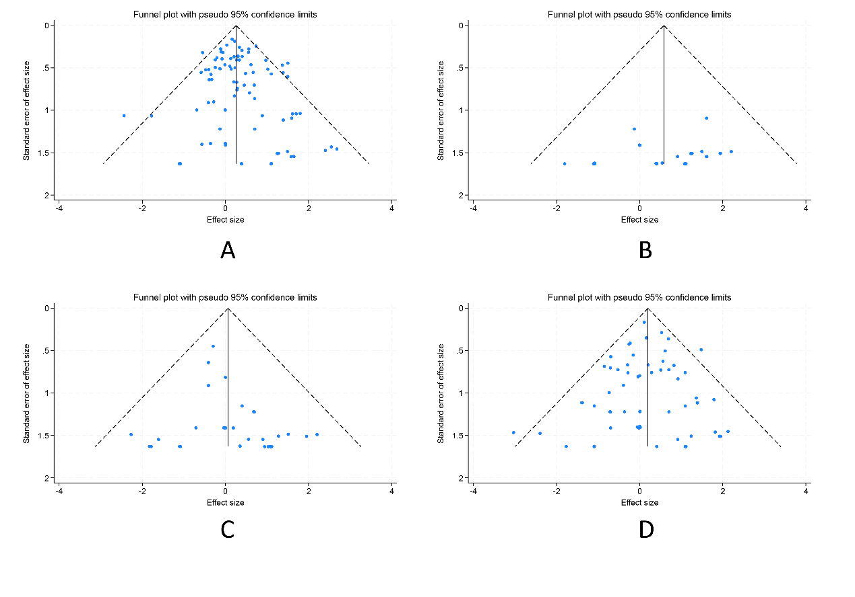
eTable 1: The incidence of anti-PD-1, anti-PD-L1, anti-CTLA-4 and the total.
ICI type | ICI group events/N | ICI group incidence (95% CI) | Non-ICI group events/N | Non-ICI group incidence (95% CI)
All | 1009/32227 | 3.0% (2.6%-3.5%) | 609/26784 | 2.3% (1.9%-2.7%)
Anti-PD-1 | 608/20809 | 3.0% (2.4%-3.6%) | 368/17571 | 2.2% (1.7%-2.7%)
Anti-PD-L1 | 169/7034 | 2.0% (1.4%-2.7%) | 100/5736 | 1.8% (1.2%-2.4%)
Anti-CTLA-4 | 231/4317 | 4.9% (3.4%-6.5%) | 135/3409 | 3.5% (2.2%-4.8%)

eTable 2: leave-one-out sensitivity analysis for all grades of cardiac adverse events in the immune checkpoint inhibitors (ICIs) group vs placebo group.
study omitted | estimate | 95% CI
F. Stephen Hodi (2010) | 1.31 | 1.16-1.47
Caroline Robert (2011) | 1.32 | 1.17-1.48
M. Reck (2013) | 1.32 | 1.18-1.47
Thomas J. Lynch (2012) | 1.31 | 1.16-1.47
Alexander M.M. Eggermont (2015) | 1.31 | 1.17-1.48
Eugene D Kwon (2014) | 1.30 | 1.15-1.47
Tomasz M. Beer (2017) | 1.29 | 1.15-1.45
Ramaswamy Govindan (2017) | 1.33 | 1.18-1.50
Martin Reck (2016) | 1.33 | 1.18-1.49
Michele Maio (2017) | 1.32 | 1.17-1.50
Frank Stephen Hodi (2018) | 1.28 | 1.15-1.43
Frank Stephen Hodi (2018) | 1.31 | 1.16-1.48
F Stephen Hodi (2016) | 1.32 | 1.18-1.49
S.J. Antonia (2018) | 1.29 | 1.15-1.44
Pier Francesco Ferrucci (2020) | 1.31 | 1.16-1.48
Yoon-Koo Kang (2017) | 1.31 | 1.16-1.48
Alexander M.M. Eggermont (2018) | 1.31 | 1.16-1.47
L.A. Emens (2021) | 1.32 | 1.18-1.49
Kohei Shitara (2020) | 1.30 | 1.16-1.47
MatthewD.Galsky (2020) | 1.31 | 1.16-1.48
Mary O’Brien (2022) | 1.31 | 1.17-1.48
S. Park (2022) | 1.31 | 1.17-1.48
Taofeek K. Owonikoko (2021) | 1.31 | 1.17-1.48
Marina C. Garassino (2023) | 1.31 | 1.16-1.48
D.F. Bajorin (2021) | 1.30 | 1.15-1.46
Michael Lim (2022) | 1.31 | 1.16-1.47
S. Loibl (2019) | 1.31 | 1.17-1.48
Philippe Merle (2023) | 1.32 | 1.17-1.48
R.J. Kelly (2021) | 1.31 | 1.16-1.47
Yoon-Koo Kang (2022) | 1.31 | 1.16-1.48
Stephen V. Liu (2021) | 1.32 | 1.17-1.49
Luis Paz-Ares (2020) | 1.32 | 1.17-1.49
Enrique Grande (2024) | 1.31 | 1.16-1.48
J. Cortes (2022) | 1.30 | 1.16-1.47
Kevin J. Harrington (2023) | 1.31 | 1.16-1.48
Niharika B. Mettu (2022) | 1.31 | 1.17-1.48
Jean-Emmanuel Kurtz (2023) | 1.31 | 1.16-1.48
Paolo A Ascierto (2023) | 1.30 | 1.15-1.46
Leisha A Emens (2020) | 1.32 | 1.17-1.48
eTable 2: leave-one-out sensitivity analysis for all grades of cardiac adverse events in the immune checkpoint inhibitors (ICIs) group vs placebo group (continued).
study omitted | estimate | 95% CI
Nancy Y Lee (2021) | 1.32 | 1.17-1.48
Reinhard Dummer (2022) | 1.32 | 1.17-1.48
Yoon-Koo Kang (2024) | 1.31 | 1.17-1.48
Sumanta Kumar Pal (2022) | 1.31 | 1.16-1.48
P. Schmid (2020) | 1.31 | 1.16-1.47
Kathleen N. Moore (2021) | 1.30 | 1.15-1.45
Jean-Pascal Machiels (2024) | 1.31 | 1.16-1.48
Shukui Qin (2023) | 1.31 | 1.16-1.47
Dean A Fennell (2021) | 1.31 | 1.16-1.47
Charles M. Rudin (2020) | 1.32 | 1.17-1.49
S. Sugawara (2021) | 1.32 | 1.17-1.49
D. Miles (2021) | 1.32 | 1.17-1.48
Thomas Powles (2022) | 1.31 | 1.16-1.48
Andreas Hagen Røssevold (2022) | 1.31 | 1.17-1.48
Jong-Mu Sun (2021) | 1.31 | 1.16-1.48
Elizabeth A Mittendorf (2020) | 1.32 | 1.18-1.49
Kohei Shitara (2024) | 1.31 | 1.16-1.47
Michael Boyer (2021) | 1.32 | 1.17-1.49
R. Dent (2024) | 1.31 | 1.17-1.48
Tamta Makharadze (2023) | 1.31 | 1.17-1.48
Heather Wakelee (2023) | 1.31 | 1.16-1.47
Jason J Luke (2022) | 1.32 | 1.18-1.49
Byoung Chul Cho (2022) | 1.32 | 1.17-1.48
Hai-Qiang Mai (2023) | 1.31 | 1.17-1.48
Yunpeng Yang (2020) | 1.31 | 1.16-1.48
Yelena Y Janjigian (2023) | 1.32 | 1.17-1.48
Caicun Zhou (2021) | 1.31 | 1.16-1.48
N. Colombo (2021) | 1.30 | 1.16-1.46
Hyun Ae Jung (2022) | 1.31 | 1.17-1.48
Shengxiang Ren (2022) | 1.31 | 1.17-1.48
Sun Young Rha (2023) | 1.34 | 1.19-1.50
HuiyanLuo (2021) | 1.31 | 1.17-1.48
Yunpeng Yang (2021) | 1.32 | 1.17-1.48
Jie Wang (2022) | 1.31 | 1.17-1.48
Josep M Llovet (2023) | 1.32 | 1.17-1.49
Qing Zhou (2022) | 1.31 | 1.16-1.47
Jianming Xu (2023) | 1.31 | 1.16-1.47
Zhihao Lu (2022) | 1.31 | 1.16-1.48
Miao-Zhen Qiu (2024) | 1.31 | 1.17-1.48
eTable 2: leave-one-out sensitivity analysis for all grades of cardiac adverse events in the immune checkpoint inhibitors (ICIs) group vs placebo group (continued).
study omitted | estimate | 95% CI
Jianming Xu (2023) | 1.31 | 1.16-1.48
Caicun Zhou (2022) | 1.31 | 1.17-1.48
Shun Lu (2022) | 1.31 | 1.16-1.47
Zi-Xian Wang (2022) | 1.28 | 1.14-1.45
Bradley J Monk (2023) | 1.32 | 1.17-1.48
Zhijie Wang (2023) | 1.31 | 1.17-1.48
Hua Zhong (2024) | 1.31 | 1.16-1.48
Do-Youn Oh (2022) | 1.31 | 1.16-1.47
Ramez N. Eskander (2023) | 1.31 | 1.17-1.48
Yunpeng Yang (2023) | 1.31 | 1.17-1.48
Yan Song (2023) | 1.31 | 1.17-1.48
M.R. Mirza (2023) | 1.31 | 1.17-1.48
Robin Kate Kelley (2023) | 1.29 | 1.15-1.45
Ying Cheng (2024) | 1.31 | 1.16-1.47
T. Cascone (2024) | 1.32 | 1.17-1.49
Caicun Zhou (2023) | 1.31 | 1.17-1.48
Ying Cheng (2022) | 1.32 | 1.16-1.49
Zefei Jiang (2024) | 1.31 | 1.17-1.48
John M. Kirkwood (2023) | 1.30 | 1.16-1.47
Shun Lu (2024) | 1.32 | 1.17-1.49
Jin Li (2024) | 1.31 | 1.17-1.48
Domenica Lorusso (2024) | 1.31 | 1.17-1.48
Shannon N. Westin (2024) | 1.31 | 1.16-1.48
Yong Li (2023) | 1.31 | 1.17-1.48
Combined | 1.31 | 1.17-1.48

eTable 3: leave-one-out sensitivity analysis for myocarditis events in the immune checkpoint inhibitors (ICIs) group vs placebo group.
study omitted | estimate | 95% CI
F. Stephen Hodi (2010) | 1.79 | 1.11-2.91
Caroline Robert (2011) | 1.79 | 1.11-2.91
M. Reck (2013) | 1.79 | 1.11-2.91
Thomas J. Lynch (2012) | 1.79 | 1.11-2.91
Alexander M.M. Eggermont (2015) | 1.77 | 1.09-2.89
Eugene D Kwon (2014) | 1.79 | 1.11-2.91
Tomasz M. Beer (2017) | 1.79 | 1.11-2.91
Ramaswamy Govindan (2017) | 1.79 | 1.11-2.91
Martin Reck (2016) | 1.79 | 1.11-2.91
Michele Maio (2017) | 1.79 | 1.11-2.91
Frank Stephen Hodi (2018) | 1.79 | 1.11-2.91
Frank Stephen Hodi (2018) | 1.79 | 1.11-2.91
F Stephen Hodi (2016) | 1.79 | 1.11-2.91
S.J. Antonia (2018) | 1.90 | 1.16-3.09
Pier Francesco Ferrucci (2020) | 1.79 | 1.11-2.91
Yoon-Koo Kang (2017) | 1.79 | 1.11-2.91
Alexander M.M. Eggermont (2018) | 1.77 | 1.09-2.89
L.A. Emens (2021) | 1.79 | 1.11-2.91
Kohei Shitara (2020) | 1.79 | 1.11-2.91
MatthewD.Galsky (2020) | 1.79 | 1.11-2.91
Mary O’Brien (2022) | 1.70 | 1.04-2.79
S. Park (2022) | 1.79 | 1.11-2.91
Taofeek K. Owonikoko (2021) | 1.79 | 1.11-2.91
Marina C. Garassino (2023) | 1.79 | 1.11-2.91
D.F. Bajorin (2021) | 1.73 | 1.06-2.82
Michael Lim (2022) | 1.77 | 1.09-2.89
S. Loibl (2019) | 1.79 | 1.11-2.91
Philippe Merle (2023) | 1.79 | 1.11-2.91
R.J. Kelly (2021) | 1.76 | 1.08-2.87
Yoon-Koo Kang (2022) | 1.79 | 1.11-2.91
Stephen V. Liu (2021) | 1.79 | 1.11-2.91
Luis Paz-Ares (2020) | 1.79 | 1.11-2.91
Enrique Grande (2024) | 1.79 | 1.11-2.91
J. Cortes (2022) | 1.80 | 1.11-2.93
Kevin J. Harrington (2023) | 1.79 | 1.11-2.91
Niharika B. Mettu (2022) | 1.80 | 1.10-2.93
Jean-Emmanuel Kurtz (2023) | 1.79 | 1.11-2.91
Paolo A Ascierto (2023) | 1.79 | 1.11-2.91
Leisha A Emens (2020) | 1.79 | 1.11-2.91
eTable 3: leave-one-out sensitivity analysis for myocarditis events in the immune checkpoint inhibitors (ICIs) group vs placebo group (continued).
study omitted | estimate | 95% CI
Nancy Y Lee (2021) | 1.79 | 1.11-2.91
Reinhard Dummer (2022) | 1.79 | 1.11-2.91
Yoon-Koo Kang (2024) | 1.79 | 1.11-2.91
Sumanta Kumar Pal (2022) | 1.77 | 1.09-2.89
P. Schmid (2020) | 1.76 | 1.08-2.87
Kathleen N. Moore (2021) | 1.83 | 1.12-2.98
Jean-Pascal Machiels (2024) | 1.79 | 1.11-2.91
Shukui Qin (2023) | 1.79 | 1.11-2.91
Dean A Fennell (2021) | 1.80 | 1.11-2.93
Charles M. Rudin (2020) | 1.87 | 1.15-3.04
S. Sugawara (2021) | 1.79 | 1.11-2.91
D. Miles (2021) | 1.79 | 1.11-2.91
Thomas Powles (2022) | 1.77 | 1.09-2.89
Andreas Hagen Røssevold (2022) | 1.79 | 1.11-2.91
Jong-Mu Sun (2021) | 1.79 | 1.11-2.91
Elizabeth A Mittendorf (2020) | 1.79 | 1.11-2.91
Kohei Shitara (2024) | 1.79 | 1.11-2.91
Michael Boyer (2021) | 1.75 | 1.07-2.85
R. Dent (2024) | 1.79 | 1.11-2.91
Tamta Makharadze (2023) | 1.79 | 1.11-2.91
Heather Wakelee (2023) | 1.77 | 1.09-2.89
Jason J Luke (2022) | 1.87 | 1.15-3.04
Byoung Chul Cho (2022) | 1.87 | 1.15-3.04
Hai-Qiang Mai (2023) | 1.79 | 1.11-2.91
Yunpeng Yang (2020) | 1.80 | 1.11-2.94
Yelena Y Janjigian (2023) | 1.87 | 1.15-3.04
Caicun Zhou (2021) | 1.83 | 1.12-2.98
N. Colombo (2021) | 1.77 | 1.09-2.89
Hyun Ae Jung (2022) | 1.79 | 1.11-2.91
Shengxiang Ren (2022) | 1.79 | 1.11-2.91
Sun Young Rha (2023) | 1.87 | 1.15-3.04
HuiyanLuo (2021) | 1.87 | 1.15-3.04
Yunpeng Yang (2021) | 1.79 | 1.11-2.91
Jie Wang (2022) | 1.79 | 1.11-2.91
Josep M Llovet (2023) | 1.77 | 1.09-2.89
Qing Zhou (2022) | 1.75 | 1.07-2.85
Jianming Xu (2023) | 1.79 | 1.11-2.91
Zhihao Lu (2022) | 1.87 | 1.15-3.04
Miao-Zhen Qiu (2024) | 1.79 | 1.11-2.91
eTable 3: leave-one-out sensitivity analysis for myocarditis events in the immune checkpoint inhibitors (ICIs) group vs placebo group (continued).
study omitted | estimate | 95% CI
Jianming Xu (2023) | 1.77 | 1.09-2.89
Caicun Zhou (2022) | 1.78 | 1.09-2.90
Shun Lu (2022) | 1.79 | 1.11-2.91
Zi-Xian Wang (2022) | 1.77 | 1.09-2.89
Bradley J Monk (2023) | 1.83 | 1.12-2.98
Zhijie Wang (2023) | 1.79 | 1.11-2.91
Hua Zhong (2024) | 1.79 | 1.11-2.91
Do-Youn Oh (2022) | 1.79 | 1.11-2.91
Ramez N. Eskander (2023) | 1.79 | 1.11-2.91
Yunpeng Yang (2023) | 1.77 | 1.09-2.89
Yan Song (2023) | 1.85 | 1.13-3.03
M.R. Mirza (2023) | 1.79 | 1.11-2.91
Robin Kate Kelley (2023) | 1.83 | 1.12-2.98
Ying Cheng (2024) | 1.71 | 1.05-2.80
T. Cascone (2024) | 1.75 | 1.07-2.87
Caicun Zhou (2023) | 1.79 | 1.11-2.91
Ying Cheng (2022) | 1.79 | 1.11-2.91
Zefei Jiang (2024) | 1.79 | 1.11-2.91
John M. Kirkwood (2023) | 1.76 | 1.08-2.87
Shun Lu (2024) | 1.73 | 1.06-2.82
Jin Li (2024) | 1.79 | 1.11-2.91
Domenica Lorusso (2024) | 1.79 | 1.11-2.91
Shannon N. Westin (2024) | 1.79 | 1.11-2.91
Yong Li (2023) | 1.79 | 1.11-2.91
Combined | 1.79 | 1.11-2.91

eTable 4: leave-one-out sensitivity analysis for pericardial events in the immune checkpoint inhibitors (ICIs) group vs placebo group.
study omitted | estimate | 95% CI
F. Stephen Hodi (2010) | 1.06 | .71-1.57
Caroline Robert (2011) | 1.09 | .73-1.62
M. Reck (2013) | 1.07 | .72-1.58
Thomas J. Lynch (2012) | 1.06 | .71-1.58
Alexander M.M. Eggermont (2015) | 1.07 | .72-1.58
Eugene D Kwon (2014) | 1.03 | .69-1.53
Tomasz M. Beer (2017) | 1.07 | .72-1.58
Ramaswamy Govindan (2017) | 1.11 | .75-1.66
Martin Reck (2016) | 1.09 | .73-1.64
Michele Maio (2017) | 1.17 | .75-1.81
Frank Stephen Hodi (2018) | 1.05 | .71-1.56
Frank Stephen Hodi (2018) | 1.05 | .71-1.56
F Stephen Hodi (2016) | 1.07 | .72-1.58
S.J. Antonia (2018) | 1.05 | .71-1.56
Pier Francesco Ferrucci (2020) | 1.07 | .72-1.58
Yoon-Koo Kang (2017) | 1.07 | .72-1.58
Alexander M.M. Eggermont (2018) | 1.05 | .71-1.56
L.A. Emens (2021) | 1.05 | .71-1.56
Kohei Shitara (2020) | 1.07 | .72-1.58
MatthewD.Galsky (2020) | 1.07 | .72-1.58
Mary O’Brien (2022) | 1.07 | .72-1.59
S. Park (2022) | 1.07 | .72-1.58
Taofeek K. Owonikoko (2021) | 1.05 | .71-1.56
Marina C. Garassino (2023) | 1.06 | .71-1.57
D.F. Bajorin (2021) | 1.07 | .72-1.58
Michael Lim (2022) | 1.05 | .71-1.56
S. Loibl (2019) | 1.07 | .72-1.58
Philippe Merle (2023) | 1.10 | .74-1.63
R.J. Kelly (2021) | 1.07 | .72-1.58
Yoon-Koo Kang (2022) | 1.07 | .72-1.58
Stephen V. Liu (2021) | 1.05 | .70-1.56
Luis Paz-Ares (2020) | 1.05 | .71-1.56
Enrique Grande (2024) | 1.05 | .71-1.57
J. Cortes (2022) | 1.07 | .72-1.58
Kevin J. Harrington (2023) | 1.04 | .70-1.55
Niharika B. Mettu (2022) | 1.07 | .72-1.58
Jean-Emmanuel Kurtz (2023) | 1.07 | .72-1.58
Paolo A Ascierto (2023) | 1.06 | .71-1.58
Leisha A Emens (2020) | 1.07 | .72-1.58
eTable 4: leave-one-out sensitivity analysis for pericardial events in the immune checkpoint inhibitors (ICIs) group vs placebo group (continued).
study omitted | estimate | 95% CI
Nancy Y Lee (2021) | 1.07 | .72-1.58
Reinhard Dummer (2022) | 1.07 | .72-1.58
Yoon-Koo Kang (2024) | 1.07 | .72-1.58
Sumanta Kumar Pal (2022) | 1.07 | .72-1.58
P. Schmid (2020) | 1.07 | .72-1.58
Kathleen N. Moore (2021) | 1.07 | .72-1.58
Jean-Pascal Machiels (2024) | 1.07 | .72-1.58
Shukui Qin (2023) | 1.07 | .72-1.58
Dean A Fennell (2021) | 1.04 | .70-1.55
Charles M. Rudin (2020) | 1.09 | .73-1.62
S. Sugawara (2021) | 1.09 | .72-1.59
D. Miles (2021) | 1.10 | .74-1.63
Thomas Powles (2022) | 1.05 | .71-1.57
Andreas Hagen Røssevold (2022) | 1.07 | .72-1.58
Jong-Mu Sun (2021) | 1.10 | .74-1.63
Elizabeth A Mittendorf (2020) | 1.07 | .72-1.58
Kohei Shitara (2024) | 1.05 | .70-1.56
Michael Boyer (2021) | 1.12 | .74-1.70
R. Dent (2024) | 1.07 | .72-1.60
Tamta Makharadze (2023) | 1.07 | .72-1.58
Heather Wakelee (2023) | 1.07 | .72-1.58
Jason J Luke (2022) | 1.07 | .72-1.58
Byoung Chul Cho (2022) | 1.07 | .72-1.58
Hai-Qiang Mai (2023) | 1.07 | .72-1.58
Yunpeng Yang (2020) | 1.08 | .73-1.61
Yelena Y Janjigian (2023) | 1.07 | .72-1.58
Caicun Zhou (2021) | 1.09 | .73-1.62
N. Colombo (2021) | 1.07 | .72-1.58
Hyun Ae Jung (2022) | 1.07 | .72-1.58
Shengxiang Ren (2022) | 1.07 | .72-1.58
Sun Young Rha (2023) | 1.07 | .71-1.61
HuiyanLuo (2021) | 1.07 | .72-1.58
Yunpeng Yang (2021) | 1.07 | .72-1.60
Jie Wang (2022) | 1.07 | .72-1.58
Josep M Llovet (2023) | 1.07 | .72-1.58
Qing Zhou (2022) | 1.07 | .72-1.58
Jianming Xu (2023) | 1.07 | .72-1.58
Zhihao Lu (2022) | 1.07 | .72-1.58
Miao-Zhen Qiu (2024) | 1.07 | .72-1.58
eTable 4: leave-one-out sensitivity analysis for pericardial events in the immune checkpoint inhibitors (ICIs) group vs placebo group (continued).
study omitted | estimate | 95% CI
Jianming Xu (2023) | 1.07 | .72-1.58
Caicun Zhou (2022) | 1.07 | .72-1.58
Shun Lu (2022) | 1.07 | .72-1.58
Zi-Xian Wang (2022) | 1.07 | .72-1.58
Bradley J Monk (2023) | 1.07 | .72-1.58
Zhijie Wang (2023) | 1.07 | .72-1.58
Hua Zhong (2024) | 1.07 | .72-1.58
Do-Youn Oh (2022) | 1.07 | .72-1.58
Ramez N. Eskander (2023) | 1.07 | .72-1.58
Yunpeng Yang (2023) | 1.07 | .72-1.58
Yan Song (2023) | 1.07 | .72-1.58
M.R. Mirza (2023) | 1.07 | .72-1.58
Robin Kate Kelley (2023) | 1.03 | .69-1.53
Ying Cheng (2024) | 1.07 | .72-1.58
T. Cascone (2024) | 1.05 | .71-1.56
Caicun Zhou (2023) | 1.07 | .72-1.58
Ying Cheng (2022) | 1.07 | .72-1.58
Zefei Jiang (2024) | 1.07 | .72-1.58
John M. Kirkwood (2023) | 1.07 | .72-1.58
Shun Lu (2024) | 1.07 | .72-1.58
Jin Li (2024) | 1.07 | .72-1.58
Domenica Lorusso (2024) | 1.07 | .72-1.58
Shannon N. Westin (2024) | 1.07 | .72-1.58
Yong Li (2023) | 1.07 | .72-1.58
Combined | 1.07 | .72-1.58

eTable 5: leave-one-out sensitivity analysis for arrhythmia events in the immune checkpoint inhibitors (ICIs) group vs placebo group.
study omitted | estimate | 95% CI
F. Stephen Hodi (2010) | 1.22 | 1.04-1.44
Caroline Robert (2011) | 1.23 | 1.04-1.45
M. Reck (2013) | 1.23 | 1.05-1.45
Thomas J. Lynch (2012) | 1.21 | 1.03-1.43
Alexander M.M. Eggermont (2015) | 1.23 | 1.04-1.45
Eugene D Kwon (2014) | 1.21 | 1.02-1.42
Tomasz M. Beer (2017) | 1.21 | 1.02-1.42
Ramaswamy Govindan (2017) | 1.24 | 1.05-1.47
Martin Reck (2016) | 1.22 | 1.03-1.43
Michele Maio (2017) | 1.22 | 1.03-1.45
Frank Stephen Hodi (2018) | 1.175 | .996-1.387
Frank Stephen Hodi (2018) | 1.187 | 1.004-1.404
F Stephen Hodi (2016) | 1.24 | 1.05-1.47
S.J. Antonia (2018) | 1.21 | 1.03-1.43
Pier Francesco Ferrucci (2020) | 1.22 | 1.04-1.44
Yoon-Koo Kang (2017) | 1.22 | 1.04-1.44
Alexander M.M. Eggermont (2018) | 1.22 | 1.04-1.44
L.A. Emens (2021) | 1.23 | 1.04-1.45
Kohei Shitara (2020) | 1.21 | 1.03-1.43
MatthewD.Galsky (2020) | 1.22 | 1.04-1.44
Mary O’Brien (2022) | 1.23 | 1.05-1.45
S. Park (2022) | 1.22 | 1.04-1.44
Taofeek K. Owonikoko (2021) | 1.23 | 1.04-1.44
Marina C. Garassino (2023) | 1.24 | 1.06-1.47
D.F. Bajorin (2021) | 1.21 | 1.03-1.43
Michael Lim (2022) | 1.21 | 1.03-1.42
S. Loibl (2019) | 1.22 | 1.04-1.44
Philippe Merle (2023) | 1.23 | 1.04-1.45
R.J. Kelly (2021) | 1.21 | 1.03-1.43
Yoon-Koo Kang (2022) | 1.22 | 1.04-1.44
Stephen V. Liu (2021) | 1.23 | 1.05-1.45
Luis Paz-Ares (2020) | 1.23 | 1.04-1.45
Enrique Grande (2024) | 1.21 | 1.03-1.42
J. Cortes (2022) | 1.22 | 1.03-1.43
Kevin J. Harrington (2023) | 1.23 | 1.04-1.45
Niharika B. Mettu (2022) | 1.22 | 1.04-1.44
Jean-Emmanuel Kurtz (2023) | 1.22 | 1.04-1.44
Paolo A Ascierto (2023) | 1.21 | 1.03-1.43
Leisha A Emens (2020) | 1.22 | 1.04-1.44
eTable 5: leave-one-out sensitivity analysis for arrhythmia events in the immune checkpoint inhibitors (ICIs) group vs placebo group (continued).
study omitted | estimate | 95% CI
Nancy Y Lee (2021) | 1.24 | 1.05-1.46
Reinhard Dummer (2022) | 1.23 | 1.05-1.45
Yoon-Koo Kang (2024) | 1.22 | 1.04-1.44
Sumanta Kumar Pal (2022) | 1.22 | 1.04-1.44
P. Schmid (2020) | 1.22 | 1.04-1.44
Kathleen N. Moore (2021) | 1.21 | 1.03-1.43
Jean-Pascal Machiels (2024) | 1.23 | 1.04-1.45
Shukui Qin (2023) | 1.22 | 1.04-1.44
Dean A Fennell (2021) | 1.22 | 1.04-1.44
Charles M. Rudin (2020) | 1.22 | 1.04-1.44
S. Sugawara (2021) | 1.22 | 1.04-1.44
D. Miles (2021) | 1.22 | 1.04-1.44
Thomas Powles (2022) | 1.22 | 1.03-1.43
Andreas Hagen Røssevold (2022) | 1.22 | 1.04-1.44
Jong-Mu Sun (2021) | 1.22 | 1.03-1.43
Elizabeth A Mittendorf (2020) | 1.22 | 1.04-1.44
Kohei Shitara (2024) | 1.22 | 1.04-1.44
Michael Boyer (2021) | 1.24 | 1.05-1.46
R. Dent (2024) | 1.22 | 1.04-1.44
Tamta Makharadze (2023) | 1.22 | 1.04-1.44
Heather Wakelee (2023) | 1.22 | 1.03-1.43
Jason J Luke (2022) | 1.21 | 1.03-1.43
Byoung Chul Cho (2022) | 1.22 | 1.04-1.44
Hai-Qiang Mai (2023) | 1.22 | 1.04-1.44
Yunpeng Yang (2020) | 1.22 | 1.03-1.43
Yelena Y Janjigian (2023) | 1.22 | 1.04-1.44
Caicun Zhou (2021) | 1.184 | .999-1.404
N. Colombo (2021) | 1.21 | 1.03-1.43
Hyun Ae Jung (2022) | 1.22 | 1.04-1.44
Shengxiang Ren (2022) | 1.22 | 1.04-1.44
Sun Young Rha (2023) | 1.21 | 1.03-1.43
HuiyanLuo (2021) | 1.22 | 1.03-1.43
Yunpeng Yang (2021) | 1.22 | 1.04-1.44
Jie Wang (2022) | 1.22 | 1.04-1.44
Josep M Llovet (2023) | 1.21 | 1.03-1.43
Qing Zhou (2022) | 1.22 | 1.04-1.44
Jianming Xu (2023) | 1.22 | 1.04-1.44
Zhihao Lu (2022) | 1.22 | 1.03-1.43
Miao-Zhen Qiu (2024) | 1.22 | 1.04-1.44
eTable 5: leave-one-out sensitivity analysis for arrhythmia events in the immune checkpoint inhibitors (ICIs) group vs placebo group (continued).
study omitted | estimate | 95% CI
Jianming Xu (2023) | 1.23 | 1.04-1.44
Caicun Zhou (2022) | 1.22 | 1.04-1.44
Shun Lu (2022) | 1.22 | 1.04-1.44
Zi-Xian Wang (2022) | 1.22 | 1.04-1.44
Bradley J Monk (2023) | 1.22 | 1.04-1.44
Zhijie Wang (2023) | 1.22 | 1.04-1.44
Hua Zhong (2024) | 1.22 | 1.04-1.44
Do-Youn Oh (2022) | 1.22 | 1.03-1.43
Ramez N. Eskander (2023) | 1.22 | 1.04-1.44
Yunpeng Yang (2023) | 1.22 | 1.04-1.44
Yan Song (2023) | 1.22 | 1.04-1.44
M.R. Mirza (2023) | 1.22 | 1.04-1.44
Robin Kate Kelley (2023) | 1.22 | 1.03-1.43
Ying Cheng (2024) | 1.22 | 1.04-1.44
T. Cascone (2024) | 1.23 | 1.05-1.45
Caicun Zhou (2023) | 1.22 | 1.04-1.44
Ying Cheng (2022) | 1.22 | 1.04-1.44
Zefei Jiang (2024) | 1.22 | 1.04-1.44
John M. Kirkwood (2023) | 1.22 | 1.04-1.44
Shun Lu (2024) | 1.26 | 1.04-1.52
Jin Li (2024) | 1.22 | 1.04-1.44
Domenica Lorusso (2024) | 1.22 | 1.04-1.44
Shannon N. Westin (2024) | 1.22 | 1.04-1.44
Yong Li (2023) | 1.22 | 1.04-1.44
Combined | 1.22 | 1.04-1.44

eTable 6 Meta-regression analysis results according to ICI types.

Covariate | estimate | se | 95% CI | P value
Intercept (anti-CTLA-4) | 0.226 | 0.135 | -0.039-0.492 | 0.094
anti-PD-1 | 0.069 | 0.157 | -0.238-0.376 | 0.660
anti-PD-L1 | 0.061 | 0.199 | -0.328-0.451 | 0.758

eTable 7: Association between the occurrence of cardiac adverse events and the use of ICIs.
group | Cardiac adverse event/N | Other adverse event/N | Total/N | χ2 | Ρ value
ICI group | 27 | 286 | 313 | 14.107 | <0.001
Placebo group | 6 | 307 | 313 | 14.107 | <0.001
Total/N | 33 | 593 | 626 | 14.107 | <0.001

