Supplementary material

Febrile controls clinical diagnoses
ID | Diagnosis | Bacterial/Viral
H003 | Aspiration pneumonia | Bacterial
H004 | VAP Multi organism pneumonia and bacteraemia | Bacterial
H005 | Appendicitis simple | Bacterial
H006 | Appendicitis complicated | Bacterial
H007 | Pneumonia - can't say viral or bacterial | Bacterial
H009 | UTI + bacteraemia | Bacterial
H012 | Appendicitis | Bacterial
H60 | Bacteraemia | Bacterial
H013 | Appendicitis complicated | Bacterial
H014 | Appendicitis - complicated | Bacterial
H015 | UTI | Bacterial
H016 | Appendicitis simple | Bacterial
H017 | ARDS following bacterial pneumonia | Bacterial
H018 | Bacterial pneumonia | Bacterial
H34 | Viral LRTI | Viral
H29 | RSV Bronchiolitis | Viral
H30 | RSV Bronchiolitis | Viral
H31 | Rhino virus LRTI + pneumothorax | Viral
H33 | Viral LTRI -RSV | Viral
H35 | Appendicitis complicated | Bacterial
H36 | RSV | Viral
H37 | Viral pneumonia | Viral
H38 | Viral pneumonia | Viral
H40 | RSV pneumonia | Viral
H42 | Viral gastroenteritis | Viral
H50 | Viral pneumonia | Viral
H51 | Bacterial pneumonia | Bacterial
H63 | Viral pneumonia | Viral
H66 | Bacterial pneumonia | Bacterial
H67 | Bacterial LRTI - sepsis | Bacterial
H68 | Viral LRTI | Viral
H56 | Rheumatic fever | Inflammatory
H57 | Rheumatic fever | Inflammatory
H64 | Croup | Viral
H65 | Quincy | Bacterial
H28 | Appendicitis | Bacterial

Proximity extension assay
There were 92 proteins quantified by the Inflammation assay and 92 proteins quantified by the Immune response assay. The Cardiometabolic assay quantified 369 proteins. Across all assays, 154 proteins were quantified in the plasma samples. There was an overlap between the assays, with 4 of the same proteins measured by both the “Inflammation” and “Immune Response” panels and 6 proteins measured by both the immune response and Cardiometabolic assays. Of the 4 proteins measured by both the inflammation and Immune response panels, the normalised protein expression values (NPX) were all significantly correlated, with a median Pearson’s r value of 0.96 (Figure 1). Similarly, of the 7 proteins which were analysed on either of the Inflammation or immune response panels and the cardiometabolic panel, 6 were significantly correlated with a median Pearson’s r value of 0.91 (Figure 2).
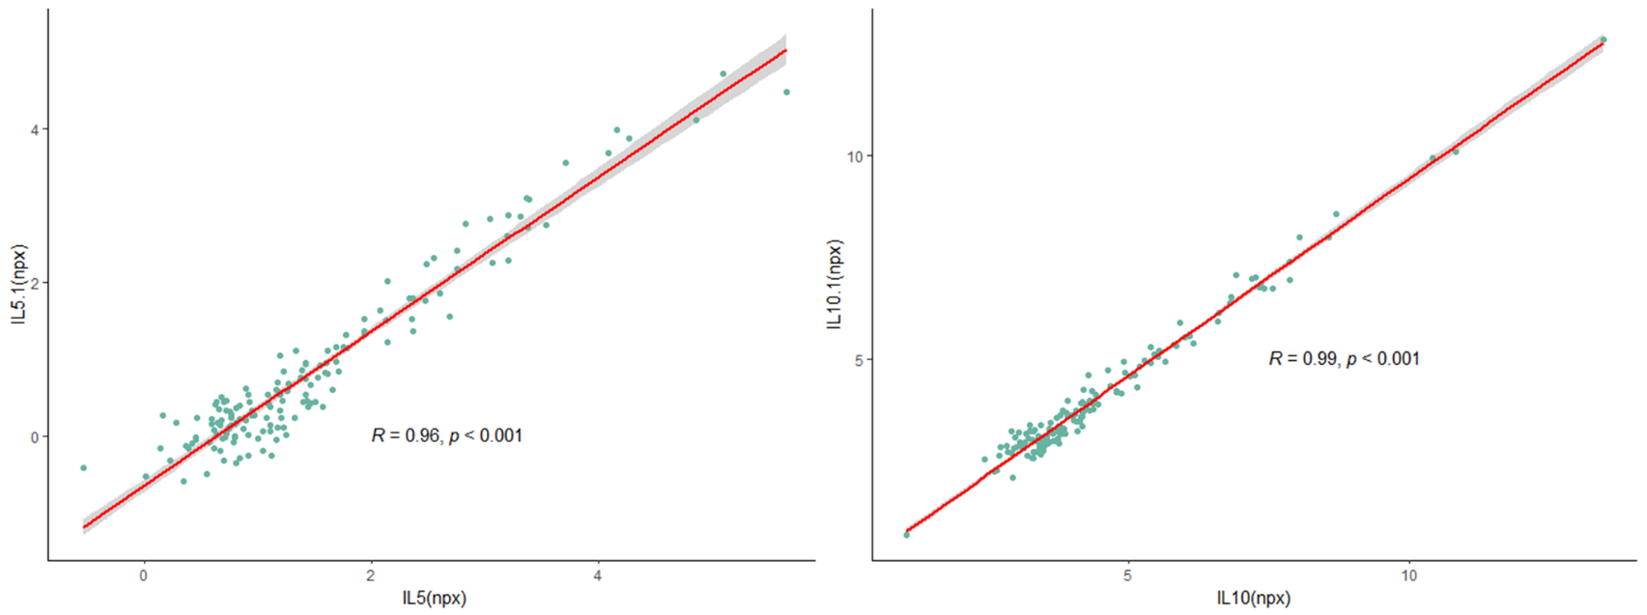
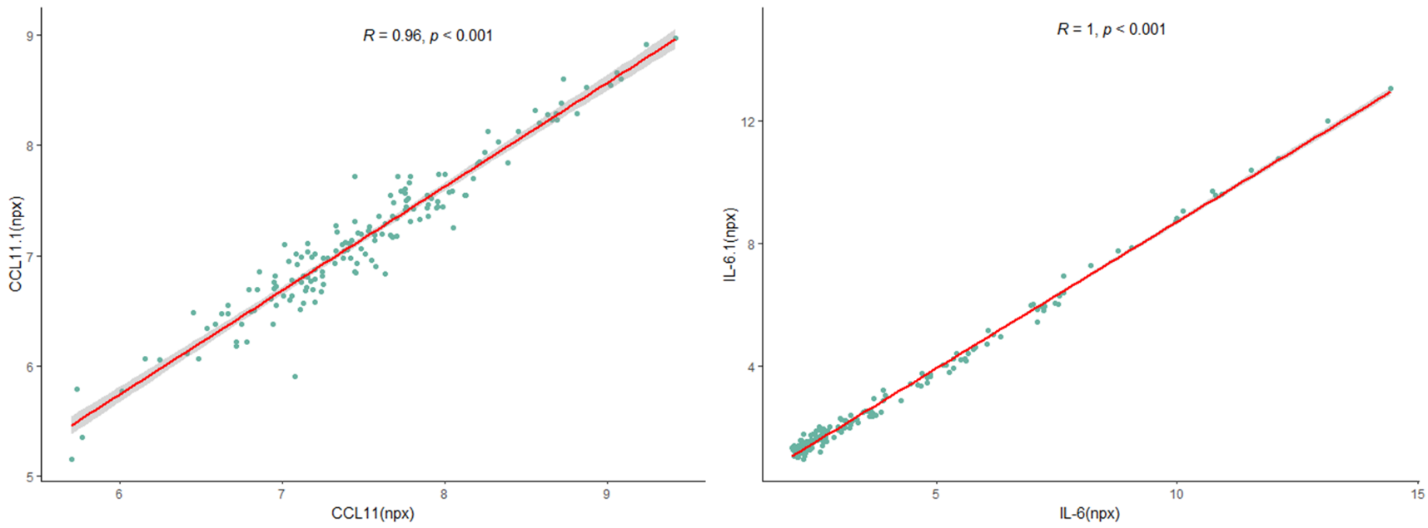
Scatterplot showing Pearson’s correlation of the 4 analytes measured by both PEA panel “Immune response” and PEA panel “Inflammation”. Grey area indicates 95% CI.
Figure 1: Correlation of analytes measured by PEA platforms analysing 92 analytes each

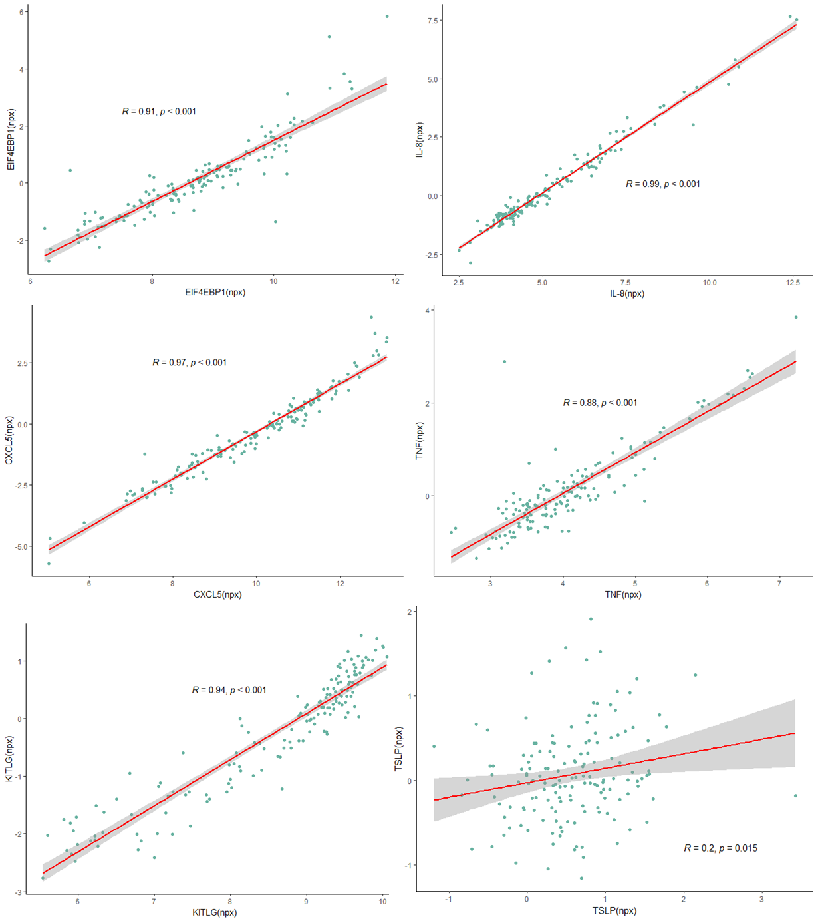
Figure 2: Correlation of analytes measured by PEA platforms
Scatterplots showing Pearson’s correlation of the protein measured by either PEA platform measuring 92 analytes (“Inflammation” or “Immune response”) and a PEA platform measuring 369 analytes (“Cardiometabolic”).

LC-MS/MS Data
LC-MS/MS analysis led to the quantification of 1,040 proteins in the total cohort of 173 analysed plasma samples. Following data filtering for missing values, 291 proteins were quantified in at least 121 (70%) of the samples (Figure 3).
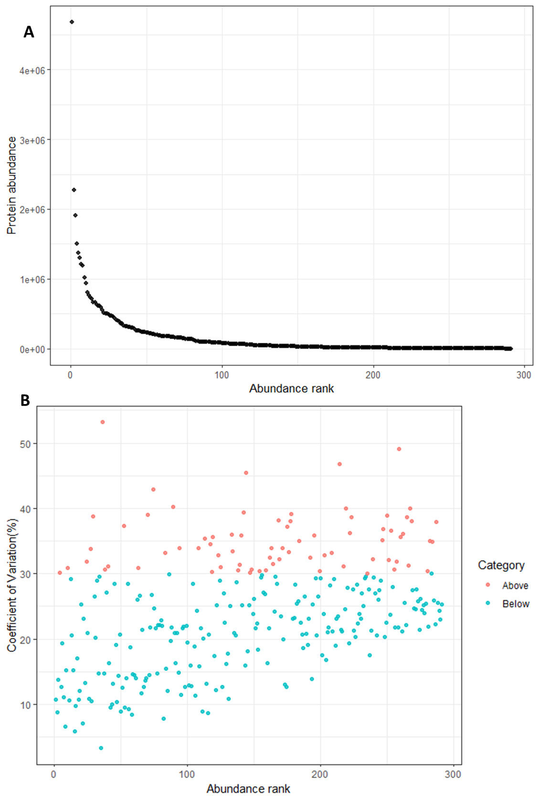
Figure 3: Technical variability of LC-MS/MS analysis
Ranked abundance of 291 proteins quantified by LC-MS/MS. (B) CVs of all quantified proteins were calculated for the nine sample replicate samples, plotted according to abundance. Proteins with CVs < 30% (Below) are coloured in blue and those with CVs >=30% in red (Above).

LASSO models
Table 1: AUC’s across outer 5 folds of finalised LASSO model using ELISA and ELLA data
Fold | AUC
1 | 1.00
2 | 0.80
3 | 1.00
4 | 1.00
5 | 0.92

Table 2: Number of times candidate proteins selected in outer 5 fold models
Feature | Number of folds selected in
(Intercept) | 5
CXCL9 | 5
PLA2G2A | 5
NTproBNP | 4
CXCL10 | 1

Table 3:LASSO coefficients in finalised model
Protein | Coefficient
CXCL9 | 1.33550806
PLA2G2A | 0.67207431
NTproBNP | 0.80390315
CXCL10 | 0

Table 4: Confusion matrix of finalised models performance in ELISA data
 |  | Actual
 |  | Febrile | MIS-C
Predicted | Febrile | 25 | 2
Predicted | MIS-C | 0 | 22

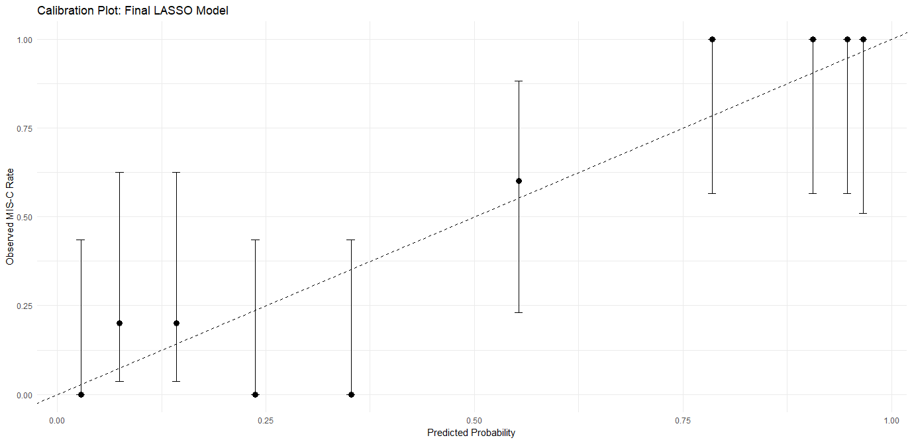
Figure 4: Calibration plot of finalised LASSO model

LASSO performance in external dataset A

Table 5: Confusion matrix of finalised LASSO model performance in external dataset A
 | Actual
 |  | COVID-19 | MIS-C
Predicted | COVID-19 | 40 | 3
Predicted | MIS-C | 13 | 31

