SMPDL3B a Novel Biomarker and Therapeutic Target in Myalgic Encephalomyelitis
Bita Rostami-Afshari,^{1,2,3,4} Wesam Elremaly,^{1,3,4} Anita Franco,^{1,3,4} Mohamed Elbakry,^{1,3,4,5} Marie-Yvonne Akoume,^{1,3,4,6} Ines Boufaied,⁷ Atefeh Moezzi,^{1,2,3,4} Corinne Leveau,^{1,2,3,4} Pierre Rompré,⁸ Christian Godbout,⁹ Olav Mella,¹⁰ Øystein Fluge,¹⁰ and Alain Moreau^{1,2,3,4,11,*}
¹ Viscogliosi Laboratory in Molecular Genetics of Musculoskeletal Diseases, Azrieli Research Center, CHU Sainte-Justine, Montreal, QC, Canada;
² Department of Biochemistry and Molecular Medicine, Faculty of Medicine, Université de Montréal, Montreal, QC, Canada;
³ Open Medicine Foundation ME/CFS Collaborative Center at CHU Sainte-Justine/Université de Montréal, Montreal, QC, Canada;
⁴ ICanCME Research Network, Azrieli Research Center, CHU Sainte-Justine, Montreal, QC, Canada;
⁵ Department of Chemistry, Biochemistry Section, Faculty of Science, Tanta University, Tanta, Gharbia Governorate, Egypt
⁶ Department of Cellular, Molecular Biology and Genetics, Université des Sciences de la Santé de Libreville (USS), Libraville, Gabon;
⁷ Flow Cytometry Platform, Azrieli Research Center, CHU Sainte-Justine, Montreal, QC, Canada;
⁸ Faculty of Dentistry, Université de Montréal, Montreal, QC, Canada;
⁹ Patient-partner, ICanCME Research Network, Azrieli Research Center, CHU Sainte-Justine, Montreal, QC, Canada;
¹⁰ Department of Oncology and Medical Physics at the University of Bergen, Haukeland University Hospital, Bergen, Norway;
¹¹ Department of Stomatology, Faculty of Dentistry, Université de Montréal, Montreal, QC, Canada;

*Corresponding Author: Prof Alain Moreau, Viscogliosi Laboratory in Molecular Genetics of Musculoskeletal Diseases, Office 2.17.027, Azrieli Research Center, CHU Sainte-Justine, 3175 Cote-Ste-Catherine Road, Montreal, QC, H3T 1C5, Canada.
Phone: 514-345-4931 ext: 5722 | Email: alain.moreau.hsj@ssss.gouv.qc.ca

SUPPLEMENTARY INFORMATION
Supplementary Table S1. Clinical and demographic characteristics of patients stratified by plasma SMPDL3B levels at 30 ng/mL.
 | Canadian cohort |  | P-value
Subgroups | < 30 ng/mL | ≥ 30 ng/mL
N (women:men) | 126 (98:28) | 123 (110:13)
Age (years) | 46.5 ± 0.9 | 49.2 ± 0.9 | 0.089
BMI (kg/m2) | 25.3 ± 0.4 | 26.7 ± 0.4 | 0.054
Disease duration | 6.5 ± 0.5 | 7.7 ± 0.6 | 0.304

Supplementary Table S2. overview of comorbidities in Canadian ME patients, healthy controls, and Norwegian ME patients
Comorbidities | Canadian ME cohort  n (249), n(%) | Canadian HC  n (63), n(%) | Norwegian ME cohort  n (141), n(%)
Hypothyroidism | 6 (2.4) | 2 (3.2) | 8 (5.7)
Depression | 77 (30.9) | 7 (11.1) | 12 (8.5)
Anxiety | 78 (31.3) | 8 (12.7) | 14 (9.9)
Allergy | 95 (38.2) | 17 (27.0) | 56 (39.7)
Fibromyalgia | 89 (35.7) | 0 | 11 (7.8)
Other | 35 (14.1) | 3 (4.8) | 26 (18.4)
The number (n) and percentage (%) of participants reporting various comorbidities within the Canadian Myalgic Encephalomyelitis (ME/CFS) cohort (n=249), the Canadian healthy control (HC) group (n=63), and the Norwegian ME cohort (n=141). The comorbidities listed include hypothyroidism, depression, anxiety, allergy, fibromyalgia, and other reported conditions.

Supplementary Table S3. Symptom scores stratified by plasma SMPDL3B levels (<30 ng/mL vs ≥30 ng/mL) in female and male participants of the Canadian cohort.
Questionnaire/ Symptom | Female ME Patients |  | Male ME Patients
 | < 30 ng/mL | >30 ng/mL | < 30 ng/mL | >30 ng/mL
n | 98 | 110 | 28 | 13
SF-36
Physical score | 33.3 ± 0.9 | 27.5 ± 0.9 | 39.6 ± 2.7 | 36.6 ± 3.6
 | 0.0012 ** |  | 0.7036
Mental score | 47.1 ± 1.6 | 41.8 ± 1.3 | 48.0 ± 3.8 | 45.4 ± 5.8
 | 0.0719 |  | 0.8087
MFI-20
Severity score | 74.7 ± 0.7 | 75.9 ± 0.8 | 65.8 ± 2.8 | 78.5 ± 3.5
 | 0.0029 ** |  | 0.0289 *
General fatigue | 17.1 ± 0.3 | 16.6 ± 0.3 | 16.3 ± 0.7 | 15.9 ± 1.5
 | 0.3472 |  | 0.9710
Physical fatigue | 17.1 ±0.2 | 17.5 ± 0.2 | 16.4 ± 0.6 | 17.4 ± 0.8
 | 0.0070 ** |  | 0.6876
Reduced activity | 15.3 ± 0.3 | 16.6 ± 0.2 | 14.2 ± 0.8 | 16.7 ± 0.8
 | 0.0001 *** |  | 0.1425
Reduced motivation | 10.6 ± 0.3 | 10.7 ± 0.3 | 10.9 ± 0.6 | 15.1 ± 1.0
 | 0.9630 |  | 0.0043 **
Mental fatigue | 14.5 ± 0.3 | 14.6 ± 0.3 | 12.9 ± 0.7 | 14.9 ± 0.9
 | 0.2173 |  | 0.2548
DSQ
Post-exertional malaise | 67.3 ± 1.6 | 71.3 ± 1.2 | 55.5 ± 3.2 | 62.0 ± 6.1
 | 0.0435 * |  | 0.3559
Autonomic disturbances | 41.7 ± 1.2 | 42.0 ± 1.0 | 29.2 ± 2.6 | 30.0 ± 4.5
 | 0.6905 |  | 0.8736
Sleep disturbances | 49.7 ± 1.4 | 51.1 ± 1.2 | 43.0 ± 2.9 | 44.1 ± 3.5
 | 0.4793 |  | 0.9173
Cognitive disturbances | 55.0 ± 1.6 | 55.0 ± 1.2 | 44.4 ± 3.6 | 43.4 ± 7.0
 | 0.5926 |  | 0.9174
Values are presented as mean ± SEM, depending on the distribution. P-values were obtained using the Mann–Whitney U test. Note: For the SF-36, lower scores indicate greater symptom severity. For the MFI-20 and DSQ, higher scores indicate greater symptom severity.

Supplementary Table S4. Symptom scores in female and male participants of the Canadian cohort
Questionnaire/ Symptom | ME Patients
 | Female | Male
n | 208 | 41
SF-36
Physical score | 30.3 ± 0.8 | 38.6 ± 2.7
 | 0.0028 **
Mental score | 44.7 ± 1.2 | 47.2 ± 3.5
 | 0.6167
MFI-20
Severity score | 75.4 ± 0.6 | 69.8 ± 2.6
 | 0.0426 *
General fatigue | 17.0 ± 0.3 | 16.2 ± 0.8
 | 0.2750
Physical fatigue | 17.5 ± 0.2 | 16.7 ± 0.6
 | 0.3660
Reduced activity | 16.2 ± 0.2 | 15.0 ± 0.7
 | 0.1774
Reduced motivation | 10.7 ± 0.3 | 12.2 ± 0.7
 | 0.0391 *
Mental fatigue | 14.7 ± 0.2 | 13.5 ± 0.7
 | 0.1463
DSQ
Post-exertional malaise | 70.3 ± 1.2 | 57.5 ± 3.3
 | 0.0004 ***
Autonomic disturbances | 42.5 ± 1.0 | 29.4 ± 2.5
 | <0.0001 ****
Sleep disturbances | 51.0 ± 1.2 | 43.4 ± 2.5
 | 0.0183 *
Cognitive disturbances | 55.6 ± 1.2 | 44.1 ± 3.7
 | 0.0018 **
Values are presented as mean ± SEM, depending on the distribution. P-values were obtained using the Mann–Whitney U test. Note: For the SF-36, lower scores indicate greater symptom severity. For the MFI-20 and DSQ, higher scores indicate greater symptom severity.

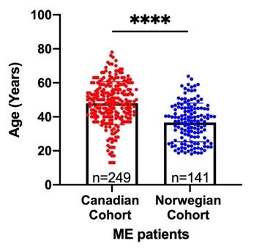
Supplementary Figure S1. Age distribution of ME participants in Canadian and Norwegian cohorts. The data are presented as histograms with mean, standard error of the mean and individuals’ distribution. Significant differences were observed between both groups. The data were analyzed using unpaired t-test . The results were significant at ***P-value <0.001.
Supplementary Figure S2. (a) Evaluation of Plasma SMPDL3B as a Biomarker for ME Severity – ROC curve analysis for threshold determination (Canadian Cohort). Receiver Operating Characteristic (ROC) curve illustrating the ability of plasma SMPDL3B levels to predict ME severity (assessed by MFI-20 global fatigue score, SF-36 score and DSQ score) in the Canadian cohort. The analysis yielded an Area Under the Curve (AUC) of 0.84, with a corresponding sensitivity of 77% and specificity of 87%. The ROC curve was generated using k-fold cross-validation with a Random Forest model. (b) Evaluation of Plasma SMPDL3B as a Biomarker for ME Severity – ROC Curve Analysis (Norwegian Cohort). Receiver Operating Characteristic (ROC) curve illustrating the ability of plasma SMPDL3B levels to predict ME severity in the Norwegian cohort. Severity was assessed using a simplified classification based on regrouped categorical fatigue levels. The analysis yielded an Area Under the Curve (AUC) of 0.73, with a corresponding sensitivity of 75% and specificity of 79%. The ROC curve was generated using k-fold cross-validation with a Random Forest model.
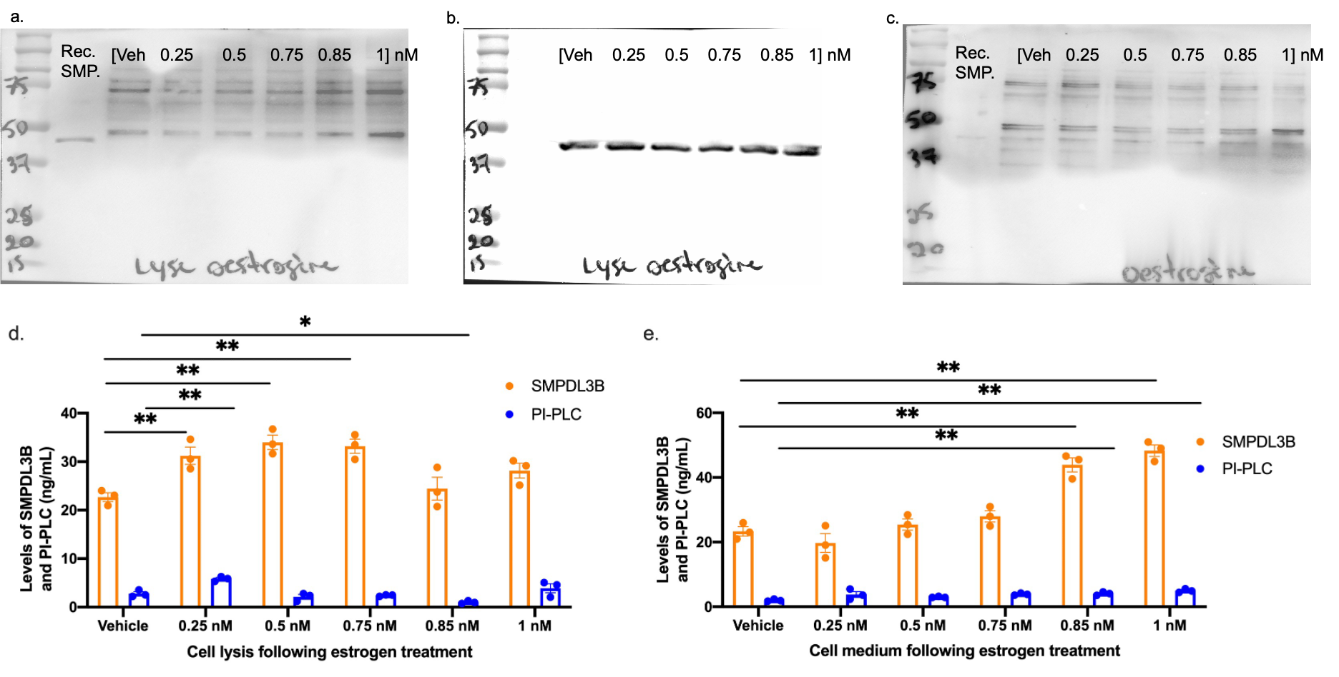
Supplementary Figure S3. SMPDL3B Expression and Secretion in Jurkat Cells Treated with Estradiol. Western blot analysis of SMPDL3B and β-actin in Jurkat cells (human immortalized T lymphocytes) treated with increasing doses [0.25–1] nM of estradiol for 18 hours. The first lane contains recombinant SMPDL3B at 46 kDa, while the second lane corresponds to the vehicle. SMPDL3B bands were detected at 50 kDa and 73 kDa on the Western blot. (a) Cell lysates were probed for SMPDL3B to assess its levels in the cytoplasm and membrane. (b) β-actin was used as a loading control to confirm equal protein loading in the lysates. (c) Culture media were probed for soluble SMPDL3B to evaluate its secretion in response to estradiol treatment. (d) SMPDL3B and PI-PLC levels were measured by ELISA in cell lysates treated with increasing doses of estradiol. (e) SMPDL3B and PI-PLC concentrations (ng/mL) were measured in culture media from cells treated with increasing doses of estradiol. SMPDL3B levels in both lysates and media indicate a dose-dependent response to estradiol treatment.

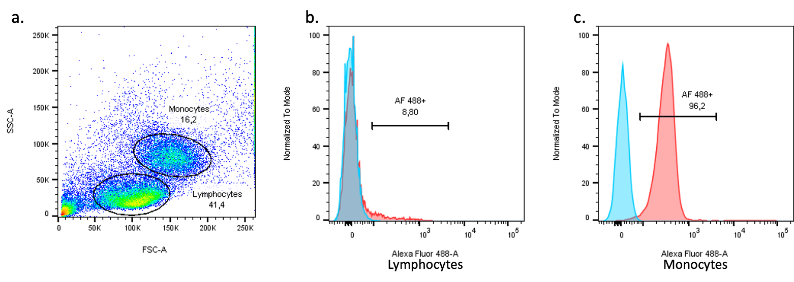
Supplementary Figure S4. Flow Cytometry Analysis of Membrane-Anchored SMPDL3B Signal Intensity in PBMC Subpopulations. Flow cytometry analysis illustrating the signal intensity of membrane-anchored SMPDL3B in peripheral blood mononuclear cell (PBMCs). (a) Scatter plot of forward and side scatter signals, visualizing different PBMC subpopulations. Monocytes and lymphocytes are gated and highlighted. (b) Density plot showing the signal intensity of membrane-anchored SMPDL3B (pink) in lymphocytes, overlaid with the background noise control signal (blue) This plot demonstrates the specificity of SMPDL3B staining in lymphocytes. (c) Density plot demonstrating a clear separation between the signal intensity of membrane-anchored SMPDL3B (pink) and the background noise control (blue) in monocytes. This plot confirms the specific detection of SMPDL3B in monocytes. These figures represent a control experiment to validate the detection of the membrane-anchored form of SMPDL3B in PBMC subsets.

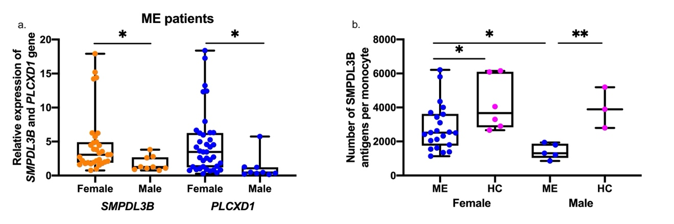
Supplementary Figure S5. Relative expression of SMPDL3B in women versus men in ME patients. (a) Relative expression of SMPDL3B and PLCXD1 gene in women (n=40) and men (n=11) ME patients. (b) Membrane-bound SMPDL3B per monocyte in women and men ME patients and healthy controls (n=22; n=6; n=5; n=3). SMPDL3B and PLCXD1 gene expression levels were measured in PBMCs using RT-qPCR and normalized to the housekeeping gene GAPDH. Significant differences were observed between women and men. The data were analyzed using unpaired t-test. The results were significant at *P-value <0.01.

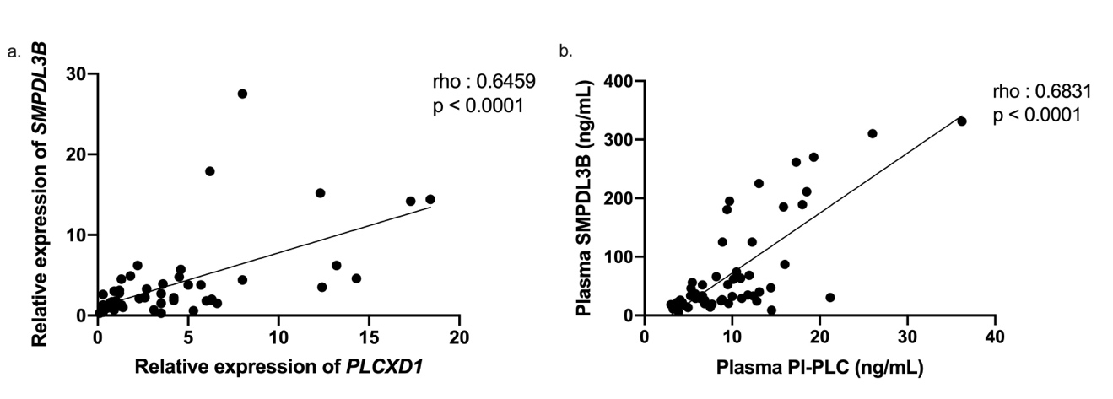
Supplementary Figure S6. Correlation between SMPDL3B and PI-PLC levels. This figure provides further evidence supporting the involvement of PI-PLC in the cleavage of SMPDL3B. (a) Scatter plot showing positive correlation between SMPDL3B and PLCXD1 gene expression in ME patients (n=51). SMPDL3B and PLCXD1 gene expression levels were measured in PBMCs using RT-qPCR and normalized to the housekeeping gene GAPDH. The correlation was assessed using spearmen correlation coefficient (rho = 0.6459, ****p-value < 0.0001 (b) Positive correlation between plasma SMPDL3B and plasma PI-PLC levels (ng/mL) in ME patients (n=54). The correlation was assessed using spearmen correlation coefficient (rho = 0.6831, ****p-value < 0.0001).

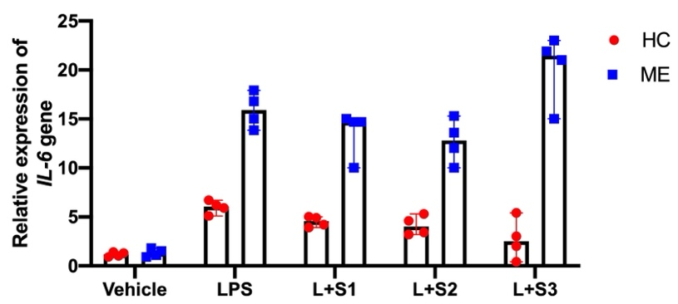

Supplementary Figure S7. Role of soluble SMPDL3B towards TLR4 receptor. LPS stimulation of PBMCs with increasing doses of recombinant SMPDL3B (12,5; 25 and 50 ng/mL) (S1, S2, and S3 respectively) or vehicle.

