Supporting Information
Low-Liver-Accumulation Lipid Nanoparticles Enhance the Efficacy and Safety of HPV Therapeutic Tumor Vaccines

Xiaodie Wang^{1†}, Zhidan Tian^{2†}, Meng Wang², Xiaoru Cai², Shuyan Yang², Jianyao Zeng², Yuan Fang¹², Xuesen Bai², Pei Wang¹², Yan Sun¹², Chuanxin Guo^{2*}, Tao Liu^{2*}, Qijun Qian^{123*}

¹School of Medicine, Shanghai University, Shanghai 200444, China.
²Shanghai Cell Therapy Group Co., Ltd, Shanghai 201805, China.
³Shanghai Mengchao Cancer Hospital, Shanghai University, Shanghai 201805, China.
†These authors contributed equally to this work and shared first authorship.

*Corresponding author：
Chuanxin Guo: guocx@shcell.com
Tao Liu: liut@shcell.com
Qijun Qian: qianqj@shu.edu.cn

Contents
Fig. S1. LNP structures with different tail lengths ····················· ········ ·········· ··3
Table S1 Characteristics of Lipid 1 - Lipid 20 ····················· ········ ·········· ·······4
¹H NMR Analysis of Lipid 1 - Lipid 20 ····················· ········ ·········· ·············5
Spectral Data for Lipid 7····················· ········ ·········· ·······························8
Fig. S2. H&E staining of male and female rat organs ············ ········ ········ ········10
Fig. S3. Sample stability analysis of HPV mRNA encapsulated by Lipid 7 ·············11
Table S2 Blood biochemistry at different doses ··································· ·······12
Table S3 Complete blood count at different doses ································· ·······12
Table S4 HPV peptide mini pool ··································· ························ ·12
Assay Procedures for hERG Activity ················· ························ ··············12

Fig. S1. LNP structures with different tail lengths.

Table S1 Characteristics of Lipid 1 - Lipid 20
LNP | Structure | ESI-MS m/z | Particle size  (nm) | PDI | Zeta potential  （mV） | EE%
Lipid 1 | 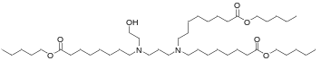 | 755.18 | 227.20 | 0.18 | 1.13 | 71.86
Lipid 2 | 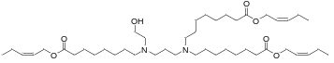 | 749.13 | 216.50 | 0.09 | 4.33 | 60.61
Lipid 3 | 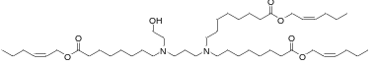 | 791.21 | 211.13 | 0.05 | 3.20 | 68.04
Lipid 4 | 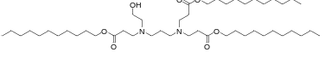 | 797.26 | 118.08 | 0.10 | 0.27 | 88.65
Lipid 5 | 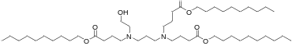 | 797.26 | 144.39 | 0.18 | 0.47 | 97.85
Lipid 6 | 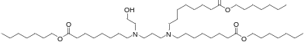 | 838.74 | 130.83 | 0.05 | 1.57 | 97.85
Lipid 7 | 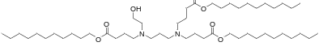 | 839.34 | 141.66 | 0.10 | 9.90 | 97.85
Lipid 8 | 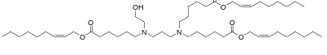 | 833.29 | 146.44 | 0.14 | 0.83 | 97.00
Lipid 9 | 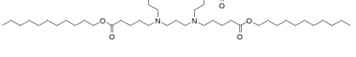 | 881.42 | 140.04 | 0.06 | 13.07 | 98.64
Lipid 10 | 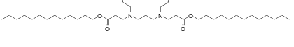 | 881.42 | 107.00 | 0.15 | 8.87 | 96.94
Lipid 11 | 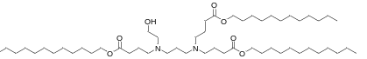 | 881.42 | 133.31 | 0.05 | 3.30 | 97.69
Lipid 12 | 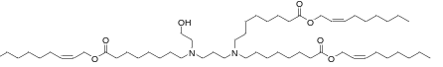 | 917.46 | 108.91 | 0.07 | 6.43 | 90.12
Lipid 13 | 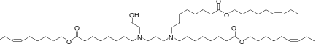 | 917.46 | 153.31 | 0.03 | 1.13 | 75.18
Lipid 14 | 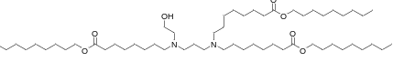 | 923.5 | 124.88 | 0.07 | 5.23 | 97.19
Lipid 15 | 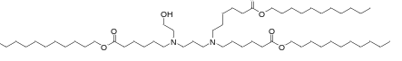 | 923.5 | 113.19 | 0.09 | 15.17 | 98.13
Lipid 16 | 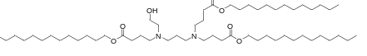 | 923.5 | 102.23 | 0.14 | 11.73 | 97.61
Lipid 17 | 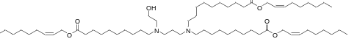 | 1000.88 | 137.10 | 0.18 | 4.73 | 97.86
Lipid 18 | 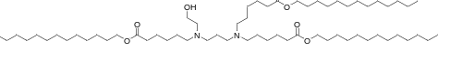 | 1007.67 | 96.35 | 0.07 | 0.13 | 98.60
Lipid 19 | 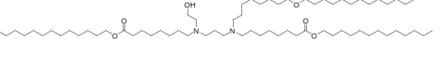 | 1091.83 | 124.59 | 0.22 | 10.00 | 97.35
Lipid 20 | 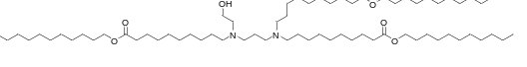 | 1091.83 | 165.89 | 0.10 | 3.60 | 97.86
¹H NMR Analysis of Lipid 1 - Lipid 20
Lipid 1 ¹H NMR (400 MHz, Chloroform-d) δ 4.12 - 4.02 (m, 6H), 3.64 - 3.57 (m, 2H), 2.70 (s, 1H), 2.66 - 2.52 (m, 8H), 2.52 - 2.45 (m, 2H), 2.33 - 2.25 (m, 6H), 1.82 - 1.72 (m, 2H), 1.67 - 1.50 (m, 16H), 1.50 - 1.40 (m, 2H), 1.39 - 1.30 (m, 27H), 1.30 - 1.22 (m, 4H), 0.96 - 0.87 (m, 9H).
Lipid 2 ¹H NMR (400 MHz, Chloroform-d) δ 5.71 - 5.59 (m, 3H), 5.55 - 5.43 (m, 3H), 4.62 (dd, J = 6.9, 1.3 Hz, 6H), 3.67 (t, J = 5.0 Hz, 2H), 2.99 - 2.90 (m, 1H), 2.87 - 2.78 (m, 4H), 2.74 - 2.65 (m, 4H), 2.61 - 2.51 (m, 2H), 2.31 (t, J = 7.5 Hz, 6H), 2.17 - 2.07 (m, 6H), 2.02 - 1.88 (m, 2H), 1.70 - 1.56 (m, 10H), 1.54 - 1.44 (m, 2H), 1.39 - 1.24 (m, 20H), 1.00 (t, J = 7.5 Hz, 9H).
Lipid 3 ¹H NMR (400 MHz, Chloroform-d) δ 5.74 - 5.62 (m, 3H), 5.62 - 5.52 (m, 3H), 4.66 (d, J = 6.8 Hz, 6H), 3.59 (t, J = 5.2 Hz, 2H), 2.60 (t, J = 5.2 Hz, 2H), 2.56 - 2.42 (m, 9H), 2.34 (t, J = 7.5 Hz, 6H), 2.17 - 2.07 (m, 6H), 1.71 - 1.58 (m, 8H), 1.54 - 1.37 (m, 13H), 1.37 - 1.24 (m, 19H), 0.94 (t, J = 7.4 Hz, 9H).
Lipid 4 ¹H NMR (400 MHz, Chloroform-d) δ 4.09 - 4.03 (m, 6H), 3.56 (t, J = 5.1 Hz, 2H), 2.85 - 2.69 (m, 6H), 2.61 - 2.54 (m, 2H), 2.54 - 2.35 (m, 10H), 1.72 - 1.52 (m, 8H), 1.41 - 1.18 (m, 49H), 0.88 (t, J = 6.8 Hz, 9H).
Lipid 5 ¹H NMR (400 MHz, Chloroform-d) δ 4.10 - 4.07 (m, 6H), 3.58 (t, J =5.2 Hz, 2H), 2.61 (t, J = 5.3 Hz, 2H), 2.52 (t, J = 7.3 Hz, 4H), 2.46 (t, J = 7.3 Hz, 4H), 2.37-2.32 (m, 6H), 1.82 - 1.75 (m, 6H), 1.66 - 1.57 (m, 8H), 1.38 - 1.29 (m, 44H), 0.91 (t, J = 6.7 Hz, 9H).
Lipid 6 ¹H NMR (400 MHz, Chloroform-d) δ 4.08 (t, J = 6.8 Hz, 6H), 3.80 - 3.69 (m, 4H), 2.93 (t, J = 7.3 Hz, 2H), 2.83 (t, J = 8.2 Hz, 4H), 2.75 - 2.65 (m, 4H), 2.61 - 2.53 (m, 2H), 2.37 - 2.30 (m, 5H), 1.64 (t, J = 6.9 Hz, 16H), 1.40 - 1.25 (m, 42H), 0.95 - 0.87 (m, 9H)
Lipid 7 ¹H-NMR (400 MHz, Chloroform-d) δ 4.09 - 4.01 (m, 6H), 3.54 (t, J = 5.2 Hz, 2H), 2.57 (t, J = 5.2 Hz, 2H), 2.48 (t, J = 7.2 Hz, 4H), 2.41 (t, J = 7.2 Hz, 6H), 2.35 - 2.26 (m, 6H), 2.02 (s, 1H), 1.82 - 1.68 (m, 6H), 1.66 - 1.49 (m, 8H), 1.27 (d, J = 8.8 Hz, 48H), 0.88 (t, J = 6.7 Hz, 9H).
Lipid 8 ¹H NMR (400 MHz, Chloroform-d6) δ 5.69 - 5.58 (m, 3H), 5.57 - 5.46 (m, 3H), 4.65 - 4.58 (m, 6H), 3.53 (t, J = 5.2 Hz, 2H), 2.58 - 2.34 (m, 11H), 2.31 (t, J = 7.5 Hz, 6H), 2.15 - 2.04 (m, 6H), 1.69 - 1.59 (m, 7H), 1.50 - 1.40 (m, 6H), 1.39 - 1.23 (m, 32H), 0.92 - 0.84 (m, 9H).
Lipid 9 ¹H-NMR (400 MHz, Chloroform-d) δ 4.08 - 4.01 (m, 6H), 3.55 (t, J = 5.2 Hz, 2H), 2.58 (t, J = 5.2 Hz, 2H), 2.48-2.31 (m, 10H), 2.30 - 2.26 (m, 6H), 1.69 - 1.50 (m, 14H), 1.49 - 1.30 (m, 6H), 1.25-1.10 (m, 48H), 0.89 (t, J = 6.7 Hz, 9H).
Lipid 10 ¹H NMR (400 MHz, Chloroform-d) δ 4.06 (q, J = 7.0 Hz, 6H), 3.56 (t, J = 5.0 Hz, 2H), 2.90-2.69 (m, 6H), 2.65 - 2.35 (m, 12H), 1.73 -1.50 (m, 8H), 1.45 - 1.16 (m, 61H), 0.88 (t, J = 6.8 Hz, 9H).
Lipid 11 ¹H NMR (400 MHz, Chloroform-d) δ 4.10 - 4.06 (m, 6H), 3.58 (t， J = 5.2 Hz, 2H), 2.60 (t, J = 5.2 Hz, 2H), 2.51 (t, J = 7.3 Hz, 4 H), 2.46 (t, J = 7.2 Hz, 6 H), 2,37 - 2.32 (m, 6H), 1.84 - 1.73 (m, 6H), 1.66 - 1.57 (m, 8H), 1.38 - 1.29 (m, 55H), 0.91 (t, J = 7.5 Hz, 9H).
Lipid 12 ¹H-NMR (400 MHz, Chloroform-d6) δ 5.68 – 5.58 (m, 3H), 5.56 - 5.46 (m, 3H), 4.61 (d, J = 6.8 Hz, 6H), 3.53 (t, J = 5.2 Hz, 2H), 2.57 - 2.36 (m, 10H), 2.35 (d, J = 5.1 Hz, 2H), 2.29 (t, J = 7.5 Hz, 6H), 2.14 - 2.04 (m, 6H), 1.66 - 1.50 (m, 8H), 1.44 - 1.24 (m, 48H), 0.91 - 0.83 (m, 9H).
Lipid 13 ¹H NMR (400 MHz, Chloroform-d) δ 5.46 - 5.29 (m, 6H), 4.09 (t, J = 6.7 Hz, 6H), 3.81 - 3.71 (m, 1H), 3.59 (t, J = 5.2 Hz, 2H), 2.64 - 2.54 (m, 4H), 2.54 - 2.43 (m, 8H), 2.32 (t, J = 7.5 Hz, 6H), 2.13 - 1.99 (m, 13H), 1.69 - 1.59 (m, 13H), 1.50 - 1.47 (m, 3H), 1.45 - 1.38 (m, 12H), 1.36 - 1.25 (m, 21H), 0.99 (t, J = 7.5 Hz, 9H).
Lipid 14 ¹H NMR (400 MHz, Chloroform-d) δ 4.05 (t, J = 6.8 Hz, 6H), 3.67 (t, J = 5.1 Hz, 2H), 3.00 - 2.84 (m, 3H), 2.84 - 2.74 (m, 4H), 2.73 - 2.63 (m, 4H), 2.56 (t, J = 7.8 Hz, 2H), 2.29 (t, J = 7.5 Hz, 6H), 2.02 - 1.88 (m, 2H), 1.71 - 1.56 (m, 16H), 1.54 - 1.45 (m, 2H), 1.42 - 1.13 (m, 54H), 0.88 (t, J = 6.7 Hz, 9H).
Lipid 15 ¹H NMR (400 MHz, Chloroform-d6) δ 4.05 (t, J = 6.8 Hz, 6H), 3.53 (t, J = 5.2 Hz, 2H), 2.56 - 2.34 (m, 11H), 2.29 (t, J = 7.5 Hz, 6H), 1.68 - 1.57 (m, 12H), 1.49 - 1.39 (m, 6H), 1.28 (d, J = 17.3 Hz, 57H), 0.88 (t, J = 6.8 Hz, 9H).
Lipid 16 ¹H NMR (400 MHz, Chloroform-d) δ 4.10 - 4.06 (m, 6H), 3.57 (t J = 5.2 Hz, 2H), 2.60 (t, J = 5.2 Hz, 2H), 2.49-2.31 (m, 10H), 2.30 - 2.27 (m, 6H), 1.68 - 1.56 (m, 6H), 1.55 - 1.50 (m, 8H), 1.25-1.15 (m, 61H), 0.90 (t, J = 6.7 Hz, 9H).
Lipid 17 ¹H NMR (400 MHz, Chloroform-d) δ 5.73 - 5.62 (m, 2H), 5.61 - 5.50 (m, 2H), 4.73 - 4.62 (m, 6H), 4.21 - 4.12 (m, 1H), 3.69 - 3.61 (m, 1H), 2.83- 2.63 (m, 6H), 2.53 - 2.48 (m, 2H), 2.34 (t, J = 7.6 Hz, 6H), 2.18 - 2.06 (m, 8H), 1.88 - 1.75 (m, 2H), 1.69 - 1.62 (m, 6H), 1.45 - 1.21 (m, 64H), 0.97 - 0.88 (m, 9H).
Lipid 18 ¹H-NMR (400 MHz, Chloroform-d) δ 4.05 (t, J = 6.7 Hz, 6H), 3.57 - 3.50 (m, 2H), 2.58 - 2.42 (m, 5H), 2.42 - 2.35 (m, 6H), 2.28 (t, J = 7.5 Hz, 6H), 1.65 - 1.52 (m, 13H), 1.49 - 1.41 (m, 5H), 1.40 - 1.33 (m, 5H), 1.33 - 1.23 (m, 64H), 0.88 (t, J = 6.8 Hz, 9H).
Lipid 19 ¹H NMR (400 MHz, Chloroform-d) δ 4.09 (t, J = 6.8 Hz, 6H), 3.79 - 3.72 (m, 1H), 2.76 - 2.57 (m, 8H), 2.52 (t, J = 7.6 Hz, 2H), 2.32 (t, J = 7.5 Hz, 6H), 1.71 - 1.55 (m, 16H), 1.45 - 1.20 (m, 85H), 0.92 (t, J = 6.8 Hz, 9H).
Lipid 20 ¹H NMR (400 MHz, Chloroform-d) δ 4.09 (t, J = 6.8 Hz, 6H), 3.83 - 3.76 (m, 1H), 3.24 - 3.17 (m, 1H), 3.09 (t, J = 8.5 Hz, 3H), 2.88 - 2.77 (m, 2H), 2.65-2.63 (m, 1H), 2.33 (t, J = 7.5 Hz, 7H), 2.12 - 1.98 (m, 2H), 1.80 - 1.54 (m, 16H), 1.46 - 1.16 (m, 85H), 1.01 - 0.83 (m, 9H).

Spectral Data for Lipid 7
¹HNMR of Lipid 7
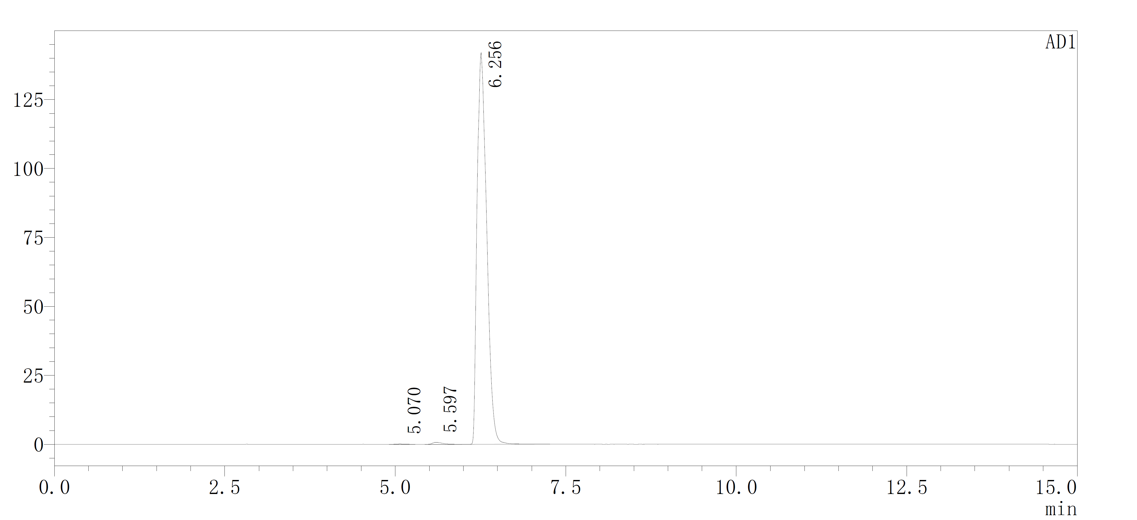
HPLC of Lipid 7

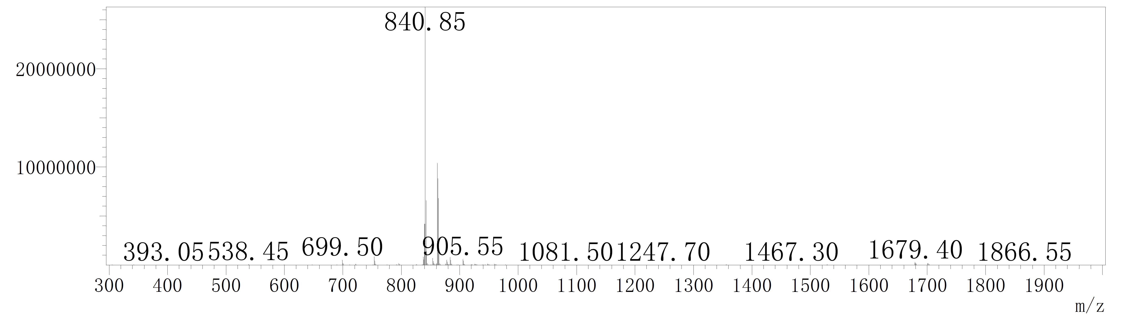
MS spectra of Lipid 7

Fig. S2. H&E staining of male and female rat organs.

Fig. S3. a. Sample stability analysis of HPV mRNA encapsulated by Lipid 7. b. Organs weight at three doses. Data are presented as Mean ± SD. n=3 for ‘a’. n=6 for ‘b’. The data were analyzed by ordinary one-way ANOVA. ns = not significant.

Table S2 Blood biochemistry at different doses

Sample | ALT (U/L) | AST (U/L) | ALP (U/L) | ALB (g/L) | GLU (mmol/L) | UREA (mmol/L)
PBS | 40.43±25.43 | 120.63±17.99 | 71.30±24.91 | 20.20±2.96 | 11.21±5.36 | 10.58±1.65
Empty LNP | 32.67±5.41 | 87.70±23.54 | 69.23±15.19 | 17.33±0.91 | 12.03±2.96 | 7.93±1.57
5 μg | 40.77±3.03 | 72.67±12.08 | 141.10±41.29 | 20.13±1.88 | 12.48±1.22 | 9.64±1.45
10 μg | 49.93±9.26 | 92.43±18.36 | 130.70±24.55 | 20.07±0.06 | 12.74±1.61 | 7.71±1.16
20 μg | 67.60±11.36 | 94.20±4.81 | 109.63±11.87 | 18.77±0.90 | 9.61±3.22 | 6.82±1.47
Normal range | 21-75 | 55-150 | 78.3-132.1 | 25-38 | 6.1-17.4 | 5.0-10.0

Table S3 Complete blood count at different doses

Sample | RBC (10^12/L) | HGB (g/L) | HCT (%) | MCV (fL) | WBC (10^9/L) | PLT (10^9/L)
PBS | 6.14±3.03 | 94.67±43.98 | 30.60±11.42 | 53.40±10.91 | 10.59±2.40 | 1,112.67±82.05
Empty LNP | 5.02±3.42 | 77.00±50.47 | 23.47±16.39 | 46.30±1.01 | 7.04±1.58 | 1,244.67±26.58
5 μg | 7.12±4.09 | 105.67±58.65 | 31.37±18.18 | 43.87±0.51 | 5.00±2.61 | 859.33±67.68
10 μg | 6.81±4.53 | 103.33±66.26 | 29.97±19.94 | 43.93±0.15 | 3.65±0.43 | 546.00±172.13
20 μg | 7.73±3.49 | 116.00±48.59 | 33.53±15.13 | 43.40±0.10 | 3.07±0.39 | 379.67±100.30
Normal range | 7.0-10.0 | 120-160 | 38.8-47.2 | 45-55 | 0.92-7.35 | 49-1507

Table S4 HPV peptide mini pool

GENE | HPV peptide mini pool
HPV 16E6 | CVYCKQQLL | FAFRDLCIV | CVYCKQQL | ILECVYCKQQLL
HPV 16E6 | EVYDFAFRDL | KISEYRHYCYSL | ISEYRHYCYSL | ISEYRHYCYS
HPV 16E6 | SEYRHYCYSL | VYDFAFRDL | YDFAFRDL | DKKQRFHNI
HPV 16E7 | RAHYNIVTF | DRAHYNIVTF | LCVQSTHVD
HPV 18E6 | ITCVYCKTV | VFEFAFKDLF | FAFKDLFVV | KCIDFYSRI
HPV 18E6 | IDFYSRIREL | TNTGLYNLL
HPV 18E7 | LEPQNEIPV | SSADDLRAFQQL | LRAFQQLFLNTL | RAFQQLFLNTL
HPV 18E7 | FQQLFLNTL | RAFQQLFL

Assay Procedures for hERG Activity
The inhibitory effect of Lipid 7 on hERG potassium channels was evaluated in HEK293 cells stably expressing these channels, employing the whole-cell patch-clamp technique. The cells were cultured in Dulbecco’s Modified Eagle Medium (DMEM) supplemented with 10% fetal bovine serum (FBS) and 2 μg/mL puromycin, and maintained at 37°C in a humidified atmosphere containing 5% CO₂. Electrophysiological recordings were conducted on individual, well-adhered cells using a MultiClamp 700B amplifier system. To elicit hERG tail currents, a voltage protocol was applied wherein cells were held at a membrane potential of -80 mV, depolarized to +40 mV for 500 ms, and subsequently repolarized to -80 mV with a 1.2 V/s ramp. Current signals were acquired using Clampex 10.6 software, and peak tail currents were subsequently analyzed with Clampfit 10.6 software. Concentration-response curves were generated and fitted using the Hill equation to determine IC₅₀ values. Key experimental parameters, including electrode resistance (3.1–4.0 MΩ) and seal resistance (>1 GΩ), were rigorously monitored throughout the experiments. The sensitivity and reliability of the assay system were validated using terfenadine as a positive control.

